**PROGRAM 1**

**Aim:** Program to print “Hello World” in JAVA

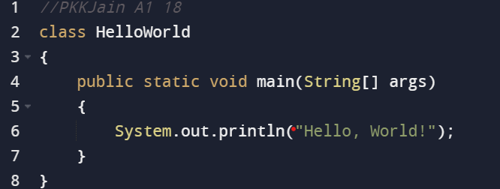

**Output:**

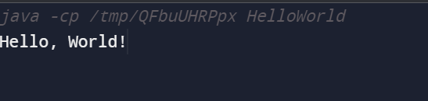

**PROGRAM 2**

**Aim:** Sum of two numbers and difference of two numbers

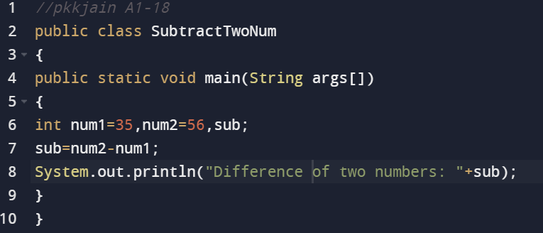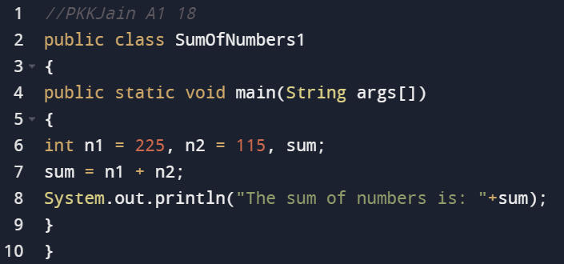

**Output:**

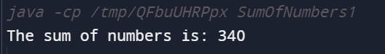

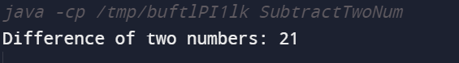

**PROGRAM 3**

**Aim:** Sum of two numbers and difference of two numbers

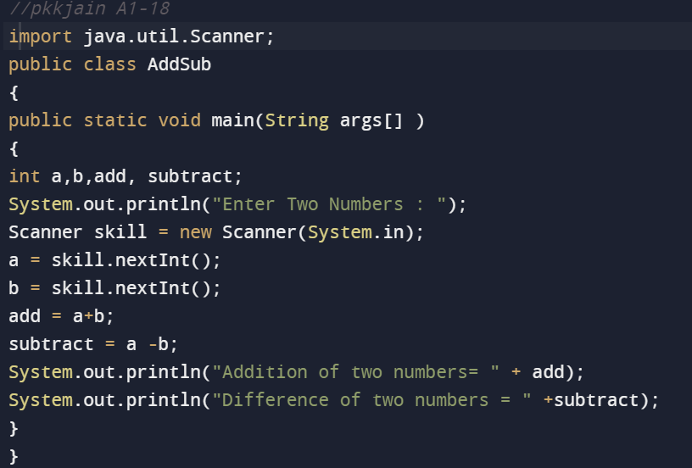

**Output;**

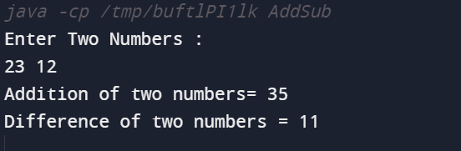

**PROGRAM 4**

**Aim:** Multiplication table of a number

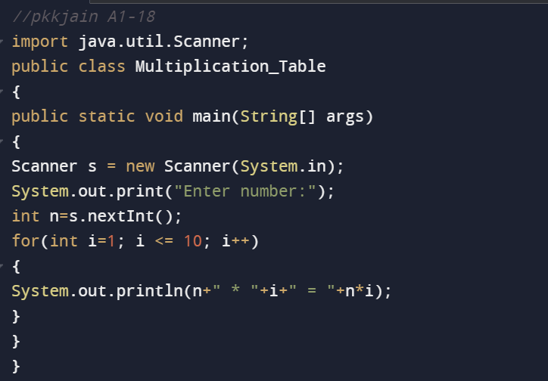

**Output:**

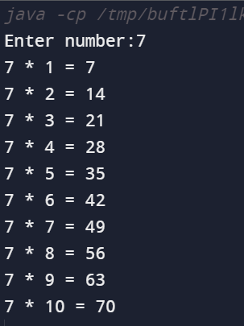

**PROGRAM 5**

**Aim:** Basic calculator

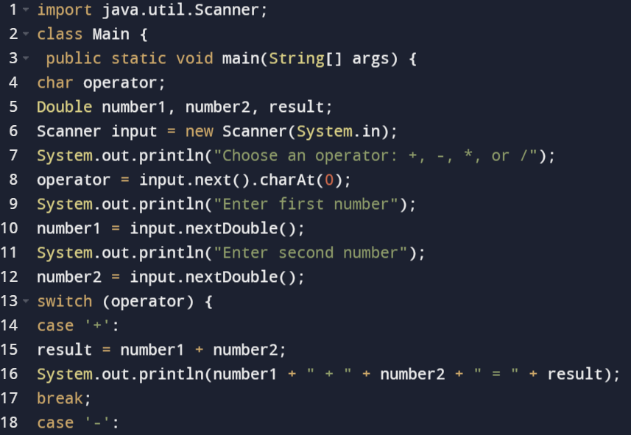

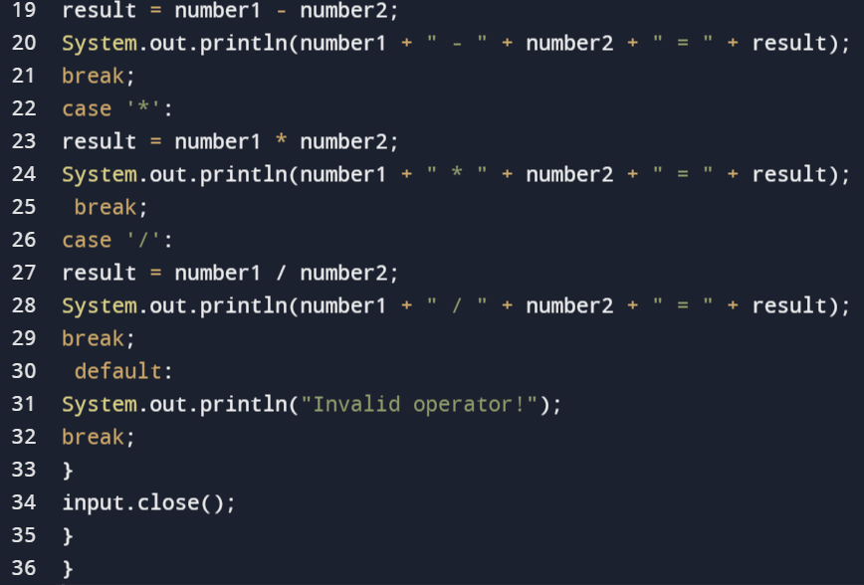

**Output:**

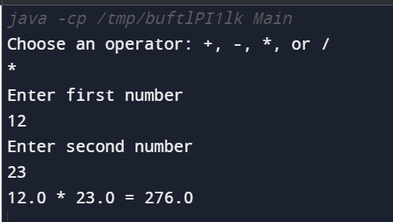

**PROGRAM 6**

**Aim:** Ascending/Descending order

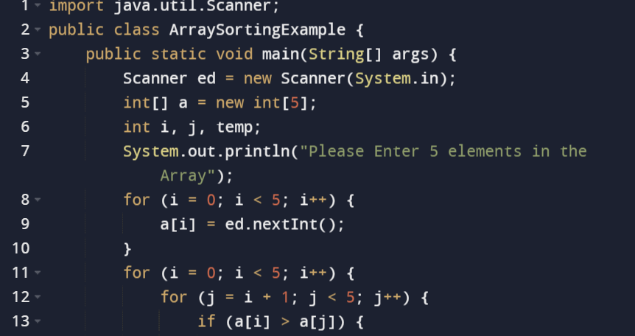

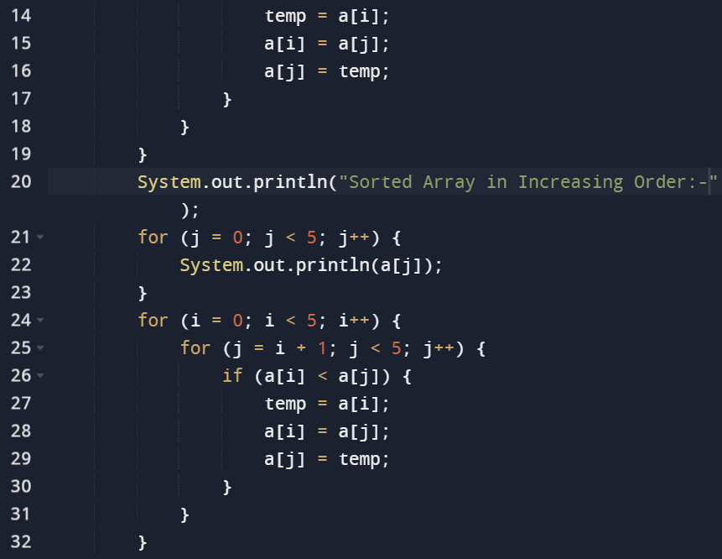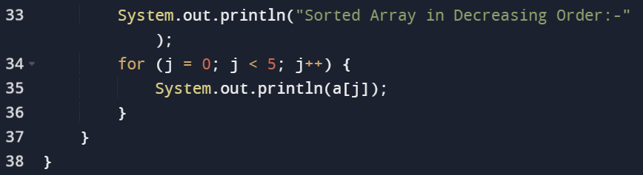

**Output:**

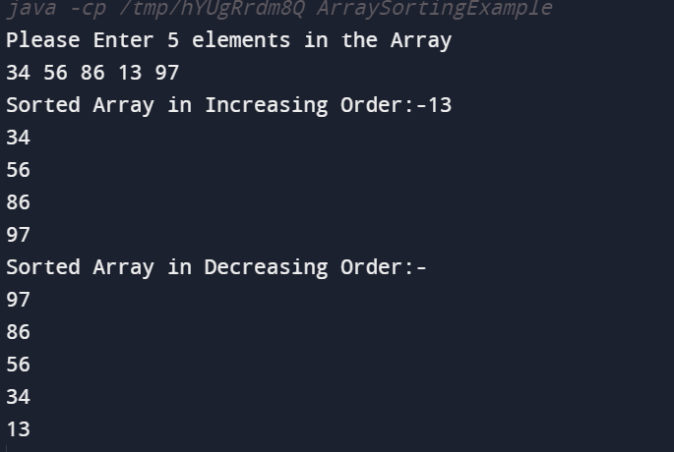

**PROGRAM 7**

**Aim:** Implementing multiple arrays using inheritance

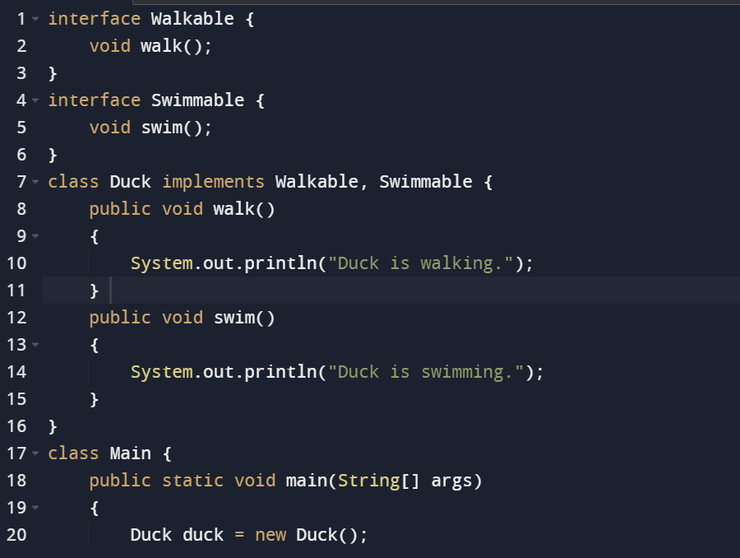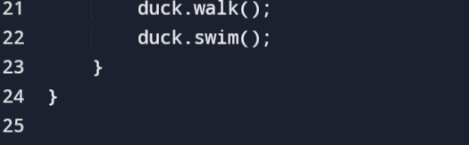

**Output**

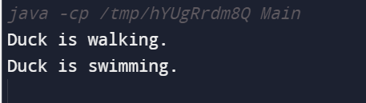

**PROGRAM 8**

**Aim:** Accessing the elements of an array

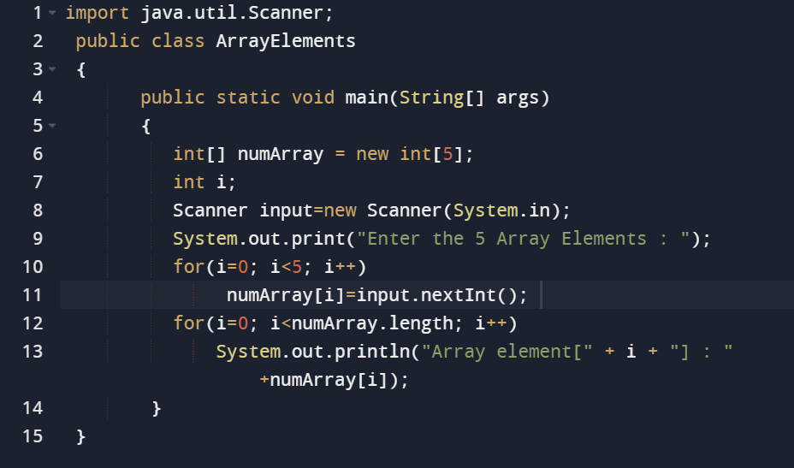

**Output:**

