Web Development- Assignment 2 Panitan Sripoom B00148508

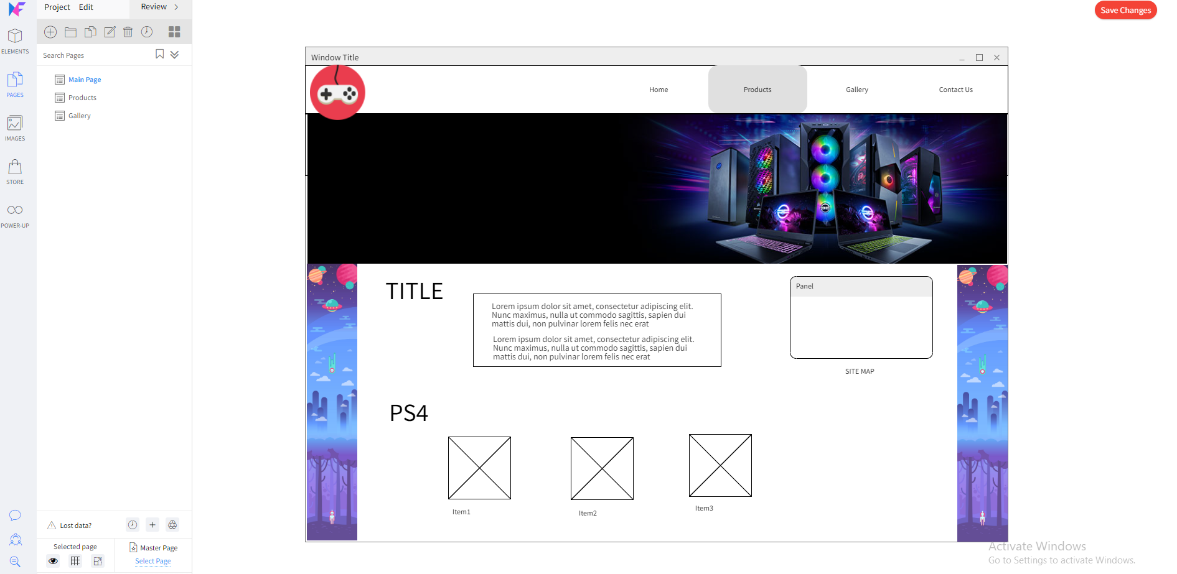

1. This is my index page it will display slide show. Then will have detail about shop and will display some Item for sale

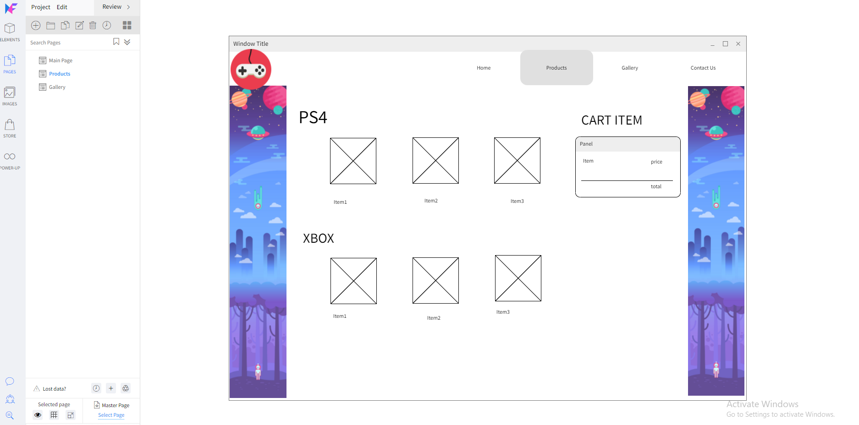

2. This is my products page This will have different category of items store in there. It will display cart on right site. Will also calculate total and shipping cost.

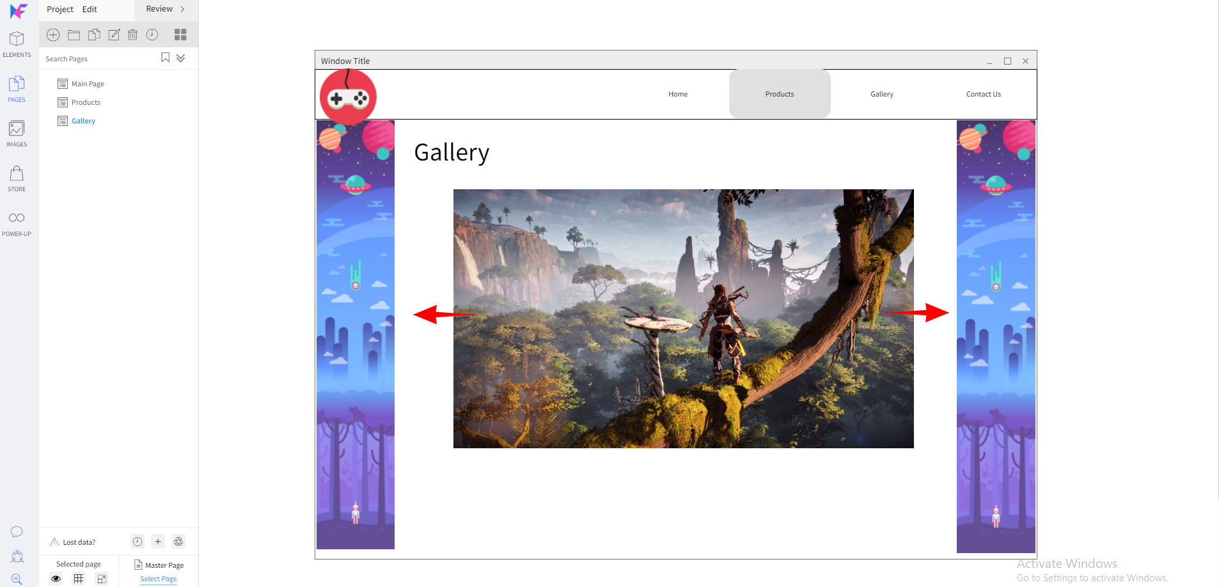

3. This is my gallery page it will display an album of picture and will automatically slides through all pictures.