Supplemental File of Robust Data-driven and Fully Distributed Volt/VAR Control for Active Distribution Networks with Multiple Virtual Power Plants

Siyun Li, Wenchuan Wu, Fellow, IEEE[1]

# Test Systems

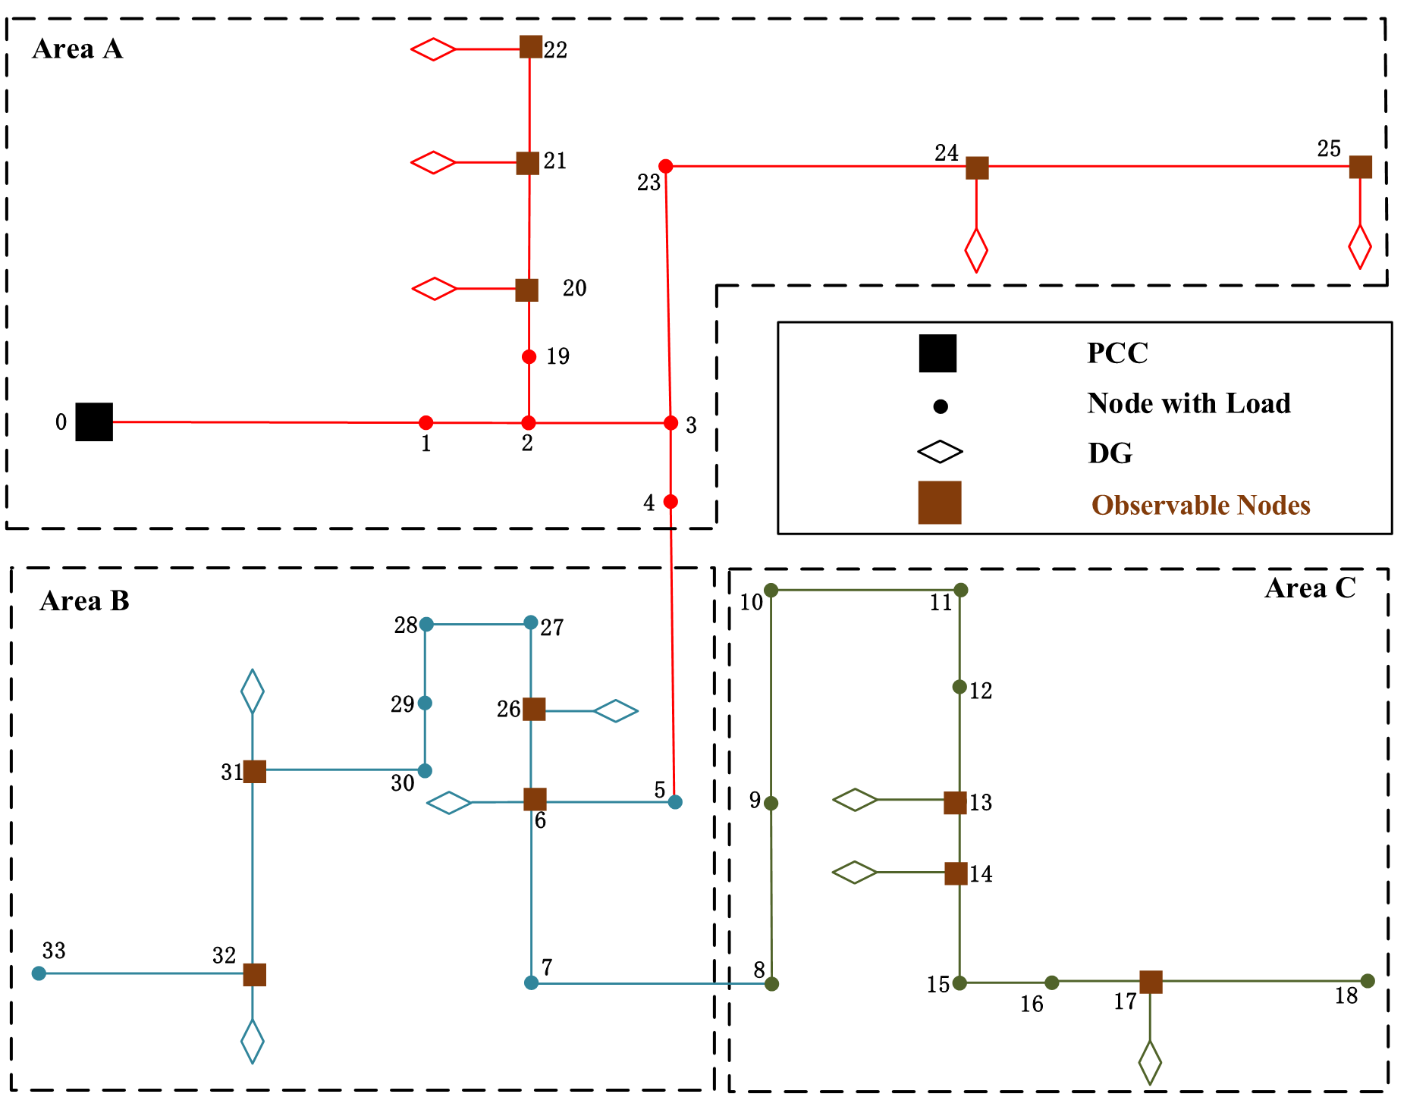

Fig. 1. Modified 33-bus system

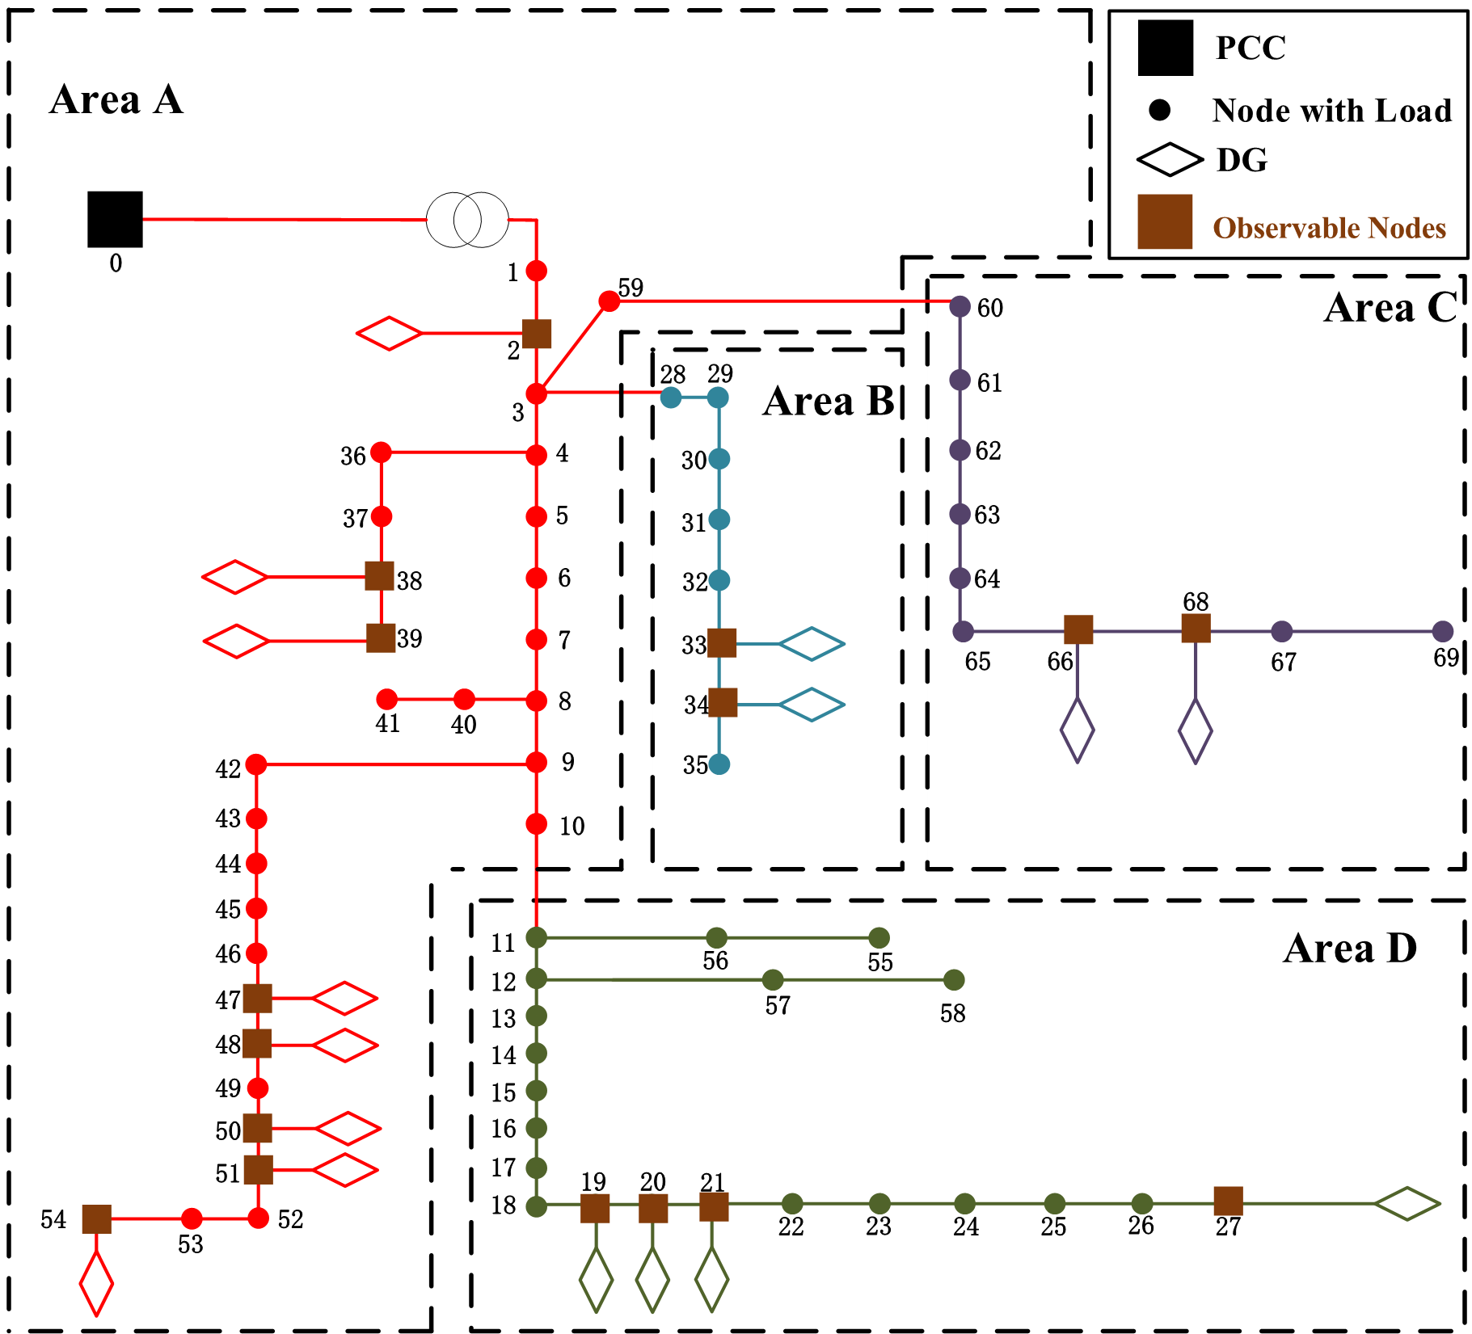

Fig. 2. Modified 69-bus system

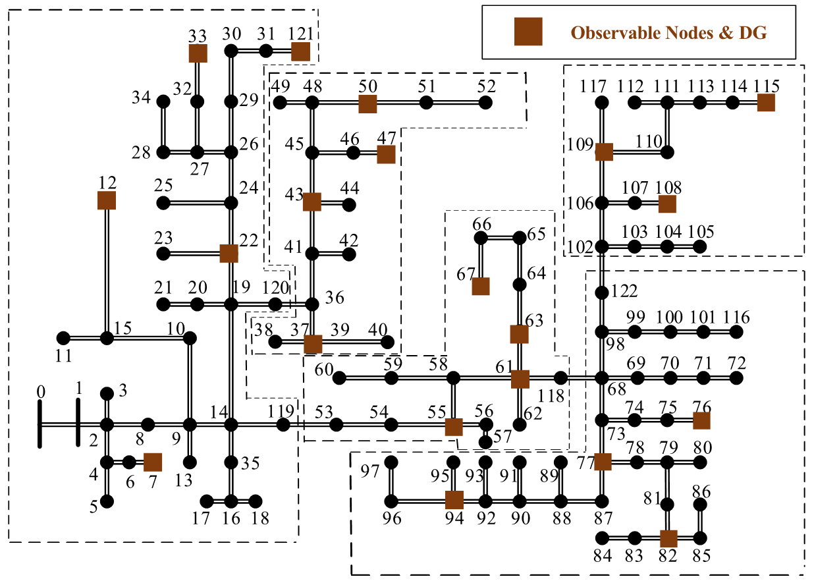

Fig. 3. Modified 123-bus system

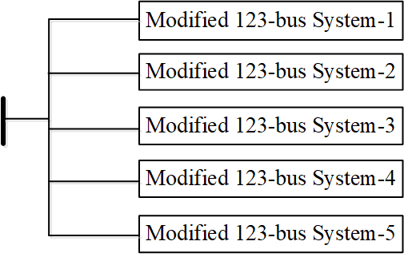

Fig. 4. A three-phase unbalanced 606-bus distribution system.

(The three-phase unbalanced 606-bus system combines five three-phase unbalanced IEEE 123- bus systems, which is illustrated as follows. The root nodes of the five IEEE 123- bus systems are connected together.)

TABLE I

area partition of 69-bus system

|  |  |  |
| --- | --- | --- |
| Partition | | Bus set |
| 69 | 3-area |  |
| 4-area |  |
| 7-area |  |

TABLE II

area partition of 606-bus system

|  |  |
| --- | --- |
| Partition | Bus set |
| 606-bus system with 25-area |  |

# Hyperparameters

The hyperparameters are shown in Table III.

If the parameters are different in the 33-bus, 69-bus, 123-bus, and 606-bus cases, they would be listed in {·, ·, ·, ·}.

TABLE III

algorithm hyperparameters

|  |  |  |
| --- | --- | --- |
| Algorithm | Parameter | value |
| Robust  data-driven |  | {0.1,1,1,1} |
|  |  | {1,1,10,10} |
|  |  | {0.5,0.5,0.2,0.1} |
|  |  | {15,15,20,20} |
|  |  | {0.6,0.7,0.98,0.98} |
|  |  | {0.5,0.5,0.8,0.8} |
|  |  | {0.1,0.5,0.01,0.01} |
|  |  | 100 |
|  |  |  |
|  |  | 0.5 |
| Non-robust  data-driven |  | 0.98 |
|  |  | {15,15,20,20} |

# Appendix: Proof of (17)

This section provides a detailed derivation to explain how - were converted to - to make the architecture fully distributed.

For any pair of neighbors,  and , with one gets



With , summing up abovementioned equations leads to



Meanwhile, with further observation, is the solution of a quadratic programming problem with respect to  and has a closed-form solution as



Thus, we will have



Comparing with , results in



And then is derived, which means - can be converted to -.

1.