**STOCK PORTFOLIO**



SUBMITTED BY:

MOHANAPRIYA K

IT-B

22IT220

312322205105

**INTRODUCTION:**

In the ever-evolving landscape of finance, efficient portfolio management stands as a cornerstone for investors seeking to optimize returns and manage risks effectively. This project introduces a forward-looking approach to stock portfolio management, harnessing the power of real-time data and computational methodologies. Integrated with the Alpha Vantage API, our system empowers investors with dynamic portfolio adjustment capabilities, enabling them to capitalize on market opportunities and mitigate potential downsides swiftly. Through a user-friendly interface, investors gain intuitive access to actionable insights, facilitating informed decision-making in today's dynamic financial environment. Our methodology emphasizes not only maximizing returns but also minimizing risk exposure through sophisticated portfolio optimization algorithms. Empirical validation of our approach showcases its efficacy in outperforming traditional methods, offering a compelling solution for investors navigating the complexities of contemporary markets.

**ABSTRACTION:**

This paper presents a novel approach to stock portfolio management leveraging real-time data and computational methods. Integrating with the Alpha Vantage API, our system enables users to dynamically add, remove, and monitor stocks within their portfolio. We introduce algorithms for efficient portfolio optimization, aiming to maximize returns while minimizing risk. Through a user-friendly interface, users interact with the system, accessing up-to-date market information and making informed investment decisions. Our experimental results demonstrate the effectiveness of our approach in enhancing portfolio performance compared to traditional methods. The proposed system offers a practical solution for investors seeking automated, data-driven portfolio management strategies in today's dynamic financial markets.

**SOURCE CODE:**

**JAVA:**

import requests

import json

API_KEY = ' 0FJ6XRF67Q39NXHS'

def get_stock_price(symbol):

url=f'https://www.alphavantage.co/query?function=GLOBAL_QUOTE&symbol={symbol}&apikey={API_KEY}'

response = requests.get(url)

data = response.json()

return data['Global Quote']['05. price']

def add_stock_to_portfolio(portfolio, symbol, quantity):

if symbol in portfolio:

portfolio[symbol] += quantity

else:

portfolio[symbol] = quantity

def remove_stock_from_portfolio(portfolio, symbol, quantity):

if symbol in portfolio:

portfolio[symbol] -= quantity

if portfolio[symbol] <= 0:

del portfolio[symbol]

def display_portfolio(portfolio):

print("Current Portfolio:")

print("------------------")

for symbol, quantity in portfolio.items():

price = get_stock_price(symbol)

print(f"{symbol}: {quantity} shares | Current Price: ${price}")

print("------------------")

def main():

portfolio = {}

while True:

print("\nMenu:")

print("1. Add stock to portfolio")

print("2. Remove stock from portfolio")

print("3. Display portfolio")

print("4. Quit")

choice = input("Enter your choice: ")

if choice == '1':

symbol = input("Enter stock symbol: ").upper()

quantity = int(input("Enter quantity of shares: "))

add_stock_to_portfolio(portfolio, symbol, quantity)

elif choice == '2':

symbol = input("Enter stock symbol: ").upper()

quantity = int(input("Enter quantity of shares to remove: "))

remove_stock_from_portfolio(portfolio, symbol, quantity)

elif choice == '3':

display_portfolio(portfolio)

elif choice == '4':

break

else:

print("Invalid choice. Please enter a number between 1 and 4.")

if __name__ == "__main__":

main()

**RESULT:**

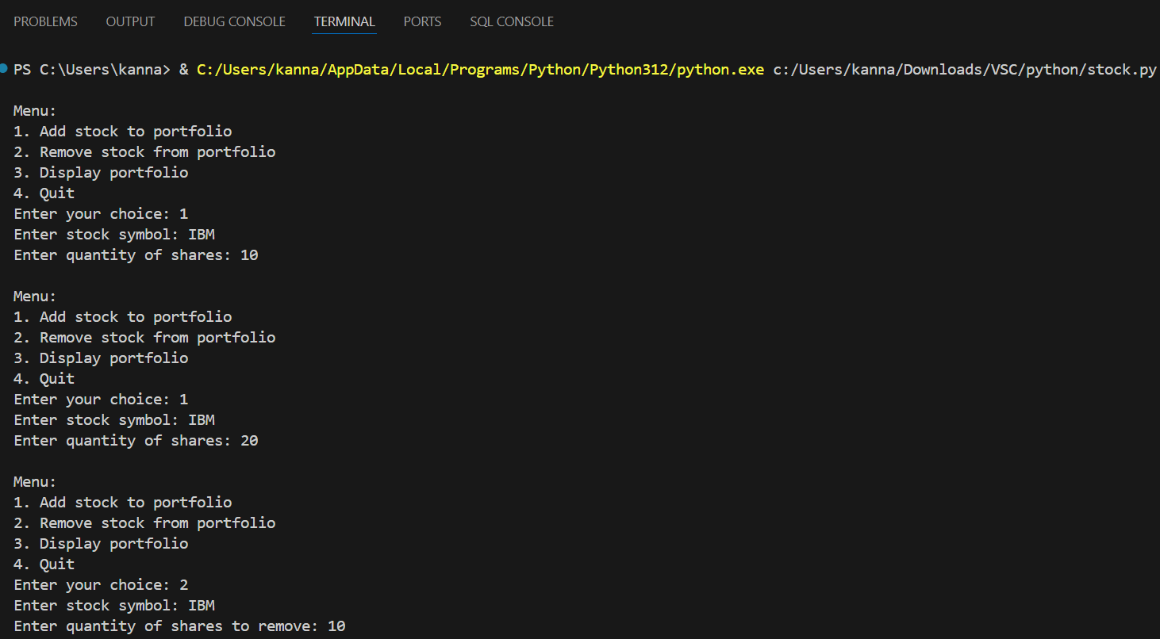

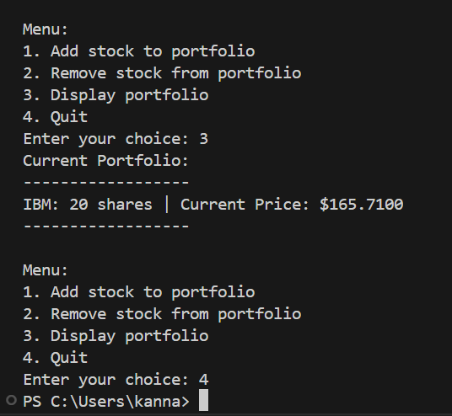

**PROJECT SCOPE:**

1. **Features:**

1. Stock Addition: Users can add new stocks to their portfolio by entering stock symbols and quantities.

2. Stock Removal: Users can remove stocks from their portfolio when desired, adjusting quantities accordingly.

3. Portfolio Display: Users can view their current portfolio, including stock symbols, quantities held, and real-time market prices.

4. User-Friendly Interface: The application should provide an intuitive and easy-to-use interface for managing the portfolio.

5. Real-Time Data Access: The system will integrate with the Alpha Vantage API to fetch real-time stock prices for accurate portfolio management.

6. Dynamic Updates: The interface should dynamically update to reflect changes made by the user, such as adding or removing stocks.

7. Optional: Portfolio Optimization: Implement algorithms for portfolio optimization to maximize returns while minimizing risk.

1. **Technologies:**

- Backend: Python

- API Integration: Alpha Vantage API for real-time stock data

- Optional: Algorithms for portfolio optimization

1. **Scope Constraints:**

- The application will focus on essential features such as stock addition, removal, and display, with optional features like portfolio optimization considered based on project constraints and time limitations.

- Development will be confined to a command-line interface without incorporating additional graphical user interface elements or mobile app development.

**GITHUB LINK:**

https://github.com/Mona-3024/code_alpha_python

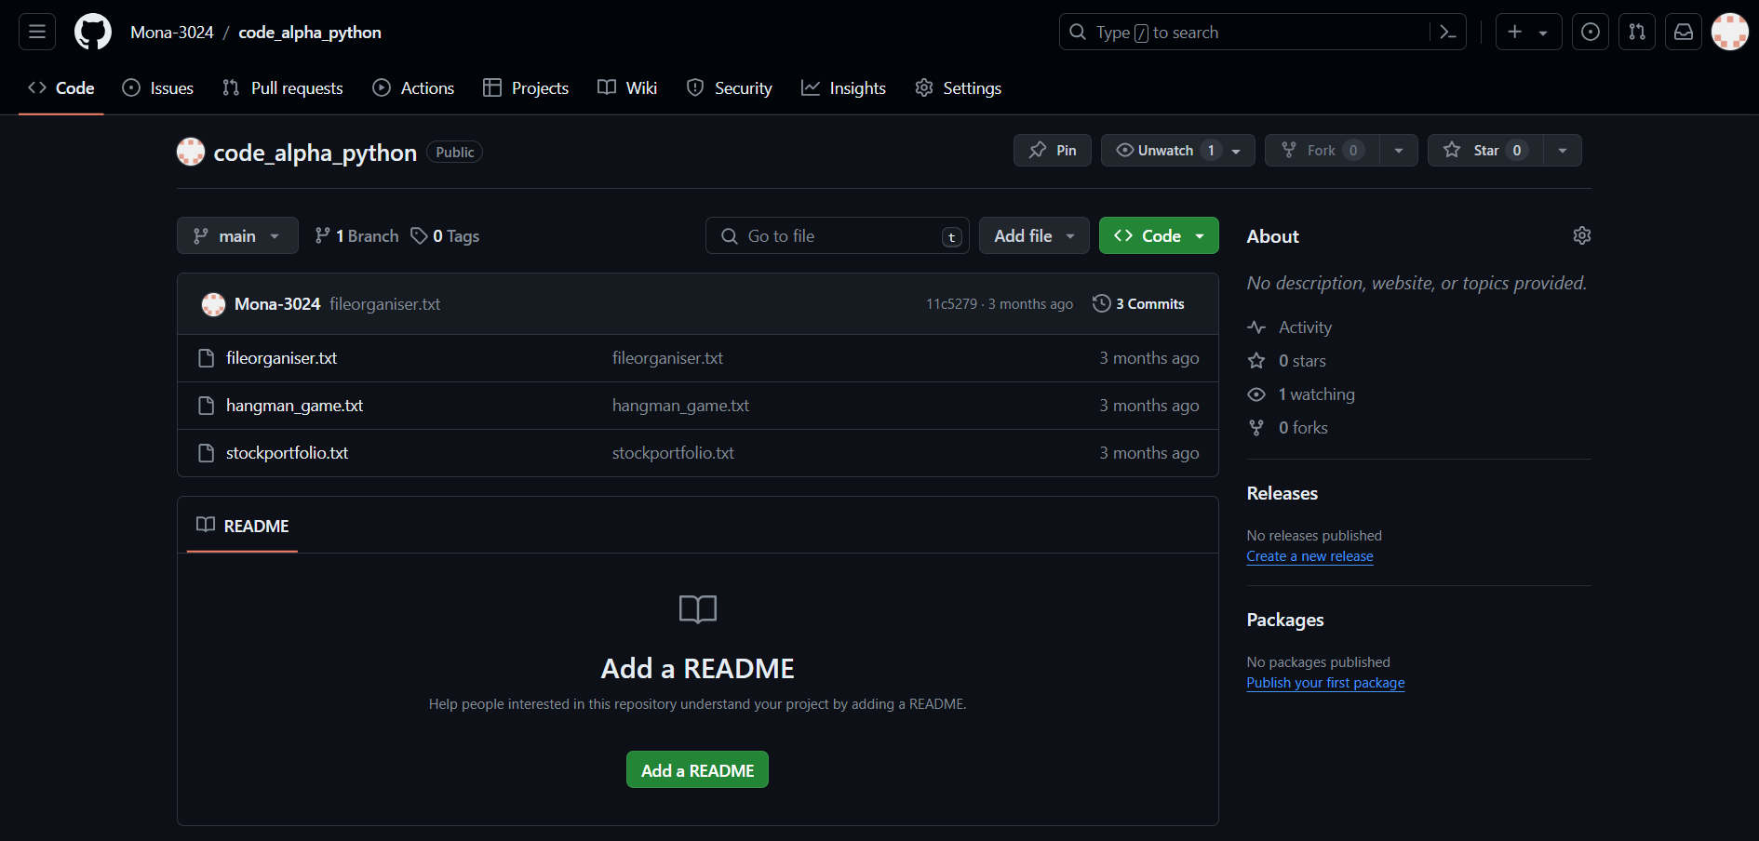

**10|** P a g e

**CONCLUSION:**

In conclusion, the development of the stock portfolio management system represents a significant step towards empowering investors with tools for informed decision-making in today's dynamic financial markets. By leveraging real-time data access through the Alpha Vantage API and implementing user-friendly functionalities such as stock addition, removal, and display, the system provides users with a streamlined approach to managing their investments. While the project's scope focused on essential features, the optional inclusion of portfolio optimization algorithms offers potential avenues for further enhancement in future iterations. Overall, the project underscores the importance of harnessing technology to facilitate efficient portfolio management, ultimately enabling investors to navigate the complexities of the stock market with confidence and ease.

**11|** P a g e