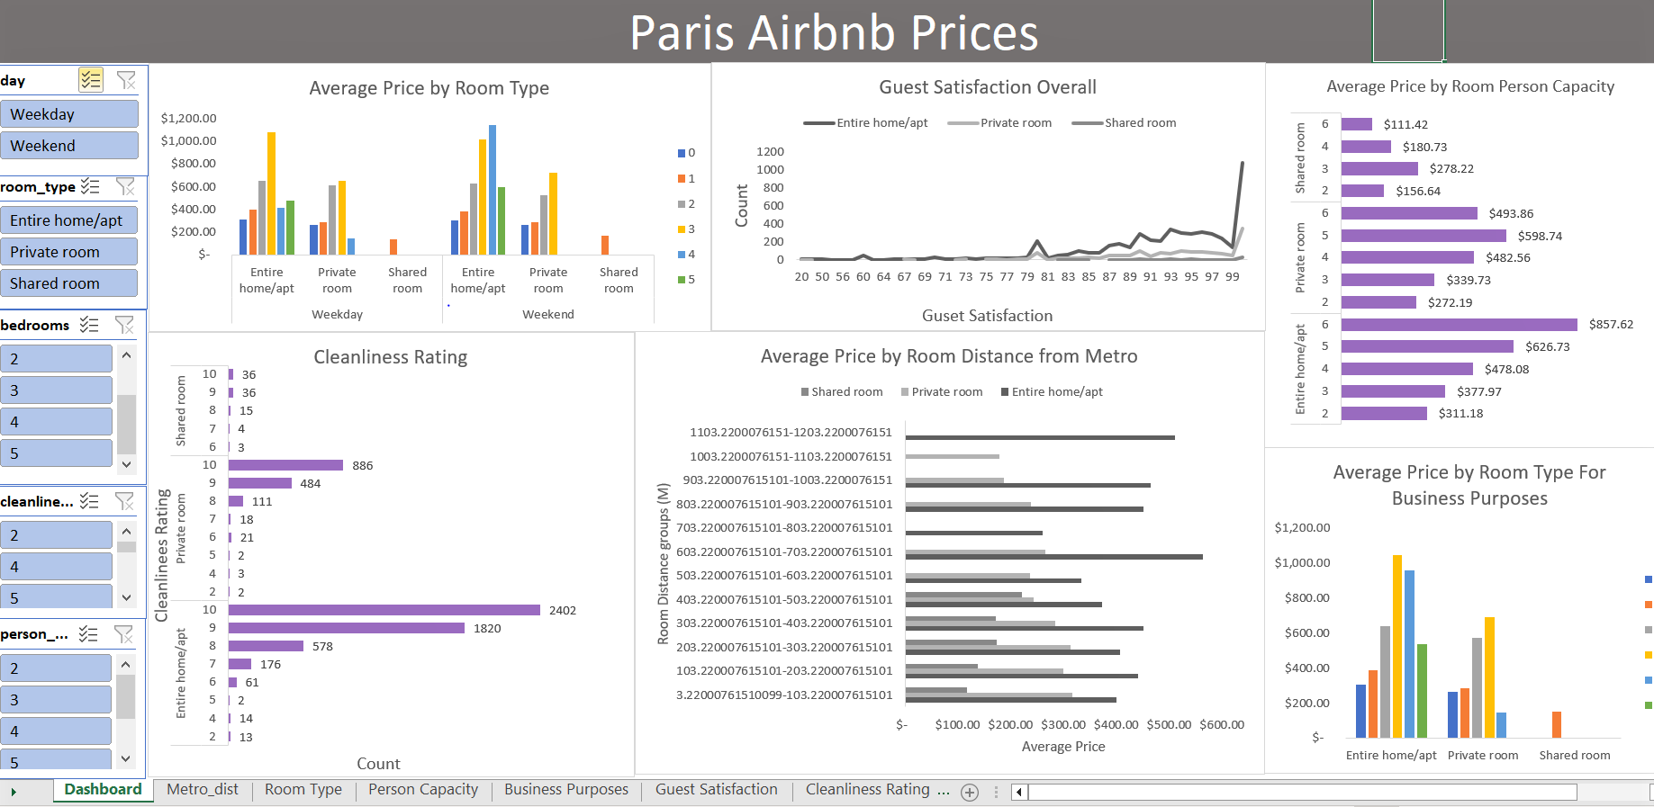

This interactive dashboard provides a comprehensive look at Airbnb prices in Paris depending on various attributes such as room types, cleanliness and satisfaction ratings, bedrooms, distance from the nearest metro station, and more to capture an in-depth understanding of Airbnb prices on both weekdays and weekends.