The idea of this assignment is to create a front-end application that presents the user with a textbox where they can list comma-separated items they usually eat for lunch. Once that's entered, the user has to click the "Check If Too Much" button.

If the number of items in the textbox is less than or equal to 3 (e.g., 1, 2, or 3), a message should show up under to the textbox saying "Enjoy!". If the number of items is greater than 3 (4, 5, and above), the message "Too much!" should show up under the textbox.

If the textbox is empty and the user clicks the "Check If Too Much" button, the message "Please enter data first" should show up. 'Empty' here means either "" (empty string) or a string with just spaces in it

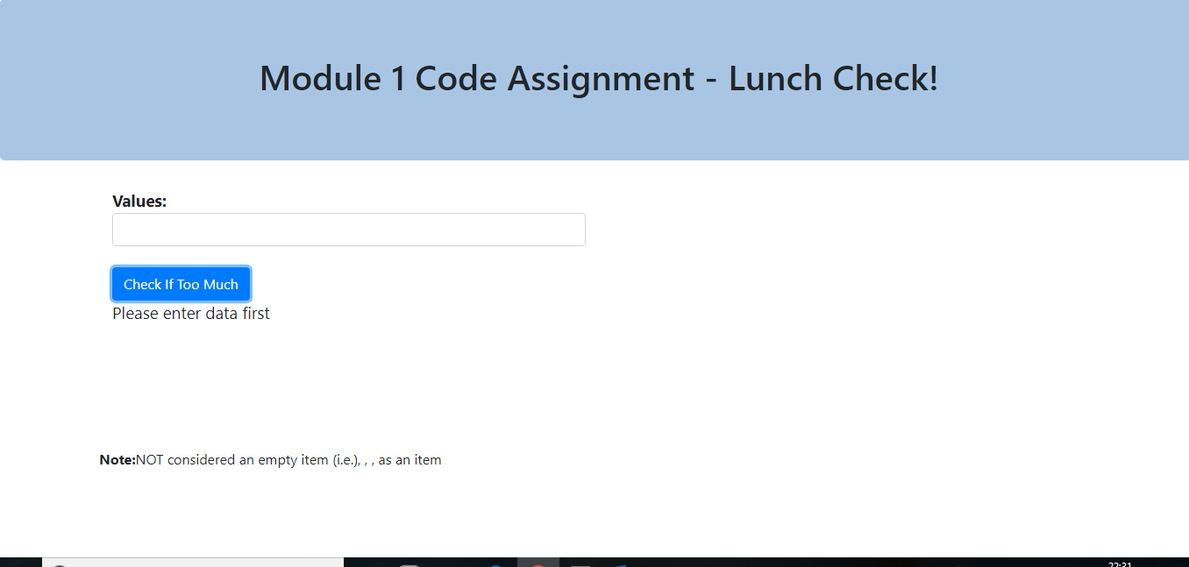

Above mentioned screenshot is the scenario 1 where when there is an empty value the message ”Please enter data first” will display.

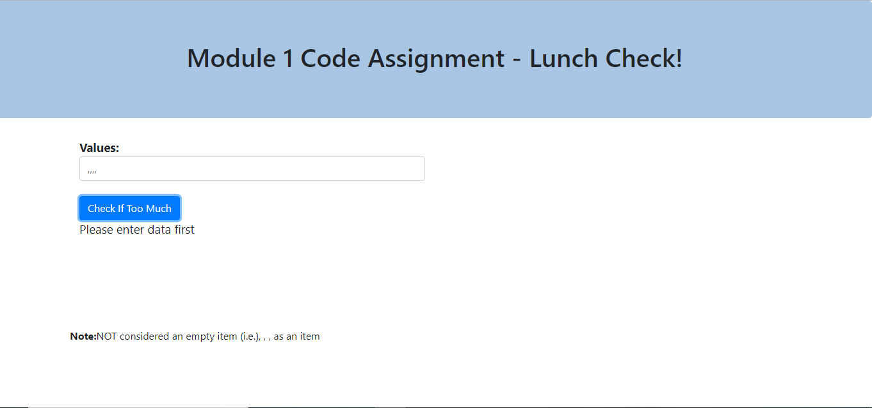

The above mentioned screenshot describes that empty strings are not considered in this case.

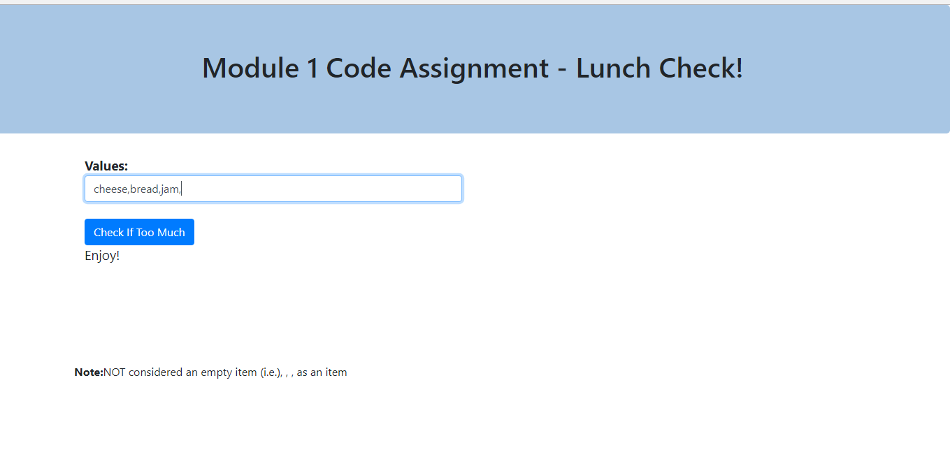

If three or less than three strings values are entered then message “Enjoy” will display

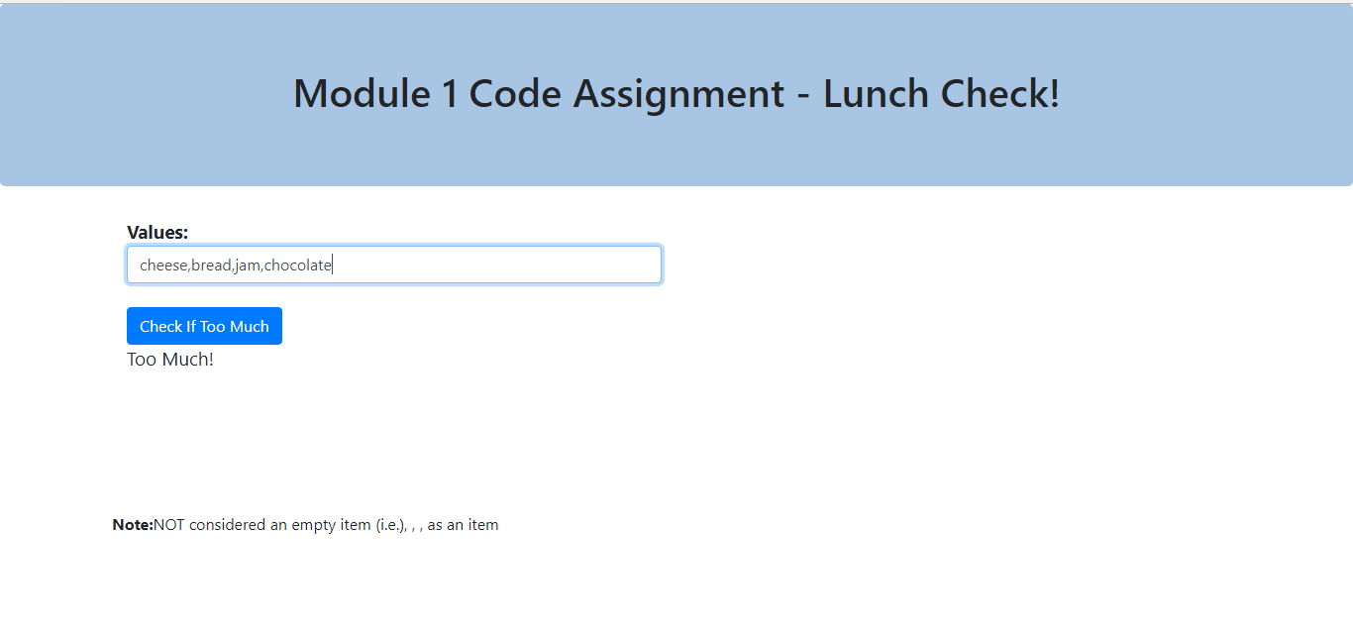

If more than three strings values are entered then message “Too Much” will display