Day 2 Exercise
City Counter MapReduce Job Using Python Streaming

1. Objective
Write a MapReduce program using Python Streaming to count the number of employees in each city.
Input: employees.csv stored in HDFS

Mapper:
- Skip the header row
- Extract city value
- Emit:
Reducer:
- Count the total number of employees per city

2. Check Input File in HDFS
- [ Command:
- hdfs dfs -find / -name employees.csv ]
- hdfs dfs -cat /tmp/PriyaITC/employees.csv | head

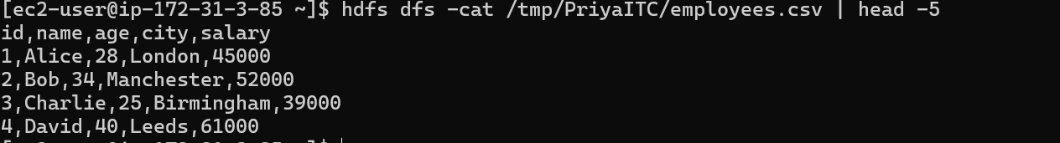

3. Create Mapper Program
Create file:
vi mapper.py

Mapper code:

import sys

header = True

for line in sys.stdin:
line = line.strip()

# Skip header
if header:
header = False
continue

fields = line.split(",")

# City column
city = fields[3].strip()

print(f"{city}\t1")

Save:
Esc
:wq
Enter

4. Create Reducer Program
Create file:
vi reducer.py

Reducer code:

import sys

current_city = None
current_count = 0

for line in sys.stdin:
city, count = line.strip().split("\t")
count = int(count)

if city == current_city:
current_count += count

else:
if current_city is not None:
print(f"{current_city}\t{current_count}")

current_city = city
current_count = count

if current_city is not None:
print(f"{current_city}\t{current_count}")

Save:
Esc
:wq
Enter

5. Give Execute Permission
Command:
chmod +x mapper.py reducer.py

show/ verify :
ls -l mapper.py reducer.py

6. Run Hadoop Streaming Job
Command:

hadoop jar /opt/cloudera/parcels/CDH-7.1.7-1.cdh7.1.7.p0.15945976/lib/hadoop-mapreduce/hadoop-streaming.jar \
-input /tmp/PriyaITC/employees.csv \
-output /tmp/city_count_output \
-mapper mapper.py \
-reducer reducer.py \
-file mapper.py \
-file reducer.py \
-numReduceTasks 1

Successful execution message:

StreamJob completed successfully

Output directory: /tmp/city_count_output

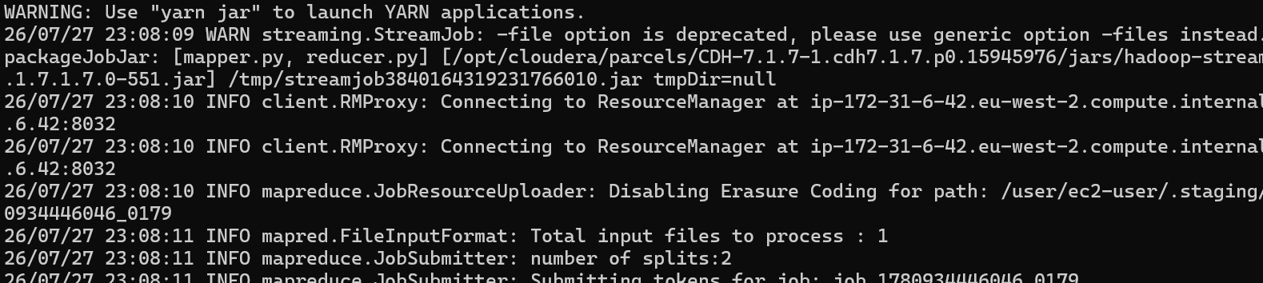

7. Display Results
Command:

hdfs dfs -cat /tmp/city_count_output/part-00000

Final output:
Birmingham 1
Bristol 1
Coventry 1
Leeds 1
Leicester 1
London 1
Manchester 1
Nottingham 1
Sheffield 1

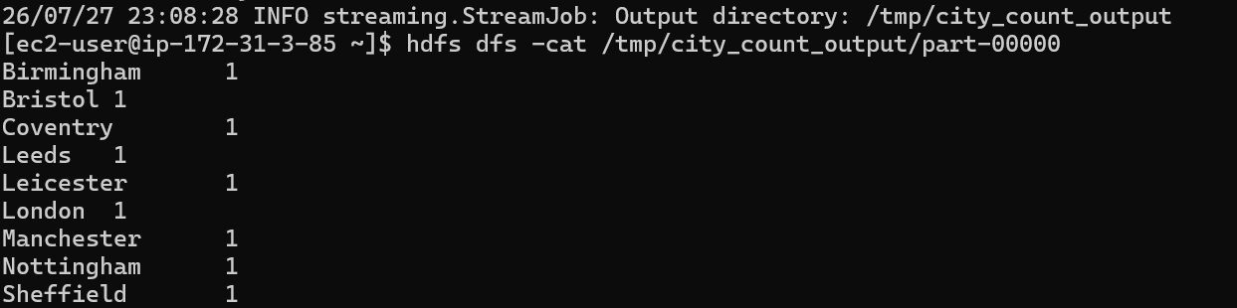

8. Conclusion
The MapReduce city counter job was successfully implemented using Python Streaming.
The mapper extracted the city field and emitted city\t1.
The reducer aggregated the counts and produced the total number of employees per city.

