**AirMasses**Links: chrome-extension://ihgdgpjankaehldoaimdlekdidkjfghe/viewer.html#https://www.globalsecurity.org/military/library/policy/navy/nrtc/14312_ch4.pdf

<https://www.pmfias.com/air-mass-air-masses-classification-geography-upsc-ias/>

* When the air remains over a homogenous area for a sufficiently longer time, it acquires the characteristics of the area. The homogenous regions can be the vast ocean surface or vast plains and plateaus.

* The air with distinctive characteristics in terms of **temperature** and **humidity**is called an air mass. It is a large body of air having **little horizontal variation** in temperature and moisture.

* Air masses form an integral part of the **global planetary wind system**. Therefore, they are associated with one or other wind belt(The global wind patterns (planetary winds) drive large bodies of air called air masses).

* They extend from **surface to lower stratosphere** and are across thousands of kilometers.

## Source regions

* The homogenous surfaces, over which air masses form, are called the **source regions.**
* The main source regions are the high pressure belts/cells in the sub tropics (giving rise to tropical air masses) and around the poles(in winter subpolar low divided into high and low pressure belts, further movement of jet streams creates high pressure in sub polar belt => stable air mass) (the source for polar air masses). There are no major source regions in the mid-latitudes as these regions are dominated by cyclonic and other disturbances. The regions of convergence are not ideal source regions. Because the air is not stagnant and there is a tendency of upward movement of air. Warm source regions (tropical air masses): Sahara Desert - warm and dry; Tropical Oceans - warm and moist  
  Cold source regions (polar air masses):Arctic Ocean - cold and moist; Siberia - cold and dry; Northern Canada - cold and dry; Southern Ocean - cold and moist
* Source Region establishes **heat and moisture equilibrium**with the overlying air mass.
* When an air mass moves away from a source region, the upper level maintains the physical characteristics for a longer period. This is possible because air masses are stable with stagnant air which **do not facilitate convection**. Conduction and radiation in upper air is not effective.

## Conditions for the formation of Air masses

* Source region should be extensive with **gentle, divergent air circulation** (slightly at high pressure).
* Areas with **high pressure but little pressure difference** or pressure gradient are ideal source regions.
* ***There are no major source regions in the mid-latitudes as these regions are dominated by cyclonic and other disturbances.***

**Air masses based on Source Regions**

An air mass, then, is named by the combination of its humidity and temperature designation. With two terms for the humidity and four terms for the temperature, eight names are possible. These are: mE, mT, mP, mA, cE, cT, cP, cA (maritime equatorial, maritime tropical, maritime polar, maritime arctic, continental equatorial, continental tropical, continental polar, continental arctic). Actually ONLY SIX different air masses exist. Since the Intertropical Convergence Zone is noted for heavy precipitation, hot air can hold much moisture, and the equator does not have a large land area, equatorial air is not dry. This means the cE air mass is not found; it is mE air, moist and hot. The very cold high latitude air does not hold much moisture and does not have heavy evaporation or precipitation, so mA air is also not found. It is cA or very cold and dry.

There are five major source regions. These are:

1. Warm tropical and subtropical oceans;
2. The subtropical hot deserts;
3. The relatively cold high latitude oceans;
4. The very cold snow covered continents in high latitudes;
5. Permanently ice covered continents in the Arctic and Antarctica.

Accordingly, following types of airmasses are recognised:

1. Maritime tropical (mT);
2. Continental tropical (cT);
3. Maritime polar (mP);
4. Continental polar (cP);
5. Continental arctic (cA).

* Tropical air masses are warm and polar air masses are cold.
* The heat transfer processes that warms or cools the air takes place slowly.

## Cold Air Mass A cold air mass is one which is colder than the underlying surface and is associated with instability and atmospheric turbulence. Cold source regions (polar air masses) * Arctic Ocean – cold and moist * Siberia – cold and dry * Northern Canada – cold and dry * Southern Ocean – cold and moist

## Warm Air Mass A warm air mass is one which is warmer than the underlying surface and is associated with ****stable**** weather conditions.

#### Warm source regions (tropical air masses) * Sahara Desert – warm and dry * Tropical Oceans – warm and moist

**AIR MASS MODIFICATION**

When an air mass moves out of its source region, a number of factors act upon the air mass to change its properties. Here, the factors of surface temperature, moisture, and topography must be considered. The five modifying factors and the changes that take place once an air mass leaves its source region

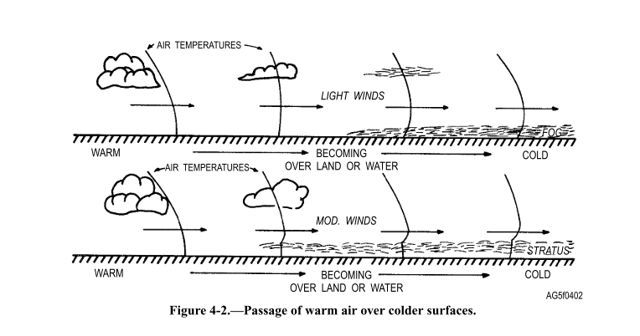

Surface Temperature

The difference in temperature between the surface and the air mass modifies not only the air temperature, but also the stability of the air mass. If the air mass is warm and moves over a colder surface (such as tropical air moving over colder water), the cold surface cools the lower layers of the air mass and the stability of the air mass increases. This stability extends to the upper layers in time, and condensation in the form of fog or low stratus normally occurs. If the air mass moves over a surface that is warmer (such as continental polar air moving out from the continent in winter over warmerwater), the warm water heats the lower layers of the air mass, increasing instability (decreasing in stability), and consequently spreading to higher layers.. The changes in stability of the air mass give valuable indications ofthe cloud types that will form, as well as the type of precipitation to be expected. Also, the increase or decrease in stability gives further indication of the lower layer turbulence and visibility.

Surface Moisture

An air mass may be modified in its moisture content by the addition of moisture as a result of evaporation or by the removal of moisture as a result of condensation and precipitation. For example, the passage of cold air over a warm water surface decreases the stability of the air with resultant vertical currents. The passage of warm, moist air over a cold surface increases the stability and could result in fog as the air is cooled ( also moisture is added by evaporation caused by warm wind on cool ocean surface). In general (dependent upon the temperature of the two surfaces), the movement over a water surface increases both the moisture content ofthe lower layers and the relative temperature near the surface.

Topography of Surface

The effect of topography is evident primarily in the mountainous regions. The air mass is modified on the windward side by the removal of moisture through precipitation with a decrease in stability; and, as the air descends on the other side ofthe mountain, the stability increases as the air becomes warmer and drier.

Trajectory

After an air mass has left its source region, the trajectory it follows (whether cyclonic or anticyclonic) has a great effect on its stability. If the air follows a cyclonic trajectory, its stability in the upper levels is decreased; this instability is a reflection of cyclonic relative vorticity. The stability of the lower layers is not greatly affected by this process. On the other hand, if the trajectory is anticyclonic, its stability in the upper levels is increased as a result of subsidence associated with anticyclonic relative vorticity(https://www.weather.gov/source/zhu/ZHU_Training_Page/Miscellaneous/vorticity/vorticity.html).

(Note: High and low pressure are not always associated with warm/cold air. eg. the subtropical air is warmer but still creates high pressure and subpolar belt creates low. Jetstreams create low pressure in trough(cold air) and high pressure in ridge(warm air)

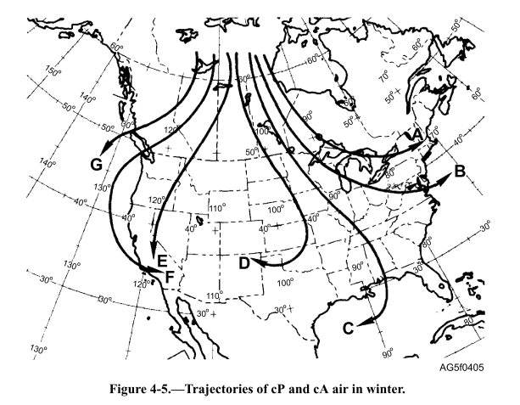

Age

Although the age of an air mass in itself cannot modify the air mass, it does determine (to a great extent) the amount ofmodification that takes place. For example, an air mass that has recently moved from its source region cannot have had time to become modified significantly. However, an air mass that has moved into a new region and stagnated for some time is now old and has lost many of its original characteristics.

**Modifying Influences on Air Mass Stability**

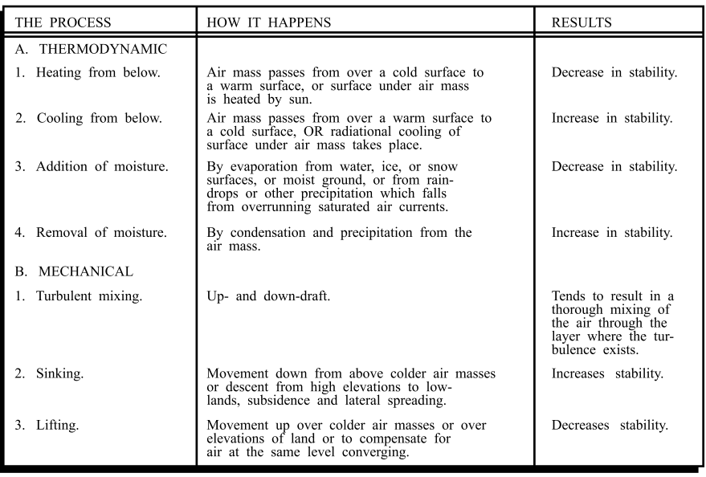

## Influence of Air Masses on World Weather

* The properties of an air mass which influence the accompanying weather are its stability(depends on temperature of air mass and underlying surface), its temperature and the **moisture content.**
* The air masses carry atmospheric moisture from oceans to continents and cause **precipitation** over landmasses.
* They transport **latent heat**, thus removing the latitudinal heat balance.
* Most of the migratory atmospheric disturbances such as cyclones and storms originate at the **contact zone** between different air masses and the weather associated with these disturbances  
  is determined by characteristics of the air masses involved.

# Classification of Air Masses

* Broadly, the air masses are classified into polar and tropical air masses.
* Both the polar and the continental air masses can be either of maritime or continental types.

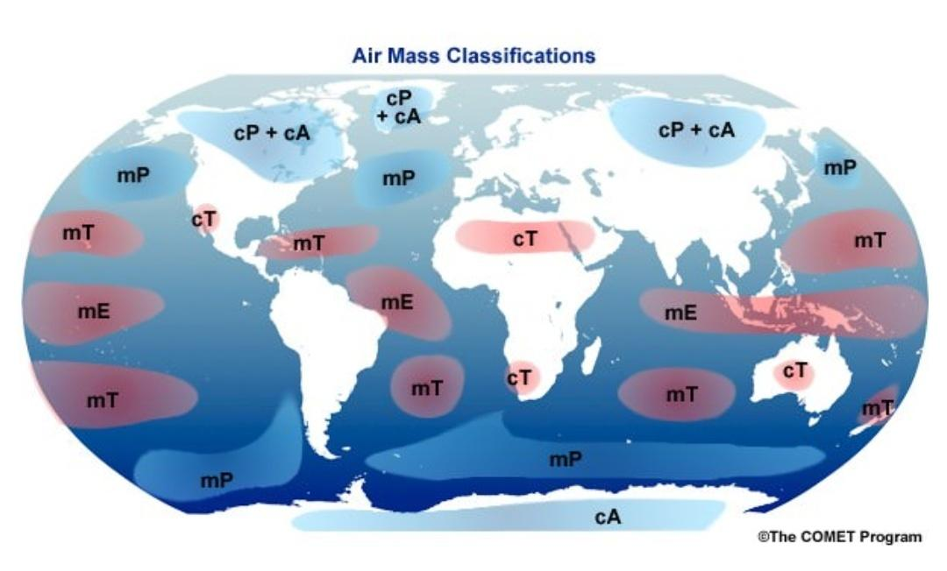

## Continental Polar Air Masses (CP)

* Source regions of these air masses are the Arctic basin, northern North America, Eurasia and Antarctica.
* These air masses are characterized by **dry, cold and stable conditions.**
* The weather during winter is frigid, clear and stable.
* During summer, the weather is less stable with lesser prevalence of anticyclonic winds, warmer landmasses and lesser snow.

## Maritime Polar Air Masses (MP)

* The source region of these air masses are the oceans between **40° and 60° latitudes**.
* These are actually those continental polar air masses which have moved over the warmer oceans, got heated up and have collected moisture.
* The conditions over the source regions are **cool, moist and unstable**. These are the regions which cannot lie stagnant for long.
* The weather during winters is characterized by high humidity, overcast skies and occasional fog and precipitation.
* During summer, the weather is clear, fair and stable.

## Continental Tropical Air Masses (CT)

* The source-regions of the air masses include tropical and sub-tropical deserts of Sahara in Africa, and of West Asia and Australia.
* These air masses are dry, hot and stable and do not extend beyond the source.
* They are dry throughout the year.

## Maritime Tropical Air Masses (MT)

* The source regions of these air masses include the oceans in tropics and sub-tropics such as Mexican Gulf, the Pacific and the Atlantic oceans.
* These air masses are **warm, humid and unstable.**
* The weather during winter has mild temperatures, overcast skies with fog.
* During summer, the weather is characterized by high temperatures, high humidity, cumulous clouds and convectional rainfall.