[**https://www.pmfias.com/fronts-frontogenesis-stationary-front-cold-front-warm-front-occluded-front/**](https://www.pmfias.com/fronts-frontogenesis-stationary-front-cold-front-warm-front-occluded-front/)

**Fronts**

* Fronts are the typical features of **midlatitudes weather (temperate region – 30° – 65° N and S).** They are uncommon (unusual) in tropical and polar regions.
* Front is a three dimensional **boundary zone formed between two converging air masses** with **different physical properties** (temperature, humidity, density etc.) which doesn’t merge readily due to low diffusion coefficient and low thermal conductivity.
* Frontogenesis takes place only when two conditions are met. First, two air masses of different densities must exist adjacent to one another; and second, a prevailing wind field must exist to bring them together.

## Front Formation

* The process of formation of a front is known as **Frontogenesis (war between two air masses)**, and dissipation of a front is known as **Frontolysis (one of the air masses win against the other).**
* Frontogenesis involves **convergence** of two distinct air masses. Frontolysis involves overriding of one of the air mass by another.

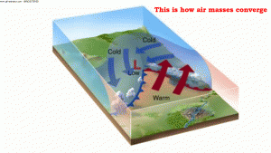

* In northern hemisphere **Frontogenesis** (convergence of air masses) happens in **anti-clockwise direction** and in southern hemisphere, **clockwise direction**. This is due to Coriolis effect.
* **Mid-latitude cyclones or temperate cyclones or extra-tropical cyclones occur due to frontogenesis.**

## General Characteristics of Fronts

* The temperature contrast influences the thickness of frontal zone in an **inversely proportional manner**, i.e., two air masses with higher temperature difference do not merge readily. So the front formed is less thick.
* There is a change in temperature, pressure, wind shift crossing from one side of a stationary front to the other. (i.e. when warm front is passing over a region and then cold front passes. The wind shift takes place, which was earlier from south-southwest but after cold front passes the winds are from north-northwest)
* Wind Shift: A change in wind direction of 45 degrees or more in less than 15 minutes with sustained wind speeds of 10 knots or more throughout the wind shift.

1 knot = 1.852 kmph

1 Nautical Mile = 1.852 km

* The frontal activity is invariably associated with **cloudiness and precipitation** because of ascent of warm air which cools down **adiabatically**, condenses and causes rainfall.

[Adiabatic Lapse Rate – Latent Heat of Condensation](https://www.pmfias.com/adiabatic-lapse-rate-latent-heat-condensation/)

* The intensity of precipitation depends on the **slope of ascent and amount of water vapour present in ascending air.**

# Classification of Fronts

* Based on the mechanism of frontogenesis and the associated weather, the fronts can be studied under the following types.

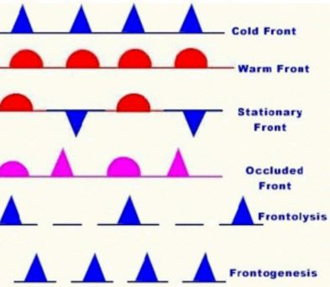

## Stationary Front

* When the surface position of a front does not change (when two air masses are unable to push against each other; a draw), a stationary front is formed.
* Occasionally cold air and warm air may flow parallel to the front(but in opposite direction due to Coriolis force). The position of the front may not move. The two different air masses are then said to be separated by a stationary front. Although the two air masses are not moving, warm air may still rise over the cold air. The slope of a stationary front is as gentle as the slope of a warm front. Weather conditions, too, are similar to those of a warm front.
* Warm or cold front stops moving, so the name stationary front.
* Stationary fronts will either dissipate after several days or devolve into shear lines, but can change into a cold or warm front if conditions aloft change.
* A stationary front becomes a **shear line** when the density contrast across the frontal boundary vanishes, usually as a result of temperature equalization, while the narrow zone of wind-shift persists for a time. This is most common over the open ocean as the temperature of the ocean surface is usually the same on both sides of the frontal boundary and modifies the air masses on either side of it to correspond to its own temperature.
* Why do fronts stop moving in the first place? It depends almost completely on upper level winds. Fronts move when upper level winds are perpendicular to the front. When these winds change direction and blow parallel to the front, the front "stalls" and becomes stationary

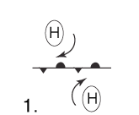

## Weather along a stationary front

* The exact weather of a stationary front depends greatly on the characteristics of its constituent air masses -- their moisture levels, for example -- and the general instability of the local atmosphere. Often, however, conditions resemble those encountered along warm front weather: extensive cloudiness and showers. Cumulonimbus clouds are formed, causing **fontal precipitation** and significant amounts of rain, freezing rain, fog(in the area of cold air due to temperature inversion) can occur. As a stationary front can be **durable**, such overcast and precipitation may persist for days.
* Occasionally, stationary fronts may provoke more extreme weather. Should the front “buckle”, a **wave of low pressure**(cyclone) could develop on the front and then **ripple along it** to the east or northeast(this front is called **Runway of Cyclones**). Sometimes more than one wave of low pressure develops along the front, while on other occasions; a singular wave of low pressure will form and then strengthen as moves off to east or northeast, taking the trailing end of the front right along with it. Series of thunderstorms or heavy rain showers may be shafted down the front, promoting flooding in areas within its influence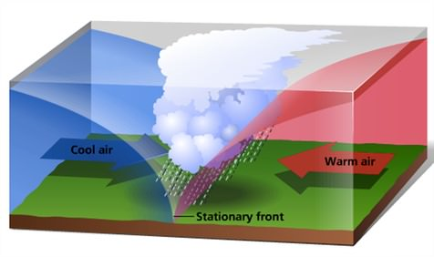

## Cold Front

* A **cold front** is the leading edge of a cooler mass of air, replacing at ground level a warmer mass of air, which lies within a fairly sharp surface [trough](https://en.wikipedia.org/wiki/Trough_(meteorology)) of [low pressure](https://en.wikipedia.org/wiki/Low-pressure_area). It forms in the wake of an [extratropical cyclone](https://en.wikipedia.org/wiki/Extratropical_cyclone), at the leading edge of its cold air [advection](https://en.wikipedia.org/wiki/Advection#Meteorology) pattern, which is also known as the [cyclone](https://en.wikipedia.org/wiki/Cyclone)'s dry conveyor belt circulation.  cooler and denser air wedges under the less-dense warmer air, lifting it. This upward motion causes lowered [pressure](https://en.wikipedia.org/wiki/Pressure) along the cold front and can cause the formation of a narrow line of [showers](https://en.wikipedia.org/wiki/Shower) and [thunderstorms](https://en.wikipedia.org/wiki/Thunderstorm) when enough [moisture](https://en.wikipedia.org/wiki/Moisture) is present
* In such a situation, the transition zone between the two is a cold front.
* It forms in the wake of an [extratropical cyclone](https://en.wikipedia.org/wiki/Extratropical_cyclone).
* **Cold front moves up to twice as quickly as warm fronts**.
* Frontolysis begin when the warm air mass is completely uplifted by the cold air mass.



Gif Image – Open in a new tab to view the animation or View in Power Point [Full Screen Mode]

**Open Question: Pressure: if you see jet stream trough(cold) is in low pressure, ridge(warm) is in high, then how come pressure is falling when cold front is approaching and rising afterwards ?(See in tropical cyclones)**

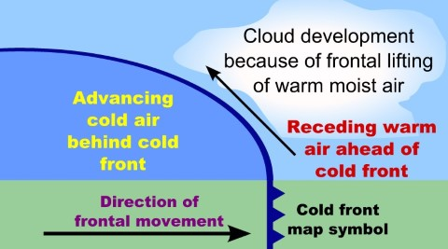

## Cloud formation along a cold front:

Warm, moisture-carrying air, rapidly lifted by the cold air behind the front, results in an unstable atmosphere around the transition area. Cumulonimbus clouds rise high into the atmosphere as the cold front arrives. Capable of reaching heights between 9,100 and 13,700 meters (30,000 and 45,000 feet), the tops of cumulonimbus clouds reach the level of the jet stream. Once there, strong winds shear off the tops of the clouds, producing an anvil shape. Once the cold front moves past, fluffy cumulus clouds develop before skies eventually begin clearing.

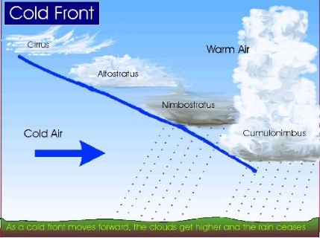

## Changing Precipitation

Most of the active weather occurs as the cold front pushes through. The cold front shoves the warmer air ahead of it upward, and as it cools the air discharges its moisture. A cold front commonly brings a narrow band of [precipitation](https://en.wikipedia.org/wiki/Precipitation_(meteorology)) that follows along the leading edge of the cold front. The upheaval of warm air and the development of cumulonimbus clouds signals thunderstorms with heavy rains, and some strong cells capable of producing heavy downpours. In the spring, these cold fronts can be very strong, and can bring strong winds when the [pressure gradient](https://en.wikipedia.org/wiki/Pressure_gradient) is higher than normal. During the winter months, cold fronts sometimes come through an area with little or no precipitation These rainstorms sometimes bring [flooding](https://en.wikipedia.org/wiki/Flood), and can move very slowly when the storm steering it is strong and embedded within a [meridional flow](https://en.wikipedia.org/wiki/Meridional_flow) pattern (with more pole to equator motion rather than west to east motion). Once the front passes, the weather begins to settle. Lingering showers continue after the front moves on before a gradual clearing returns.

## Barometric Pressure

The barometer begins falling as the lower air pressure associated with a cold front approaches. A falling barometer is often seen as an indication of deteriorating weather conditions. Pressure continues to fall steadily until the cold front arrives. Once it does, the air pressure bottoms out at its lowest point relative to the particular front’s intensity, then shows a steep rise. After the cold front passes through, the barometer begins a steady increase.

## Temperature Changes

Cold front temperatures can fall rapidly as the front approaches, sometimes more than 8 degrees Celsius (15 degrees Fahrenheit). As cold air sinks, it displaces warmer air near the surface and sends it aloft, which accounts for the rapid deterioration in temperature readings. After the cold front passes, air temperature continues to fall, though not as rapidly before it finally stabilizes.

## Wind Speed and Direction

* The displacement of air masses also signals a change in wind direction and speed. Warmer air blowing in from the south gives way to gusty winds that shift directions as the cold front passes. Winds typically blow from a northwestly direction, or western direction on the other side of a cold front.

|  |  |  |  |
| --- | --- | --- | --- |
|  | **Before Passing** | **While Passing** | **After Passing** |
| **Winds From** | south-southwest | gusty; shifting | west-northwest |
| **Temperature** | warm | sudden drop | steadily dropping |
| **Pressure** | falling steadily | minimum, then sharp rise | rising steadily |
| **Clouds** | increasing: Cirrus, Cirrostratus and Cumulonimbus | Dark nimbus and Cumulonimbus | Cumulus |
| **Precipitation** | short period of showers | heavy rains, sometimes with hail, thunder and lightning | showers then clearing |
| **Visibility** | fair to poor in haze | poor, followed by improving | good, except in showers |
| **Dew Point** | high; remains steady | sharp drop | lowering |

## Warm Front

* It is a **sloping frontal surface**(transition zone) along which active movement of warm air over cold air takes place (warm air mass is too weak to beat the cold air mass).
* The slope of a typical warm front is 1:200, compared with the much steeper 1:100 slope of a cold front. This is why warm fronts are characterized by a much larger area of cloud cover and precipitation
* These fronts typically form east of a center of low pressure, due to combined effect of low’s counter clockwise rotation and northward push from equatorial winds.
* move more slowly than the cold fronts which usually follow because cold air is denser and less easy to remove from the Earth's surface(and warm air being lighter gives way to cold air). While in warm fronts the leading cold air is dense and sluggish causing the warm air and hence warm front to move slowly; and hence contribute to the longer periods of clouds and precipitation.
* Frontolysis (front dissipation) begin when the warm air mass makes way for cold air mass on the ground, i.e. when the warm air mass completely sits over the cold air mass.



Gif Image – Open in a new tab to view the animation or View in Power Point [Full Screen Mode]

## Cloud and Precipitation

Clouds and precipitation can extend for hundreds of miles both in advance and behind the warm front. As a warm front approaches, you will typically first observe high, wispy cirrus clouds. As the front nears, the cloud layer will thicken and the base will drop. This sequence will typically consist of cirrostratus clouds, followed by altostratus, stratus and nimbostratus clouds. Following the passage of the warm front, stratocumulus clouds can form, eventually followed by clearing. Precipitation associated with a warm front is typically steady and light to moderate in intensity. Due to the slow speed of these fronts, the rain can last several hours or even several days. If there is significant instability along the boundary, a narrow line of thunderstorms can form along the frontal zone. The passage of warm front is marked by **rise in temperature, pressure** and change in weather.

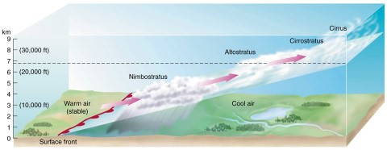

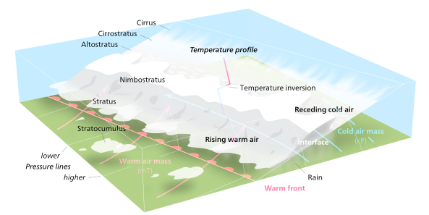

## Additional Characteristics

Warm fronts are typically characterized by a transition from southeasterly to southwesterly winds. Unlike cold fronts, winds along the front itself are generally light and variable. Warm fronts, as their name implies, are also characterized by a rise in temperature, but also humidity. Because warm fronts generally involve low pressure centers, barometric pressure will fall as a warm front approaches. Behind a warm front, pressures will rise slightly followed by fall. Warm fronts are generally characterized by poor visibility due to low layers of overcast and steady precipitation.

|  |  |  |  |
| --- | --- | --- | --- |
|  | **Before Passing** | **While Passing** | **After Passing** |
| **Winds From** | south-southeast | variable | south-southwest |
| **Temperature** | cool-cold, slow warming | steady rise | warmer, then steady |
| **Pressure** | usually falling | leveling off | **slight rise, followed by fall** |
| **Clouds** | in this order: cirrus, cirrostratus, Altostratus, Nimbostratus, Stratus, and fog; occasionally Cumulonimbus in summer | stratus-type | clearing with scattered stratocumulos; occasionally Cumulonimbus in summer |
| **Precipitation** | light-to-moderate rain, snow, sleet, or drizzle | drizzle or none | usually none, sometimes light rain or showers |
| **Visibility** | poor | poor, but improving | fair in haze |
| **Dew Point** | steady rise | steady | rise, then steady |

## Occluded Front

* **Occlusion:** an **occluded front** is a [weather front](https://en.wikipedia.org/wiki/Weather_front) formed during the process of [cyclogenesis](https://en.wikipedia.org/wiki/Cyclogenesis) when a [cold front](https://en.wikipedia.org/wiki/Cold_front) overtakes a [warm front](https://en.wikipedia.org/wiki/Warm_front)., A developing [cyclone](http://ww2010.atmos.uiuc.edu/(Gh)/wwhlpr/cyclone.rxml?hret=/guides/mtr/af/frnts/ofdef.rxml) typically has a preceding [warm front](http://ww2010.atmos.uiuc.edu/(Gh)/wwhlpr/warm_front_def.rxml?hret=/guides/mtr/af/frnts/ofdef.rxml) (the leading edge of a warm moist air mass) and a faster moving [cold front](http://ww2010.atmos.uiuc.edu/(Gh)/wwhlpr/cold_front_def.rxml?hret=/guides/mtr/af/frnts/ofdef.rxml) (the leading edge of a colder drier air mass wrapping around the storm). North of the warm front is a mass of cooler air that was in place before the storm even entered the region. As the storm intensifies, the cold front rotates around the storm and catches the warm front. This forms an occluded front, which is the boundary that separates the new cold air mass (to the west) from the older cool air mass already in place north of the warm front.
* Frontolysis begin when warm sector diminishes and the cold air mass completely undertakes the warm sector on ground.
* Thus, a long and backward swinging occluded front is formed which could be a **warm front type or cold front type occlusion**.
* In a **cold occlusion**, the cold air mass overtaking the warm front is **colder** than the cool air ahead of the warm front, and plows under both air masses.
* In a **warm occlusion**, the cold air mass overtaking the warm front is **warmer** than the cool air ahead of the warm front, and rides over the colder air mass while lifting the warm air.
* The **trowal** (short for TROugh of Warm air ALoft) is the projection on the Earth's surface of the trough of warm air aloft formed during the occlusion process of the depression.
* The formation **Mid-latitude** cyclones [temperate cyclones or extra-tropical cyclones] involve the formation of **occluded front**.

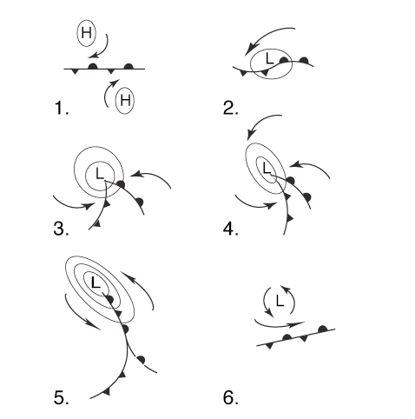

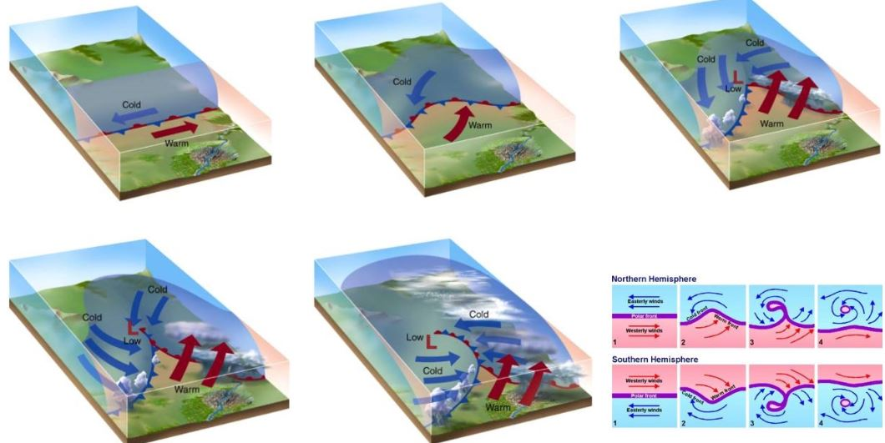

### Weather along an occluded front

* Cold Occlusion: With this type of occluded front, it acts as if it is a cold front. Cold fronts are responsible for the strong, severe storms that can produce damaging winds, hail and tornadoes. The weather also tends to exhibit a dip in temperature prior to the storms and a drastic change in wind direction and speed.
* Warm Occlusion: This causes a warm occluded front to act more like a warm front instead. A warm front is known for producing lighter rains that do not have the severe symptoms of the storms produced by cold fronts. The rain is often steady and covers a wide area of land. Winds do not change direction and the air temperature remains consistent.

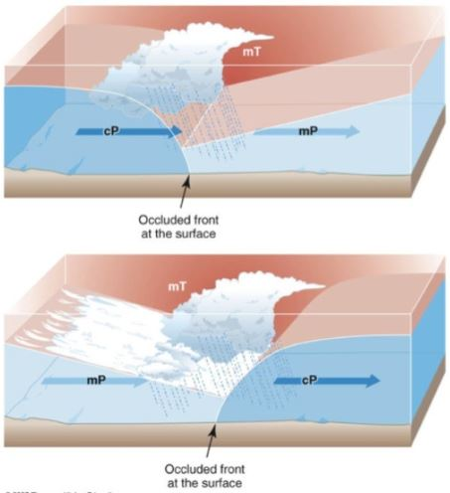

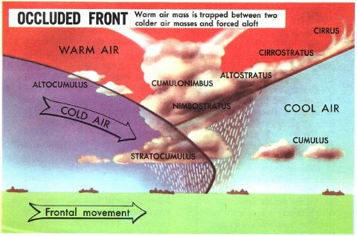

|  |  |  |  |  |  |  |  |  |  |  |  |  |  |  |  |  |  |  |  |  |  |  |  |  |  |  |  |  |  |  |  |  |
| --- | --- | --- | --- | --- | --- | --- | --- | --- | --- | --- | --- | --- | --- | --- | --- | --- | --- | --- | --- | --- | --- | --- | --- | --- | --- | --- | --- | --- | --- | --- | --- | --- |
| |  |  |  |  | | --- | --- | --- | --- | |  | **Before Passing** | **While Passing** | **After Passing** | | **WindsFrom** | southeast-south | variable | From west to northwest | | **Temperature**  Cold Type  Warm Type | cold-cool  cold | dropping  rising | colder  milder | | **Pressure** | usually falling | low point | usually rising | | **Clouds** | in order: Cirrus, Cirrostratus, Altostratus, Nimbostratus | Nimbostratus, sometimes Cumulonimbus | Nimbostratus, Altostratus or scattered Cumulus | | **Precipitation** | light, moderate or heavy precipitation, fog | light, moderate or heavy continuous precipitation or showers | light-to-moderate precipitation followed by general clearing | | **Visibility** | poor in precipitation | poor in precipitation | improving | | **Dew Point** | steady | usually slight drop, especially if cold-occluded | slight drop, although may rise a bit if warm-occluded |   Table adapted from: [Ahrens](http://ww2010.atmos.uiuc.edu/(Gh)/wwhlpr/ahrens.rxml?hret=/guides/mtr/af/frnts/ofdef.rxml), (1994) |

**Warm Front and Occluded front are examples of Temperature Inversion and can have fog**

Note: Instability in air = low pressure = thunderstorms and tornedos