# Evaporation

* Evaporation is a process by which water is transformed from **liquid to gaseous state**. Heat is the main cause for evaporation.
* **Movement of air replaces the saturated layer with the unsaturated layer. Hence, the greater the movement of air, the greater is the evaporation**.

## Factors Affecting Rate of Evaporation

* **Amount of water available.**
* **Temperature.**
* **Relative humidity.** [explained in previous post]
* **Area of evaporating surface.**
* **Wind speed:** A high wind speed removes the saturated air from the evaporating surface and replaces it with dry air which favors more evaporation.
* Whenever there is a combination of **high temperature**, very **low relative humidity** and **strong winds**, the rate of evaporation is exceptionally high. This leads to **dehydration of soil** to a depth of several inches.
* **Air Pressure:** Evaporation is also affected by the atmospheric pressure exerted on the evaporating surface. Lower pressure over open surface of the liquid results in a higher rate of evaporation.
* **Composition of water:** Evaporation is **inversely proportional to salinity of water.**
* Rate of evaporation is always greater over fresh water than over salt water. [Because of the reduction in the water vapor pressure at the water surface due to salinity.]
* Under similar conditions, ocean water evaporates about 5% more slowly than fresh water.
* **More evaporation by plants:** Water from plants generally evaporates at a faster rate than from land.

# Condensation

* The transformation of **water vapour into water** is called **condensation**.
* Condensation is caused by the **loss of heat** (**latent heat of condensation, opposite of latent heat of vaporization).**
* When moist air is cooled, it may reach a level when its capacity to hold water vapour ceases (Saturation Point = 100% Relative Humidity = Dew Point reached). Then, the excess water vapour condenses into liquid form. If it directly condenses into solid form, it is known as **sublimation**.

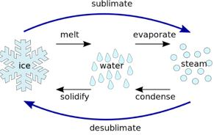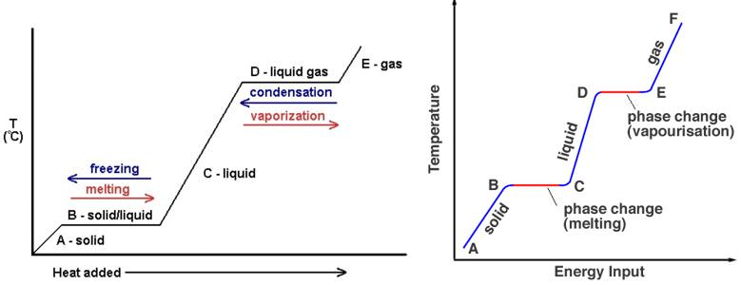

* In free air, condensation results from cooling around very small particles termed as **hygroscopic condensation nuclei**. Particles of **dust, smoke, pollen** and **salt** from the ocean are particularly good nuclei because they absorb water.
* Condensation also takes place when the moist air comes in contact with some colder object and it may also take place when the temperature is close to the **dew point.**
* Condensation, therefore, depends upon the **amount of cooling** and the **relative humidity** of the air.
* Condensation takes place:

1. when the temperature of the air is **reduced to dew point** with its volume remaining constant (**adiabatically**),
2. when both the volume and the temperature are reduced,
3. when moisture is added to the air through evaporation,

* After condensation the water vapour or the moisture in the atmosphere takes one of the following forms — **dew, frost, fog and clouds**.
* **Condensation takes place when the dew point is lower than the freezing point as well as higher than the freezing point.**

## Processes of Cooling for Producing Condensation

* These processes can be studied under the” headings, **adiabatic and non-adiabatic.**

### Adiabatic Temperature Changes

* (Explained in detail in previous posts)
* When the air rises, it expands. Thus, heat available per unit volume is reduced and, therefore, the temperature is also reduced. Such a temperature change which does not involve any subtraction of heat, and cooling of air takes place only by ascent and expansion, is termed ‘adiabatic change’.
* The vertical displacement of the air is the major cause of **adiabatic and katabatic** (cold, dense air flowing down a slope) temperature changes.
* Near the earth’s surface, most processes of change are **non-adiabatic** because horizontal movements often produce mixing of air and modify its characteristics.

### Non-Adiabatic Temperature Changes

* Non-adiabatic processes include cooling by **radiation, conduction or mixing** with colder air. The air may be cooled due to loss of heat by radiation.
* In case there is direct radiation from moist air, the cooling produces **fog or clouds**, subject to presence of hygroscopic nuclei in the air.
* Cooling by contact with a cold surface produces **dew, frost or fog** depending on other atmospheric conditions.
* But the effect of cooling produced by radiation, conduction and mixing is confined to a thin layer of the atmosphere.
* The non-adiabatic processes of cooling produce only dew, fog or frost. They are **incapable** of producing a substantial amount of precipitation.

# Forms of Condensation

* The forms of condensation can be classified on the basis of temperature at which the dew point is reached.
* Condensation can take place when the dew point is

1. **lower than the freezing point,**
2. **higher than the freezing point.**

* **White frost, snow and some clouds (cirrus clouds)** are produced when the temperature is lower than the freezing point.
* **Dew, fog and clouds** result even when the temperature is higher than the freezing point.
* Forms of condensation may also be classified on the basis of their location, i.e. at or near the earth’s surface and in free air.
* **Dew, white frost, fog and mist** come in the first category, whereas **clouds** are in the second category.

## Dew

* When the moisture is deposited in the form of water droplets on cooler surfaces of solid objects (rather than nuclei in air above the surface) such as stones, grass blades and plant leaves, it is known as dew.
* The ideal conditions for its formation are **clear sky, calm air, high relative humidity**, and **cold and long nights**.
* For the formation of dew, it is necessary that the **dew point is above the freezing point.**

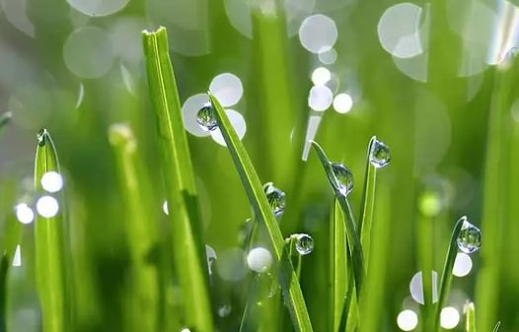

## White Frost

* Frost forms on cold surfaces when condensation takes place **below freezing point (0° C)**, i.e. the **dew point** is at or below the freezing point.
* The excess moisture is deposited in the form of **minute ice crystals** instead of water droplets.
* The ideal conditions for the formation of white frost are the same as those for the formation of dew, except that the **air temperature must be at or below the freezing point.**

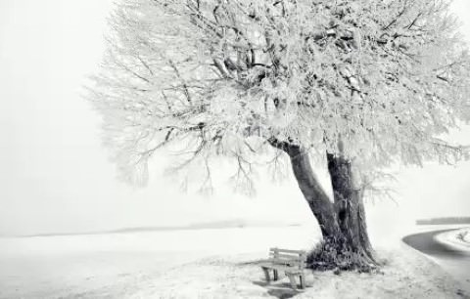

## Fog

* When the temperature of an air mass containing a large quantity of water vapour falls all of a sudden, condensation takes place within itself on fine dust particles.
* So, the fog is a **cloud with its base at or very near to the ground**. Because of the **fog and mist**, the visibility becomes poor to zero.
* In urban and industrial centers smoke provides plenty of nuclei which help the formation of fog and mist. Such a condition when fog is mixed with smoke, is described as **smog (will be discussed in detail in next post).** [Related Question Asked in Mains 2015: **Mumbai, Delhi and Kolkata are the three mega cities of the country but the air pollution is much more serious problem in Delhi as compared to the other two. Why is this so?]**
* **Radiation fog** results from radiation, cooling of the ground and adjacent air. These fogs are **not very thick**. Usual in winters.
* Fogs formed by condensation of warm air when it moves horizontally over a cold surface, are known as **advectional fog**. These fogs are **thick and persistent**. Occurs over warm and cold water mixing zones in oceans.
* **Frontal or precipitation fog** is produced due to convergence of warm and cold air masses where warm air mass is pushed under by the heavier cold air mass.
* Precipitation in the warm air mass condenses to produce fog at the boundary of the two air masses. These are called **frontal or precipitation fog**.

[Fronts – Frontogenesis – Stationary Front, Cold Front, Warm Front, Occluded Front](https://www.pmfias.com/fronts-frontogenesis-stationary-front-cold-front-warm-front-occluded-front/)

* **In fog visibility is less than one kilometer**.

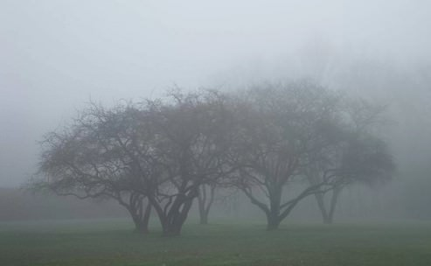

## Mist

* The difference between the mist and fog is that mist contains more moisture than fog.
* In mist each nuclei contains a thicker layer of moisture.
* Mists are frequent over mountains as the rising warm air up the slopes meets a cold surface.
* Mist is also formed by water droplets, but with less merging or coalescing. This means mist is less dense and quicker to dissipate.
* Fogs are drier than mist and they are prevalent where warm currents of air come in contact with cold currents.
* **In mist visibility is more than one kilometer but less than two kilometres.**

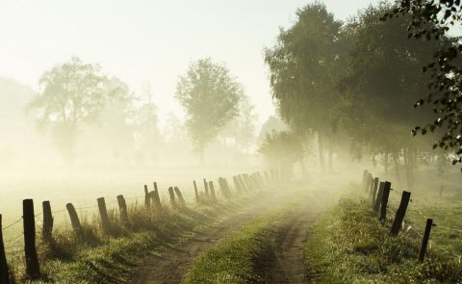

## Haze

* Haze is traditionally an atmospheric phenomenon where dust, smoke and other dry particles obscure the clarity of the sky (No condensation. Smog is similar to haze but there is condensation in smog).
* Sources for haze particles include farming (ploughing in dry weather), traffic, industry, and wildfires.

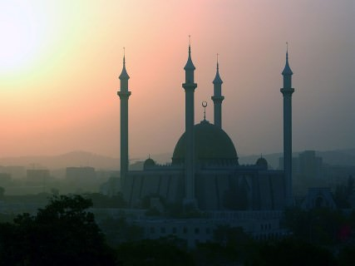

## Smog

* Smog = smoke + fog (smoky fog) caused by the burning of large amounts of coal, vehicular emission and industrial fumes (Primary pollutants).

We will study about smog in detail in the next post.

## Clouds

* Cloud is a mass of minute water droplets or tiny crystals of ice formed by the condensation of the water vapour in free air at considerable elevations.
* Clouds are caused mainly by the **adiabatic cooling of air below its dew point.**
* As the clouds are formed at some height over the surface of the earth, they take various shapes.
* According to their height, expanse, density and transparency or opaqueness clouds are grouped under four types **: (i) cirrus; (ii) cumulus; (iii) stratus; (iv) nimbus.**

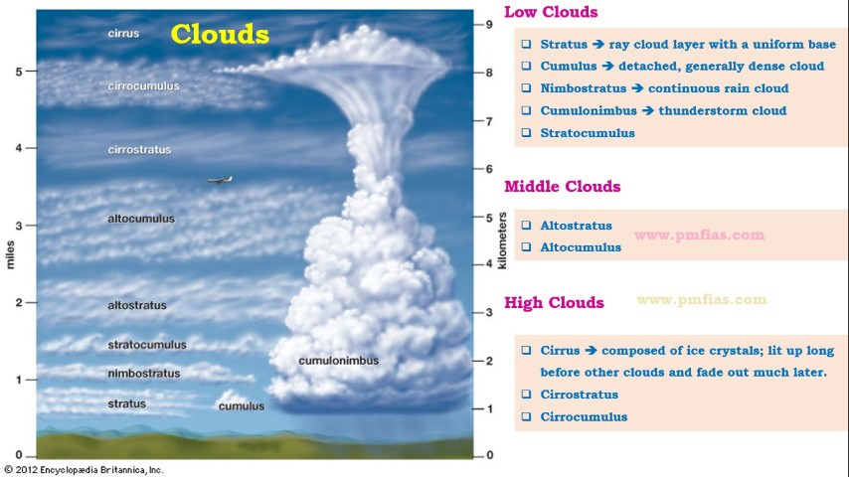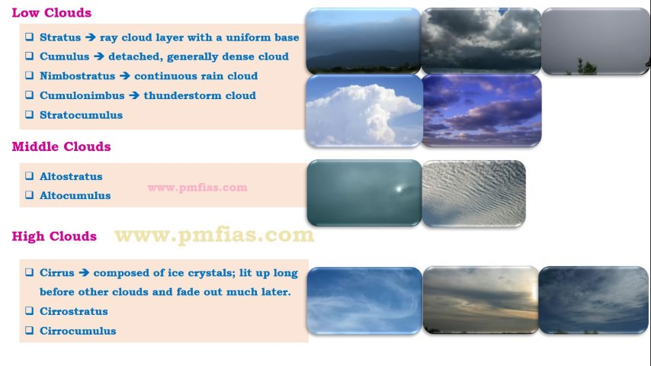

### Cirrus Clouds

* Cirrus clouds are formed at high altitudes (8,000 – 12,000m). They are thin and detached clouds having a feathery appearance. They are always white in colour.

### Cumulus Clouds

* Cumulus clouds look like cotton wool. They are generally formed at a height of 4,000 -7,000 m. They exist in patches and can be seen scattered here and there. They have a flat base.

### Stratus Clouds

* As their name implies, these are layered clouds covering large portions of the sky.
* These clouds are generally formed either due to loss of heat or the mixing of air masses with different temperatures.

### Nimbus Clouds

* Nimbus clouds are black or dark gray. They form at middle levels or very near to the surface of the earth.
* These are extremely dense and opaque to the rays of the sun.
* Sometimes, the clouds are so low that they seem to touch the ground.
* Nimbus clouds are shapeless masses of thick vapour.

A combination of these four basic types can give rise to the following types of clouds:

1. **High clouds – cirrus, cirrostratus, cirrocumulus;**
2. **Middle clouds – altostratus and altocumulus;**
3. **Low clouds – stratocumulus and nimbostratus (long duration rainfall cloud) and**
4. **Clouds with extensive vertical development – cumulus and cumulonimbus (thunderstorm cloud)**

**Sun’s halo is produced by the refraction of light in: [2002]**  
(a) water vapour in Stratus clouds  
(b) ice crystals in Cirro-Cumulus clouds  
(c) **ice crystals in Cirrus clouds**  
(d) dust particles in Stratus clouds