* The process of continuous condensation in free air helps the condensed particles to grow in size. When the resistance of the air fails to hold them against the force of gravity, they fall on to the earth’s surface. So after the condensation of water vapour, the release of moisture is known as precipitation. This may take place in liquid or solid form.
* Precipitation in the form of drops of water is called rainfall, when the drop size is more than **5 mm**.
* It is called **virga** when precipitation evaporate or sublimate before reaching the earth while passing through dry air.
* **Drizzle** is light rainfall with drop size being less than 0.5 mm.
* When the temperature is lower than the 0° C, precipitation takes place in the form of fine flakes of snow and is called **snowfall**. Moisture is released in the form of hexagonal crystals. These crystals form flakes of snow. Besides rain and snow, other forms of precipitation are **sleet** and **hail** (more about hail while studying thunderstorms), though the latter are limited in occurrence and are sporadic in both time and space.
* **Sleet** is frozen raindrops and refrozen melted snow-water. When the temperature falls below 32 degrees, precipitation falls out of a cloud as snow. When that snow falls through a warmer layer of the atmosphere, it will melt slightly, and then turn into an ice pellet as it falls through a colder zone, causing it to hit the Earth in the form of sleet
* Hail usually [forms in the summer](http://www.nssl.noaa.gov/education/svrwx101/hail/) months during a thunderstorm, according to the National Severe Storms Laboratory, and here’s how it happens: Raindrops form in the bottom of clouds during a thunderstorm, and updrafts during a severe storm cause those raindrops to be carried from the bottom of the clouds to the top of the clouds, where the temperature is significantly cooler. This cooled water will freeze on contact with ice crystals, dust or other matter and will form a tiny piece of hail. It then falls to the bottom of the cloud only to be carried upwards again by an updraft. It then comes into contact with more extremely cooled water, causing another layer to freeze around the hailstone. The hail finally falls to the ground when the updraft weakens or the hailstone becomes too heavy to stay in the cloud. Like a tree, a hailstone’s rings bear significance. If you pick up a piece of hail and slice it, you should be able to tell how many times it was carried to the top of a storm by how many layers it has. Hailstones have several **concentric**layers of ice one over the other.
* Even though Florida ranks as the state with the most thunderstorms, hail is most likely to occur in Nebraska, Wyoming and Colorado. In fact, the area where the three states meet is known as “Hail Alley,” averaging seven to nine days of hail a year.
* Hail occurs in warm weather, while sleet occurs during cold weather. Unlike hail, sleet is tiny in size and falls only once from the sky. It's quite noisy when it hits your windshield or the ground, but it can’t cause the damage that hail can.
* **Rainfall:** drop size more than 0.5 mm.
* **Virga:** raindrops evaporate before reaching the earth.
* **Drizzle:** light rainfall; drop size less than 0.5 mm.
* **Mist:** evaporation occurs before reaching the ground leading to foggy weather.
* **Snowfall:** fine flakes of snow fall when the temperature is less than 0°C.
* **Sleet:** frozen raindrops and refrozen melted snow; mixture of snow and rain or merely partially melted snow.
* **Hail:** precipitation in the form of hard rounded pellets is known as hail; 5 mm and 50 mm.

# Types of Rainfall

* On the basis of origin, rainfall may be classified into three main types – the **convectional, orographic or relief** and the **cyclonic or frontal.**

## Conventional Rainfall

* The, air on being heated, becomes light and rises up in convection currents. As it rises, it expands and loses heat and consequently, condensation takes place and clouds are formed. This process releases **latent heat of condensation** which further heats the air and forces the air to go further up.
* Convectional precipitation is heavy but of **short duration**, **highly localised** and is associated with minimum amount of cloudiness. It occurs mainly during **summer**and is common over **equatorial doldrums** in the Congo basin, the Amazon basin and the islands of south-east Asia.
* [Adiabatic Lapse Rate – Latent Heat of Condensation](https://www.pmfias.com/adiabatic-lapse-rate-latent-heat-condensation/)

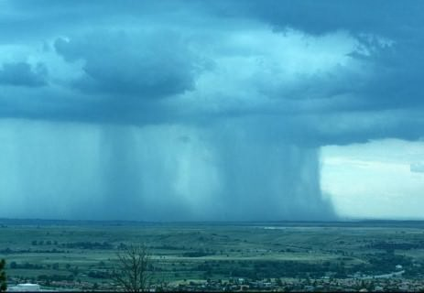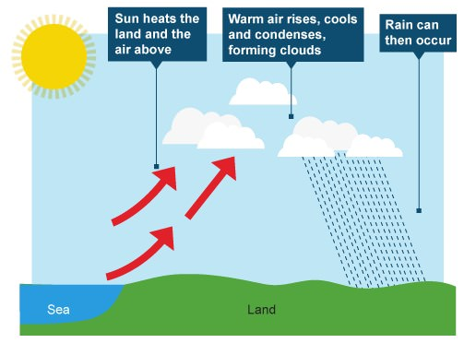

## Orographic Rainfall

* When the saturated air mass comes across a mountain, it is forced to ascend and as it rises, it expands (because of fall in pressure); the temperature falls, and the moisture is condensed.
* This type of precipitation occurs when warm, humid air strikes an orographic barrier (a mountain range) head on. Because of the initial momentum, the air is forced to rise. As the moisture laden air gains height, condensation sets in, and soon saturation is reached. The surplus moisture falls down as orographic precipitation along the windward slopes.
* The chief characteristic of this sort of rain is that the **windward slopes** receive greater rainfall. After giving rain on the windward side, when these winds reach the other slope, they descend under the force of gravity, and their temperature rises. Then their capacity to take in moisture increases and hence, these **leeward slopes** remain rainless and dry. The area situated on the leeward side, which gets less rainfall is known as the **rain-shadow area** (Some arid and semi-arid regions are a direct consequence of rain-shadow effect. Example: **Patagonian desert in Argentina, Eastern slopes of Western Ghats**). It is also known as the **relief rain.**
* Example: Mahabaleshwar, situated on the Western Ghats, receives more than 600 cm of rainfall, whereas Pune, lying in the rain shadow area, has only about 70 cm.

The Wind Descending on the Leeward Side is heated adiabatically. **Katabatic Wind: any wind that flows down (leeward side) or** drainage wind, a wind that carries high-density air from a higher elevation down a slope under the force of gravity.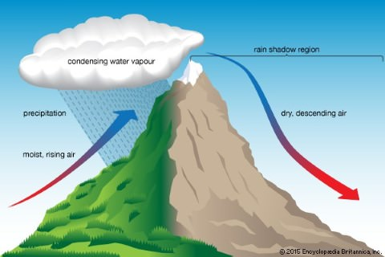

## Frontal Precipitation

* When two air masses with different temperatures meet, turbulent conditions are produced. Along the front convection occurs and causes precipitation (we studied this in Fronts). For instance, in north-west Europe, cold continental air and warm oceanic air converge to produce heavy rainfall in adjacent areas.

[Fronts – Frontogenesis – Stationary Front, Cold Front, Warm Front, Occluded Front](https://www.pmfias.com/fronts-frontogenesis-stationary-front-cold-front-warm-front-occluded-front/)

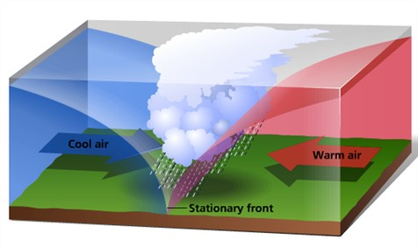

## Cyclonic Rain

* Cyclonic Rainfall is **convectional rainfall on a large scale**. (we will see this in detail later)
* The precipitation in a tropical cyclone is of convectional type while that in a temperate cyclone is because of frontal activity.

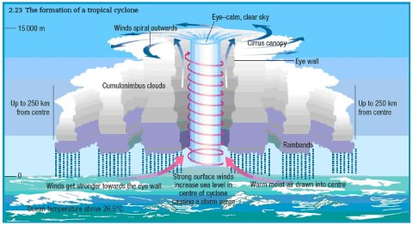

## Monsoonal Rainfall

* This type of precipitation is characterized by **seasonal reversal of winds** which carry oceanic moisture (especially the south-west monsoon) with them and cause extensive rainfall in south and southeast Asia. (More while studying Indian Monsoons).

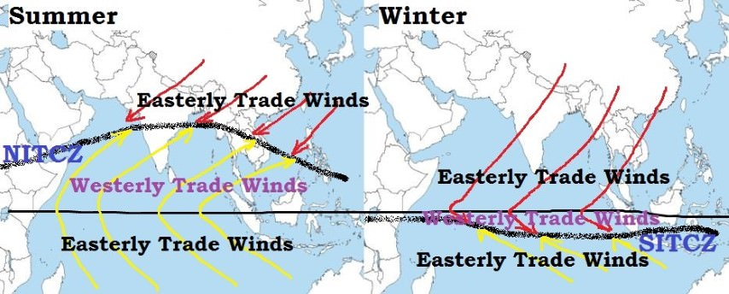

# World Distribution of Rainfall

Global precipitation patterns are largely determined by air masses and their movements, which in turn are produced by global air circulation patterns. let’s look at Figure 7.6, which shows the general patterns expected for a hypothetical supercontinent that has most of the features of the Earth’s [continents](http://geography.name/continents/) but is simplified. The map recognizes and defines five classes of annual precipitation: wet, humid, subhumid, semiarid, and arid.

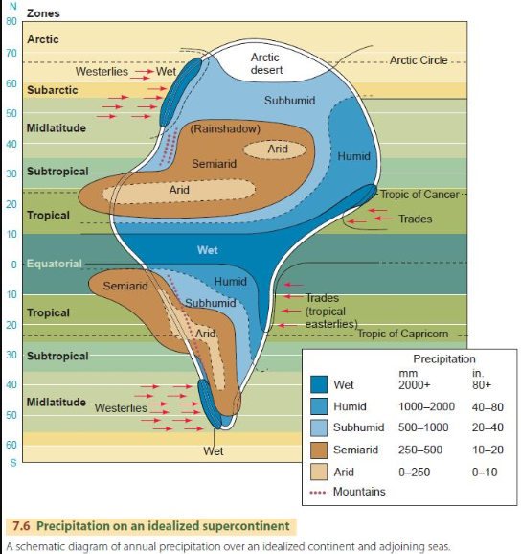

Beginning with the equatorial zone, the figure shows a wet band stretching across the continent. This band is produced by convective precipitation over the equatorial lows near the intertropical [convergence zone](http://geography.name/zones-of-convergencedivergence/). Note that the wet band widens and is extended poleward into the tropical zone along the continent’s eastern coasts. This region is kept moist by the influence of the trade winds, which move warm, moist mT air masses and tropical [cyclones](http://geography.name/cyclones/) westward onto the continental coast.

Farther poleward, humid conditions continue along the east coasts into the midlatitude zones. In these regions, subtropical high-pressure cells tend to move mT air masses from the southeast onto the continent in the summer, whereas in winter, midlatitude cyclones bring cyclonic precipitation from the west.

In the arctic zone, shown on the continent as arctic desert, precipitation remains low because air temperatures are low, and only a small amount of moisture is contained in cold air.

Another important feature of the hypothetical continent is the pattern of arid and semiarid regimes that stretches from tropical west coasts to subtropical and midlatitude continental interiors. In the tropical and subtropical latitudes, the arid pattern is produced by dry, subsiding air in persistent subtropical high-pressure cells. The aridity continues eastward and poleward into semiarid continental interiors, which remain relatively dry because they are far from source regions for moist air masses. Rainshadow effects provided by coastal mountain barriers are also important in maintaining inland aridity.

Yet another obvious feature of the supercontinent is the pair of wet bands along the west coasts of the midlatitude and subarctic zones. These are produced by the eastward movement of moist mP air masses onto the continent, as driven by the prevailing westerlies. These features of the supercontinent are echoed in the actual pattern of global precipitation, shown in Figure 7.7. This map of mean annual precipitation shows isohyets—lines drawn through all points having the same annual precipitation. Using the same logic that we used to explain the precipitation patterns of the hypothetical continent, we can recognize seven global precipitation regions as follows:

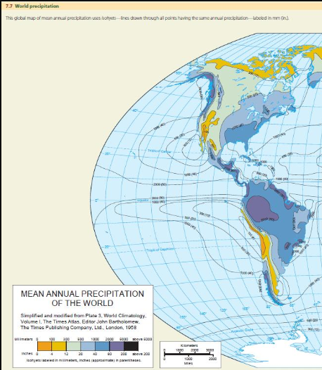

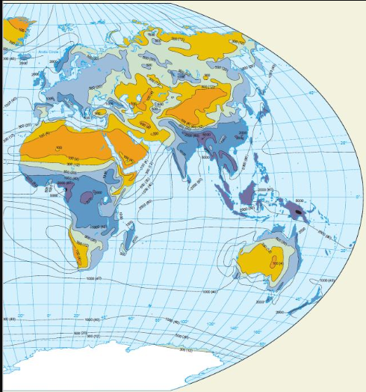

Note: These are based on Total annual precipitation. That’s why they are not following the exact pressure belt based distribution, as pressure belts tends to move according to the sun’s position.

1. **Wet equatorial belt**. This zone of heavy rainfall, over 2000 mm (80 in.) annually, straddles the Equator and includes the [Amazon River](http://geography.name/amazon-river/) Basin in South America, the [Congo River](http://geography.name/congo-river/) Basin of equatorial Africa, much of the African coast from [Nigeria](http://geography.name/nigeria/) west to Guinea, and the East Indies. In this zone, the warm temperatures and high-moisture content of the mE air masses favor abundant convective rainfall.
2. **Trade-wind coasts**. Narrow coastal belts of high rainfall, 1500 to 2000 mm (about 60 to 80 in.), extend from near the Equator to latitudes of about 25° to 30° N and S on the eastern sides of every continent or large island. Examples include the eastern coast of [Brazil](http://geography.name/brazil/), Central America, [Madagascar](http://geography.name/madagascar/), and northeastern [Australia](http://geography.name/australia/). The rainfall of these coasts is supplied by moist mT air masses from warm oceans that are brought over the land by the trade winds and encounter coastal hills and mountains, producing heavy orographic rainfall.
3. **Tropical deserts**. In contrast to the wet equatorial belt are the zones of tropical deserts lying approximately on the Tropics of Cancer and Capricorn. These are hot, barren deserts with less than 250 mm (10 in.) of rainfall annually and, in many places, with less than 50 mm (2 in.). They are located under the large, stationary subtropical cells of high pressure, in which the subsiding cT air mass is adiabatically warmed and dried.
4. **Midlatitude deserts and steppes**. Farther northward, in the interiors of Asia and North America between latitude 30° and latitude 50°, are great deserts, as well as vast expanses of semiarid [grasslands](http://geography.name/grasslands/) known as [steppes](http://geography.name/steppe/). Annual precipitation ranges from less than 100 mm (4 in.) in the driest areas to 500 mm (20 in.) in the moister steppes. Located in regions of prevailing westerly winds, these arid lands are far from sources of oceanic moisture and typically lie in rain shadows on the lee side of coastal mountains and highlands. In the southern [hemisphere](http://geography.name/hemisphere/), the dry steppes of Patagonia, lying on the lee side of the Andean chain, are roughly the counterpart of the North American deserts and steppes.
5. **Moist subtropical regions**. On the southeastern sides of the continents of North America and Asia, in latitude 25° to 45° N(because of movement of subtropical high pressure belt), are the moist subtropical regions, with 1000 to 1500 mm (about 40 to 60 in.) of rainfall annually. Smaller areas of the same type are found in [Uruguay](http://geography.name/uruguay/), [Argentina](http://geography.name/argentina/), and  
   southeastern Australia. These regions are positioned on the moist western sides of the oceanic subtropical high-pressure circulations, which bring moist mT air masses from the tropical ocean onto the continent.
6. **Midlatitude west coasts**. Another wet location is on midlatitude west coasts of all continents and large islands lying between latitudes about 35° and 65° in the region of prevailing westerly winds. In these zones, abundant [orographic precipitation](http://geography.name/orographic-precipitation/) occurs as a result of forced uplift of mP air masses. Where the coasts are mountainous, as in British Columbia, southern [Chile](http://geography.name/chile/), Scotland, and South Island of [New Zealand](http://geography.name/new-zealand/), the annual precipitation is over 2000 mm (79 in.).
7. **Arctic and polar deserts**. A seventh precipitation region is formed by the arctic and polar deserts. Northward of the 60th parallel, annual precipitation is largely under 300 mm (12 in.), except for the west-coast belts. Cold cP and cA air masses cannot contain much moisture, and, consequently, they do not yield large amounts of precipitation.

Is same annual precipitation guarantee the same crops all over the region ?

Total annual precipitation is a useful quantity in establishing the character of a climate type, but it does not account for the seasonality of precipitation. If there is a pattern of alternating dry and wet [seasons](http://geography.name/seasons/) instead of a uniform distribution of precipitation throughout the year, we can expect that the natural [vegetation](http://geography.name/vegetation-geography/), soils, crops, and human use of the land will all be different. It also makes a difference whether the wet season coincides with a season of higher temperatures or with a season of lower temperatures. If the warm season is also wet, growth of both native plants and crops is enhanced.

If the warm season is dry, the stress on growing plants is great, and [irrigation](http://geography.name/irrigation/) is required for most crops.

Why Mediterranean climate has disturbance in winter ?

In Mediterranean climates, summer drought is produced by subtropical high-pressure cells, which intensify and move poleward during the high-Sun season. These cells extend into the regions of Mediterranean climate, providing the hot, dry weather associated with cT air masses while blocking the passage of moister air masses from the oceans. In the low-Sun season, the subtropical high-pressure cells move equatorward and weaken, allowing frontal and cyclonic precipitation to penetrate into Mediterranean climate regions.

Can areas have less rainfall in summer ? why ?

The dry-summer, moist-winter cycle is carried into the higher midlatitudes along narrow strips of west coasts. Shannon Airport, [Ireland](http://geography.name/ireland-introduction/) (53° N), has this marine westcoast type of climate, although the difference between summer and winter rainfall is not as marked. Summers at Shannon Airport have less rainfall for two reasons. First, the blocking effects of subtropical high-pressure cells tend to extend poleward into the region, keeping moister air masses and cyclonic storms away. Second, the cyclonic storms that produce much of the winter precipitation are reduced in intensity during the high-Sun season because the temperature and moisture contrasts between polar and arctic air masses and tropical air masses are weaker in summer. The weaker contrasts are caused by increased high-latitude insolation. Without the strong temperature contrast, disturbances in the [jet stream](http://geography.name/jet-stream/) do not tend to grow as large(weak jet streams), so neither do the underlying midlatitude cyclones.

