# Tropical Cyclones

<https://www.pmfias.com/tropical-cyclones-favorable-conditions-tropical-cyclone-formation/>

* Tropical cyclones are violent storms that originate over oceans in **tropical areas** and move over to the coastal areas bringing about large scale destruction due to violent winds (squalls), very heavy rainfall (torrential rainfall) and **storm surge**.
* They are irregular wind movements involving **closed circulation** of air around a low pressure center. This closed air circulation (whirling motion) is a result of **rapid upward movement of hot air** which is subjected to [**Coriolis force**](https://www.pmfias.com/wind-movement-factors-affecting-winds-coriolis-force/). The low pressure at the center is responsible for the wind speeds.

Squall == a sudden violent gust of wind or localized storm, especially one bringing rain, snow, or sleet.

Torrent == a strong and fast-moving stream of water or other liquid.

* The cyclonic wind movements are **anti-clockwise in the northern hemisphere** and **clockwise in the southern hemisphere** (This is due to [**Coriolis force**](https://www.pmfias.com/wind-movement-factors-affecting-winds-coriolis-force/)).
* The cyclones are often characterized by existence of an anticyclone between two cyclones.

# Conditions Favourable for Tropical Cyclone Formation

1. Large sea surface with temperature higher than **27° C**,
2. high [humidity](https://en.wikipedia.org/wiki/Humidity) in the lower to middle levels of the [troposphere](https://en.wikipedia.org/wiki/Troposphere)
3. Presence of the Coriolis force enough to create a cyclonic vortex,
4. A pre-existing weak low-pressure area or low-level-cyclonic circulation, atmospheric instability,
5. Upper divergence above the sea level system,
6. Small variations in the vertical wind speed,

## Good Source of Latent Heat[point 1 and 2]

* Ocean waters having temperatures of 27° C or more is the source of moisture which feeds the storm. The condensation of moisture releases enough [**latent heat of condensation**](https://www.pmfias.com/adiabatic-lapse-rate-latent-heat-condensation/) to drive the storm.

#### Why tropical cyclones form mostly on the western margins of the oceans? OR

#### Why tropical cyclones don’t form in the eastern tropical oceans?

* The depth of warm water **(26-27°C)** should extend for **60-70 m** from surface of the ocean/sea, so that deep convection currents within the water do not churn and mix the cooler water below with the warmer water near the surface.
* The above condition occurs only in western tropical oceans because of warm ocean currents (easterly trade winds pushes ocean waters towards west) that flow from east towards west forming a thick layer of water with temperatures greater than 27°C. This supplies enough moisture to the storm.
* The **cold currents** lower the surface temperatures of the eastern parts of the tropical oceans making them unfit for the breeding of cyclonic storms.

[One Exception: During strong El Nino years, strong hurricanes occur in the eastern Pacific. This is due to the accumulation of warm waters in the eastern Pacific due to **weak**[**Walker Cell**](https://www.pmfias.com/winds-hadley-ferrel-polar-walker-cell-trade-winds-westerlies-polar-easterlies-loo-foehn-fohn-chinook-mistral-sirocco/)]

#### Why cyclones occur mostly in late summers?

#### In the North [Atlantic](https://en.wikipedia.org/wiki/Atlantic_Ocean), a distinct hurricane season occurs from June 1 through November 30, sharply peaking from late August through October

#### In the [Southern Hemisphere](https://en.wikipedia.org/wiki/Southern_Hemisphere), tropical cyclone activity generally begins in early November and generally ends on April 30. Southern Hemisphere activity peaks in mid-February to early March

#### For eg, the peak of the Atlantic hurricane season is typically in September. Mid-August to mid-October is when we see over 74% of tropical storm days, 87% of category 1-2 hurricane days, and over 95% of category 3-5 (major) hurricane days.

* Whirling motion is enhanced when the [**doldrums**](https://www.pmfias.com/pressure-belts-pressure-systems-equatorial-low-sub-tropical-high-sub-polar-low-polar-high/) (region within ITCZ) over oceans are farthest from the equator. This happens during the autumnal equinox (August-September).#coriolisForce increases as going away from equator.
* Wind shear, which can tear disturbances apart before they strengthen, is strong in May, but gradually fades through June and July, reaching a minimum by mid to late August. This minimum in the shear combines with favorable thermodynamics – ocean temperatures in the deep tropics that increase with each day of summer sun, warmer air temperatures, and increasing atmospheric moisture.
* Oceans (water) have great heat capacity than land masses because of something called specific heat. Specific heat is defined as the amount of *heat* for some given unit mass that is required to increase temperature by 1 degree C. Because of its higher specific heat, it takes water longer to heat up or cool down than dry soil (land). This explains why the ocean waters are warmer in late summers than in June(i.e. peak of summer).

## Coriolis Force (f)

* The [**Coriolis force**](https://www.pmfias.com/wind-movement-factors-affecting-winds-coriolis-force/)**is zero at the equator** **(no cyclones at equator because of zero Coriolis Force)**but it increases with latitude. Coriolis force at **5°** latitude is significant enough to create a storm [cyclonic vortex].
* **About 65 per cent of cyclonic activity occurs between 10° and 20° latitude**.

## Low-level Disturbances and Instability

Whether it be a depression in the [intertropical covergence zone (ITCZ)](https://en.wikipedia.org/wiki/Intertropical_convergence_zone), a [tropical wave](https://en.wikipedia.org/wiki/Tropical_wave), a broad [surface front](https://en.wikipedia.org/wiki/Surface_weather_analysis), or an [outflow boundary](https://en.wikipedia.org/wiki/Outflow_boundary) [all having low and high pressure zones nearby], a low level feature with sufficient [vorticity](https://en.wikipedia.org/wiki/Vorticity) and convergence is required to begin tropical cyclogenesis. Even with perfect upper level conditions and the required atmospheric instability, the lack of a surface focus will prevent the development of organized convection and a surface low. A weak cyclonic circulation develops around the areas of low pressure.Then, because of the rising warm humid air, a true cyclonic vortex may develop very rapidly. However, only a few of these disturbances develop into cyclones. Tropical cyclones can form when smaller circulations within the [Intertropical Convergence Zone](https://en.wikipedia.org/wiki/Intertropical_Convergence_Zone) merge. A preexisting low level focus is required for tropical cyclone to from.

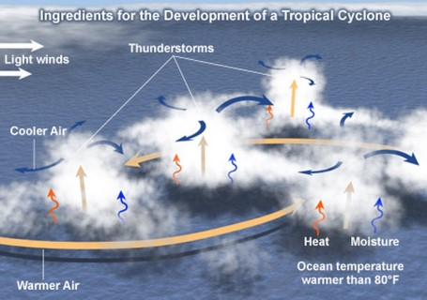

[rising of humid air =>  adiabatic lapse rate => fall in temperature of air => condensation of moisture in air => latent heat of condensation released => air gets more hot and lighter => air is further uplifted => more air comes in to fill the gap => new moisture available for condensation => latent heat of condensation and the cycle repeats]

## Temperature contrast between air masses

* Trade winds from both the hemispheres meet along inter-tropical front. Temperature contrasts between these air masses must exist when the ITCZ is farthest, from the equator.
* Thus, the convergence of these air masses of different temperatures and the resulting instability are the prerequisites for the origin and growth of violent tropical storms.

## Upper Air Disturbance

* The remains of an upper tropospheric cyclone from the Westerlies move deep into the tropical latitude regions. As divergence prevails on the eastern side of the troughs, a rising motion occurs; this leads to the development of thunderstorms.
* Further, these old abandoned troughs (remnants of temperate cyclones) usually have cold cores, suggesting that the environmental lapse rate is steeper and unstable below these troughs. Such instability encourages thunderstorms (child cyclones).

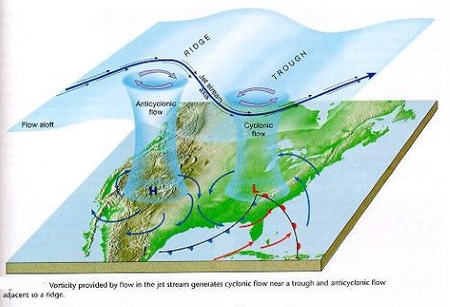

## Wind Shear

* Wind Shear == differences between wind speeds at different heights.
* Tropical cyclones develop when the wind is uniform.
* **Because of weak vertical wind shear, cyclone formation processes are limited to latitude equator ward of the**[**subtropical jet stream.**](https://www.pmfias.com/subtropical-jet-stream-polar-jet-stream-tropical-easterly-jet-somali-jet/)**[**[**Jet streams**](https://www.pmfias.com/jet-streams-geostrophic-wind-upper-level-westerlies/)**]**
* In the temperate regions, wind shear is high due to westerlies and this inhibits convective cyclone formation.
* Vertical wind shear of less than 10 m/s (20 kt, 22 mph) between the surface and the tropopause is favored for tropical cyclone development. A weaker vertical shear makes the storm grow faster vertically into the air, which helps the storm develop and become stronger. If the vertical shear is too strong, the storm cannot rise to its full potential and its energy becomes spread out over too large of an area for the storm to strengthen. Strong wind shear can "blow" the tropical cyclone apart, as it displaces the mid-level warm core from the surface circulation and dries out the mid-levels of the troposphere, halting development.

## Upper Tropospheric Divergence

* A well – developed divergence in the upper layers of the atmosphere is necessary so that the rising air currents within the cyclone continue to be pumped out and a low pressure maintained at the center.

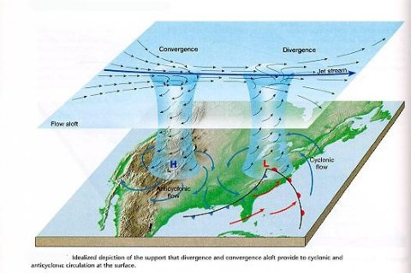

## Humidity Factor

* High humidity (around 50 to 60 per cent) is required in the lower to middle level of troposphere(5 km [3 mi]), since the presence of moist air leads to the formation of [**cumulonimbus cloud**](https://www.pmfias.com/condensation-forms-of-condensation-types-of-clouds/). Dry mid levels are not conducive for allowing the continuing development of widespread thunderstorm activity.

# Origin and Development of Tropical Cyclones

* The tropical cyclones have a **thermal origin**, and they develop over tropical seas during late summers (August to mid-November).
* At these locations, the strong local convectional currents acquire a whirling motion because of the Coriolis force.
* After developing, these cyclones advance till they find a weak spot in the trade wind belt.

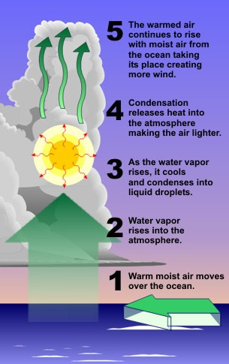

## Formation and Intensification stage

* In the thunderstorm, air is uplifted as it is **warm and light**. At certain height, due to [**lapse rate and adiabatic lapse rate**](https://www.pmfias.com/adiabatic-lapse-rate-latent-heat-condensation/), the temperature of air falls and moisture in the air undergoes **condensation**.
* Condensation releases [**latent heat of condensation**](https://www.pmfias.com/adiabatic-lapse-rate-latent-heat-condensation/) making the air more warmer. It becomes much lighter and is further uplifted.
* The space is filled by fresh moisture laden air. Condensation occurs in this air and the cycle is repeated as long as the moisture is supplied.
* Due to excess moisture over oceans, the thunderstorm intensifies and sucks in air at much faster rate. The air from surroundings rushes in and undergoes deflection due to **Coriolis force** creating a **cyclonic vortex (spiraling air column. Similar to**[**tornado**](https://www.pmfias.com/thunderstorm-thunder-and-lightning-tornado-waterspout/)**).**

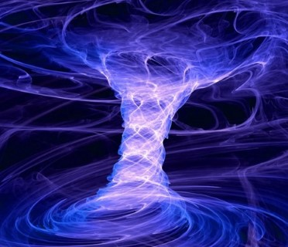

* The spiraling winds rotate faster as they approach the center.  Centrifugal force flings the rotating air outward, making it increasingly difficult for air to reach the center. Due to this, air in the vortex is forced to form a region of calmness called an **eye** at the center of the cyclone. The inner surface of the vortex forms the **eye wall**, the **most violent region** of the cyclone.

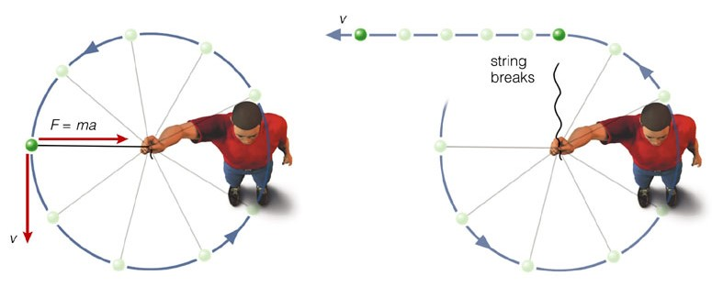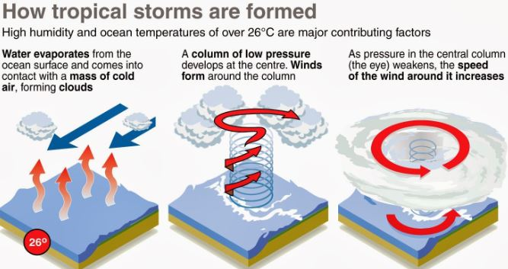

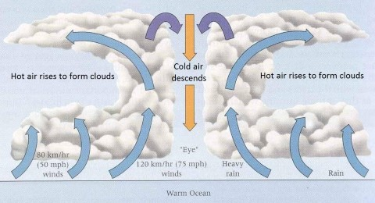

* All the wind that is carried upwards loses its moisture and becomes cold and dense. It descends to the surface through the cylindrical eye region and at the edges of the cyclone. Which prevent cloud formation at the eye region.
* Continuous supply of **moisture** from the sea is the major driving force behind every cyclone. On reaching the land the **moisture supply is cut off** and the storm dissipates.
* If ocean can supply more moisture, the storm will reach a mature stage.

## Mature stage

* Under favorable conditions, multiple thunderstorms originate over the oceans. At the stage of maturity the spiraling winds cause these thunderstorms to flow in circular pattern(driven by spiraling winds) around the low pressure center. Which cause multiple convective cells with successive calm and violent regions.
* The regions with cumulonimbus cloud (rising limbs of convective cell) formation are called **rain bands** below which intense rainfall occurs.
* The ascending air will lose moisture at some point and descends (subsides) back to surface through the calm regions (descending limbs of convection cell – subsiding air) that exist between two rain bands.
* Cloud formation is dense at the center. The cloud size(height) decreases from center(eye wall) to periphery.
* Rain bands are mostly made up of cumulonimbus clouds. The ones at the periphery are made up of nimbostratus and cumulus clouds.
* The dense overcast at the upper levels of troposphere is due to [**cirrus clouds**](https://www.pmfias.com/condensation-forms-of-condensation-types-of-clouds/) which are mostly made up of hexagonal ice crystals.
* The dry air flowing along the central dense overcast descends at the periphery and the eye region.

## Dissipation stage

* When a cyclone has its energy supply interrupted, by moving over colder water or over land, it reaches the decaying stage. The system may persist over land as a rain-bearing depression or move into higher latitudes and interact with frontal systems. It may move into a region of increasing wind shear that disturbs the vertical alignment of the system causing the upper and lower circulations to become separated.

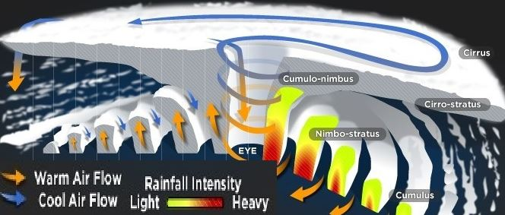

# Structure of a tropical cyclone

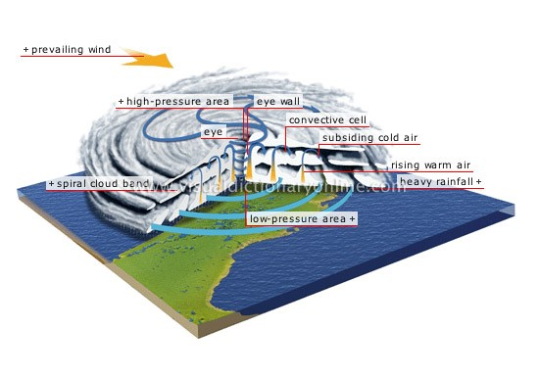

## Eye

* The “eye” is a roughly circular area of comparatively **light winds and fair weather** found at the center of a severe tropical cyclone. although the sea may be extremely violent.
* There is little or **no precipitation** and sometimes blue sky or stars can be seen.
* The eye is the region of **lowest surface pressure** and warmest temperatures aloft (in the upper levels) – the eye temperature may be 10°C warmer or more at an altitude of 12 km than the surrounding environment, but only 0-2°C warmer at the surface in the tropical cyclone.
* Eyes range in size from 8 km to over 200 km across, but most are approximately 30-60 km in diameter.

## Eye wall

* The eye is surrounded by the “eye wall”, the roughly circular ring of **deep convection**, which is the area of **highest surface winds** in the tropical cyclone. Eye Wall region also sees the maximum sustained winds i.e. **fastest winds in a cyclone occur along the eye wall region.**
* The eye is composed of air that is slowly sinking and the eye wall has a net upward flow as a result of many moderate – occasionally strong – [**updrafts and downdrafts [Explained in ‘Thunderstorms’]**.](https://www.pmfias.com/thunderstorm-thunder-and-lightning-tornado-waterspout/)
* The eye’s warm temperatures are due to compressional warming (adiabatic) of the subsiding air.
* Most soundings taken within the eye show a low-level layer, which is relatively moist, with an inversion above – suggesting that the sinking in the eye **typically does not reach the ocean surface**, but instead only gets to around 1-3 km of the surface.

## Spiral bands

* Another feature of tropical cyclones that probably plays a role in **forming and maintaining the eye** is the eye wall convection.
* Convection in tropical cyclones is organized into long, narrow rain bands which are oriented in the same direction as the horizontal wind.
* Because these bands **seem to spiral into the center** of a tropical cyclone, they are called “spiral bands”.
* Along these bands, low-level convergence is a maximum, and therefore, upper-level divergence is most pronounced above.
* A direct circulation develops in which warm, moist air converges at the surface, ascends through these bands, **diverges aloft**, and **descends on both sides of the bands**.
* Subsidence is distributed over a wide area on the outside of the rain band but is concentrated in the small inside area.
* As the air subsides, adiabatic warming takes place, and the air dries.
* Because subsidence is concentrated on the inside of the band, the adiabatic warming is stronger inward from the band causing a sharp contrast in pressure falls across the band since warm air is lighter than cold air.
* Because of the pressure falls on the inside, the tangential winds around the tropical cyclone increase due to increased pressure gradient. Eventually, the band moves toward the center and encircles it and the **eye and eye wall form**.
* Thus, the cloud-free eye may be due to a **combination of dynamically forced centrifuging of mass out of the eye into the eye wall and to a forced descent caused by the moist convection of the eye wall.**

## Vertical Structure of a Tropical Cyclone

There are three divisions in the vertical structure of tropical cyclones.

* The lowest layer, extending up to 3 km and known as the inflow layer, is responsible for **driving the storm**.
* The middle layer, extending from 3 km to 7 km, is where the **main cyclonic storm** takes place.
* The outflow layer lies above 7 km. The maximum outflow is found at 12 km and above. The movement of air is **anticyclonic** in nature.

# Categories of Tropical Cyclones

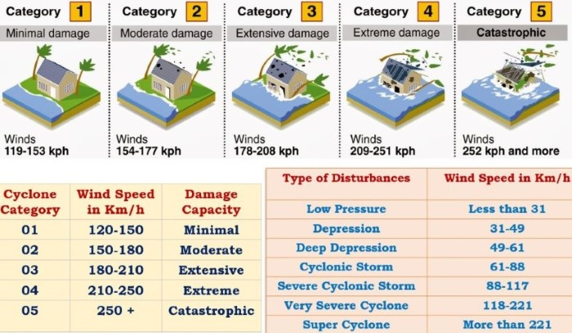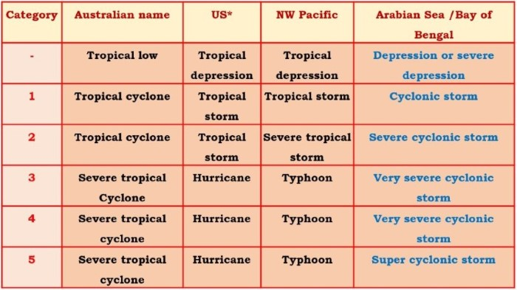

# Favorite Breeding Grounds for Tropical Cyclones

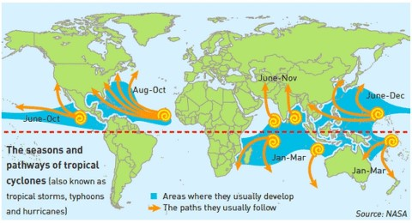

* South-east Caribbean region where they are called hurricanes.
* Philippines islands, eastern China and Japan where they are called typhoons.
* Bay of Bengal and Arabian Sea where they are called cyclones.
* Around south-east African coast and Madagascar-Mauritius islands.
* North-west Australia.

## Regional names for Tropical Cyclones

|  |  |
| --- | --- |
| Regions | What they are called |
| **Indian Ocean** | **Cyclones** |
| **Atlantic** | **Hurricanes** |
| **Western Pacific and South China Sea** | **Typhoons** |
| **Western Australia** | **Willy-willies** |

# Characteristics of Tropical Cyclones

* The main features of tropical cyclones are as follows.

## Size and Shape

* Tropical cyclones have symmetrical **elliptical shapes** (2:3 ratio of length and breadth) with steep pressure gradients. They have a compact size—80 km near center, which may develop up to 300 km to 1500 km.

## Wind Velocity and Strength

* Wind velocity, in a tropical cyclone, is more in poleward margins than at center and is more over oceans than over landmasses, which are scattered with physical barriers. The wind velocity may range from nil to 1200 km per hour.

## Path of Tropical Cyclones

* These cyclones start with a westward movement, but turn northwards around 20° latitude. They turn further north-eastwards around 25° latitude, and then eastwards around 30° latitude. They then lose energy and subside.
* Tropical cyclones follow a **parabolic path**, their axis being parallel to the isobars.
* Coriolis force or earth’s rotation, easterly and westerly winds influence the path of a tropical cyclone.
* Tropical cyclones die at 30° latitude because of cool ocean waters and increasing wind shear due to westerlies.

|  |
| --- |
| Path of Tropical Cyclones a) These cyclones start with a westward movement —- This is because the earth is rotating from west to east and the zone of cyclone formation is under the influence of easterlies. b) but turn northwards around 20° latitude — Coriolis force deflects the path towards right. c) They turn further north-eastwards around 25° latitude — Coriolis force deflects it furthur towards the right. d) and then eastwards around 30° latitude — Because of westerly winds. e) They then lose energy and subside — Ocean water at 30 ° latitude is not warm enough to sustain a cyclone. Also increasing wind shear due to westerlies doesn’t facilitate the formation of cyclonic vortex. |

# Warning of Tropical Cyclones

* Detection of any unusual phenomena in the weather leading to cyclones has three main parameters: **fall in pressure, increase in wind velocity, and the direction and movement (track) of storm.**
* There are a network of weather stations monitoring pressure fall and wind velocities in all countries of the world, including the Arctic and Antarctic regions.
* The islands attain special significance in this as they facilitate monitoring of these developments.
* In India, there are detection radars along both the coasts.
* Monitoring is also done by aircraft which carry a number of instruments including a weather radar.
* Cyclone monitoring by satellites is done through very high resolution radiometers, working in the visual and infra-red regions (for night view) of the spectrum to obtain an image of the cloud cover and its structure.
* Remote sensing by radars, aircraft and satellites helps predict where exactly the cyclone is going to strike. It helps in taking advance steps in the following areas:

1. closing of ports and harbours,
2. suspension of fishing activities,
3. evacuation of population,
4. stocking of food and drinking water, and
5. provision of shelter with sanitation facilities (safety homes).

* Today, it is possible to detect a cyclone right from its genesis in the high seas and follow its course, giving a warning at least 48 hours prior to a cyclone strike.
* However, the predictions of a storm course made only 12 hours in advance do not have a very high rate of precision.