***Name:*** *Mona Muhammad Abdullah*

***ID:*** *4211144*

***Section:*** *B4*

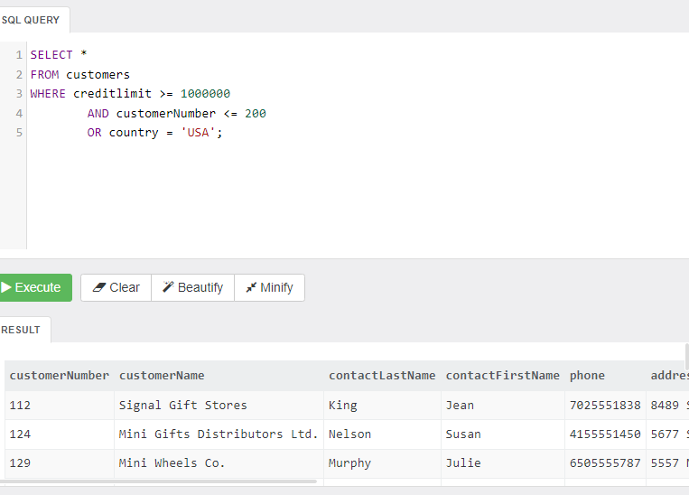

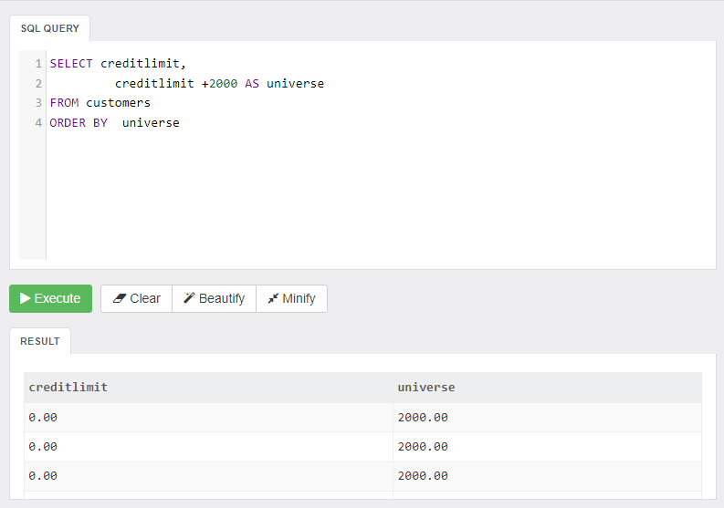

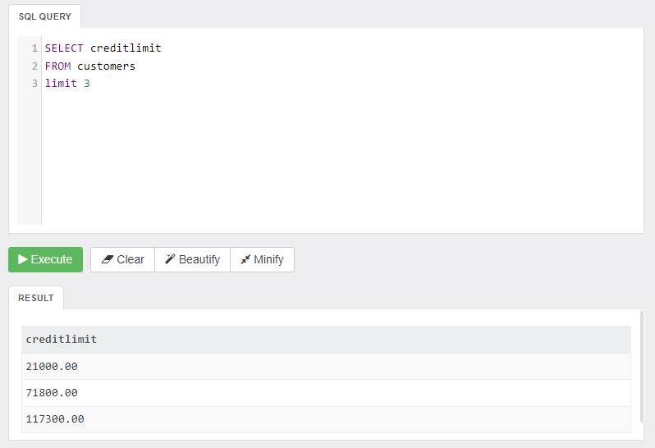

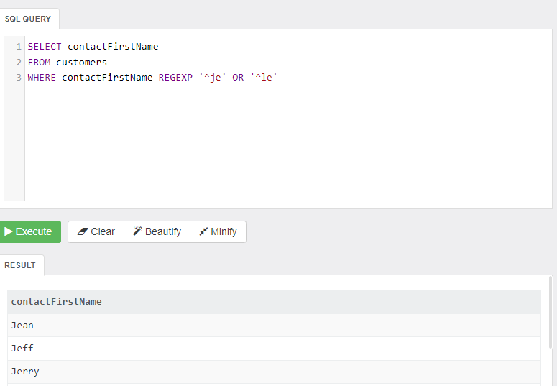

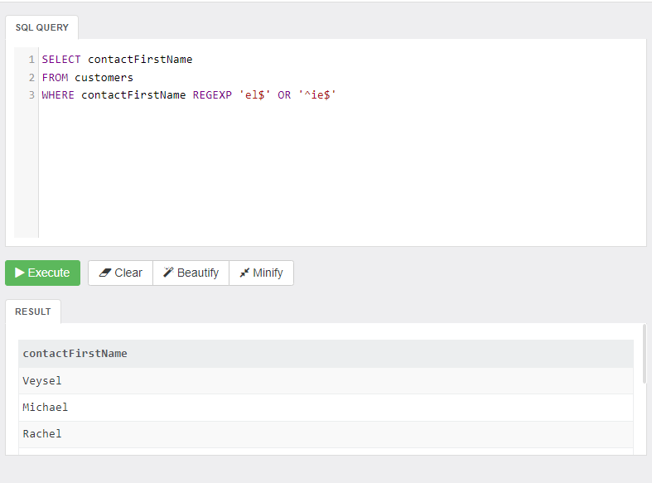

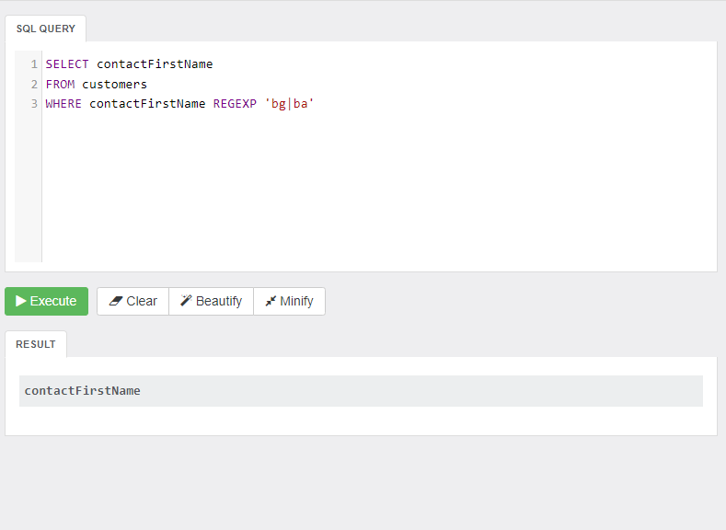

***REGEXP***

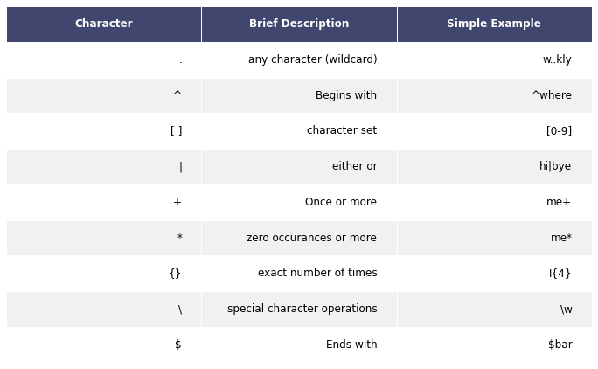

A regular expression (shortened as regex or regexp; also referred to as rational expression is a sequence of characters that specifies a search pattern in text. Usually such patterns are used by string-searching algorithms for "find" or "find and replace" operations on strings, or for input validation. It is a technique developed in theoretical computer science and formal language theory.

Regular expressions are used in [search engines](https://en.wikipedia.org/wiki/Search_engine" \o "Search engine), search and replace dialogs of [word processors](https://en.wikipedia.org/wiki/Word_processor" \o "Word processor) and [text editors](https://en.wikipedia.org/wiki/Text_editor" \o "Text editor), in [text processing](https://en.wikipedia.org/wiki/Text_processing" \o "Text processing) utilities such as [sed](https://en.wikipedia.org/wiki/Sed" \o "Sed) and [AWK](https://en.wikipedia.org/wiki/AWK" \o "AWK) and in [lexical analysis](https://en.wikipedia.org/wiki/Lexical_analysis" \o "Lexical analysis). Many [programming languages](https://en.wikipedia.org/wiki/Programming_language" \o "Programming language) provide regex capabilities either built-in or via [libraries](https://en.wikipedia.org/wiki/Library_(computing)" \o "Library (computing)), as it has uses in many situations.