# Analysis Report for Column C-00 (prophet Model)

Report Generated On: 2025-10-14 12:40

Data Analyzed From: 2025-09-03 to 2025-09-30

## 1. Predictive Maintenance Analysis

This analysis predicts the future trend of a key sensor to forecast potential equipment failure.

Status: No immediate failure predicted within the next 50 days.

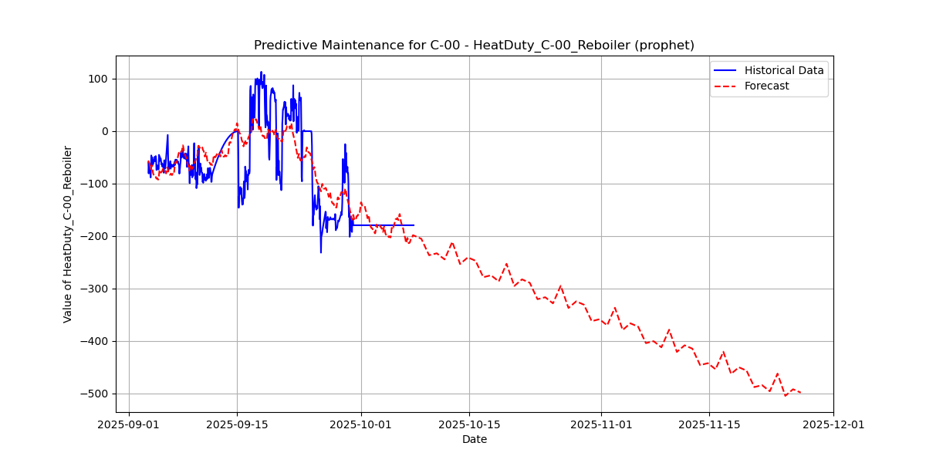

## 2. Real-time Anomaly Detection Analysis

This analysis identifies unusual sensor readings that deviate from normal operating behavior.

Status: ALERT: Anomaly detected in the data stream!

