C-00 Packed Distillation Column Analysis Report

Analysis Period: 2025-09-03 00:00:00 to 2025-09-30 00:00:00

Report Generated: 2025-10-14 13:28:13

# 1. Executive Summary

The column achieved an average moisture removal efficiency of **93.23%**. An overall material balance error of **3.50%** was observed, which is within acceptable limits.

# 2. Key Performance Indicators (KPIs)

All values are averages over the analysis period, with outliers removed for accuracy.

• Average Feed Flow (FT-01): 2285.84 kg/h

• Average Moisture Flow (FT-61): 16.19 kg/h

• Average Bottom Product Flow (FT-62): 2189.60 kg/h

• Overall Material Balance Error (%): 3.50

• Average Differential Pressure: 44.09

• Maximum Differential Pressure: 548.75

• Average Reboiler Heat Duty: N/A (Missing data)

• Average Condenser Heat DUTY: -501902.79

# 3. Performance Analysis

This section correlates key operational factors with column performance.

## 3.1 Moisture Removal

• Average Moisture Content in Feed: 0.20%

• Average Moisture Removal Efficiency: 93.23%

The plot below shows how moisture removal efficiency is correlated with the reboiler heat duty. It helps identify the optimal operating window.

Plot not generated due to missing data.

## 3.2 Factor Correlations

The plots below show the relationships between key performance factors.

The plot below shows how moisture removal efficiency is affected by the feed temperature.

Plot not generated due to missing data.

The plot below shows how moisture removal efficiency is affected by the top product flow.

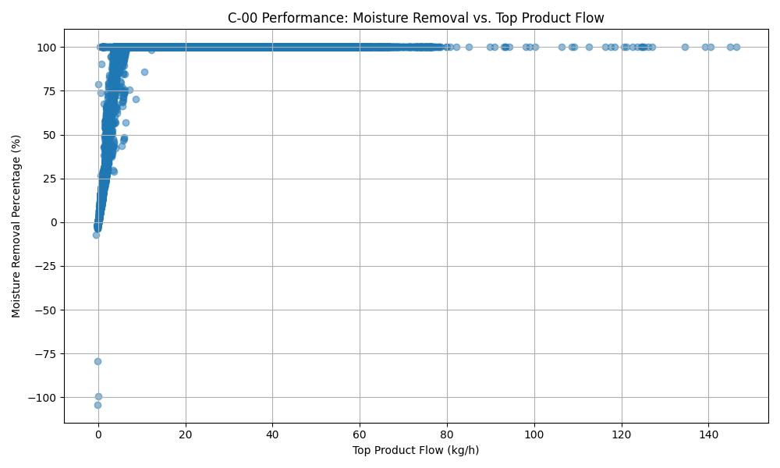

• Moisture Removal vs. Moisture Flow (FT-61) Correlation: 0.34

• DP vs. Feed Flow Correlation: 0.15

## 3.3 Bottom Product Composition

The composition of the bottom product (the feed to C-01) is calculated based on the assumption that non-moisture components are not separated by this column.

Composition data for the bottom product is not available due to missing flow data.

# 4. Performance Plots

## 4.1 Temperature Profile

The temperature profile plot shows the gradient across the column. A consistent gradient indicates stable operation.

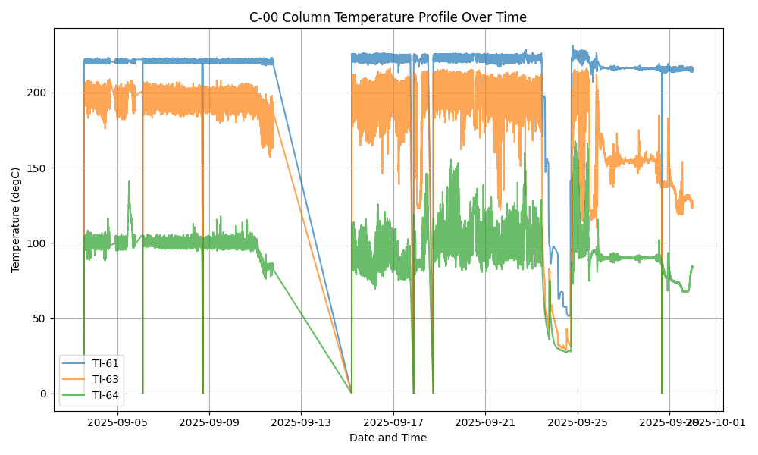

## 4.2 Differential Pressure (DP)

Differential pressure is a key indicator of flooding, foaming, or fouling inside the column.

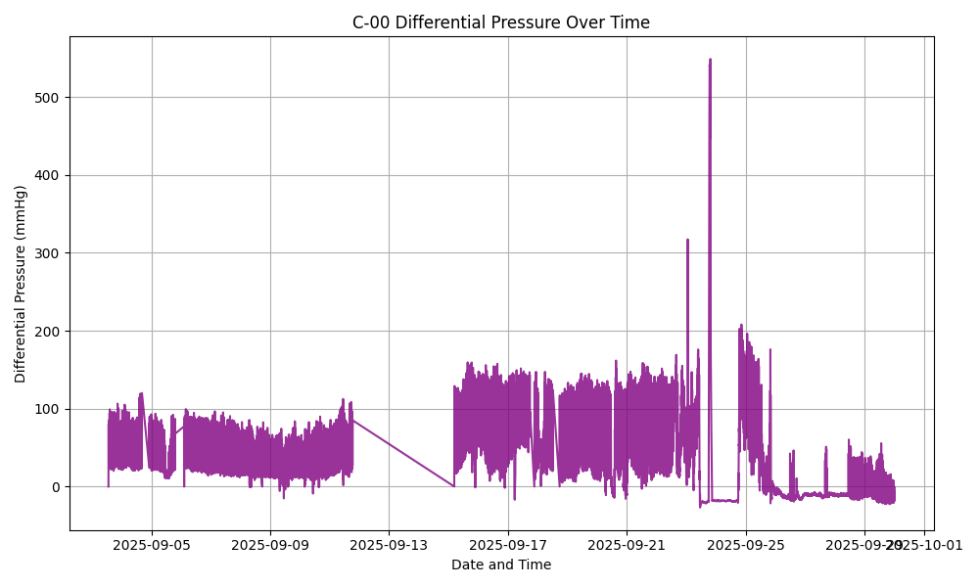

## 4.3 Daily Trends

This plot shows the daily average trends of key variables, helping to visualize long-term shifts in performance.

