C-01 Anthracene Oil Recovery Column Analysis Report

Analysis Period: 2025-09-03 00:00:00 to 2025-09-30 00:00:00

Report Generated: 2025-10-14 13:30:27

# 1. Executive Summary

The column experienced an **average naphthalene loss of 0.40%**. This falls within the acceptable limit of up to 2% and suggests effective operation. The column operated with an average reflux ratio of **1.59**, which is a key factor in achieving the desired separation. A material balance error of **1.31%** was calculated, which is within acceptable limits for typical process data.

# 2. Key Performance Indicators (KPIs)

All values presented are **averages** over the analysis period.

• Average Feed Flow (FT-62): 2189.60 kg/h

• Average Top Product Flow (FT-02): 1748.83 kg/h

• Average Bottom Product Flow (FT-05): 412.09 kg/h

• Material Balance Error (%): 1.31

• Average Naphthalene Loss (%): 0.40

• Average Naphthalene Loss (mass): 8.24

• Average Reflux Ratio: 1.59

• Average Differential Pressure: -7.56

• Maximum Differential Pressure: 25.80

# 3. Performance Analysis & Composition

## 3.1 Naphthalene Loss Analysis

The primary performance goal of this column is to minimize naphthalene loss in the bottom product. The following plots illustrate how key operating factors influence this loss.

### Naphthalene Loss vs. Reboiler Heat Duty

This plot shows how increasing the energy input to the reboiler improves separation, leading to a reduction in naphthalene loss.

Plot not generated due to missing data.

### Naphthalene Loss vs. Reflux Ratio

The reflux ratio directly impacts separation efficiency. A higher reflux ratio generally results in a cleaner separation and less naphthalene lost to the bottom stream.

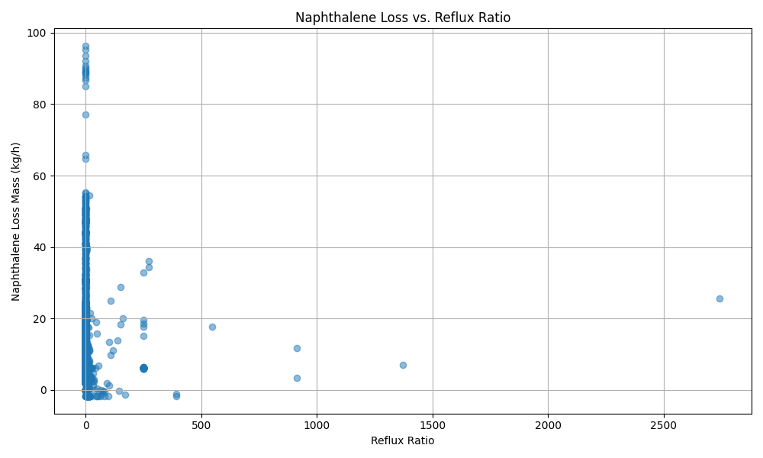

### Naphthalene Loss vs. Column Bottom Temperature

The bottom temperature controls the vaporization of components. A higher temperature favors more naphthalene vaporizing, which should reduce the amount leaving in the bottom product.

Plot not generated due to missing data.

## 3.2 Average Stream Compositions

The following are the average compositions of the key streams during the analysis period.

### Feed (FT-62) Composition

• Naphthalene: 95.00%

• Thianaphthalene: 2.00%

• Quinoline: 1.70%

• Unknown impurity: 1.30%

### Bottom Product (FT-05) Composition

• Naphthalene: 2.00%

• Anthracene oil: 98.00%

# 4. General Performance Plots

## 4.1 Temperature Profile

The temperature profile plot shows the gradient across the column.

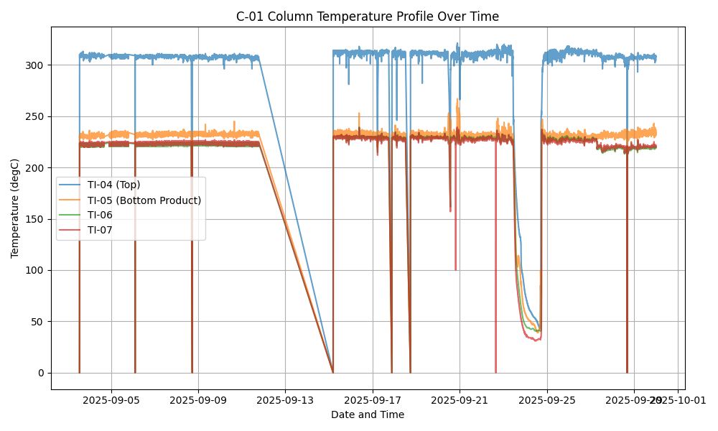

## 4.2 Differential Pressure (DP)

Differential pressure is a key indicator of flooding or fouling.

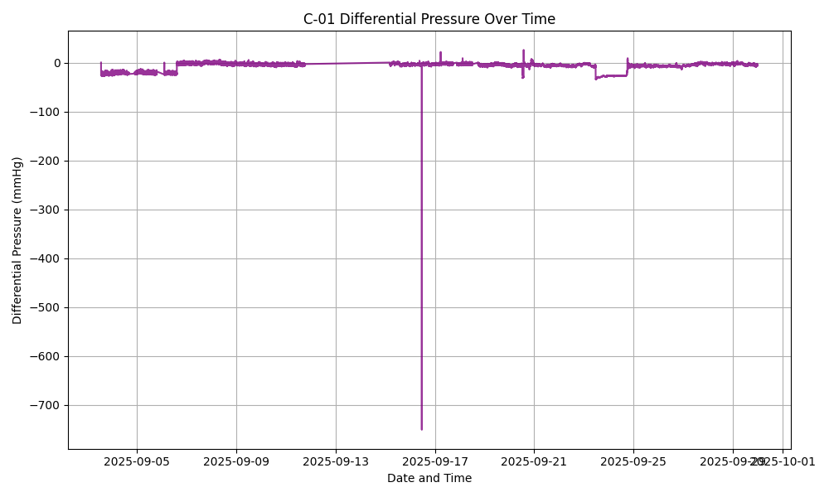

## 4.3 Daily Trends

This plot shows the daily average trends of key variables.

