C-02 Light Oil Recovery Column Analysis Report

Analysis Period: 2025-09-03 00:00:00 to 2025-09-30 00:00:00

Report Generated: 2025-10-15 11:18:49

# 1. Executive Summary

The column operated with an average reflux ratio of 56.93, indicating effective control over product separation. The C-02 column had a material balance error of 94.32%. The naphthalene loss in the C-01 column was calculated to be 3.17%, which is above the acceptable limit. Naphthalene concentration in the C-02 top product was found to be 8.00%.

# 2. Key Performance Indicators (KPIs)

All values are averages over the analysis period.

• Naphthalene Loss in C-01 (%): 3.17

• C-02 Overall Material Balance Error (%): 94.32

• Average Reflux Ratio: 56.93

• Average Differential Pressure: 209.91

• Maximum Differential Pressure: 396.44

• Average Condenser Heat Duty: -4921716.66

• Naphthalene in C-02 Top Product (%): 8.00

# 3. Material Balance Analysis

## 3.1 C-00 and C-01 Material Balance

• C-00 Overall Material Balance Error: 4.50%

• Naphthalene Loss in C-01: 3.17%

- ALERT: Naphthalene loss is above the 2% limit.

## 3.2 C-02 Material Balance

• C-02 Overall Material Balance Error: 94.32%

## 3.3 Component-wise Balance

This section details the material balance for key components across the C-01 and C-02 system.

# 4. Performance Plots

## 4.1 Naphthalene in Top Product vs. Reflux Ratio

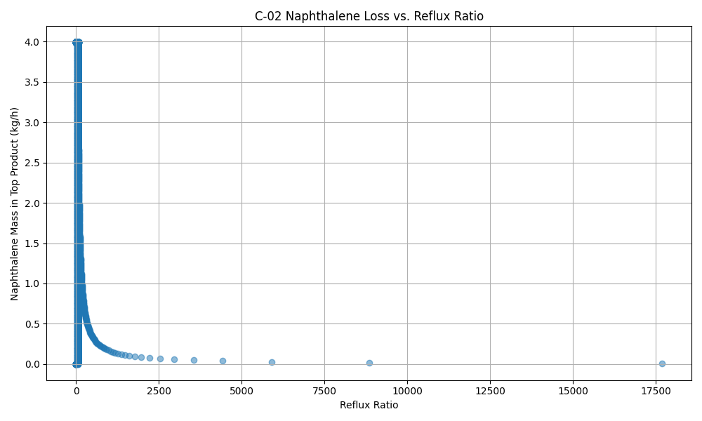

## 4.2 Naphthalene in Top Product vs. Reboiler Temperature

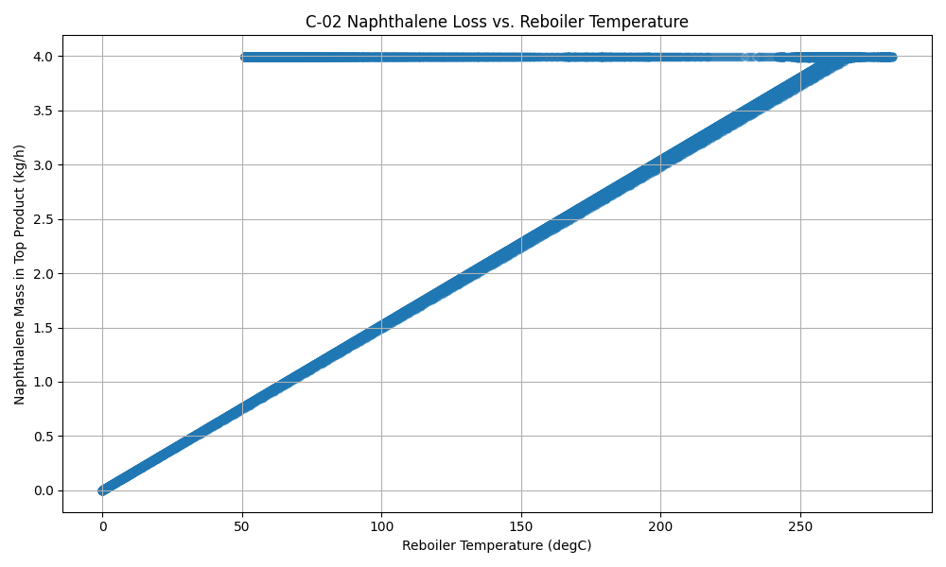

## 4.3 Feed vs. Differential Pressure

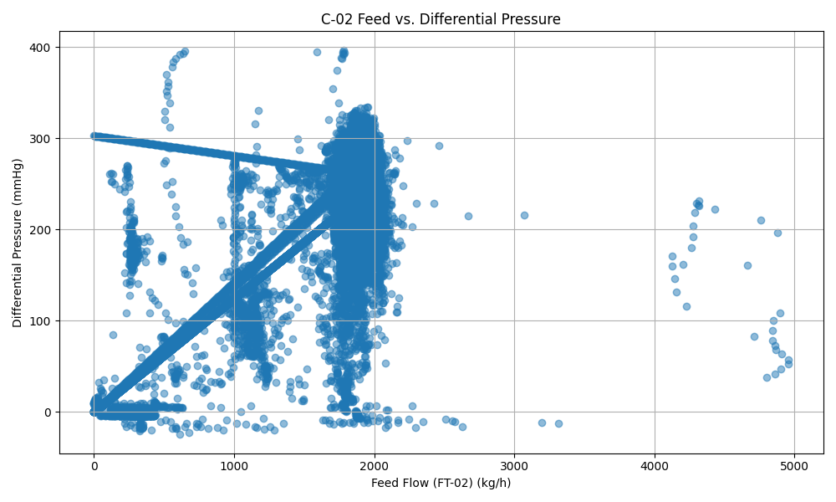

## 4.4 Temperature Profile

The temperature profile plot shows the gradient across the column.

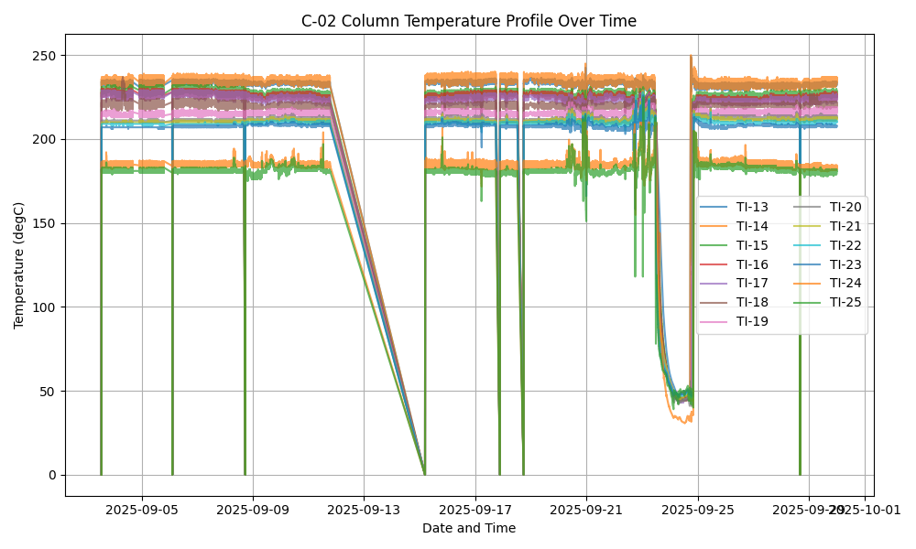

## 4.5 Differential Pressure (DP)

Differential pressure is a key indicator of flooding or fouling.

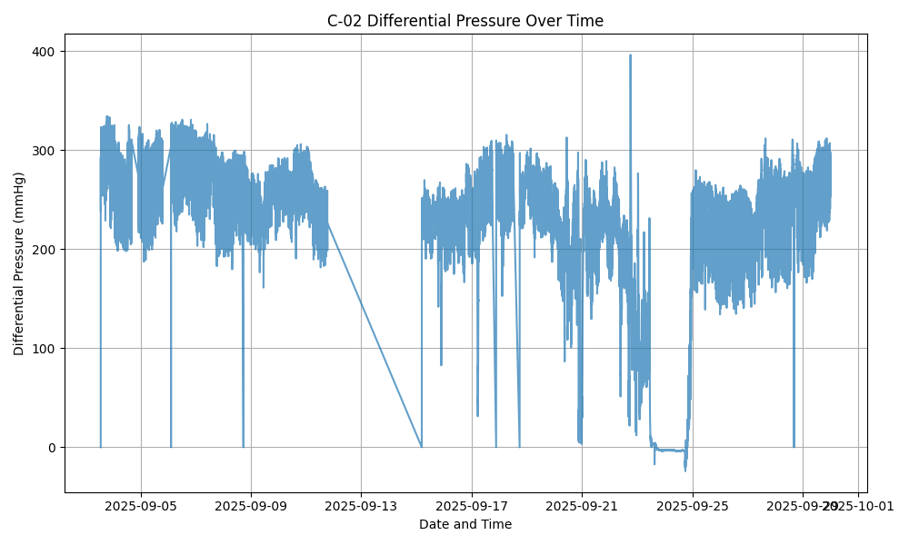

## 4.6 Daily Trends

This plot shows the daily average trends of key variables.

