C-03 Naphthalene Oil Column Analysis Report

Report Generated: 2025-10-15 11:20:52

# 1. Executive Summary

The column operated with an average reflux ratio of 3.57, indicating effective control over product separation. A material balance error of 4007.34% was calculated. ALERT: Naphthalene purity is below target (96%). (Current purity: 87.71%)

# 2. Key Performance Indicators (KPIs)

All values are averages over the analysis period.

• Average Feed Flow (FT-06): 49.90 kg/h

• Average Top Product Flow (FT-04): 1308.41 kg/h

• Average Bottom Product Flow (FT-07): 741.19 kg/h

• Material Balance Error (%): 4007.34

• Average Reflux Ratio: 3.57

• Average Differential Pressure: 217.99

• Maximum Differential Pressure: 217.99

• Average Reboiler Heat Duty: N/A (Missing data)

• Average Condenser Heat Duty: N/A (Missing data)

# 3. Composition Analysis

## 3.1 Naphthalene Purity

• Naphthalene Purity Status: ALERT: Naphthalene purity is below target (96%).

• Naphthalene in Top Product (FT-04): 87.71%

• Naphthalene in Bottom Product (FT-07): 1.25%

• Naphthalene Loss in C-03 Bottoms: 34.76%

## 3.2 Impurity Analysis

• Thianaphthalene in Top Product: 4.37%

• Quinoline in Top Product: 23446.00 ppm

• Unknown Impurities in Top Product: 0.75%

# 4. Performance Plots

## 4.1 Temperature Profile

The temperature profile plot shows the gradient across the column.

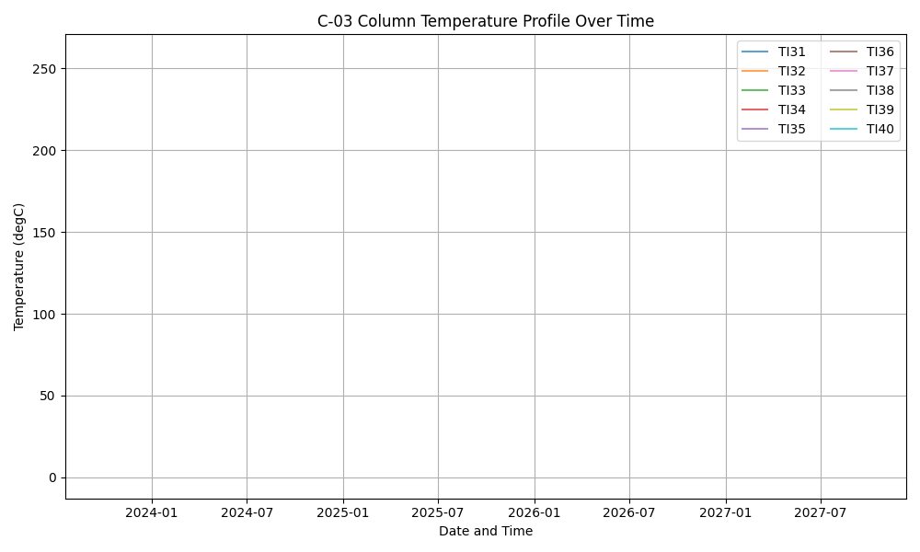

## 4.2 Differential Pressure (DP)

Differential pressure is a key indicator of flooding or fouling.

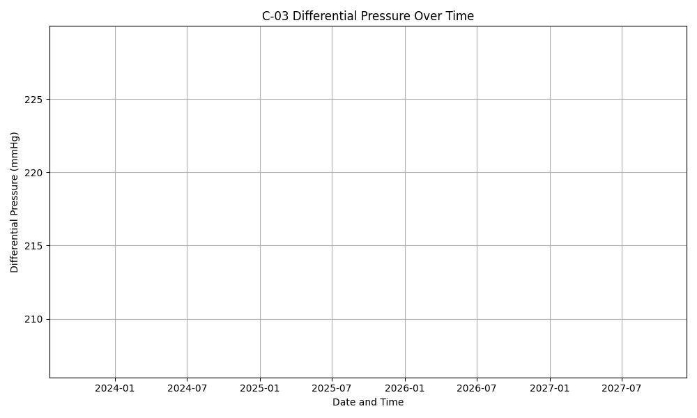

## 4.3 Daily Trends

This plot shows the daily average trends of key variables.

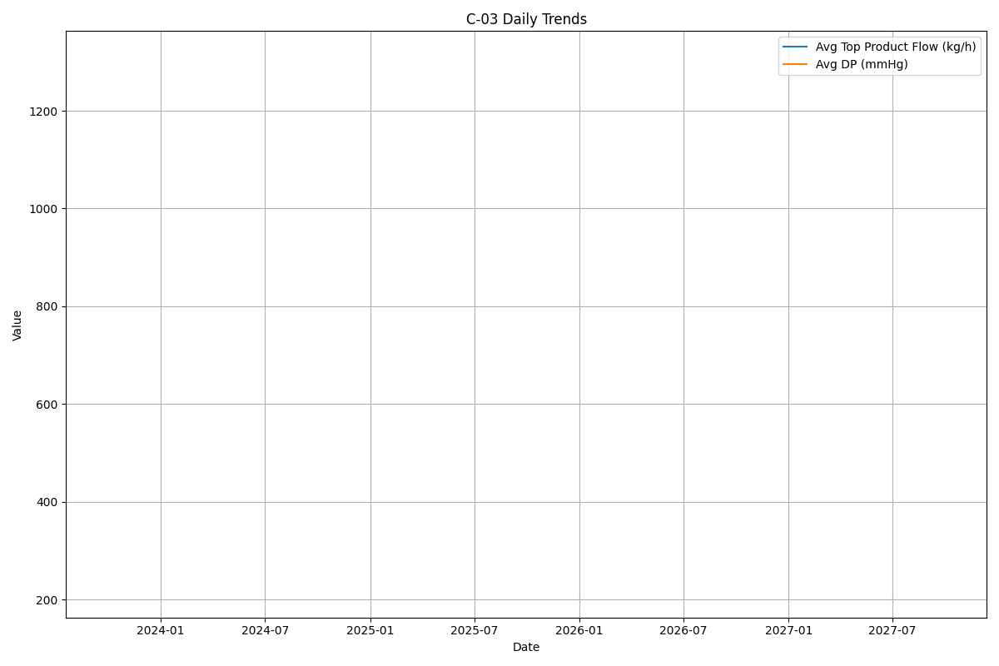

## 4.4 Naphthalene Purity vs. Reflux Ratio

This plot shows how product purity is affected by the reflux ratio.

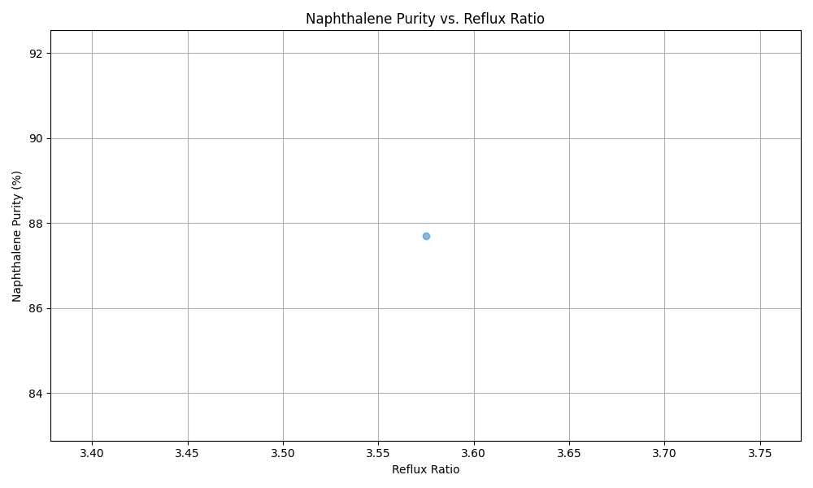

## 4.5 Naphthalene Purity vs. Differential Pressure

This plot illustrates the relationship between product purity and column stability.

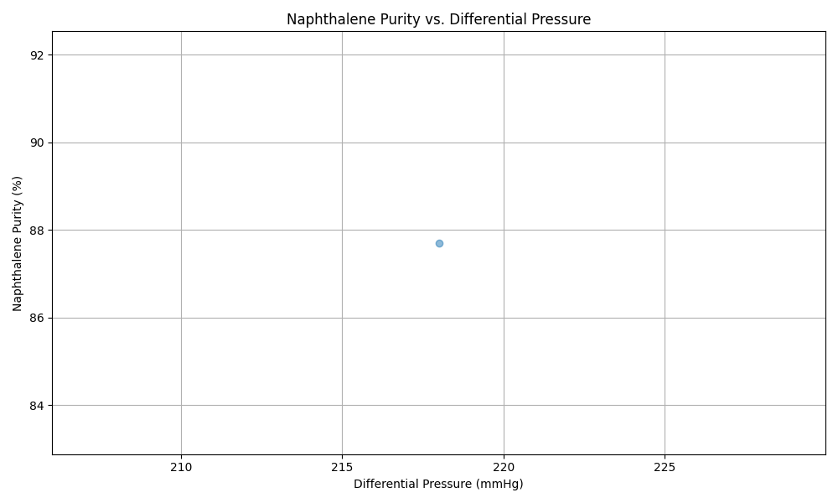

## 4.6 Reboiler Heat Duty vs. Reflux Ratio

This plot visualizes the energy consumption cost for different reflux ratios.