Energy Consumption Forecast Report

Report Generated On: 2025-10-13 20:03:32

Analysis Period: 2025-09-03 to 2025-09-30

# 1. Executive Summary

This report presents a forecast of future energy flow using a time-series model. The forecast is based on historical data patterns and key operational variables.

# 2. Model and Forecast Details

The forecast was generated using a **SARIMAX** model, which accounts for external factors.

The model's AIC (Akaike Information Criterion) is: **-755.38**

Model validation was performed on a test set, yielding an RMSE of: **63.91** kWh.

# 3. Key Forecasts (Next 5 Days)

The table below shows the key forecast values:

|  |  |
| --- | --- |
| Date | Forecasted Energy (kWh) |
| 2025-09-30 01:00 | -1512.94 |
| 2025-09-30 02:00 | -1530.21 |
| 2025-09-30 03:00 | -1480.48 |
| 2025-09-30 04:00 | -1491.69 |
| 2025-09-30 05:00 | -1508.22 |
| 2025-09-30 06:00 | -1504.53 |
| 2025-09-30 07:00 | -1518.77 |
| 2025-09-30 08:00 | -1500.29 |
| 2025-09-30 09:00 | -1494.18 |
| 2025-09-30 10:00 | -1498.04 |
| 2025-09-30 11:00 | -1517.65 |
| 2025-09-30 12:00 | -1516.36 |
| 2025-09-30 13:00 | -1503.75 |
| 2025-09-30 14:00 | -1495.26 |
| 2025-09-30 15:00 | -1546.40 |
| 2025-09-30 16:00 | -1542.25 |
| 2025-09-30 17:00 | -1541.14 |
| 2025-09-30 18:00 | -1531.45 |
| 2025-09-30 19:00 | -1571.68 |
| 2025-09-30 20:00 | -1562.90 |
| 2025-09-30 21:00 | -1564.37 |
| 2025-09-30 22:00 | -1521.99 |
| 2025-09-30 23:00 | -1560.72 |
| 2025-10-01 00:00 | -1563.99 |
| 2025-10-01 01:00 | -1566.34 |
| 2025-10-01 02:00 | -1543.05 |
| 2025-10-01 03:00 | -1493.78 |
| 2025-10-01 04:00 | -1492.81 |
| 2025-10-01 05:00 | -1485.63 |
| 2025-10-01 06:00 | -1503.72 |
| 2025-10-01 07:00 | -1526.01 |
| 2025-10-01 08:00 | -1502.54 |
| 2025-10-01 09:00 | -1518.37 |
| 2025-10-01 10:00 | -1543.18 |
| 2025-10-01 11:00 | -1559.33 |
| 2025-10-01 12:00 | -1555.20 |
| 2025-10-01 13:00 | -1543.13 |
| 2025-10-01 14:00 | -1529.71 |
| 2025-10-01 15:00 | -1562.07 |
| 2025-10-01 16:00 | -1554.32 |
| 2025-10-01 17:00 | -1560.00 |
| 2025-10-01 18:00 | -1545.97 |
| 2025-10-01 19:00 | -1586.40 |
| 2025-10-01 20:00 | -1568.11 |
| 2025-10-01 21:00 | -1581.69 |
| 2025-10-01 22:00 | -1541.94 |
| 2025-10-01 23:00 | -1571.82 |
| 2025-10-02 00:00 | -1589.51 |
| 2025-10-02 01:00 | -1589.38 |
| 2025-10-02 02:00 | -1590.71 |
| 2025-10-02 03:00 | -1516.19 |
| 2025-10-02 04:00 | -1521.16 |
| 2025-10-02 05:00 | -1525.68 |
| 2025-10-02 06:00 | -1523.15 |
| 2025-10-02 07:00 | -1534.42 |
| 2025-10-02 08:00 | -1511.02 |
| 2025-10-02 09:00 | -1518.68 |
| 2025-10-02 10:00 | -1545.10 |
| 2025-10-02 11:00 | -1556.72 |
| 2025-10-02 12:00 | -1563.00 |
| 2025-10-02 13:00 | -1544.37 |
| 2025-10-02 14:00 | -1533.20 |
| 2025-10-02 15:00 | -1566.79 |
| 2025-10-02 16:00 | -1563.37 |
| 2025-10-02 17:00 | -1557.81 |
| 2025-10-02 18:00 | -1547.82 |
| 2025-10-02 19:00 | -1576.15 |
| 2025-10-02 20:00 | -1565.77 |
| 2025-10-02 21:00 | -1569.44 |
| 2025-10-02 22:00 | -1536.00 |
| 2025-10-02 23:00 | -1569.36 |
| 2025-10-03 00:00 | -1577.38 |
| 2025-10-03 01:00 | -1579.09 |
| 2025-10-03 02:00 | -1589.01 |
| 2025-10-03 03:00 | -1514.54 |
| 2025-10-03 04:00 | -1522.09 |
| 2025-10-03 05:00 | -1531.65 |
| 2025-10-03 06:00 | -1524.54 |
| 2025-10-03 07:00 | -1534.14 |
| 2025-10-03 08:00 | -1511.79 |
| 2025-10-03 09:00 | -1514.76 |
| 2025-10-03 10:00 | -1536.64 |
| 2025-10-03 11:00 | -1549.03 |
| 2025-10-03 12:00 | -1555.84 |
| 2025-10-03 13:00 | -1537.14 |
| 2025-10-03 14:00 | -1527.02 |
| 2025-10-03 15:00 | -1564.65 |
| 2025-10-03 16:00 | -1561.98 |
| 2025-10-03 17:00 | -1555.02 |
| 2025-10-03 18:00 | -1545.94 |
| 2025-10-03 19:00 | -1574.31 |
| 2025-10-03 20:00 | -1565.93 |
| 2025-10-03 21:00 | -1567.04 |
| 2025-10-03 22:00 | -1532.99 |
| 2025-10-03 23:00 | -1568.24 |
| 2025-10-04 00:00 | -1573.20 |
| 2025-10-04 01:00 | -1575.44 |
| 2025-10-04 02:00 | -1579.97 |
| 2025-10-04 03:00 | -1510.96 |
| 2025-10-04 04:00 | -1517.21 |
| 2025-10-04 05:00 | -1524.20 |
| 2025-10-04 06:00 | -1521.58 |
| 2025-10-04 07:00 | -1533.57 |
| 2025-10-04 08:00 | -1511.21 |
| 2025-10-04 09:00 | -1515.97 |
| 2025-10-04 10:00 | -1537.53 |
| 2025-10-04 11:00 | -1550.89 |
| 2025-10-04 12:00 | -1555.46 |
| 2025-10-04 13:00 | -1538.17 |
| 2025-10-04 14:00 | -1527.55 |
| 2025-10-04 15:00 | -1564.90 |
| 2025-10-04 16:00 | -1561.28 |
| 2025-10-04 17:00 | -1556.76 |
| 2025-10-04 18:00 | -1546.80 |
| 2025-10-04 19:00 | -1577.79 |
| 2025-10-04 20:00 | -1567.68 |
| 2025-10-04 21:00 | -1570.95 |
| 2025-10-04 22:00 | -1535.55 |
| 2025-10-04 23:00 | -1570.03 |
| 2025-10-05 00:00 | -1577.10 |

# 4. Visual Analysis

The chart below shows the historical energy flow and the future forecast.

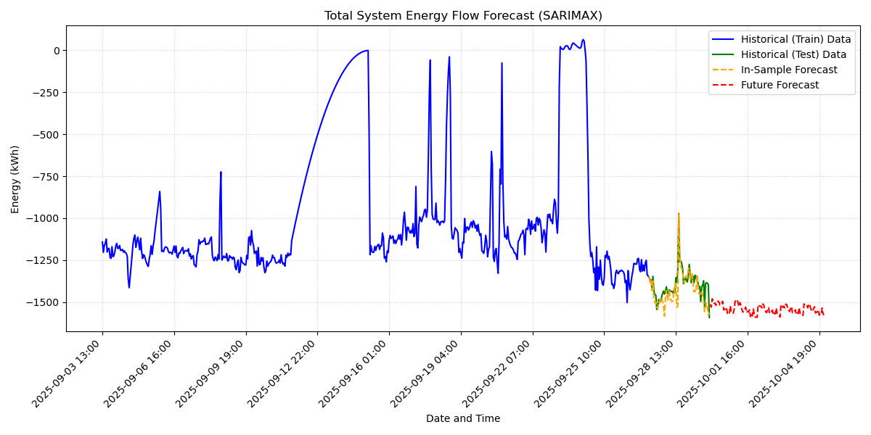

# 5. Proactive Recommendation

The forecast indicates the system is generating energy. Continue monitoring the process, but no immediate action is required based on the forecast.