**SQL Capstone Project**

**1. Understanding the Data**

The dataset consists of 17 columns with a focus on sales transactions. Key columns include:

* branch, city → Geographic data
* product_line, unit_price, quantity, total, VAT, gross_income → Sales and revenue data
* customer_type, gender → Customer demographic information
* date, time → Temporal data for sales trends
* rating → Customer satisfaction measure

**2. Goals and Objectives**

The primary objectives are:

* Product Analysis
* Sales Analysis
* Customer Analysis

**3. Steps to Implement the Project**

**Step 1: Data Wrangling**

1. **Create a Database and Table:**

CREATE DATABASE amazon;

CREATE TABLE amazon_sales (

invoice_id VARCHAR(30) NOT NULL,

branch VARCHAR(5) NOT NULL,

city VARCHAR(30) NOT NULL,

customer_type VARCHAR(30) NOT NULL,

gender VARCHAR(10) NOT NULL,

product_line VARCHAR(100) NOT NULL,

unit_price DECIMAL(10,2) NOT NULL,

quantity INT NOT NULL,

VAT FLOAT(6,4) NOT NULL,

total DECIMAL(10,2) NOT NULL,

date DATE NOT NULL,

time TIME NOT NULL,

payment_method VARCHAR(30) NOT NULL,

cogs DECIMAL(10,2) NOT NULL,

gross_margin_percentage FLOAT(11,9) NOT NULL,

gross_income DECIMAL(10,2) NOT NULL,

rating FLOAT(3,1) NOT NULL

);

1. **Insert Data**
2. **Check for NULL Values:**

SELECT column_name

FROM information_schema.columns

WHERE table_name = 'amazon_sales' AND is_nullable = 'YES';

**Step 2: Feature Engineering**

1. **Add a new column named month_name**

ALTER TABLE amazon_sales

ADD COLUMN month_name VARCHAR(20);

UPDATE amazon_sales SET month_name = MONTHNAME(date);

1. **Add a new column named time_of_day (Extract the part of the day: Morning, Afternoon, or Evening.)**

ALTER TABLE amazon_sales

ADD COLUMN time_of_day VARCHAR(20);

UPDATE amazon_sales

SET time_of_day = CASE

WHEN EXTRACT(HOUR FROM time) BETWEEN 6 AND 11 THEN 'Morning'

WHEN EXTRACT(HOUR FROM time) BETWEEN 12 AND 17 THEN 'Afternoon'

WHEN EXTRACT(HOUR FROM time) BETWEEN 18 AND 23 THEN 'Evening'

ELSE 'Night'

END;

1. **Add a new column named  day_name (Extract the day of the week.)**

ALTER TABLE amazon_sales

ADD COLUMN day_name VARCHAR(10);

UPDATE amazon_sales

SET day_name = DAYNAME(date);

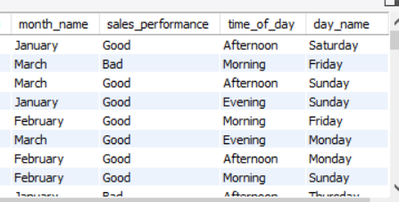

**Step 3: Exploratory Data Analysis (EDA)**

**Business Questions & Queries:**

1. **What is the count of distinct cities in the dataset?**

SELECT COUNT(DISTINCT city) AS City_Count

FROM amazon_sales;

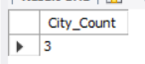

1. **For each branch, what is the corresponding city?**

SELECT branch, city

FROM amazon_sales

GROUP BY branch, city;

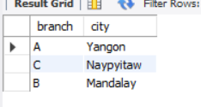

1. **What is the count of distinct product lines in the dataset?**

SELECT COUNT(DISTINCT product_line) AS No_Of_ProductLine

FROM amazon_sales;



1. **Which payment method occurs most frequently?**

SELECT payment_method, COUNT(payment_method) AS frequency

FROM amazon_sales

GROUP BY payment_method

ORDER BY frequency DESC

LIMIT 1;

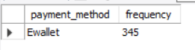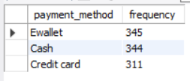

1. **Which product line has the highest sales?**

SELECT product_line, SUM(quantity) AS total_sales

FROM amazon_sales

GROUP BY product_line

ORDER BY total_sales DESC

LIMIT 1;

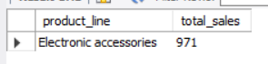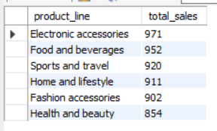

1. **How much revenue is generated each month?**

SELECT month_name, SUM(total) AS total_revenue

FROM amazon_sales

GROUP BY month_name

ORDER BY total_revenue DESC

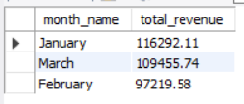

1. **In which month did the cost of goods sell reach its peak?**

SELECT month_name, SUM(cogs) AS total_cogs

FROM amazon_sales

GROUP BY month_name

ORDER BY total_cogs DESC

LIMIT 1;

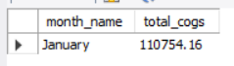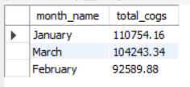

1. **Which product line generated the highest revenue?**

SELECT product_line, SUM(total) AS total_revenue

FROM amazon_sales

GROUP BY product_line

ORDER BY total_revenue DESC

LIMIT 1;

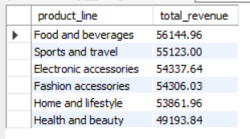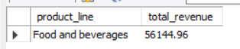

1. **In which city was, the highest revenue recorded?**

SELECT city, SUM(total) AS total_revenue

FROM amazon_sales

GROUP BY city

ORDER BY total_revenue DESC

LIMIT 1;

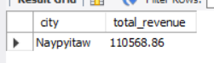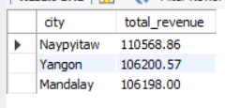

1. **Which product line incurred the highest Value Added Tax?**

SELECT product_line, SUM(VAT) AS total_VAT

FROM amazon_sales

GROUP BY product_line

ORDER BY total_VAT DESC

LIMIT 1;

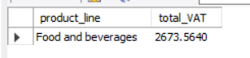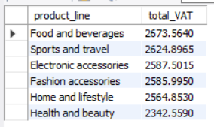

1. **For each product line, add a column indicating "Good" if its sales are above average, otherwise "Bad."**

ALTER TABLE amazon_sales

ADD COLUMN sales_performance VARCHAR(10);

CREATE TEMPORARY TABLE temp_avg_total AS

SELECT AVG(total) AS avg_total

FROM amazon_sales;

UPDATE amazon_sales

SET sales_performance = CASE

WHEN total > (SELECT avg_total FROM temp_avg_total) THEN 'Good'

ELSE 'Bad'

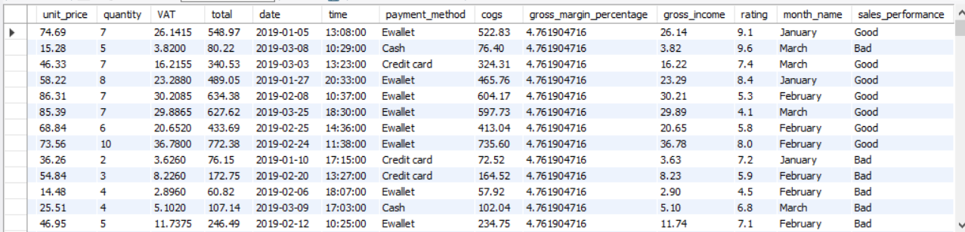END;

1. **Identify the branch that exceeded the average number of products sold.**

SELECT branch , SUM(quantity) AS total_products

FROM amazon_sales

GROUP BY branch

HAVING SUM(quantity) > (SELECT AVG(quantity) FROM amazon_sales);

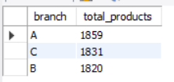

1. **Which product line is most frequently associated with each gender?**

SELECT gender, product_line, COUNT(*) AS frequency

FROM amazon_sales

GROUP BY gender, product_line

ORDER BY gender, frequency DESC;

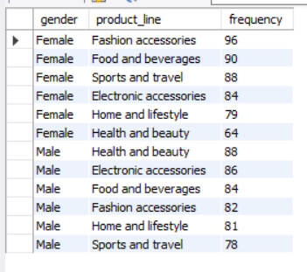

1. **Calculate the average rating for each product line.**

SELECT product_line, ROUND(AVG(rating),2) AS avg_rating

FROM amazon_sales

GROUP BY product_line

ORDER BY avg_rating DESC

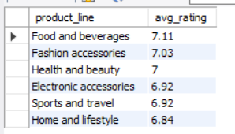

1. **Count the sales occurrences for each time of day on every weekday.**

SELECT day_name, time_of_day, COUNT(*) AS sales_count

FROM amazon_sales

GROUP BY day_name, time_of_day

ORDER BY day_name, time_of_day;

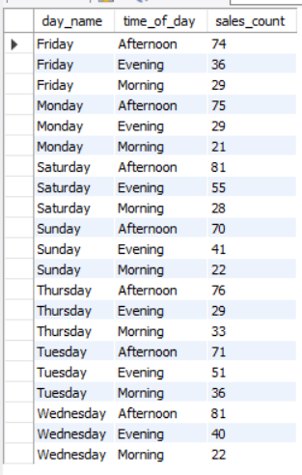

1. **Identify the customer type contributing the highest revenue.**

SELECT customer_type , SUM(total) AS total_revenue

FROM amazon_sales

GROUP BY customer_type

ORDER BY total_revenue DESC

LIMIT 1;

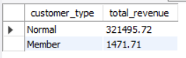

1. **Determine the city with the highest VAT percentage.**

SELECT city, ROUND(AVG(VAT), 4) AS average_VAT

FROM amazon_sales

GROUP BY city

ORDER BY average_VAT DESC

LIMIT 1;

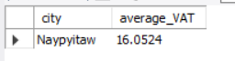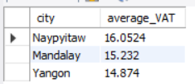

1. **Identify the customer type with the highest VAT payments.**

SELECT customer_type, SUM(VAT) AS total_VAT

FROM amazon_sales

GROUP BY customer_type

ORDER BY total_VAT DESC

LIMIT 1;

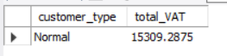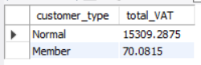

1. **What is the count of distinct customer types in the dataset?**

SELECT COUNT(DISTINCT customer_type) AS distinct_customer_types

FROM amazon_sales;

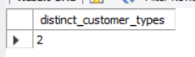

1. **What is the count of distinct payment methods in the dataset?**

SELECT COUNT(DISTINCT payment_method) AS distinct_payment_method

FROM amazon_sales;

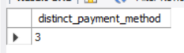

1. **Which customer type occurs most frequently?**

SELECT customer_type, COUNT(*) AS frequency

FROM amazon_sales

GROUP BY customer_type

ORDER BY frequency DESC

LIMIT 1;

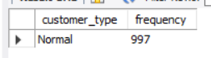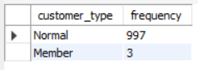

1. **Identify the customer type with the highest purchase frequency.**

SELECT customer_type, COUNT(*) AS purchase_count

FROM amazon_sales

GROUP BY customer_type

ORDER BY purchase_count DESC

LIMIT 1;

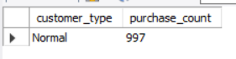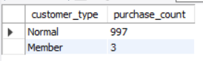

1. **Determine the predominant gender among customers.**

SELECT gender, COUNT(*) AS gender_count

FROM amazon_sales

GROUP BY gender

ORDER BY gender_count DESC

LIMIT 1;

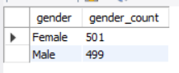

1. **Examine the distribution of genders within each branch.**

SELECT branch, gender, COUNT(*) AS gender_count

FROM amazon_sales

GROUP BY branch, gender

ORDER BY branch, gender_count DESC;

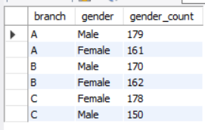

1. **Identify the time of day when customers provide the most ratings.**

SELECT time_of_day, COUNT(rating) AS rating_count

FROM amazon_sales

GROUP BY time_of_day

ORDER BY rating_count DESC;

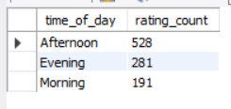

1. **Determine the time of day with the highest customer ratings for each branch.**

SELECT branch, time_of_day, ROUND(AVG(rating), 2) AS avg_rating

FROM amazon_sales

GROUP BY branch, time_of_day

ORDER BY branch, avg_rating DESC;

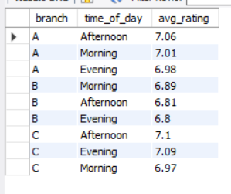

1. **Identify the day of the week with the highest average ratings.**

SELECT day_name, ROUND(AVG(rating), 2) AS avg_rating

FROM amazon_sales

GROUP BY day_name

ORDER BY avg_rating DESC

LIMIT 1;

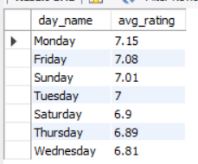

1. **Determine the day of the week with the highest average ratings for each branch.**

SELECT branch, day_name, ROUND(AVG(rating), 2) AS avg_rating

FROM amazon_sales

GROUP BY branch, day_name

ORDER BY branch, avg_rating DESC;

