
Gym Managemet
Implementation Tasks

Eng. Ahmed emam
Prepared by

Task 2 — Define Domain Layer (Entities + BaseEntity + Enums)
Create the core business model of the Gym Management System:
- Base entity
- Enums
- Domain entities
- Navigation properties
- Zero infrastructure or EF Core concerns
This layer must be:
- Pure C#
- Free of EF Core attributes
- Free of validation, logging, or Identity

📁 Folder Structure (Gym.Domain)
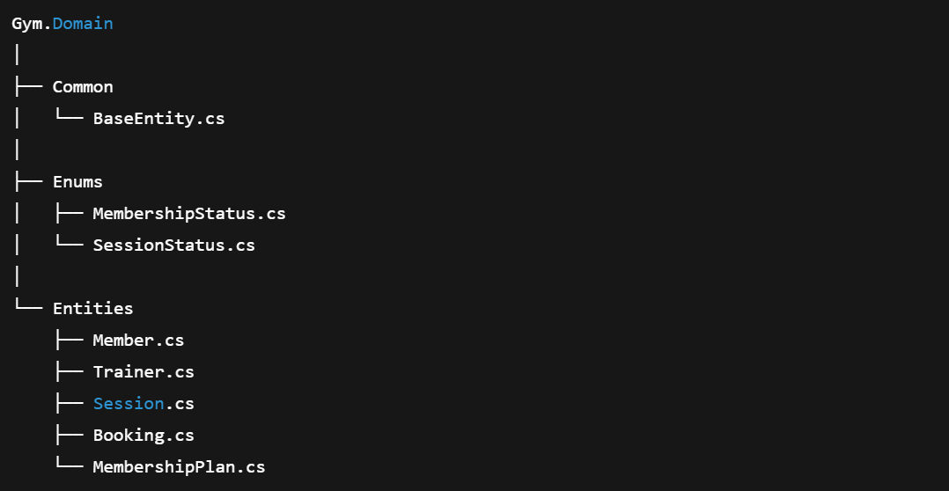

1️⃣ BaseEntity
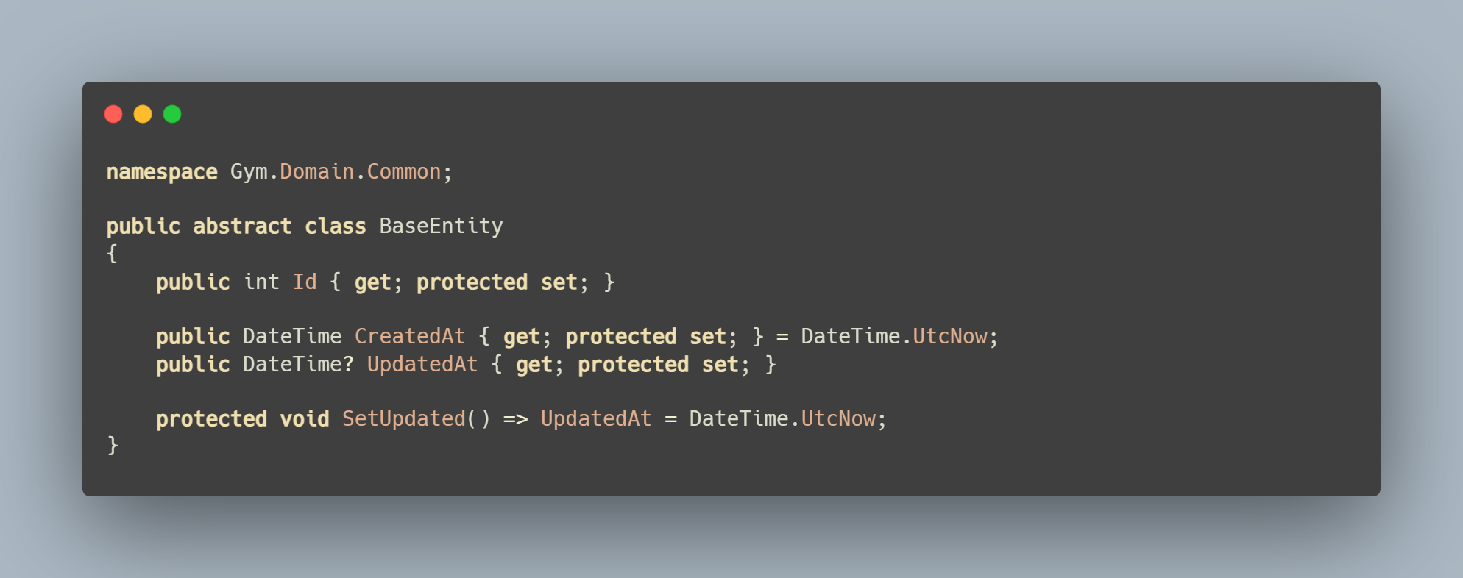

2️⃣ MembershipPlan
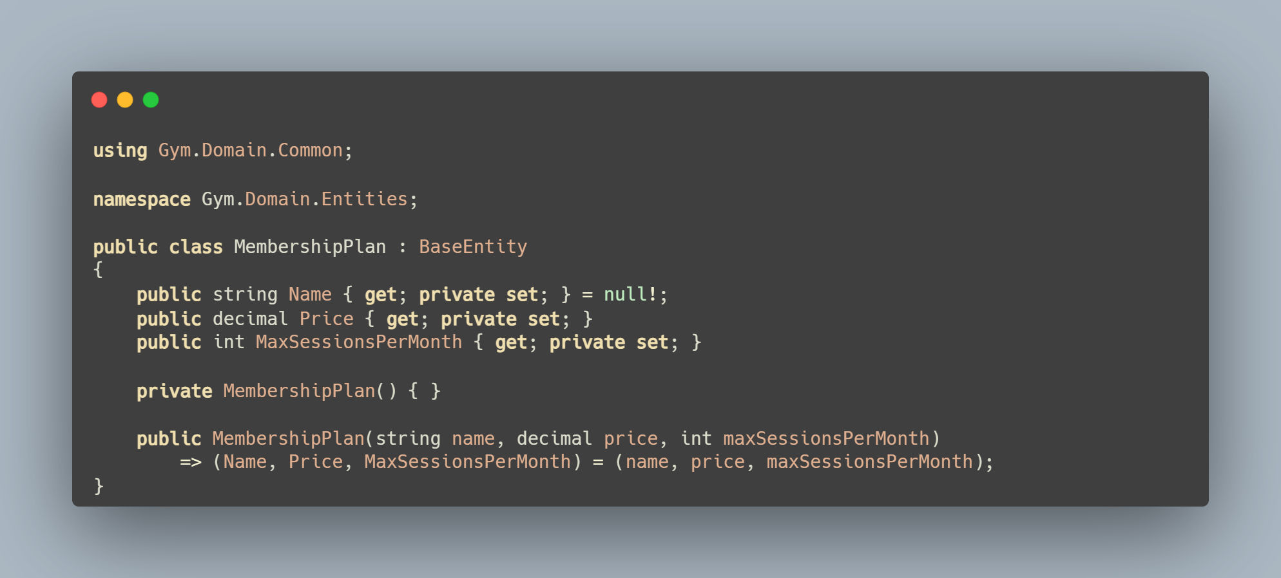

3️⃣ Trainer
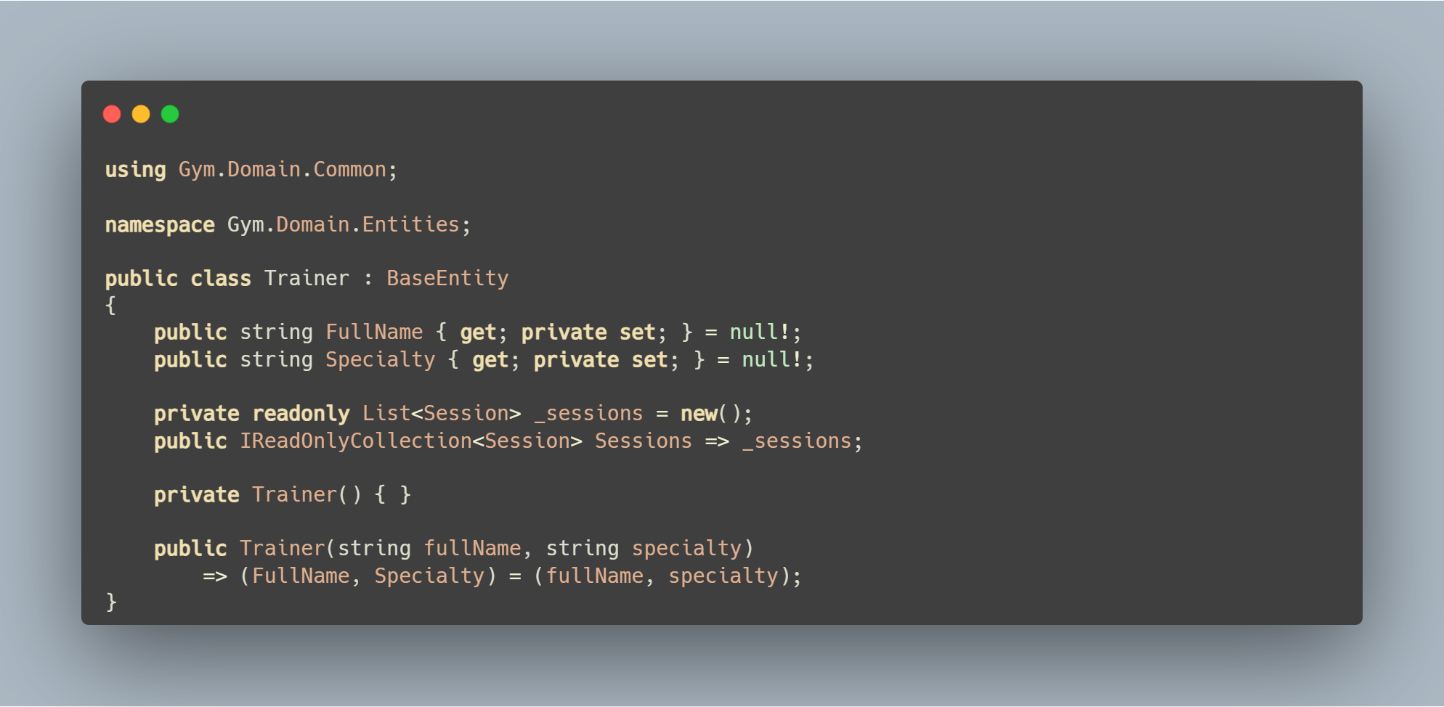

4️⃣ Member
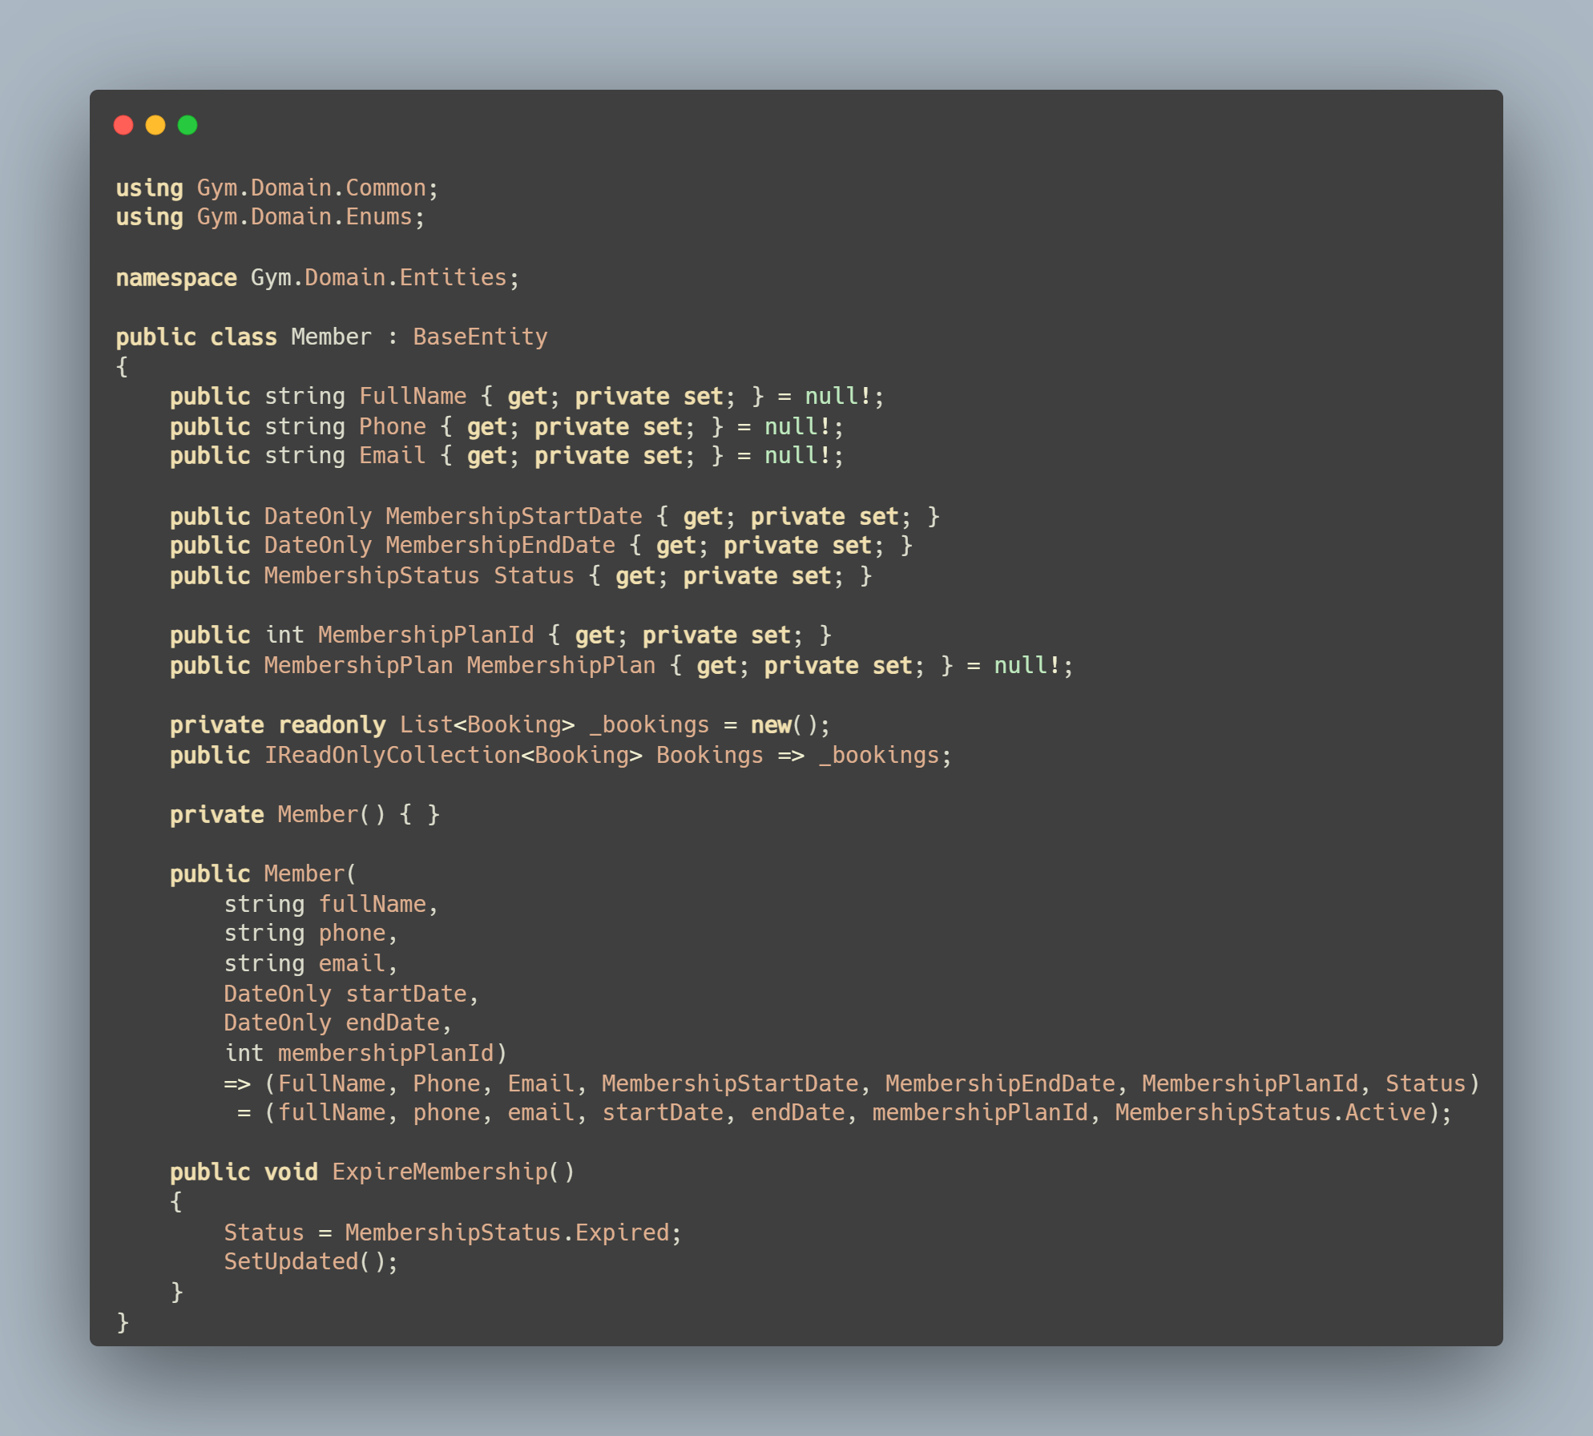
5️⃣ Session
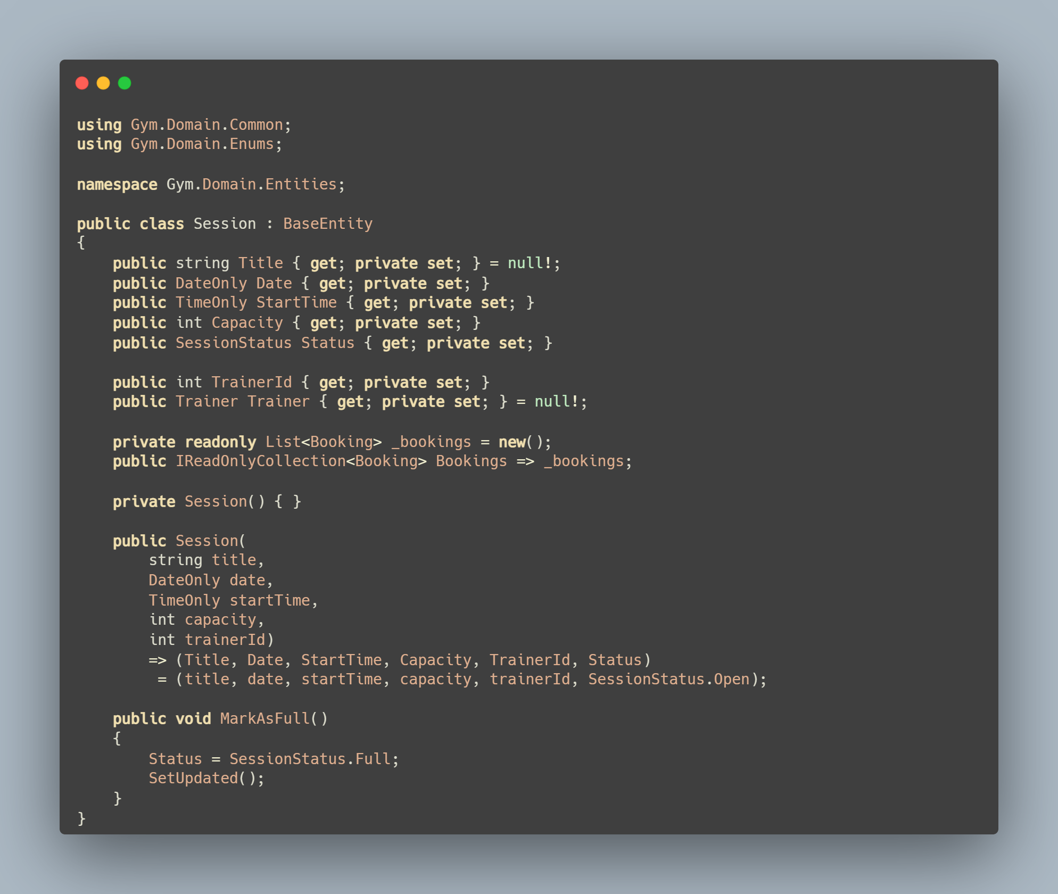
6️⃣ Booking
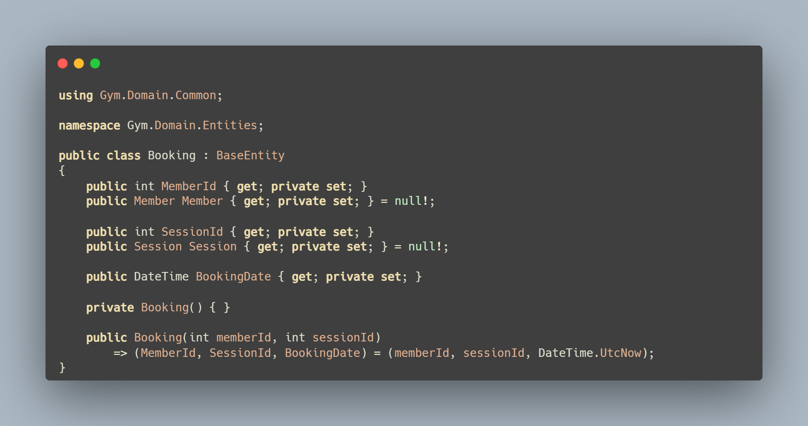

7️⃣ Enums
📄 Enums/MembershipStatus.cs
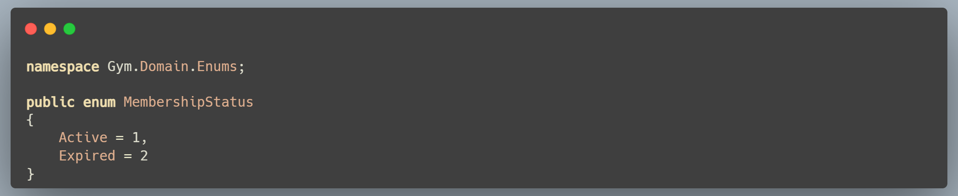

📄 Enums/SessionStatus.cs
