
Gym Managemet
Implementation Tasks

Eng. Ahmed emam
Prepared by

Task 3 — DbContext + Fluent API Configuration, at the end of this task you will have:
- A working GymDbContext
- Explicit Fluent API mappings for all entities
- Proper SQL Server mapping for DateOnly / TimeOnly
- Clear relationships, keys, and constraints
- Ready-for-migration model

📁 Target Folder Structure (Infrastructure)
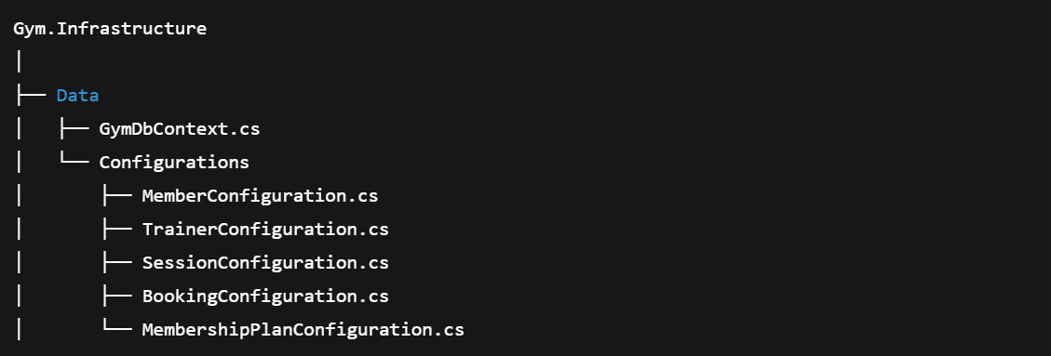

1️⃣ Create GymDbContext
📄 Gym.Infrastructure/Data/GymDbContext.cs
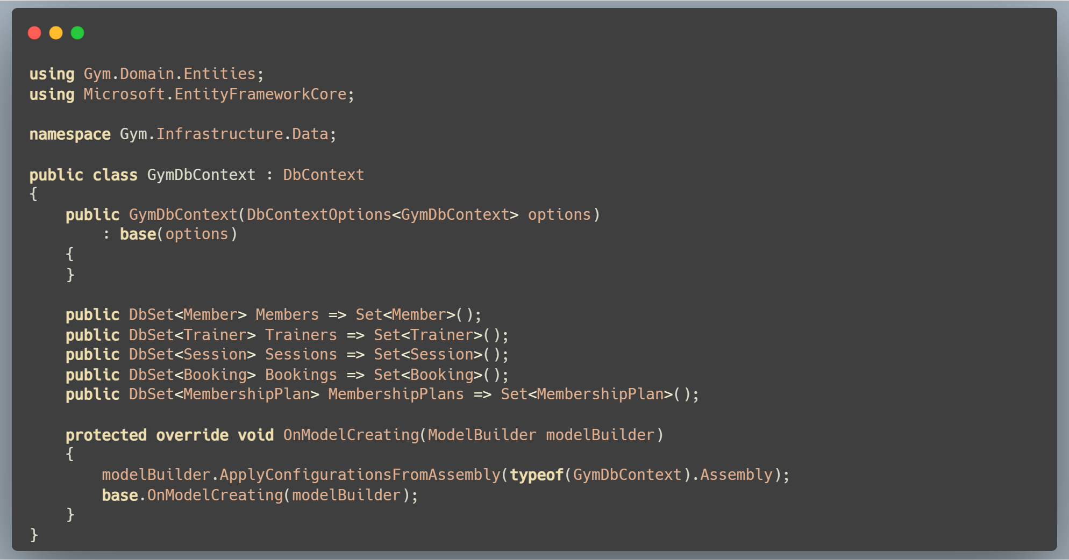

2️⃣ MembershipPlan Configuration
📄 Configurations/MembershipPlanConfiguration.cs
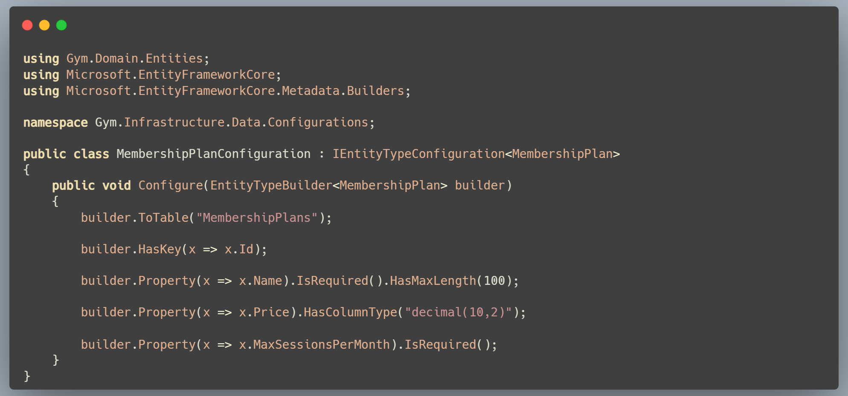

3️⃣ Trainer Configuration
📄 Configurations/TrainerConfiguration.cs
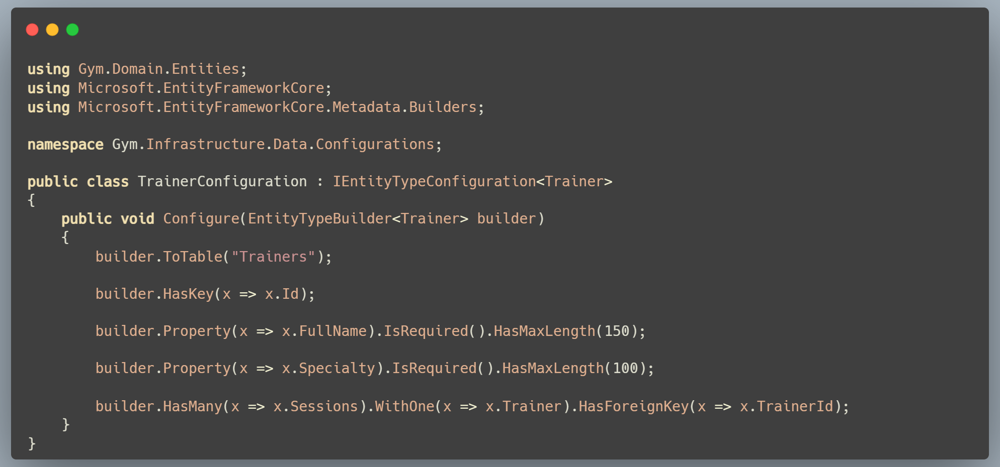

4️⃣ Member Configuration
📄 Configurations/MemberConfiguration.cs
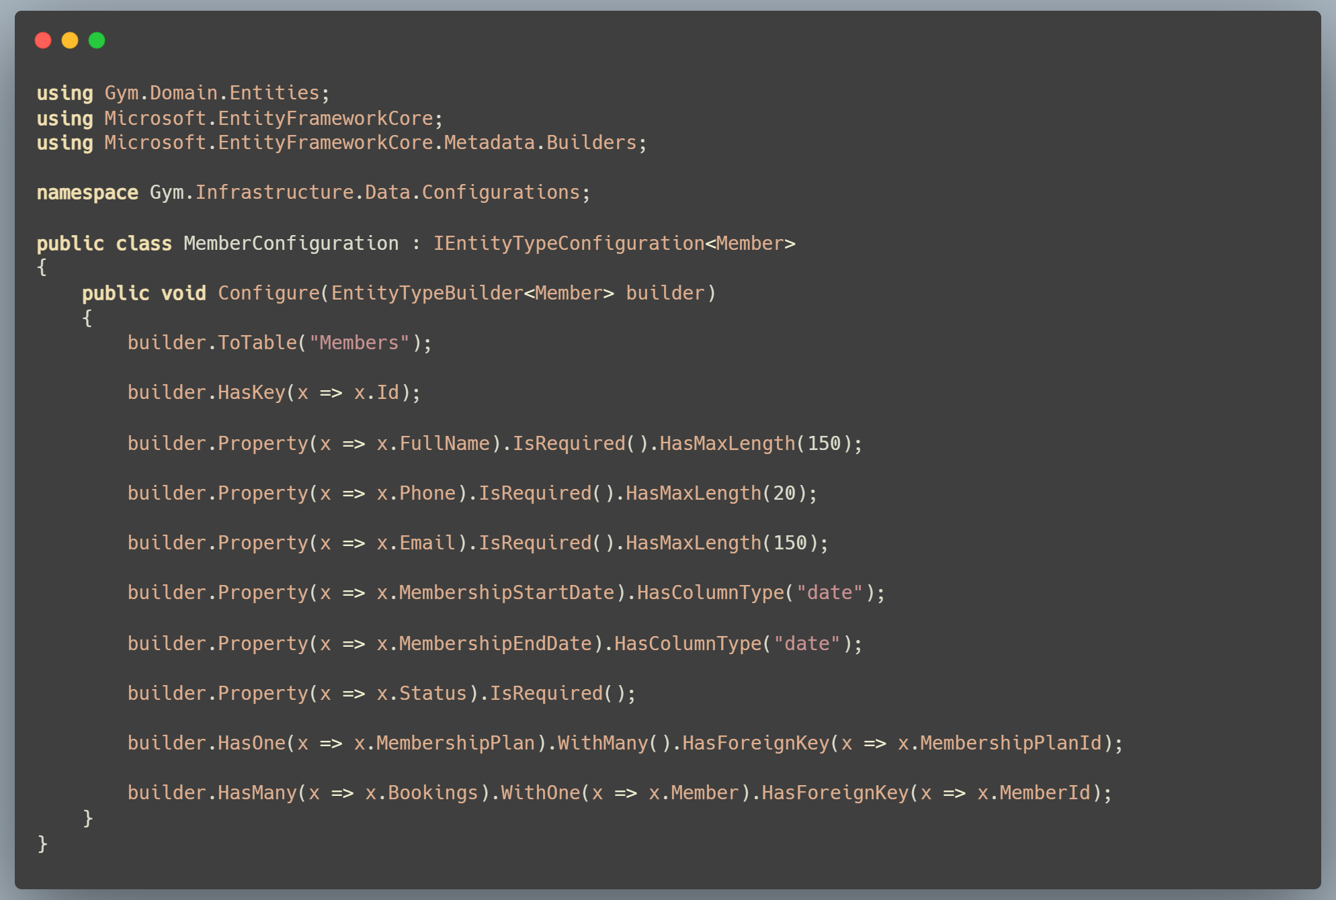
5️⃣ Session Configuration
📄 Configurations/SessionConfiguration.cs
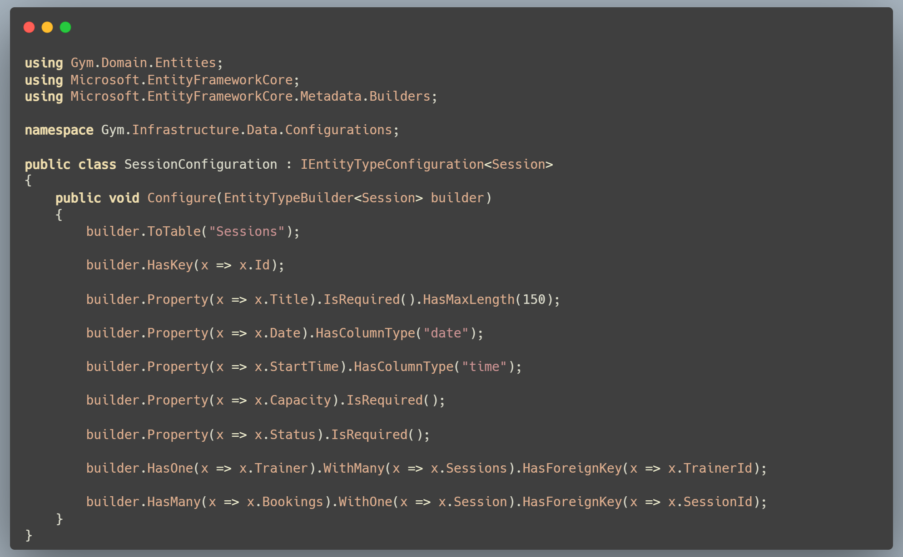
6️⃣ Booking Configuration (Unique constraint included)
📄 Configurations/BookingConfiguration.cs
