
Gym Managemet
Implementation Tasks

Eng. Ahmed emam
Prepared by

Task 4 — First Migration & Database Creation, by the end of this task, you will have:
- SQL Server connection configured
- GymDbContext registered correctly
- First EF Core migration created
- Database created & verified
- Confidence that Domain + Fluent API are correct
This is the checkpoint task: if this works, everything before it is solid.

1️⃣ Add Connection String
📄 Gym.API/appsettings.json
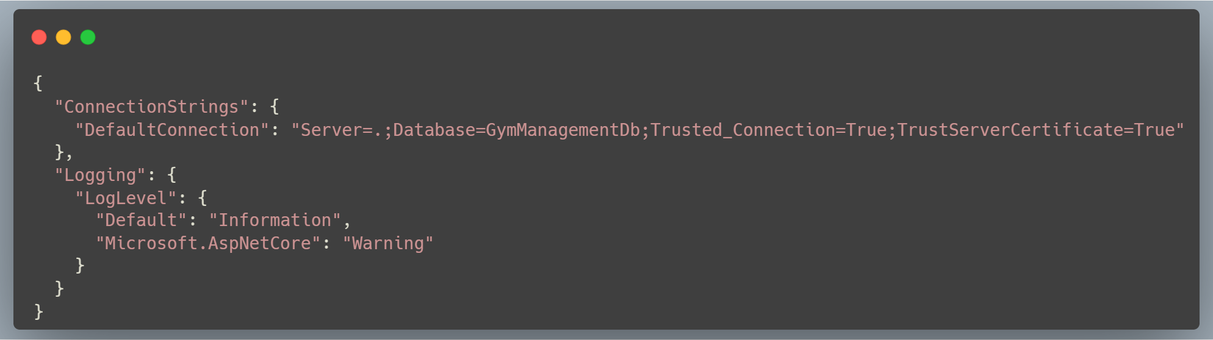
Adjust Server=. if you’re using another SQL instance.

2️⃣ Register DbContext in API
📄 Gym.API/Program.cs
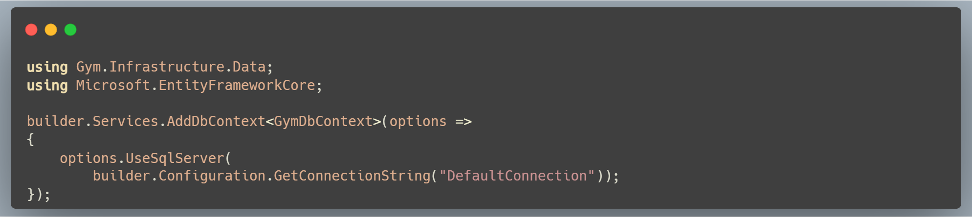
3️⃣Ensure EF Core Tools Are Installed

4️⃣Create the Initial Migration
From the solution root, run:
5️⃣Apply Migration

