
Gym Managemet
Implementation Tasks

Eng. Ahmed emam
Prepared by

Task 5 — Repository Pattern + Unit of Work, by the end of this task, you will have:
- Clear repository interfaces (Application)
- EF Core repository implementations (Infrastructure)
- A Unit of Work coordinating everything
- Application layer talking only to abstractions

1️⃣ Define Generic Repository Interface (Application)
📁 Gym.Application/Interfaces/Repositories
📄 IGenericRepository.cs
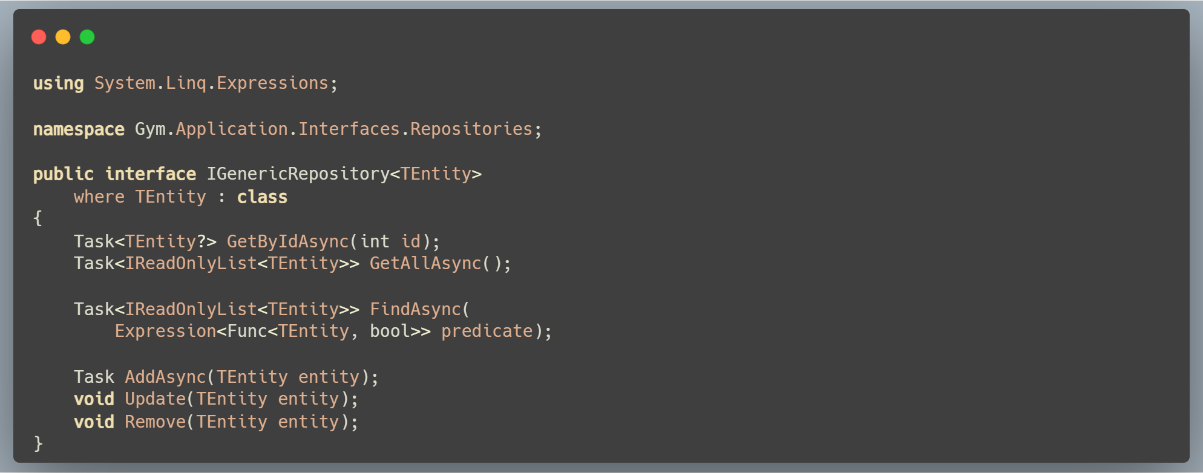

2️⃣ Define Unit of Work Interface (Application)
📁 Gym.Application/Interfaces/UnitOfWork
📄 IUnitOfWork.cs
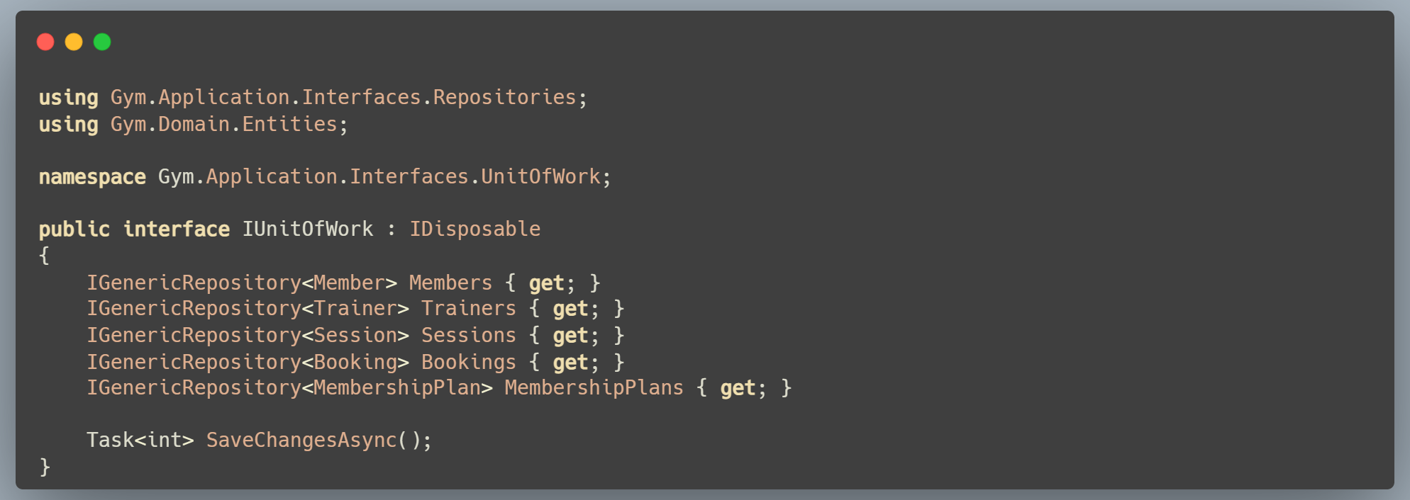

3️⃣ Implement Generic Repository (Infrastructure)
📁 Gym.Infrastructure/Repositories
📄 GenericRepository.cs
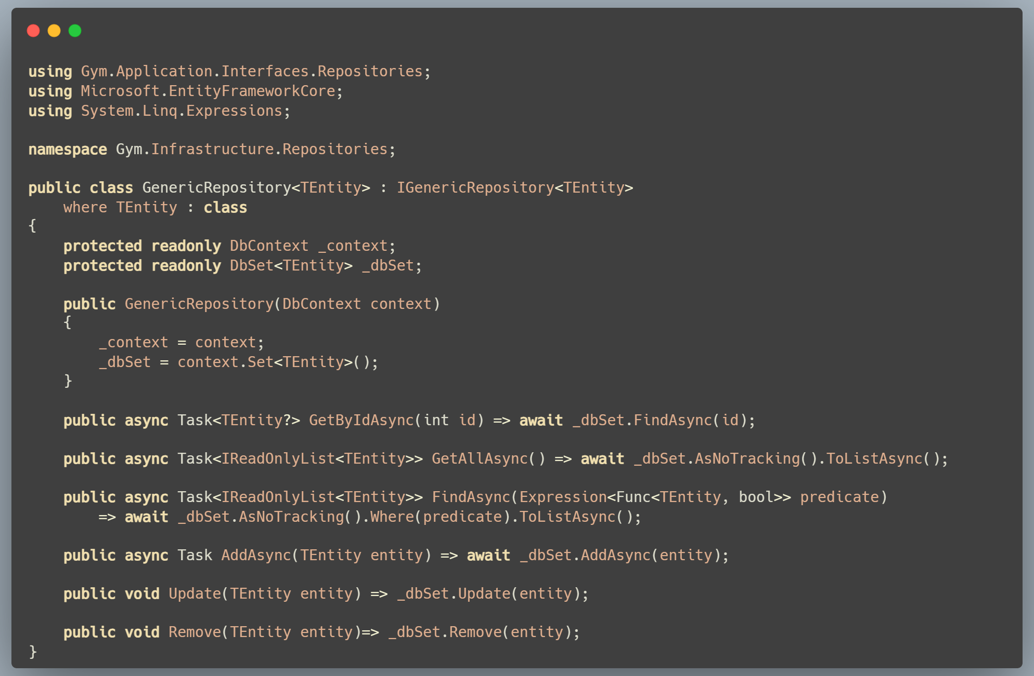
4️⃣ Implement Unit of Work (Infrastructure)
📁 Gym.Infrastructure/UnitOfWork
📄 UnitOfWork.cs
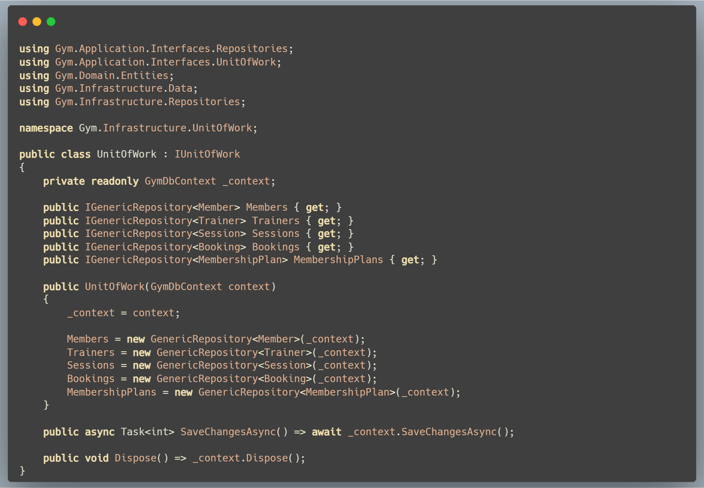
5️⃣ Register Unit of Work in DI (API)
📄 Gym.API/Program.cs
