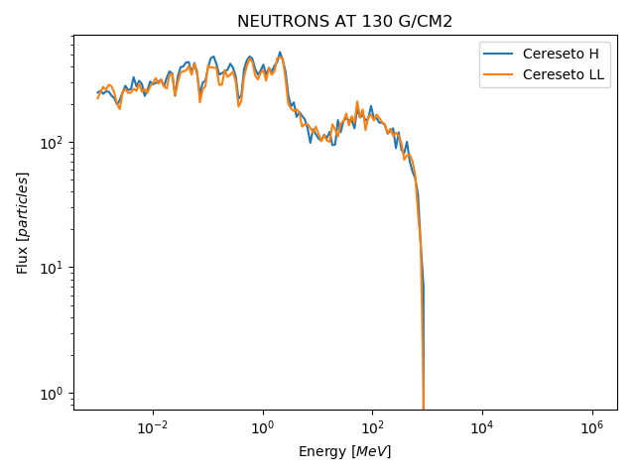

Flux of secundary neutrons in functions of their energy, near the center of the Cereseto meteorite (H and LL), for 1GeV proton primaries.
From ~1KeV to ~1MeV fluxes are positively correlated and have a difference in magnitude around 20%. This can be due to cosmic ray spallation.

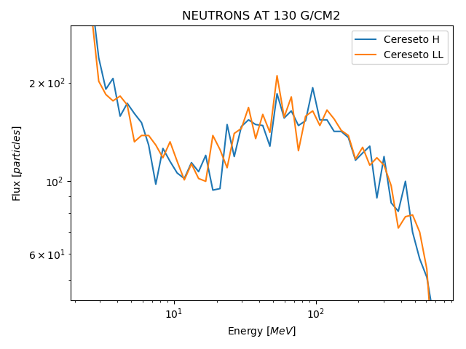
The area of interest occurs from ~10 Mev to 1GeV, where cosmogenic neutrons resides. In this area spectra should be smoother, but low statistics introduce noise in histograms: however, the difference between the two fluxes in this area doesn’t suggest a strong dependence of the flux of secundaries from the composition of the meteorite.

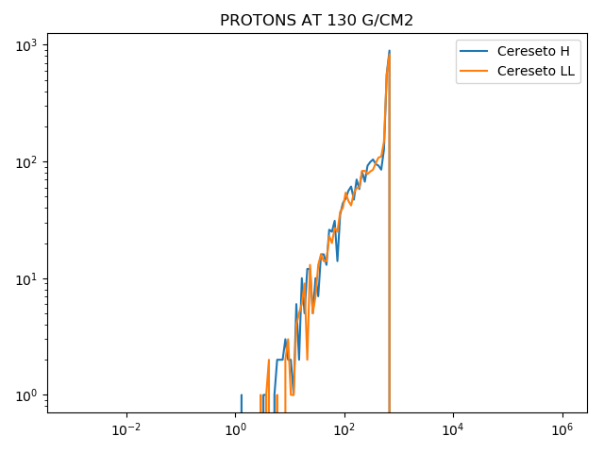
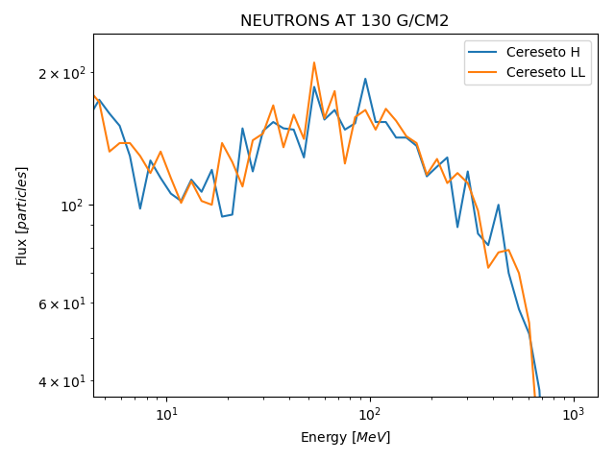

The same analysis is valid also for secundary protons flux, where the area of interest from ~10 Mev to 1GeV shows around 10% percent magnitude difference.

