Hei Stepan, hope your American conference is going great.
Here I report some observations about our current model, using 44Ti activity (dpm/kg(Fe+Ni)) Carla Taricco sent us.
When you see Figure #, you can see them better in detail from the images I sent you, they’re named Figure#.png
1) Conversion of dpm/kg in dpm/kg(Fe+Ni)
I simply evaluated the actual amount of Fe in FeO, FeS, Fe(m) in H L LL chondrites basing on Jarosewich, I added the amount of Ni and obtained three normalization factors for the three types of meteorites. The factors are:
 | H | L | LL
Factors | 3.40 | 4.32 | 4.83
They’re in accord with the different amount of Fe in H (High iron), L (Low iron), LL (Low Low iron). The lower the iron amount, the higher is the normalization factor.
I did the same thing for ALL the meteorites of JGR 2006, using the amount of Fe+Ni as reported in Table1 of that paper. The normalization factors are:

As you see, it is not very different from the ones retrieved with Jarosewich’s compositions. I would say that the difference is almost neglectable as you can see from the following plots. There you have 44Ti activity, using Burger spectra and the right interpolated phi series, for both Jarosewich and JGR normalization factors. To compute this, I used all meteorites’ yield functions with no limitation on 10GeV for the primaries and no pions. Activities are calculated at the “surface” of the actual meteorites, basing on actual masses found in JGR Table 1 from which I retrieved actual radiuses supposing a spherical geometry and using bulk densities from Britt and Consolmagno 2001. I did this to avoid the most inner layers of the meteorites, where fluctuations are great as we agreed before your departing.

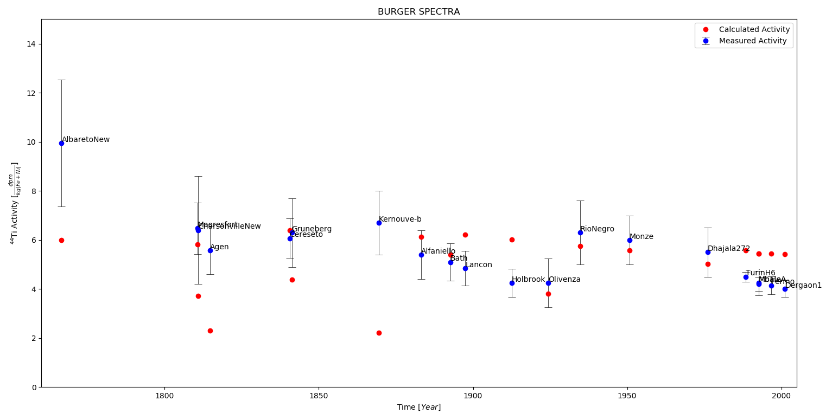
Figure 1: 44Ti activity with Jarosewich normalization factors

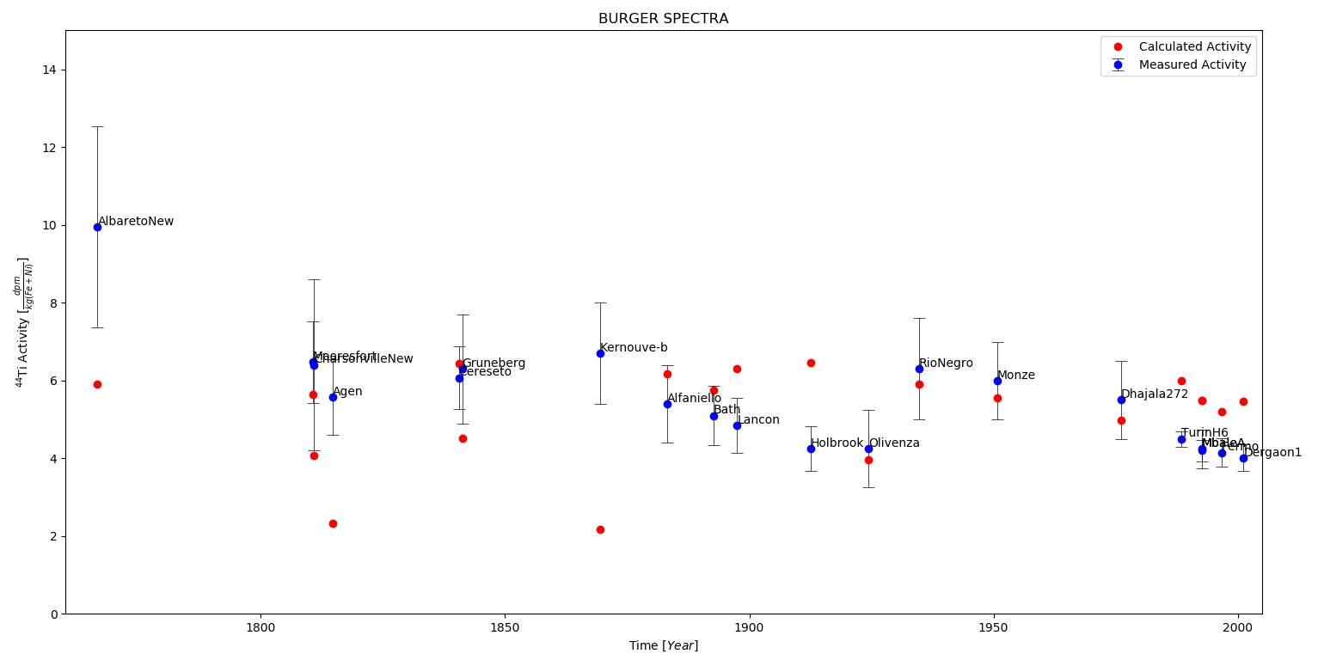
Figure 2: 44Ti activity with JGR normalization factors
Regardless of the goodness of the results, we can say that we’re not encountering a matter of composition and we’re more than allowed to continue to use Jarosewich data. I was wrong yesterday.
2) 44Ti activity considerations
Now let’s focus on what we have: basically the agreement is bad almost everywhere, except for four meteorites in a row, namely OLIVENZA RIO NEGRO MONZE DHAJALA. A Fun fact here is that if we added the 15% contribution by pions, probably we would have perfect agreement. 44Ti activity trend is respected also for Turin H6 MbaleAT Fermo and Dergaon, however there’s a substantial difference in magnitude.
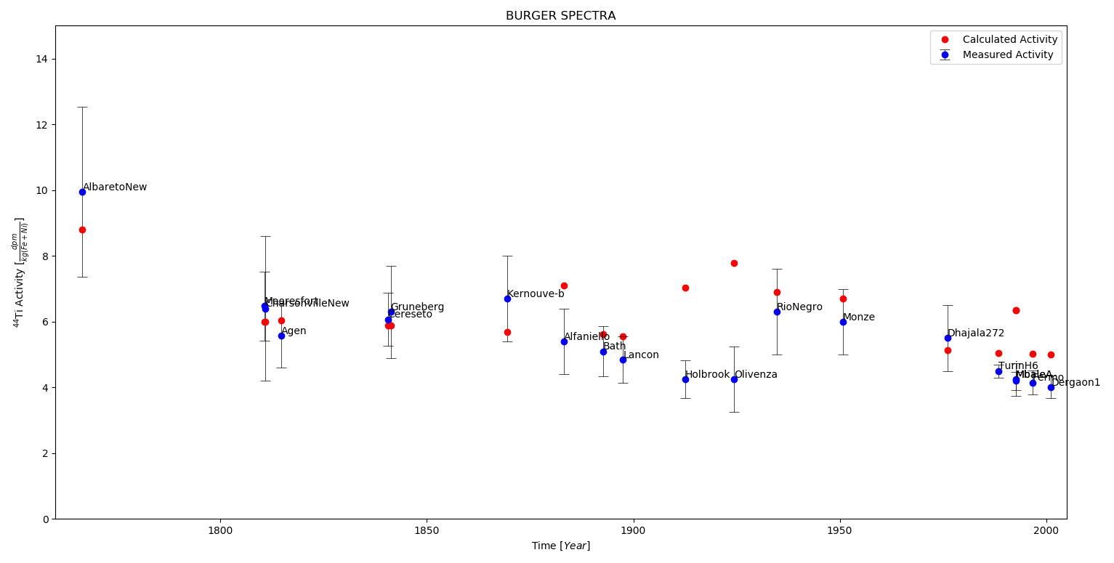
Rio Negro and Monze are both L and, basing on JGR 2006, they have the same expected pre-atmospheric radius (40cm). Olivenza (LL) is expected to have been much bigger (85 cm) but Dhajala (H) is expected to have been only slightly bigger (50cm). 3 out of 4 of this meteorites have completely different features and the results are quite good, so if we assume that our current phi series is reliable, the computation-measurement matching is due to an exact guess on pre-atmospheric size (that determines the cascade in geant4 basically, other than the composition) with values taken from JGR 2006.
But what if the pre-atmospheric size is not correctly established for the other meteorites? This could explain, for example, why the last 4 meteorites of the series (where we now phi very well) appear to follow the trend but have a difference in activity magnitude. What if they were smaller?
Look for example at Agen and Kernouvre-b: they’re both H and both 120cm expected pre-atmospheric radius, so they basically they have the same yield function (important, maybe we have to discuss this? Is it something we want to accept?). They have almost the same computed activity in different years: this means phi in those years must be more or less the same. (I haven’t check yet, but… logics works) We can conclude that the difference from measurements is due to the dimension of the meteoroids, that probably is overestimated by JGR 2006.
In one word: maybe it is better not to be so dependent on this radiuses values.
I propose we define three typical H L and LL meteorites, with the average same dimension, compute with geant4 with high statistics and use production curves to retrieve activity (instead of computing production every time during the activity computation). In this way, maybe we wouldn’t fix perfectly the last four meteorites results (as I said, in my opinion they were smaller than what is reported in JGR) but I bet we could have generally better results.
Just for fun, I computed activity for every meteorite using the production curve of the Michel and Neumann meteorite (it has been performed with low statistics), 40 cm, H
Figure 3: 44Ti activity with Jarosewich normalization factors using MN meteorite production curve
As you can see the agreement is generally better. By the way, some weeks ago we saw that composition do not determine too much difference in secondaries multiplicity (if you remember, we studied the secondaries histograms and we concluded that we could use an “average” composition, if we wanted) and this would mean that this last plot could be taken as a good benchmark.
Finally, I attach here the production curve I used to compute Figure 3
Figure 4: MN meteorite production curve, burger spectra, near the center
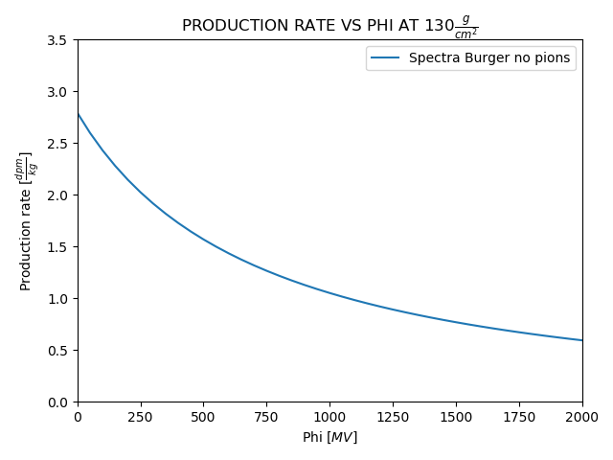
The meteorite is 40 cm, corresponding to 143.2 g/cm2, I chose 130 because until 100 there’s no much difference in production (the “plateau” we happily want). Maybe we can consider to use another spectra, which would imply a lower production for high phi. It would fix the problem with the recent meteorites, for example.
PS: this production rate is measured in dpm/kg because in my activity computation first I retrieve activity in dpm/kg and only then I apply the normalization factor to have dpm/kg(Fe+Ni)
Sorry for grammar errors, see you next week! :)

