Assignment 1
Mohadeseh Najafi Semnani

Advances in data analysis and statistical modelling
Supervisor: Dr. Maurizio Vichi,
Dr. Mario Fordellone

Dimensionality reduction and classification.

1) Using “MixSampling.m” function, generate 300 observations by a bivariate Gaussian mixture with a structure of three groups.

PROCEDURE

- in the beginning, this command has been used which has 5 input objects introduced as follows :

[X,U,u]=MixSampling(n, Pr, dist, csigma, esigma)

- Create n (number of observations/Objects)

n = 300;

- Create the vector of a prior probabilities (K x 1), k=3

The sum of the weights must be equal to 1 since “Pr” represents a probability vector
(Recall the proprieties of a probability)

Pr= [0.33; 0.33; 0.34];

- define csigma that represents the error to perturbate centroids that is equal to 0 in the beginning. csigma = 0;

–define dist that represents constant distance in symmetric matrix ,dist = 9;

-Create esigma: standard deviation of erro, esigma = 1.5;

- As OUTPUTs of our procedure we obtain:

X: the Data Matrix (n x (K-1))

U: the Membership Matrix

u: the categorical clustering variable

[X,U,u]=MixSampling(n, Pr, dist, csigma, esigma)

The result of the procedure represents a diagram separated in 4 charts that is mainly partitioned into left and right diagram groups. Considering the left half of this graph, that has the best way of representation since is been used the rotation applying the varimax option. There is less confusion and the cluster groups shown in the diagram with different colors are well-represented. The distribution of the clusters on the left confirms the clearness and evidence of the interpretation too.

2) Apply the Well Structured Partition (WSP) and Well Structured Perfect Partition (WSPP) models on data generated in the step 1) fixing the number of clusters equal to 3. Compare the membership matrices obtained by the two models with the “real” memberships values. Comment the results.

PROCEDURE

- Let D be the Distance Vector between the observations/objects (i.e. D =

matrix of (dis)similarities)

D = pdist(X);

- to generate the Square Form of D

D = squareform(D);

- Let K be the number of clusters of the partition
K=3;

- Let Rndstart be the number of random starts, Rndstart=10;

- Applying the function on MATLAB we will obtain:

Well Structured Partition (Final): loopOtt=1, fOtt=0.027988, iter=1

using [UOtt,DbOtt, DwOtt, fOtt,iterOtt]=WSP(D, K, Rndstart);

and proceeding with WSPr = Uott'*U we obtain:

WSPr =
0 0 92
101 0 0
0 107 0

It is clear that 102+107+92=300

- As OUTPUTs we have:

a) Uott – Optimal Membership Matrix
b) DbOtt – Optimal Between Distances
c) DwOtt – Optimal Within Distances
d) fOtt - Optimal value of the Loss Function
e) iterOtt - Optimal NUMBER of iterations

To sum up: loopOtt=1, fOtt=0.027988, iter=1 is the optimal choice.

- Now we apply the Well Structured Perfect Partition (WSPP) models on data generated in the step 1).

- Use the same INPUTs (d, k, rndstart) as used before in the WSP procedure

- REMARK: Use the index 2 after every OUTPUT (UOtt2, bOtt2, aOtt2, fOtt2,

iterOtt2) in order to avoid errors and misunderstandings in the interpretation.

- Applying in MATLAB:

[UOtt2, bOtt2, aOtt2, fOtt2, iterOtt2] =WSPP(D,K,Rndstart) we obtain that

Well Structured Perfect Partition (Final): loopOtt=1, fOtt=0.0283536, iter=1

- Proceeding with WSPPRr = UOtt2'*U we obtain this result:

WSPPRr =

0 107 0
0 0 92
101 0 0

It is clear that 102+107+92=300

To sum up: loopOtt=1, fOtt=0.0283536, iter=1

- We Compare the Membership Matrixes obtained by the two models with the “real”

memberships values and we Comment the results:

- We obtain that, making a confrontation between the Membership Matrixes obtained by the two models WSP & WSPPR, with the “real” Memberships values, there is absolutely no difference in both of the models because they work the same way on our given input. So, in practice we can choose both of them in this kind of problems because we obtain the same result. This happens because the number of clusters(three clusters)chosen by us, respects the Parsimonious Principle and of course, makes an easier interpretation of the results.

3) Generate 4 noise variables of 300 observations by a Gaussian distribution with 𝜇=0 and 𝜎=2. Add these 4 variables to the data generated in the step 1). Now, you have a new 300×6 data matrix.

PROCEDURE
First of all, we use the command Xn = randn(300,4)*2;
This code shows a random selection from Gaussian distribution. The number of observations is equal to 300, the number of variables is equal to 4 and we do the multiplication for 2, because we have as assumption that the standard deviation in our case is equal to 2.
Afterwards, applying the command Xcn = [X Xn] is created/generqated a new data matrix where X is the initial data matrix with the real values and Xn is represented by 4 noise variables.

4) Now, we apply the k-means model on this new data set fixing the number of clusters equal to 3. Then, we compare the membership matrix obtained by k-means with the “real” memberships values, and comment the results.

PROCEDURE

The INPUTs that we take into consideration are:

Xcn = value taken from the previous case, in the third exercise
K = number of clusters of the partition

Set K =3

Apply the function:

[loopOtt3,UOtt3,fOtt3,iterOtt3]=kmeansVICHI(Xcn,K,10)

From this application we obtain that the optimal value of loss function is fOtt3 = 4.3069e+003 and this happens in the optimal iteration, i.e. iterOtt3= 6

To check out if the obtained result is good enough we verify if the product of 2 matrixes of memebership gives a diagonal matrix:

Kmr= UOtt3'*U

Kmr =

44 37 34
27 32 21
30 38 37
In fact, we do not obtain a diagonal matrix, therefore we can summarise that the K-Means procedure has been confused by the presence of the noise variables.

plotmatrix(Xcn)

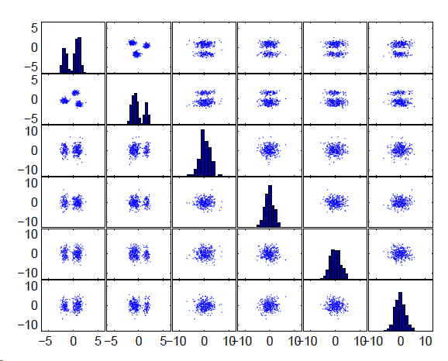

6) Apply Reduced k-means (REDKM) on data generated in the step 3) fixing the number of clusters equal to 3. Compare the membership matrix obtained by the REDKM with the “real” memberships values. Comment the results underling the simultaneous approach advantages with respect to the sequential approach.

X (n x J) data matrix
A (J x Q) loading matrix for dimensionality reduction
U (n x k) membership matrix for clustering objects

INPUTs:

Q = 2 i.e. number of factors chosen prior to the application
Rndstart = 10

[Urkm4,Arkm4, Yrkm4,frkm4,inrkm4]=REDKM(Xcn, 3, Q, 10)

frkm4 =

31.0777 (optimal value of the loss function)

inrkm4 =

19

REDKMr = Urkm4'*U

REDKMr =

0 107 0
101 0 0
0 0 92

The interpretation of the matrix is based on the fact that the result obtained illustrates the method applied is pretty good. We base this affirmation on the fact that the matrix of REDKMr is diagonal after we notice the presence of the label switching, just as in the previous cases applied. This method applied is fast and works considerable for this type of exercise. But, the total variance explained by the factors is not so high so, the method is good but not the best to be used. Or maybe we could re-apply it using other values of the inputs.

7)

load data02.mat;
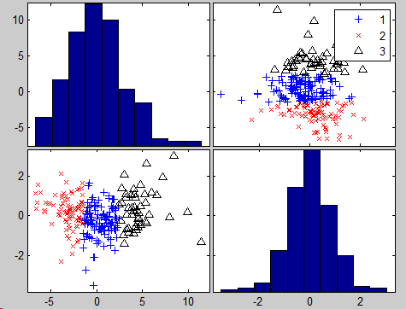
[Urkm,Arkm, Yrkm,frkm,inrkm]=REDKM(X, 3, 2, 25);

From the graphic made, we can easily see that the groups are not being well-separated so the between variance is not well explained, and the same thing we can affirm for the within variance, and even though we apply the rotation to obtain a better interpretation of the result, the variance is not much better explained and we have this just because we cut off lot of information of the real, initial dataset, using just 2 factors.

