Qwen2-VL-2B-Instruct on RadImageNet-VQA: blank-image control
Zero-shot results with a blank white image on the same 500 closed-ended and multiple-choice questions
13 November 2026 – source files: vqa_results_qwen2vl_2b.csv, vqa_scores_qwen2vl_2b.csv (blank control); vqa_results_qwen2vl_2b.csv (real-image run)
Summary
With the scan replaced by a blank white image, Qwen2-VL-2B-Instruct answered 208 of 500 questions correctly (41.6%, 95% CI 37.4–46.0%), against 321 of 500 (64.2%) on the real images. The blank image contains no medical information, so this run shows how much of the score comes from the question text, the answer options and the model’s own answer habits rather than from the image.
Biggest drop: Anatomy (MCQ) falls from 87% to 28%.
Anatomy (MCQ): 28% on the blank image (real image 87%, chance 25%). The image carries most of the information for this task.
Anatomy (yes/no): 55% on the blank image (real image 88%, chance 50%). The image carries most of the information for this task.
Abnormality (yes/no): 50% on the blank image (real image 55%, chance 50%). The model answers “yes” to 0 of 100 questions: recall of true “yes” 0/50, of true “no” 50/50.
Pathology (yes/no): 51% on the blank image (real image 57%, chance 50%). The model answers “yes” to 7 of 100 questions: recall of true “yes” 4/50, of true “no” 47/50.
Pathology (MCQ): 24% on the blank image (real image 34%, chance 25%).
Each yes/no group was sampled 50% yes and 50% no, so its accuracy equals balanced accuracy. Compare the blank-image numbers with chance level, not with zero.
1. Experimental setup
Table 1. Settings
Item | Setting
Model | Qwen2-VL-2B-Instruct, zero-shot (no fine-tuning, no in-context examples).
Control | Every image was replaced by a blank white image; question text, options, prompt, decoding and scoring are unchanged from the real-image run.
Dataset | raidium/RadImageNet-VQA, benchmark/test split (questions only; images not used)
Questions used | Closed-ended (yes/no) and multiple-choice (4 options). Open-ended questions excluded.
Sample | 500 questions: 5 groups × 100, random seed 42; every yes/no group is 50 “yes” + 50 “no”. Identical question IDs to the real-image run (checked row by row).
Prompt | Same fixed instruction as the real-image run: only the option letter, or only ‘Yes’ / ‘No’.
Scoring | Exact match with the reference answer; unparsed answers would count as wrong. 95% Wilson intervals; one-sided exact binomial test against chance.

Table 2. Sample design (100 questions per group)
Group | Format | Example question | Class split | Chance
Anatomy yes/no | Yes/No | Is the knee visible in the image? | 50 / 50 | 50%
Abnormality yes/no | Yes/No | Does the lung look abnormal? | 50 / 50 | 50%
Pathology yes/no | Yes/No | Is there evidence of renal lesion in this image? | 50 / 50 | 50%
Anatomy MCQ | 4 options | Select the correct anatomical region. | random letters | 25%
Pathology MCQ | 4 options | What is the most likely pathology in this image? | random letters | 25%

2. Results by question group
On the blank image, 0 of 5 groups are significantly above chance at the Bonferroni threshold of 0.01. Any accuracy above chance here cannot come from the image; it comes from the wording of the question and options or from a fixed answer habit.
Table 3. Accuracy by group (blank image) and change from the real-image run
Group | Correct / n | Accuracy | 95% CI | Chance | p vs chance | Real image | Change
Anatomy (yes/no) | 55 / 100 | 55% | 45.2–64.4% | 50% | 0.184 | 88% | -33 pts
Anatomy (MCQ) | 28 / 100 | 28% | 20.1–37.5% | 25% | 0.278 | 87% | -59 pts
Pathology (yes/no) | 51 / 100 | 51% | 41.3–60.6% | 50% | 0.460 | 57% | -6 pts
Abnormality (yes/no) | 50 / 100 | 50% | 40.4–59.6% | 50% | 0.540 | 55% | -5 pts
Pathology (MCQ) | 24 / 100 | 24% | 16.7–33.2% | 25% | 0.629 | 34% | -10 pts
Overall | 208 / 500 | 41.6% | 37.4–46.0% | – | – | 64.2% | -22.6 pts

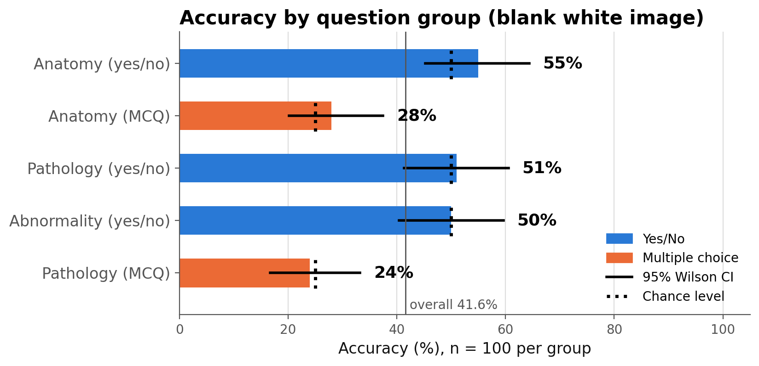
Figure 1. Accuracy by question group on the blank image with 95% Wilson intervals. Dotted marks show chance level for each group.
3. Yes/No analysis
With no image to look at, a yes/no answer depends on the question wording and on the model’s default. The confusion matrices and recalls below show which default it falls back on (Figures 2–3, Table 4a).
Abnormality: “yes” for 0 of 100 questions, “no” for 100. Recall of true “yes” 0/50, of true “no” 50/50. Errors: 0 false alarms and 50 misses. Lean: “no”. Real-image run for comparison: “yes” for 77 of 100.
Pathology: “yes” for 7 of 100 questions, “no” for 93. Recall of true “yes” 4/50, of true “no” 47/50. Errors: 3 false alarms and 46 misses. Lean: “no”. Real-image run for comparison: “yes” for 43 of 100.
Anatomy: “yes” for 29 of 100 questions, “no” for 71. Recall of true “yes” 17/50, of true “no” 38/50. Errors: 12 false alarms and 33 misses. Lean: “no”. Real-image run for comparison: “yes” for 42 of 100.
Across all yes/no questions 12% of the blank-image answers are “yes”, against 54% on real images (exactly 50% are correct as “yes”).
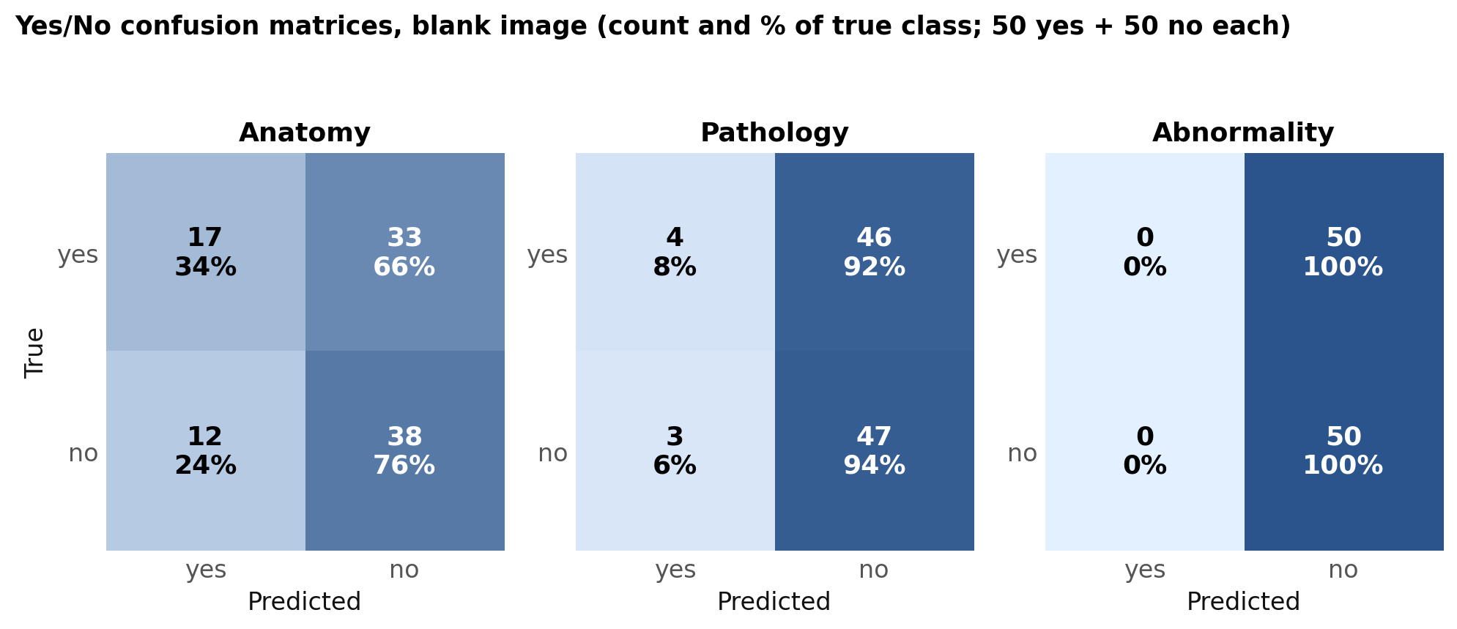
Figure 2. Yes/No confusion matrices on the blank image. Each cell shows the count and the percentage of the true class.
Table 4a. Yes/No metrics on the blank image (positive class = “yes”)
Group | Recall yes | Recall no | Precision yes | F1 yes | Predicted yes | Accuracy
Anatomy | 34% | 76% | 58.6% | 0.43 | 29% | 55%
Pathology | 8% | 94% | 57.1% | 0.14 | 7% | 51%
Abnormality | 0% | 100% | 0.0% | 0.00 | 0% | 50%
All yes/no | 14.0% | 90.0% | 58.3% | 0.23 | 12.0% | 52.0%

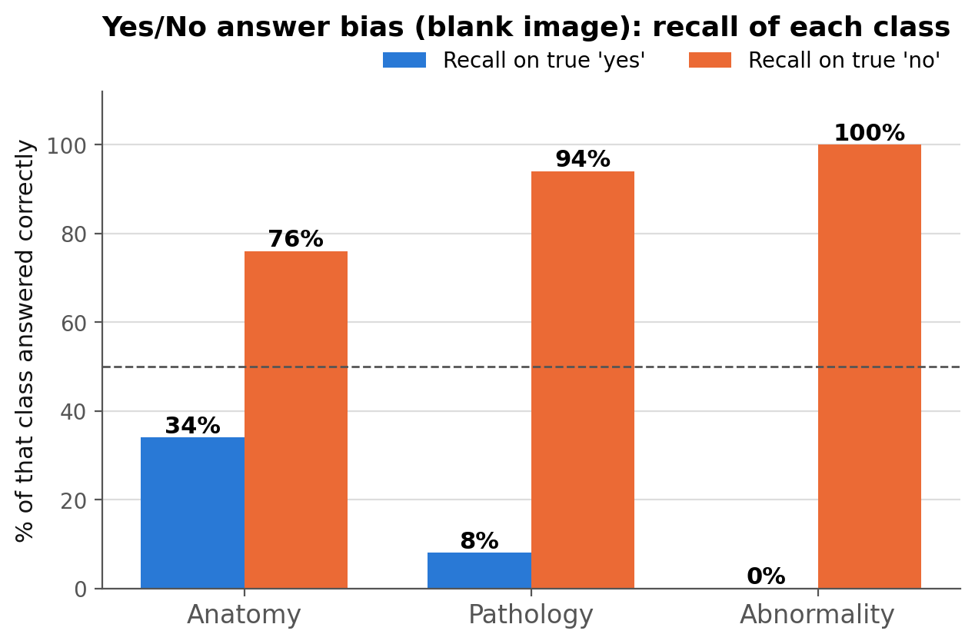
Figure 3. Recall of true “yes” and true “no” questions in each yes/no group (blank image). The dashed line marks 50%.
Effect of the sampling design. The full benchmark has more “yes” than “no” answers for abnormality (71.9% yes) and more “no” for pathology (64.1% no). Re-weighting the measured per-class recall to those natural shares gives Table 4b. These are rough estimates: each class rests on only 50 questions.
Table 4b. Estimated blank-image accuracy at the dataset’s natural yes/no mix
Group | Yes share (full set) | Accuracy on 50/50 sample | Estimated at natural mix | Always-majority baseline
Anatomy | 50.0% | 55% | 55.0% | 50.0%
Pathology | 36.0% | 51% | 63.0% | 64.0% (always “no”)
Abnormality | 71.9% | 50% | 28.1% | 71.9% (always “yes”)

Where the blank-image estimate is above 50% only because the natural mix is lopsided and the model leans the same way, it reflects the data mix and the model’s habit, not any use of the image. These are re-weighted estimates, not measured results; the natural shares come from the earlier audit of the full split (abnormality 719 yes / 281 no; pathology 719 yes / 1,281 no).
4. Multiple-choice analysis
Anatomy (MCQ): 28% correct (real image 87%). The model chose B 33 times (letter B is correct 22 times); answer counts A/B/C/D = 7/33/30/30 against correct counts 29/22/27/22.
Pathology (MCQ): 24% correct (real image 34%). The model chose C 37 times (letter C is correct 25 times); answer counts A/B/C/D = 16/27/37/20 against correct counts 25/22/25/28.
A model that ignores the image and always picks one letter scores the share of that letter among the correct answers; a spread of letters near the correct-answer counts is not a sign of image use.
Table 5. Option-letter statistics (blank image)
Group | Letter | Correct answers (n) | Model answers (n) | Recall
Anatomy (MCQ) | A | 29 | 7 | 13.8%
 | B | 22 | 33 | 54.5%
 | C | 27 | 30 | 18.5%
 | D | 22 | 30 | 31.8%
Pathology (MCQ) | A | 25 | 16 | 16.0%
 | B | 22 | 27 | 9.1%
 | C | 25 | 37 | 40.0%
 | D | 28 | 20 | 28.6%

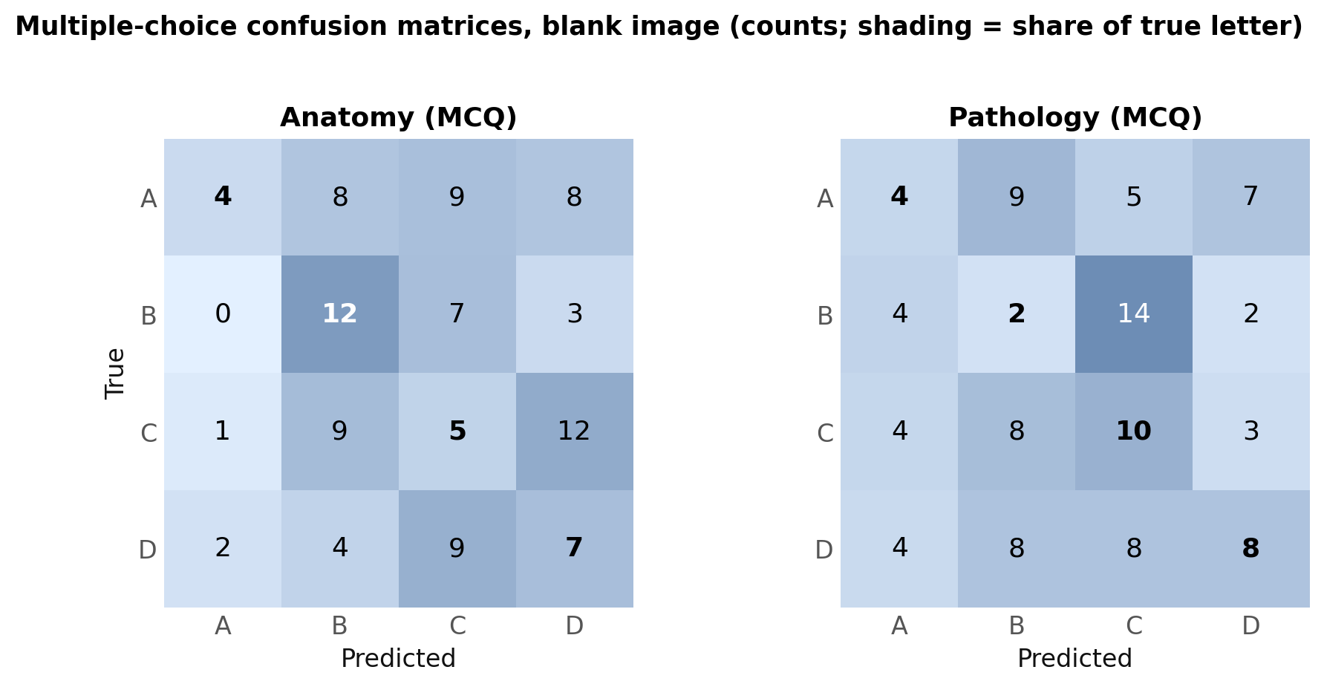
Figure 4. Multiple-choice confusion matrices on the blank image (counts).
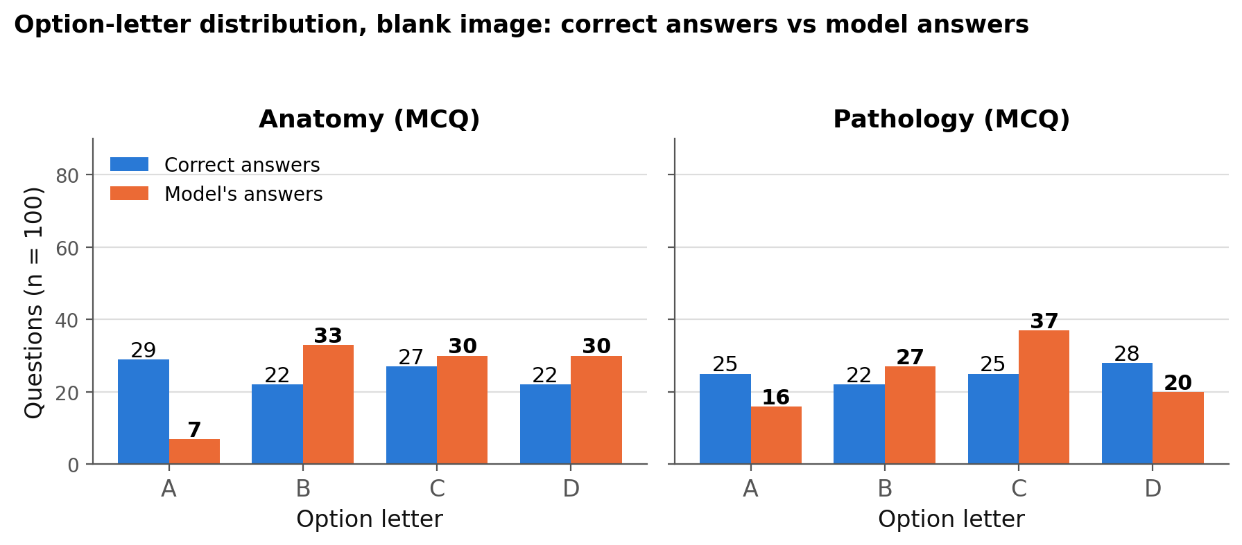
Figure 5. How often each letter is correct versus how often the model chooses it (blank image).
5. Anatomical regions
On the blank image, overall region accuracy ranges from 14/52 (ankle foot) to 93/163 (abdomen). Because the image is identical for every question, regional differences reflect how the question text and the mix of true answers differ by region, not anatomy seen in a scan. Most cells hold fewer than 30 questions, so differences are not reliable.
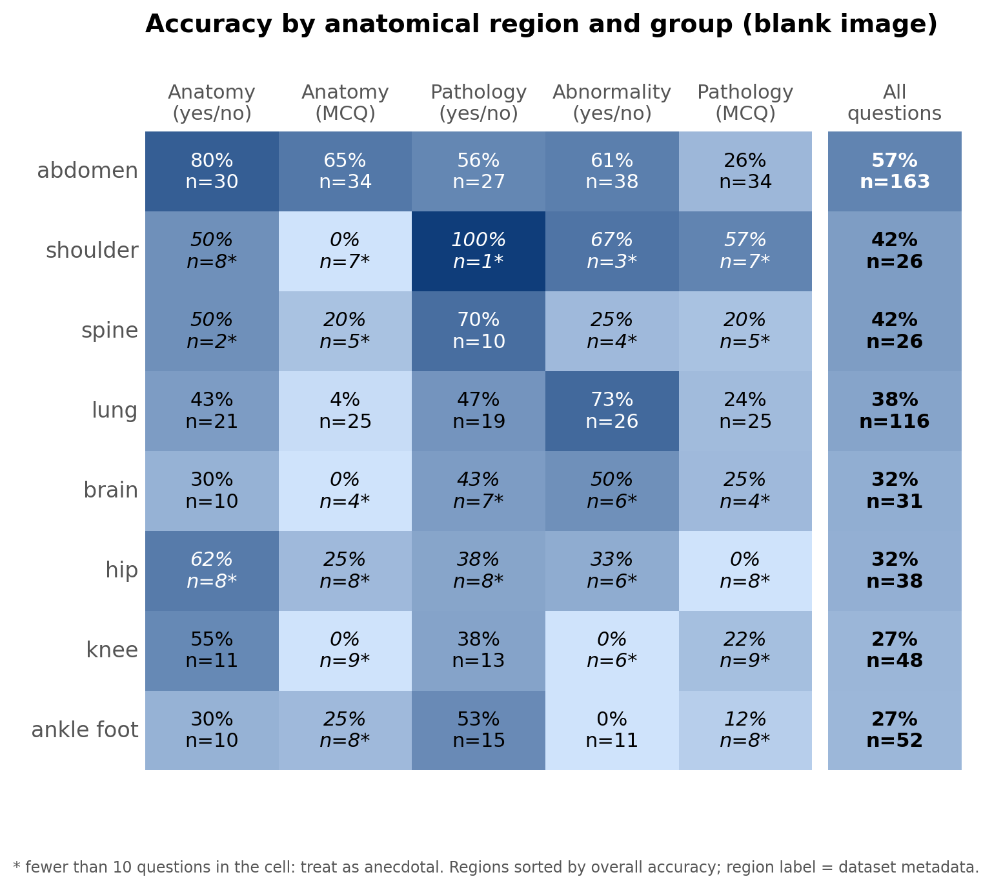
Figure 6. Blank-image accuracy by anatomical region (rows) and question group (columns). Starred cells have fewer than 10 questions.
6. Comparison with the real-image run and the other models
The blank run and the real-image run use the same 500 questions, so answers can be compared question by question (Table 6, Figure 8). Figure 7 shows all four models on the blank image.
Overall: 321 correct with the real image, 208 with the blank image (-113). Right on both 9844, only real 15127, only blank 5425, wrong on both 9846. McNemar exact p = < 0.001.
Same answer: the model gives the same answer with and without the scan on 33% of questions.
All four models on the blank image: Gemma 3 4B-it 194; MedGemma 4B-it 192; MedVLM-R1 219; Qwen2-VL-2B-Instruct 208 correct out of 500.
Table 6. Real image vs blank image for Qwen2-VL-2B-Instruct (same 500 questions)
Group | Real | Blank | Both right | Only real | Only blank | Both wrong | Same answer
Anatomy (yes/no) | 88 | 55 | 2504 | 1896 | 246 | 354 | 57%
Anatomy (MCQ) | 87 | 28 | 2436 | 6264 | 364 | 936 | 24%
Pathology (yes/no) | 57 | 51 | 1338 | 1633 | 981 | 1290 | 56%
Abnormality (yes/no) | 55 | 50 | 2750 | 2750 | 2250 | 2250 | 23%
Pathology (MCQ) | 34 | 24 | 816 | 2584 | 1584 | 5016 | 27%
Overall (p = < 0.001) | 321 | 208 | 9844 | 15127 | 5425 | 9846 | 33%

Table 6b. All four models on the blank image: correct answers per group (n = 100 each)
Group | Gemma | MedGemma | MedVLM-R1 | Qwen2-VL-2B
Anatomy (yes/no) | 52 | 51 | 57 | 55
Anatomy (MCQ) | 11 | 15 | 36 | 28
Pathology (yes/no) | 53 | 51 | 51 | 51
Abnormality (yes/no) | 54 | 50 | 50 | 50
Pathology (MCQ) | 24 | 25 | 25 | 24
Overall (of 500) | 194 | 192 | 219 | 208

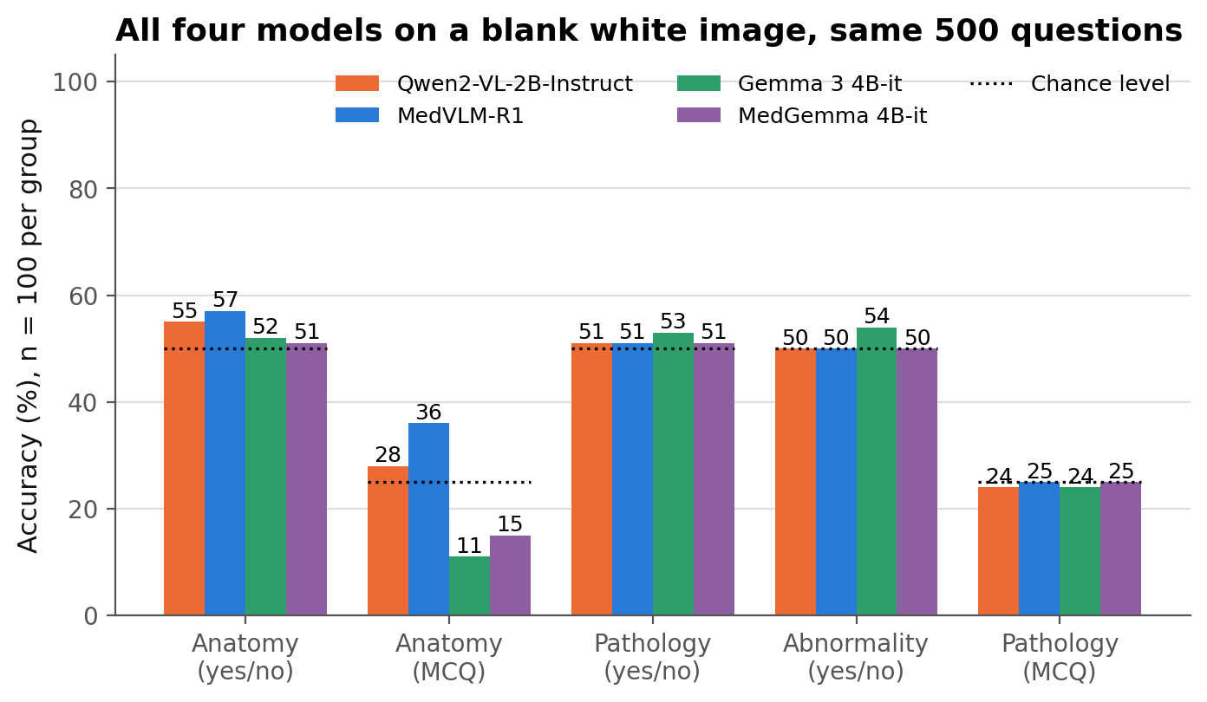
Figure 7. Blank-image accuracy of the four models on each group (same questions). Dotted marks show chance level.
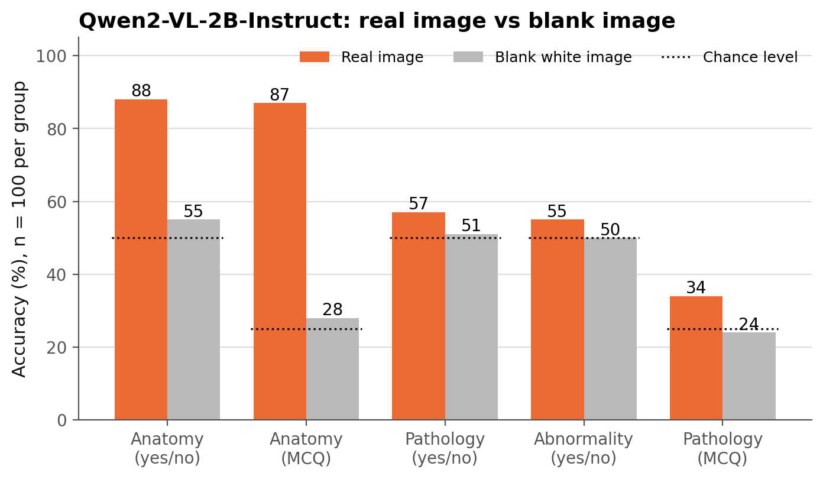
Figure 8. Qwen2-VL-2B-Instruct: accuracy on real images versus the blank white image.
7. Error analysis
Normal scans called abnormal: 0 of 50 true-“no” abnormality questions were answered “yes” (blank-image run); on real images the figure was 36 of 50.
Abnormality questions: the model answered “no” to 100 of 100 and “yes” to 0.
Formatting: 0 unparsed outputs out of 500; raw outputs begin with: “No” (264), “C” (67), “B” (60), “D” (50).
Table 7. Examples of wrong answers on the blank image
Group | Region | Question | True | Model
Anatomy (yes/no) | ankle foot | Can you see the ankle foot? | yes | no
Anatomy (yes/no) | knee | Is the knee visible in the image? | yes | no
Anatomy (MCQ) | shoulder | Select the correct anatomical region. | D | C
Anatomy (MCQ) | abdomen | Select the correct anatomical region. | B | D
Pathology (yes/no) | abdomen | Does the patient have pancreatic lesion? | yes | no
Pathology (yes/no) | abdomen | Is the abdomen affected by bowel mass? | yes | no
Abnormality (yes/no) | hip | Does this scan reveal any abnormalities? | yes | no
Abnormality (yes/no) | brain | Does this scan reveal any abnormalities? | yes | no
Pathology (MCQ) | abdomen | Select the pathology that best describes this image: | B | A
Pathology (MCQ) | abdomen | What pathology is shown in this scan of abdomen | C | D

The results file stores the question text but not the answer options, so the options behind a wrong MCQ letter cannot be read from it.
8. Limitations
Sample size: 100 questions per group gives intervals of about ±9 points. Small differences between groups or models are not reliable.
One control, one prompt: a single blank white image, greedy decoding and one fixed prompt. A black or noise image, or a different prompt, could give a different fallback behaviour; these were not tested here.
Interpretation: accuracy above chance on a blank image points to information in the question and options (or a fixed answer habit). It is an estimate of that non-image component, not a precise subtraction from the real-image score.
Possible overlap: the dataset is derived from RadImageNet; overlap with the model’s training data is unknown.
Not a clinical evaluation: these results describe benchmark behaviour only.
9. Files
Files produced with this report (all in the same folder as the blank-control results, each ending in _blank): figures 1–6 as in the real-image report, figure 7 (all four models on the blank image) and figure 8 (real vs blank image for this model).

