Zero-shot Bangla Medical VQA
Blank-image control across four models
13 November 2026 – built from the blank-control and real-image results CSVs of each model (500 questions each, every image replaced by a blank white image)
1. Summary
Replacing every scan with a blank white image lowers LAVE for all four models: Gemma 3 4B-it 24.1% → 11.7%; MedGemma 4B-it 31.5% → 7.2%; MedVLM-R1 16.0% → 2.6%; Qwen2-VL-2B-Instruct 15.1% → 2.7%.
What survives on the blank image comes from question wording and stock answers. Categories that stay high without the scan (for example modality, where X-ray is the majority answer) are partly base-rate tasks.

2. LAVE, real versus blank
Table 1. Headline comparison (n = 500 per model).
Model | Real LAVE % | Blank LAVE % | Change (pts) | Paired diff. 95% CI | Exact (real / blank) | English-only % (blank) | Empty % (blank)
Gemma 3 4B-it | 24.1 | 11.7 | -12.4 | 9.1–15.9 | 12 / 2 | 45.6 | 25.0
MedGemma 4B-it | 31.5 | 7.2 | -24.3 | 20.6–27.9 | 8 / 0 | 94.8 | 0.4
MedVLM-R1 | 16.0 | 2.6 | -13.4 | 10.7–16.2 | 0 / 0 | 68.2 | 2.4
Qwen2-VL-2B-Instruct | 15.1 | 2.7 | -12.4 | 9.7–15.3 | 0 / 0 | 58.2 | 1.2

Table 2. LAVE % by category, both sources pooled (real / blank)
Category | Gemma 3 4B | MedGemma 4B | MedVLM-R1 | Qwen2-VL-2B
Abnormality | 0.0 / 0.3 | 5.0 / 1.0 | 6.4 / 3.9 | 6.1 / 1.4
Condition | 6.6 / 1.7 | 11.1 / 2.2 | 8.0 / 3.5 | 8.3 / 2.8
Modality | 60.7 / 48.7 | 73.3 / 7.3 | 56.5 / 2.3 | 55.8 / 1.6
Organ | 47.1 / 0.5 | 63.1 / 21.4 | 5.3 / 0.3 | 3.3 / 0.4
Position | 6.1 / 7.2 | 4.9 / 4.0 | 3.7 / 3.0 | 2.2 / 7.3

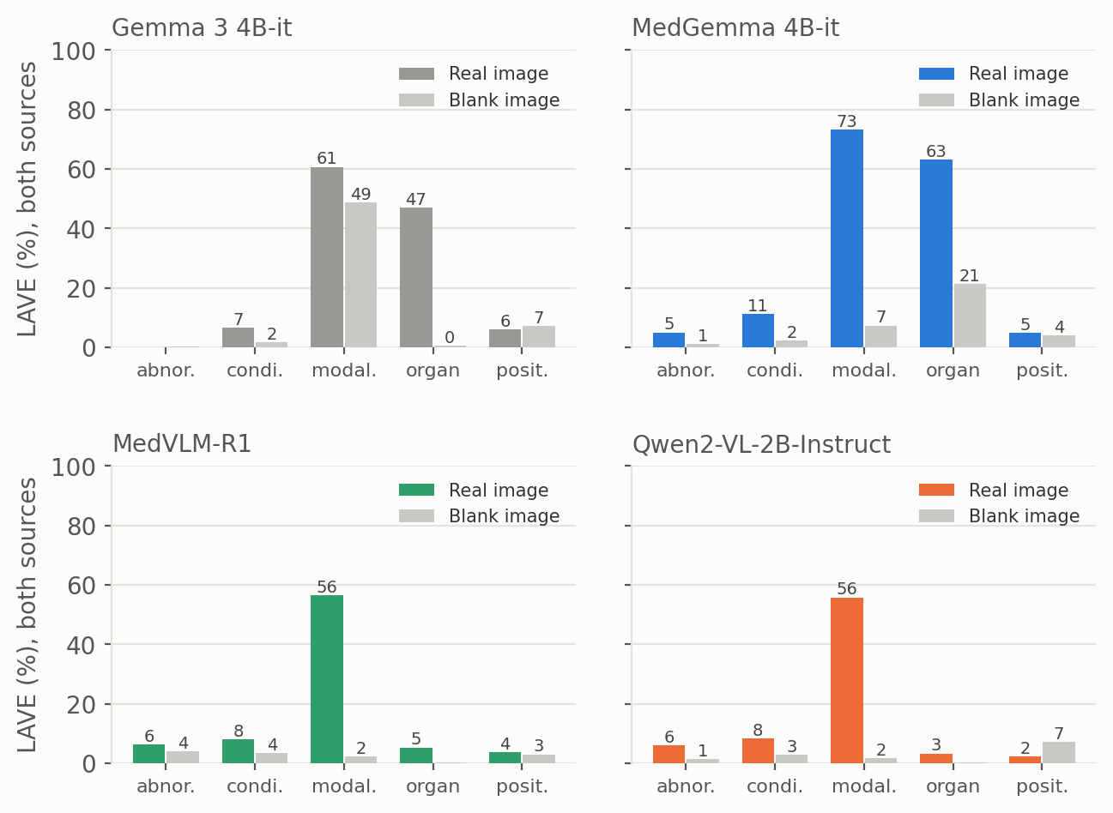
Figure 1. LAVE by category, real versus blank image, for each model (both sources pooled).
3. Abnormality answers
Table 3. Abnormality answers on the blank image (of 100 per model).
Model | Yes | No | Other | Empty | Clear Yes/No right
Gemma 3 4B-it | 0 | 4 | 4 | 92 | 2 of 4
MedGemma 4B-it | 0 | 99 | 0 | 1 | 50 of 99
MedVLM-R1 | 0 | 55 | 33 | 12 | 28 of 55
Qwen2-VL-2B-Instruct | 0 | 57 | 37 | 6 | 30 of 57

4. Notes
Per-model reports (Figures 1–9 and Tables 1–6) are in each model's blank-control folder, with every file name ending in _blank. Yes/No classification and modality matching are our own rule-based audits; LAVE is the paper's GPT-4.1-mini judge.

