Zero-shot Bangla Medical VQA
Gemma 3 4B-it on BanglaMedVQA: blank-image control
500 questions (5 categories × 2 sources × 50) · open-ended · paper's zero-shot prompt · LAVE judge: GPT-4.1-mini · every image replaced by a blank white image
13 November 2026 – source files: bnvqa_results_gemma3_4b.csv, bnvqa_scores_gemma3_4b.csv (blank control); bnvqa_results_gemma3_4b.csv (real-image run)
1. Summary
With every scan replaced by a blank white image, Gemma 3 4B-it reaches exact-match accuracy 2 of 500 (real image: 12). LAVE is 11.7% (95% CI 9.2–14.2) against 24.1% (CI 20.9–27.5) on the real images, a change of -12.4 points; paired difference per question 12.4 points lower with the blank image (95% CI 9.1–15.9). ChestX-ray8 19.5% vs MedICaT 3.8% LAVE on the blank image.
Without an image the best categories are Modality (48.7% LAVE averaged over the two sources; real image 60.7%) and Position (7.2%; real image 6.1%). Whatever LAVE remains on the blank image comes from the question wording and from stock answers, not from the scan.

2. Setup
Item | Value
Model | google/gemma-3-4b-it, bf16, greedy decoding, 96 new tokens max
Control | Every image is replaced by a 512×512 solid white RGB image. Question, system prompt, decoding, answer cleaning and all metrics are unchanged from the real-image run. The same 500 rows (checked row by row).
Data | BanglaMedVQA, Bangla columns only (question_bn, answer_bn). Train splits of ChestX-ray8 and MedICaT
Sample | 50 questions per category per source = 500. Seed 42, one image per question, abnormality balanced 25 Yes / 25 No per source. Same 500 for every model
Prompt | Paper's English zero-shot system prompt (one word or short phrase, no punctuation); Bangla question as the user turn; no options, no few-shot
Metrics | Accuracy (exact match after minimal cleaning), BERTScore F1 (mBERT, layer 9, no rescaling), LAVE (GPT-4.1-mini, paper's simplified judge prompt, one pair per call, temperature 0). Normalized accuracy is our supplementary metric
Confidence intervals | Accuracy: Wilson 95%. LAVE: percentile bootstrap, 5,000 resamples

3. Results
3.1 Headline numbers
Table 1. Paper-style headline table on the blank image. 'Avg. of sources' is the paper's Overall (Avg.): the mean of the two source scores.
Source | n | Accuracy % (CI) | Norm. acc. % | BERTScore | LAVE % (CI) | English-only % | Empty %
ChestX-ray8 | 250 | 0.8 (0.2–2.9) | 1.6 | 53.7 | 19.5 (15.1–24.0) | 45.2 | 26.4
MedICaT | 250 | 0.0 (0.0–1.5) | 0.0 | 52.9 | 3.8 (1.9–5.9) | 46.0 | 23.6
All 500 | 500 | 0.4 (0.1–1.4) | 0.8 | 53.3 | 11.7 (9.2–14.2) | 45.6 | 25.0
Avg. of sources | 500 | 0.4 | 0.8 | 53.3 | 11.7

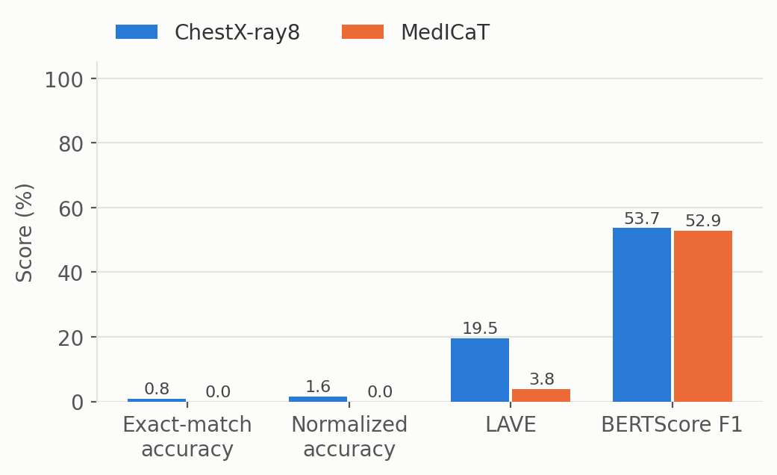
Figure 1. The four metrics on one scale (blank image).
3.2 Per category
Table 2. Per-category results on the blank image (n = 50 each), with the real-image LAVE for comparison. A LAVE interval of 0–0 means every one of the 50 answers scored 0.
Source | Category | Acc. % | Norm. acc. % | BERTScore | LAVE % (CI) | English-only % | >6 words % | Real LAVE %
ChestX-ray8 | Abnormality | 0 | 4 | 11.8 | 0.6 (0–2) | 8 | 0 | 0.0
ChestX-ray8 | Condition | 0 | 0 | 60.5 | 3.4 (1–7) | 90 | 0 | 3.6
ChestX-ray8 | Modality | 4 | 4 | 76.7 | 88.4 (86–90) | 96 | 0 | 64.4
ChestX-ray8 | Organ | 0 | 0 | 65.3 | 0.4 (0–1) | 2 | 0 | 47.8
ChestX-ray8 | Position | 0 | 0 | 54.3 | 4.8 (1–9) | 30 | 0 | 2.6
MedICaT | Abnormality | 0 | 0 | 0.0 | 0.0 (0–0) | 0 | 0 | 0.0
MedICaT | Condition | 0 | 0 | 62.3 | 0.0 (0–0) | 92 | 0 | 9.6
MedICaT | Modality | 0 | 0 | 69.1 | 9.0 (2–16) | 100 | 0 | 57.0
MedICaT | Organ | 0 | 0 | 69.0 | 0.6 (0–2) | 0 | 0 | 46.4
MedICaT | Position | 0 | 0 | 64.1 | 9.6 (4–16) | 38 | 0 | 9.6

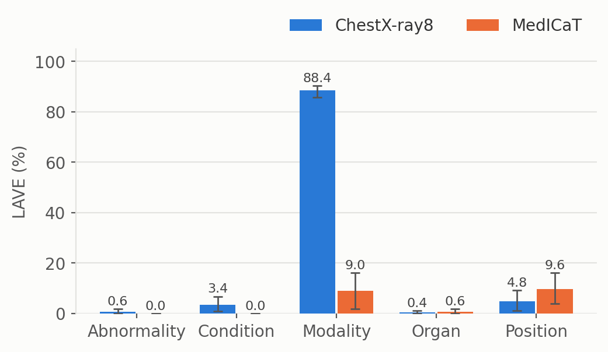
Figure 2. LAVE by category and source on the blank image with 95% bootstrap intervals.
4. What the model actually outputs
Language and format. 45.6% of the answers contain only Latin text (real image: 86.6%). 272 answers are not English-only (125 of them empty); their mean LAVE is 2.8% against 22.3% for English-only answers (n = 228). Exact matches: 2 (most frequent matching answer: “এক্স-রে”).
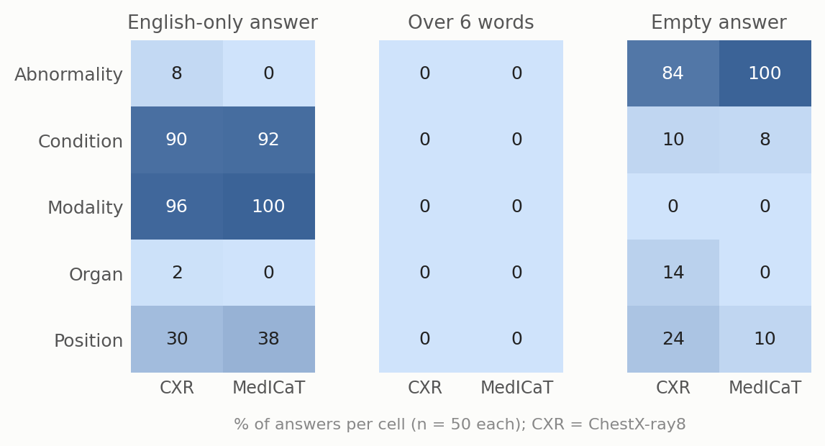
Figure 3. Output-format failures per cell on the blank image. Longest answers: 0 of 500 exceed 6 words. Empty answers: 125 of 500.
It repeats a few stock answers. MedICaT / abnormality: 100% of answers are (empty); CXR / modality: 96% of answers are “xray”; MedICaT / modality: 92% of answers are “xray”. With a blank image every question about the same category is answered from the same fixed habit, so the more repetitive a cell is, the less the answer depends on the scan.
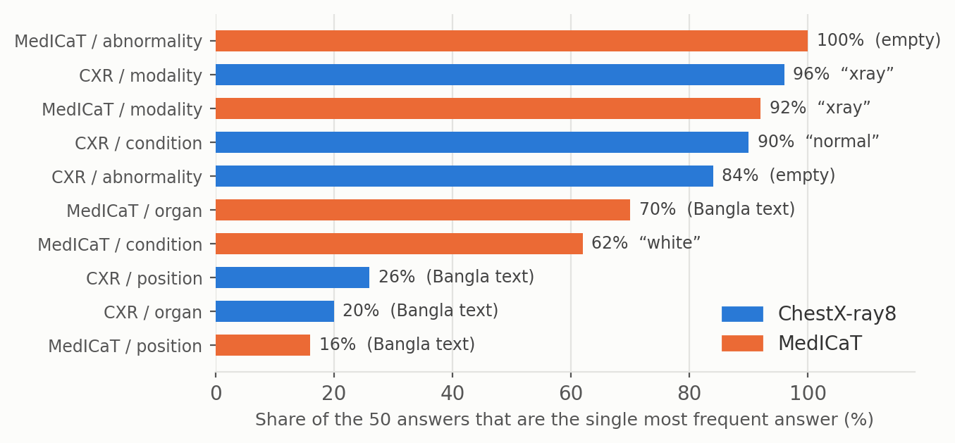
Figure 4. Share of the 50 answers in each cell taken by the single most frequent answer (blank image).
5. Abnormality (Yes/No)
The 100 abnormality questions are balanced (50 Yes, 50 No), so a constant answer scores 50%. We classified each model answer by rule: “no”, “no abnormality”, “there is no abnormality” count as No; anything without a clear Yes/No is Other.
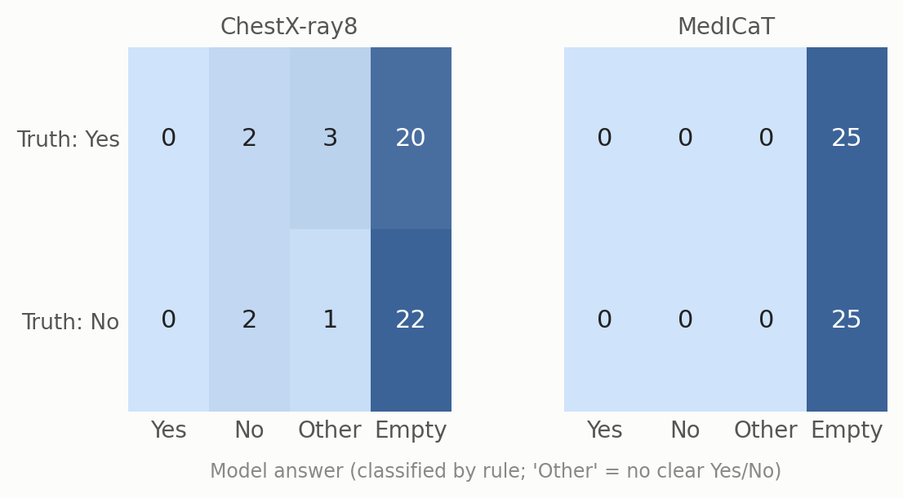
Figure 5. Abnormality on the blank image: reference label (rows) against the model's answer (columns). Rule-based classification of the model answer.
Answer breakdown (of 100): Yes 0, No 4, other 4, empty 92. The most common “other” answers are “নেই” (2), “లేదు” (1), “কোনোটা নেই” (1).
Of its 4 clear Yes/No answers, 2 match the reference (50%); chance on this balanced set is 50%. Real-image run: Yes 17, No 2, other 72, empty 9; 12 of 19 clear answers right.
On ChestX-ray8, the 25 Yes questions got: Yes 0, No 2, other 3, empty 20. The 25 No questions got: Yes 0, No 2, other 1, empty 22.
6. How far to trust the scores
6.1 BERTScore only partly separates right from wrong
Mean BERTScore F1 is 69.9 for non-empty answers the judge scored 0, 70.7 for 0 < LAVE ≤ 0.5, and 77.1 for LAVE > 0.5. Non-empty answers range from 55.0 to 100.0, and the rank correlation with LAVE is 0.43. Without baseline rescaling (as run here) multilingual BERT gives most Bangla text pairs a high similarity, so BERTScore is a moderate, at best, signal here.
6.2 LAVE is bimodal and noisy on cross-language pairs
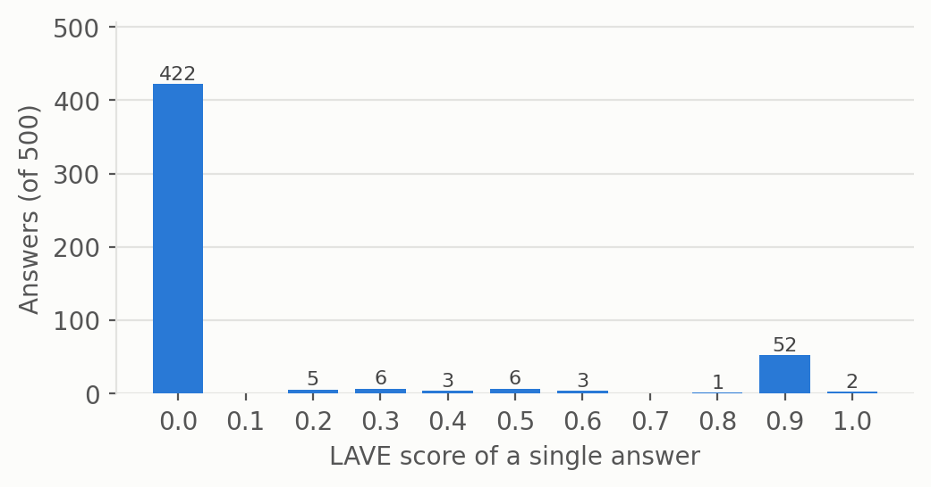
Figure 6. Distribution of single-answer LAVE scores (blank image). 422 of 500 answers (84%) get exactly 0; 55 get 0.8 or more.
Because the judge sees only the reference and the prediction, an English answer to a Bangla reference is sometimes accepted and sometimes not. Two audits that do not use the judge:
Modality. A rule-based match of the imaging modality (X-ray, CT, MRI in English or Bangla) finds the right modality in 55 of 100 answers (100% ChestX-ray8, 10% MedICaT). Mean LAVE on those same 55 answers is 89%. Right-modality answers by wording: “X-ray” n = 55 (LAVE 89%); “CT” n = 0; “MRI” n = 0; other wording n = 0. Modality is close to a base-rate task: X-ray is 56% of the references in this sample, so a constant “x-ray” answer already finds the right modality for those questions without seeing the image.
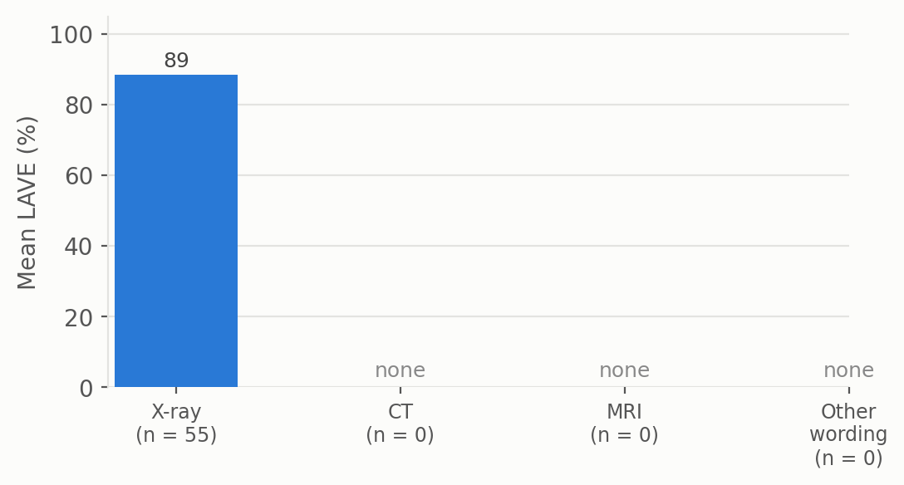
Figure 7. Mean LAVE for answers whose modality is correct by rule-based matching, split by how the answer is worded (blank image).
Yes/No. 2 abnormality answers are a correct Yes or No (Yes where the reference is Yes, No where it is No). The judge gives credit to 0 of them (mean LAVE 0.00).
Table 3. LAVE for correct Yes/No answers, by exact answer string.
Reference | Model answer | n | Mean LAVE
না | No | 2 | 0.00

Reading. For this model the paper's LAVE protocol is a noisy lower bound: it can under-credit correct English answers. Use LAVE as the main metric, but read its category pattern together with the audits above.
7. Real image versus blank image
The blank run and the real-image run use the same 500 questions, so scores can be compared question by question.
LAVE: 24.1% with the real image, 11.7% with the blank image (-12.4 points). Per question, the real image scores higher on 125, the blank image on 44, and they tie on 331. Mean paired difference 12.4 points (95% bootstrap CI 9.1–15.9). The model gives the same answer with and without the scan on 11% of questions.
Exact match: 12 of 500 with the real image, 2 with the blank image.
Table 4. LAVE by cell, real image versus blank image for Gemma 3 4B-it.
Source | Category | Real LAVE % | Blank LAVE % | Change (pts)
ChestX-ray8 | Abnormality | 0.0 | 0.6 | +0.6
ChestX-ray8 | Condition | 3.6 | 3.4 | -0.2
ChestX-ray8 | Modality | 64.4 | 88.4 | +24.0
ChestX-ray8 | Organ | 47.8 | 0.4 | -47.4
ChestX-ray8 | Position | 2.6 | 4.8 | +2.2
MedICaT | Abnormality | 0.0 | 0.0 | +0.0
MedICaT | Condition | 9.6 | 0.0 | -9.6
MedICaT | Modality | 57.0 | 9.0 | -48.0
MedICaT | Organ | 46.4 | 0.6 | -45.8
MedICaT | Position | 9.6 | 9.6 | +0.0
All 500 |  | 24.1 | 11.7 | -12.4

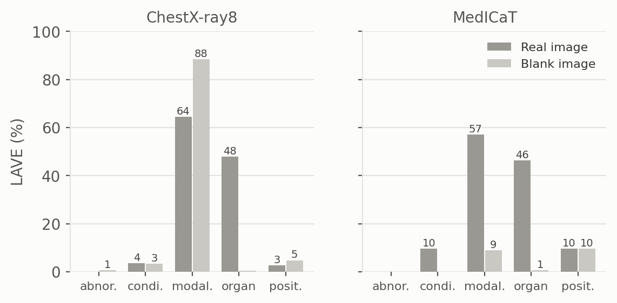
Figure 8. Gemma 3 4B-it: LAVE by category on real images versus the blank white image.
Table 5. All four models on the blank image.
Metric | Gemma 3 4B | MedGemma 4B | MedVLM-R1 | Qwen2-VL-2B
LAVE % (real) | 24.1 | 31.5 | 16.0 | 15.1
LAVE % (blank) | 11.7 | 7.2 | 2.6 | 2.7
Exact match (blank, of 500) | 2 | 0 | 0 | 0
English-only % (blank) | 45.6 | 94.8 | 68.2 | 58.2
Empty % (blank) | 25.0 | 0.4 | 2.4 | 1.2

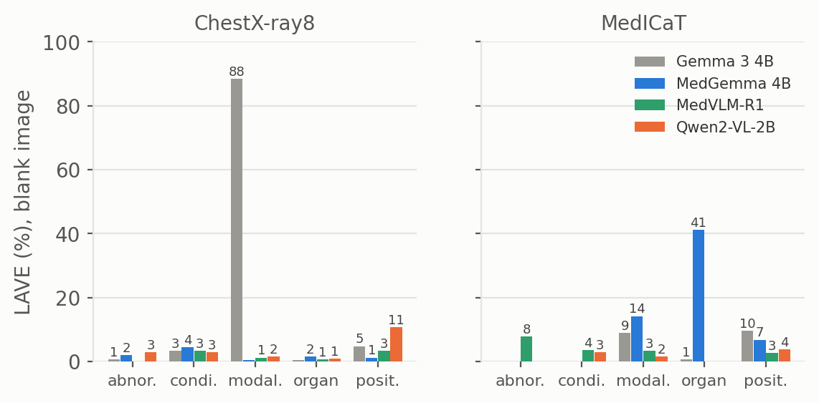
Figure 9. LAVE by category for all four models on the blank image.
8. Example answers
Table 6. One random example per cell (seed 7), blank-image run.
Cell | Question | Reference | Model answer | LAVE
ChestX-ray8 / abnormality | ছবিতে কোনও অস্বাভাবিকতা সনাক্ত হয়েছে কি | না | (empty) | 0.0
ChestX-ray8 / condition | এখানে কোন নির্দিষ্ট অবস্থা চিহ্নিত করা হ | প্রলায়, এম্ফিসেমা, এবং মাঝ বাম দিকে নিউ | Normal | 0.0
ChestX-ray8 / modality | এই ইমেজিং পদ্ধতিটি কী ধরণের? | এক্স-রে | X-ray | 0.9
ChestX-ray8 / organ | এই ছবিতে প্রাথমিকভাবে কোন অঙ্গতন্ত্র চিত | বুক | (empty) | 0.0
ChestX-ray8 / position | চিহ্নিত কোনও অবস্থার অ্যানাটোমিক্যাল অবস | কোন অবস্থা চিহ্নিত করা হয়নি। | (empty) | 0.0
MedICaT / abnormality | ছবিতে কি কোনো অস্বাভাবিকতা আছে? | না | (empty) | 0.0
MedICaT / condition | ছবিতে কী কী অবস্থা দেখা যাচ্ছে? | প্লুরাল-ভিত্তিক ঘনত্ব | White | 0.0
MedICaT / modality | এই ছবিতে কোন ইমেজিং মোডালিটি ব্যবহার করা | এমআরআই | X-ray | 0.0
MedICaT / organ | এই ছবিতে কোন অঙ্গ দেখানো হয়েছে? | বুক | প্লুরাল | 0.0
MedICaT / position | সাবঅ্যারাকনয়েড হেমোরেজ (SAH) এর অবস্থান | ইন্ট্রাক্রানিয়াল | Subarachnoid | 0.0

9. What we take from this
On a blank image Gemma 3 4B-it still scores LAVE 11.7% (real image 24.1%), exact match 2/500, BERTScore 53.3. The share of the real-image LAVE that survives without an image is 48%.
The best blank-image cell is ChestX-ray8 / modality at 88.4% LAVE (real image 64.4%). Cells that keep most of their real-image score depend on question wording or stock answers, not on the scan; cells that collapse depend on the image.
English-only answers: 46% of outputs; empty answers: 125 of 500. Abnormality: a clear Yes/No on only 4 of 100 questions.
Caveats
• Sample is from the train splits, not the paper's test split. n = 50 per cell, so category-level intervals are wide (Table 2).
• References are LLM-generated from metadata (paper: 97% acceptance on an expert-checked subset). Some references are generic, for example “no specific condition identified”.
• LAVE uses the paper's simplified prompt (reference and prediction only, no question). The Yes/No classification and modality matching in Sections 5 and 6 are our own rule-based audits, not paper metrics.
• One greedy run per question; a single white blank image. A black or noise image, or other prompts, could give a different fallback behaviour; these were not tested here.
• LAVE above zero on a blank image measures the non-image part of the score; it is not a precise amount to subtract from the real-image score.

