Zero-shot Bangla Medical VQA
MedVLM-R1 on BanglaMedVQA: blank-image control
500 questions (5 categories × 2 sources × 50) · open-ended · paper's zero-shot prompt · LAVE judge: GPT-4.1-mini · every image replaced by a blank white image
13 November 2026 – source files: bnvqa_results_medvlm_r1.csv, bnvqa_scores_medvlm_r1.csv (blank control); bnvqa_results_medvlm_r1.csv (real-image run)
1. Summary
With every scan replaced by a blank white image, MedVLM-R1 reaches exact-match accuracy 0 of 500 (real image: 0). LAVE is 2.6% (95% CI 1.9–3.4) against 16.0% (CI 13.5–18.6) on the real images, a change of -13.4 points; paired difference per question 13.4 points lower with the blank image (95% CI 10.7–16.2). ChestX-ray8 1.7% vs MedICaT 3.5% LAVE on the blank image.
Without an image the best categories are Abnormality (3.9% LAVE averaged over the two sources; real image 6.4%) and Condition (3.5%; real image 8.0%). Whatever LAVE remains on the blank image comes from the question wording and from stock answers, not from the scan.

2. Setup
Item | Value
Model | JZPeterPan/MedVLM-R1, bf16, greedy decoding, 256 new tokens max
Control | Every image is replaced by a 512×512 solid white RGB image. Question, system prompt, decoding, answer cleaning and all metrics are unchanged from the real-image run. The same 500 rows (checked row by row).
Data | BanglaMedVQA, Bangla columns only (question_bn, answer_bn). Train splits of ChestX-ray8 and MedICaT
Sample | 50 questions per category per source = 500. Seed 42, one image per question, abnormality balanced 25 Yes / 25 No per source. Same 500 for every model
Prompt | Paper's English zero-shot system prompt (one word or short phrase, no punctuation); Bangla question as the user turn; no options, no few-shot
Metrics | Accuracy (exact match after minimal cleaning), BERTScore F1 (mBERT, layer 9, no rescaling), LAVE (GPT-4.1-mini, paper's simplified judge prompt, one pair per call, temperature 0). Normalized accuracy is our supplementary metric
Confidence intervals | Accuracy: Wilson 95%. LAVE: percentile bootstrap, 5,000 resamples

3. Results
3.1 Headline numbers
Table 1. Paper-style headline table on the blank image. 'Avg. of sources' is the paper's Overall (Avg.): the mean of the two source scores.
Source | n | Accuracy % (CI) | Norm. acc. % | BERTScore | LAVE % (CI) | English-only % | Empty %
ChestX-ray8 | 250 | 0.0 (0.0–1.5) | 4.0 | 67.6 | 1.7 (1.1–2.5) | 68.0 | 4.0
MedICaT | 250 | 0.0 (0.0–1.5) | 4.8 | 67.4 | 3.5 (2.1–5.0) | 68.4 | 0.8
All 500 | 500 | 0.0 (0.0–0.8) | 4.4 | 67.5 | 2.6 (1.9–3.4) | 68.2 | 2.4
Avg. of sources | 500 | 0.0 | 4.4 | 67.5 | 2.6

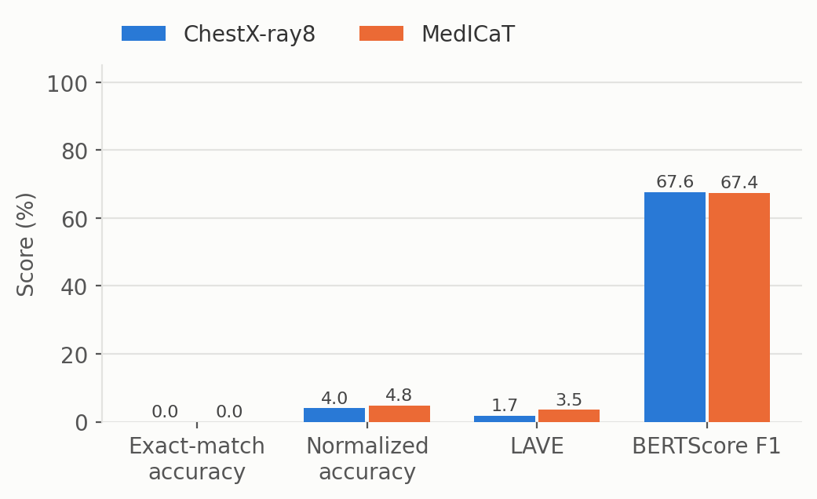
Figure 1. The four metrics on one scale (blank image).
3.2 Per category
Table 2. Per-category results on the blank image (n = 50 each), with the real-image LAVE for comparison. A LAVE interval of 0–0 means every one of the 50 answers scored 0.
Source | Category | Acc. % | Norm. acc. % | BERTScore | LAVE % (CI) | English-only % | >6 words % | Real LAVE %
ChestX-ray8 | Abnormality | 0 | 20 | 57.5 | 0.0 (0–0) | 80 | 2 | 12.8
ChestX-ray8 | Condition | 0 | 0 | 64.3 | 3.4 (2–5) | 100 | 0 | 3.8
ChestX-ray8 | Modality | 0 | 0 | 69.0 | 1.2 (0–2) | 96 | 4 | 58.6
ChestX-ray8 | Organ | 0 | 0 | 77.7 | 0.6 (0–2) | 10 | 4 | 5.2
ChestX-ray8 | Position | 0 | 0 | 69.4 | 3.4 (1–6) | 54 | 10 | 4.0
MedICaT | Abnormality | 0 | 24 | 68.7 | 7.8 (3–14) | 96 | 0 | 0.0
MedICaT | Condition | 0 | 0 | 64.8 | 3.6 (2–5) | 100 | 2 | 12.2
MedICaT | Modality | 0 | 0 | 66.2 | 3.4 (2–6) | 74 | 14 | 54.4
MedICaT | Organ | 0 | 0 | 70.1 | 0.0 (0–0) | 38 | 0 | 5.4
MedICaT | Position | 0 | 0 | 67.1 | 2.6 (0–5) | 34 | 18 | 3.4

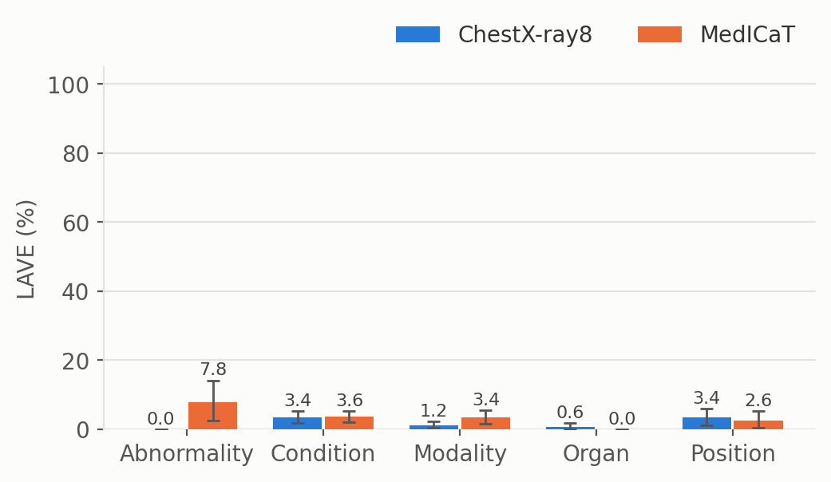
Figure 2. LAVE by category and source on the blank image with 95% bootstrap intervals.
4. What the model actually outputs
Language and format. 68.2% of the answers contain only Latin text (real image: 88.6%). 159 answers are not English-only (12 of them empty); their mean LAVE is 2.1% against 2.8% for English-only answers (n = 341). Exact matches: 0.
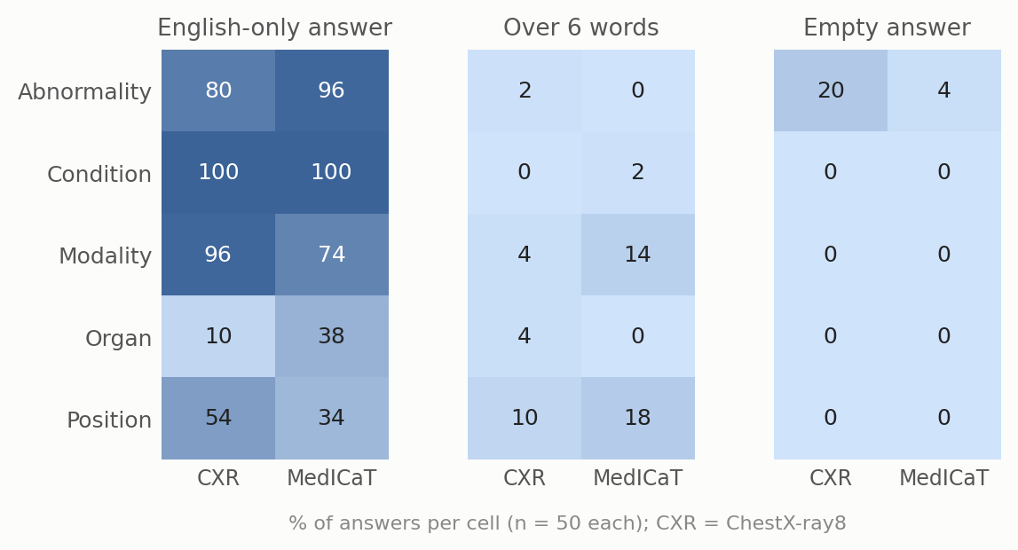
Figure 3. Output-format failures per cell on the blank image. Longest answers: 27 of 500 exceed 6 words. Empty answers: 12 of 500.
It repeats a few stock answers. CXR / condition: 88% of answers are “abnormality”; MedICaT / abnormality: 50% of answers are “no abnormalities”; MedICaT / condition: 50% of answers are “the image shows a medical condition”. With a blank image every question about the same category is answered from the same fixed habit, so the more repetitive a cell is, the less the answer depends on the scan.
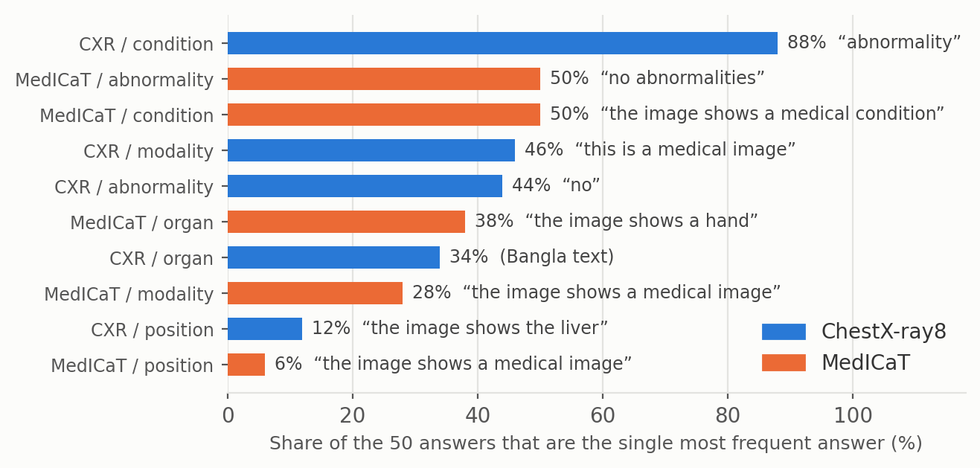
Figure 4. Share of the 50 answers in each cell taken by the single most frequent answer (blank image).
5. Abnormality (Yes/No)
The 100 abnormality questions are balanced (50 Yes, 50 No), so a constant answer scores 50%. We classified each model answer by rule: “no”, “no abnormality”, “there is no abnormality” count as No; anything without a clear Yes/No is Other.
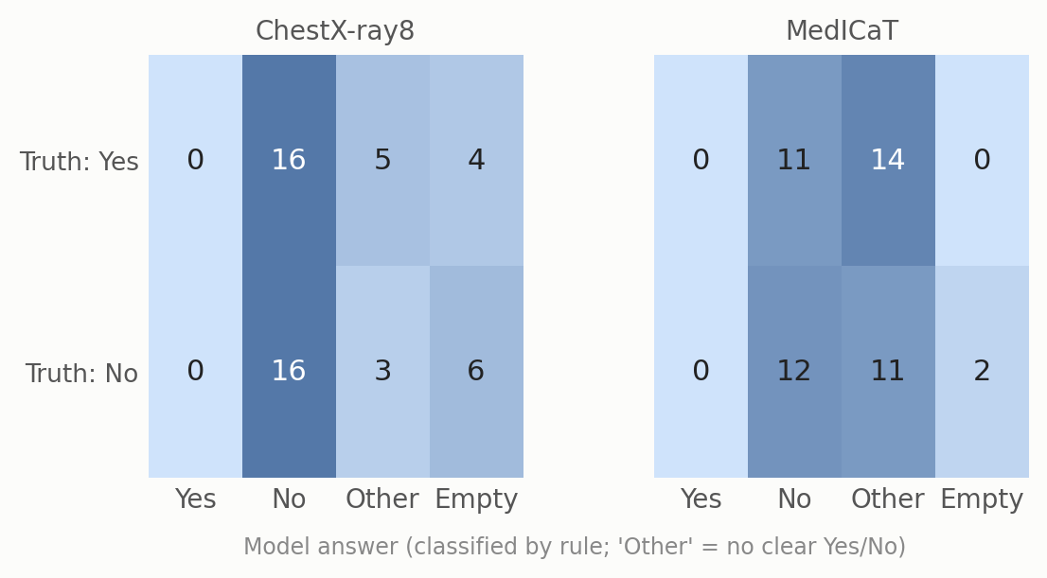
Figure 5. Abnormality on the blank image: reference label (rows) against the model's answer (columns). Rule-based classification of the model answer.
Answer breakdown (of 100): Yes 0, No 55, other 33, empty 12. The most common “other” answers are “No abnormalities” (31), “This is a medical image” (1), “There is no abnormality in the image” (1).
Of its 55 clear Yes/No answers, 28 match the reference (51%); chance on this balanced set is 50%. Real-image run: Yes 0, No 61, other 36, empty 3; 31 of 61 clear answers right.
On ChestX-ray8, the 25 Yes questions got: Yes 0, No 16, other 5, empty 4. The 25 No questions got: Yes 0, No 16, other 3, empty 6.
6. How far to trust the scores
6.1 BERTScore only partly separates right from wrong
Mean BERTScore F1 is 69.5 for non-empty answers the judge scored 0, 65.9 for 0 < LAVE ≤ 0.5, and 79.8 for LAVE > 0.5. Non-empty answers range from 52.7 to 87.2, and the rank correlation with LAVE is -0.21. Without baseline rescaling (as run here) multilingual BERT gives most Bangla text pairs a high similarity, so BERTScore is a moderate, at best, signal here.
6.2 LAVE is bimodal and noisy on cross-language pairs
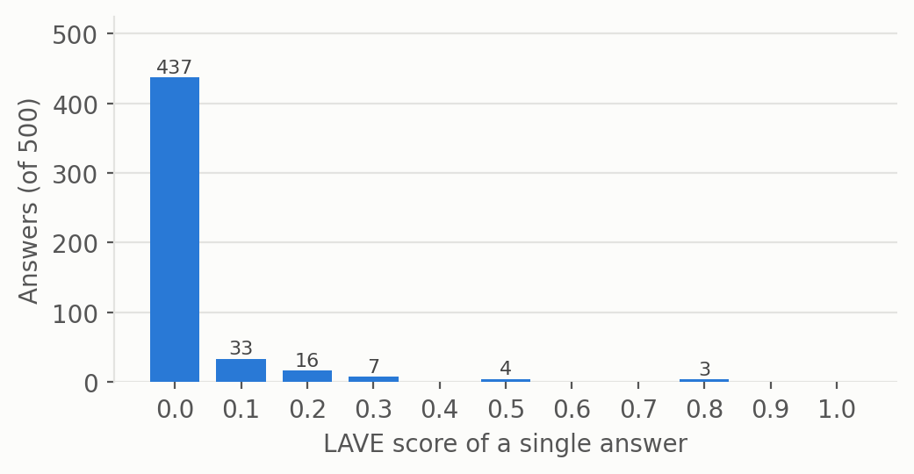
Figure 6. Distribution of single-answer LAVE scores (blank image). 437 of 500 answers (87%) get exactly 0; 3 get 0.8 or more.
Because the judge sees only the reference and the prediction, an English answer to a Bangla reference is sometimes accepted and sometimes not. Two audits that do not use the judge:
Modality. A rule-based match of the imaging modality (X-ray, CT, MRI in English or Bangla) finds the right modality in 0 of 100 answers (0% ChestX-ray8, 0% MedICaT). Mean LAVE on those same 0 answers is not defined (none). Right-modality answers by wording: “X-ray” n = 0; “CT” n = 0; “MRI” n = 0; other wording n = 0. Modality is close to a base-rate task: X-ray is 56% of the references in this sample, so a constant “x-ray” answer already finds the right modality for those questions without seeing the image.
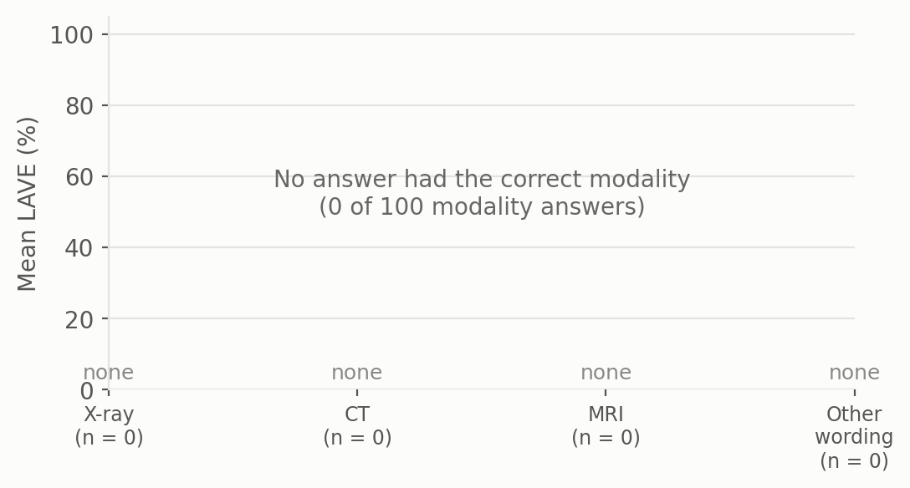
Figure 7. Mean LAVE for answers whose modality is correct by rule-based matching, split by how the answer is worded (blank image).
Yes/No. 28 abnormality answers are a correct Yes or No (Yes where the reference is Yes, No where it is No). The judge gives credit to 6 of them (mean LAVE 0.14).
Table 3. LAVE for correct Yes/No answers, by exact answer string.
Reference | Model answer | n | Mean LAVE
না | No | 15 | 0.00
না | No abnormality | 6 | 0.00
না | no | 7 | 0.56

Reading. For this model the paper's LAVE protocol is a noisy lower bound: it can under-credit correct English answers. Use LAVE as the main metric, but read its category pattern together with the audits above.
7. Real image versus blank image
The blank run and the real-image run use the same 500 questions, so scores can be compared question by question.
LAVE: 16.0% with the real image, 2.6% with the blank image (-13.4 points). Per question, the real image scores higher on 136, the blank image on 39, and they tie on 325. Mean paired difference 13.4 points (95% bootstrap CI 10.7–16.2). The model gives the same answer with and without the scan on 8% of questions.
Exact match: 0 of 500 with the real image, 0 with the blank image.
Table 4. LAVE by cell, real image versus blank image for MedVLM-R1.
Source | Category | Real LAVE % | Blank LAVE % | Change (pts)
ChestX-ray8 | Abnormality | 12.8 | 0.0 | -12.8
ChestX-ray8 | Condition | 3.8 | 3.4 | -0.4
ChestX-ray8 | Modality | 58.6 | 1.2 | -57.4
ChestX-ray8 | Organ | 5.2 | 0.6 | -4.6
ChestX-ray8 | Position | 4.0 | 3.4 | -0.6
MedICaT | Abnormality | 0.0 | 7.8 | +7.8
MedICaT | Condition | 12.2 | 3.6 | -8.6
MedICaT | Modality | 54.4 | 3.4 | -51.0
MedICaT | Organ | 5.4 | 0.0 | -5.4
MedICaT | Position | 3.4 | 2.6 | -0.8
All 500 |  | 16.0 | 2.6 | -13.4

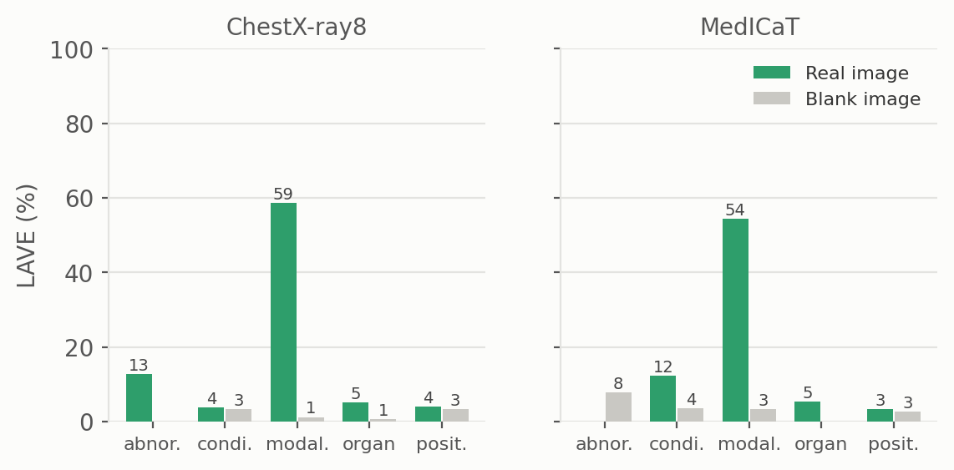
Figure 8. MedVLM-R1: LAVE by category on real images versus the blank white image.
Table 5. All four models on the blank image.
Metric | Gemma 3 4B | MedGemma 4B | MedVLM-R1 | Qwen2-VL-2B
LAVE % (real) | 24.1 | 31.5 | 16.0 | 15.1
LAVE % (blank) | 11.7 | 7.2 | 2.6 | 2.7
Exact match (blank, of 500) | 2 | 0 | 0 | 0
English-only % (blank) | 45.6 | 94.8 | 68.2 | 58.2
Empty % (blank) | 25.0 | 0.4 | 2.4 | 1.2

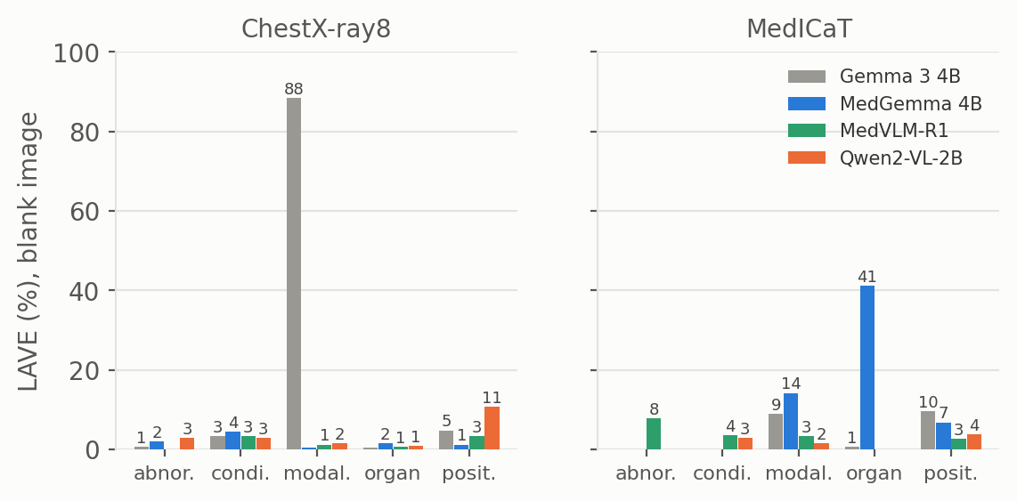
Figure 9. LAVE by category for all four models on the blank image.
8. Example answers
Table 6. One random example per cell (seed 7), blank-image run.
Cell | Question | Reference | Model answer | LAVE
ChestX-ray8 / abnormality | ছবিতে কোনও অস্বাভাবিকতা সনাক্ত হয়েছে কি | না | No abnormality | 0.0
ChestX-ray8 / condition | এখানে কোন নির্দিষ্ট অবস্থা চিহ্নিত করা হ | প্রলায়, এম্ফিসেমা, এবং মাঝ বাম দিকে নিউ | abnormality | 0.1
ChestX-ray8 / modality | এই ইমেজিং পদ্ধতিটি কী ধরণের? | এক্স-রে | This is a medical image | 0.0
ChestX-ray8 / organ | এই ছবিতে প্রাথমিকভাবে কোন অঙ্গতন্ত্র চিত | বুক | লাইন | 0.0
ChestX-ray8 / position | চিহ্নিত কোনও অবস্থার অ্যানাটোমিক্যাল অবস | কোন অবস্থা চিহ্নিত করা হয়নি। | The image shows a medical image | 0.0
MedICaT / abnormality | ছবিতে কি কোনো অস্বাভাবিকতা আছে? | না | No abnormalities | 0.0
MedICaT / condition | ছবিতে কী কী অবস্থা দেখা যাচ্ছে? | প্লুরাল-ভিত্তিক ঘনত্ব | The image shows a heart | 0.0
MedICaT / modality | এই ছবিতে কোন ইমেজিং মোডালিটি ব্যবহার করা | এমআরআই | এই ছবিতে কোন ইমেজিং মোডালিটি ব্যবহার করা | 0.2
MedICaT / organ | এই ছবিতে কোন অঙ্গ দেখানো হয়েছে? | বুক | রান্নার অঙ্গ | 0.0
MedICaT / position | সাবঅ্যারাকনয়েড হেমোরেজ (SAH) এর অবস্থান | ইন্ট্রাক্রানিয়াল | লম্বায় দুর্ঘটনা হামলা হয় | 0.0

9. What we take from this
On a blank image MedVLM-R1 still scores LAVE 2.6% (real image 16.0%), exact match 0/500, BERTScore 67.5. The share of the real-image LAVE that survives without an image is 16%.
The best blank-image cell is MedICaT / abnormality at 7.8% LAVE (real image 0.0%). Cells that keep most of their real-image score depend on question wording or stock answers, not on the scan; cells that collapse depend on the image.
English-only answers: 68% of outputs; empty answers: 12 of 500. Abnormality: a clear Yes/No on only 55 of 100 questions.
Caveats
• Sample is from the train splits, not the paper's test split. n = 50 per cell, so category-level intervals are wide (Table 2).
• References are LLM-generated from metadata (paper: 97% acceptance on an expert-checked subset). Some references are generic, for example “no specific condition identified”.
• LAVE uses the paper's simplified prompt (reference and prediction only, no question). The Yes/No classification and modality matching in Sections 5 and 6 are our own rule-based audits, not paper metrics.
• One greedy run per question; a single white blank image. A black or noise image, or other prompts, could give a different fallback behaviour; these were not tested here.
• LAVE above zero on a blank image measures the non-image part of the score; it is not a precise amount to subtract from the real-image score.

