MedGemma 4B-it on RadImageNet-VQA
Zero-shot results on 500 closed-ended and multiple-choice questions
12 October 2026 · source files: vqa_results_medgemma_4b.csv, vqa_scores_medgemma_4b.csv

Summary
MedGemma 4B-it answered 306 of 500 questions correctly (61.2%, 95% CI 56.9–65.4%). All 500 outputs were a single parseable answer. This is the lowest overall score of the four models, although the spread between all four is only 19 questions and not statistically significant.
- Anatomy: 80% on multiple-choice (chance 25%) and 79% on yes/no (chance 50%). The lowest anatomy scores of the four models.
- Abnormality: 55% (interval 45–64%), not above chance (p = 0.18). The model leans toward “no”: it finds only 44% of abnormal scans and 66% of normal ones.
- Pathology yes/no: 60% (interval 50–69%). It answers “yes” only 32% of the time: recall of “yes” 42%, of “no” 78%.
- Pathology multiple-choice: 32% (interval 24–42%), not significantly above chance (p = 0.069). It picks option B for 42 questions although B is correct for 22.
- Direction of bias: the opposite of Gemma 3 4B-it. Gemma answers “yes” to 74% of yes/no questions, MedGemma to 42%.
- Regions: weakest are hip (37%, n = 38) and knee (50%, n = 48); strongest is brain (81%, n = 31).
- Versus the other three (same 500 questions): 306 vs 321 (Qwen2-VL-2B), 325 (MedVLM-R1) and 315 (Gemma 3 4B). No overall difference is significant (McNemar p = 0.28, 0.16, 0.56). The medically tuned MedGemma did not beat its general-purpose base Gemma 3 4B-it in this setting.
Each yes/no group was sampled 50% yes and 50% no, so its accuracy equals balanced accuracy. It is not directly comparable to accuracy on the dataset’s natural yes/no mix (Table 4b).

1. Experimental setup
Table 1. Settings
Item | Setting
Model | google/medgemma-4b-it, zero-shot (no further fine-tuning, no in-context examples). Gemma 3 4B-based model adapted to medical data.
Dataset | raidium/RadImageNet-VQA, benchmark/test split (9,000 questions on 1,000 CT/MRI images)
Questions used | Closed-ended (yes/no) and multiple-choice (4 options). Open-ended questions excluded.
Sample | 500 questions: 5 groups × 100, random seed 42; every yes/no group is 50 “yes” + 50 “no”. Identical to the sample used for the other models.
Prompt | Same fixed instruction as the other models: only the option letter, or only “Yes” / “No”; input is the image, the question and (for MCQ) the options. No model-specific system prompt.
Decoding | Greedy (do_sample=False), at most 16 new tokens, batch size 1
Precision | bf16 weights (AutoModelForImageTextToText, device_map="auto")
Answer parsing | MCQ: first standalone letter A–D. Yes/No: first “yes” or “no” in the lowercased output. Text inside <answer>…</answer> is read first if present (it never occurred).
Scoring | Exact match with the reference answer. An unparsed answer would count as wrong (none occurred). 95% Wilson intervals; one-sided exact binomial test against chance.
Hardware | Not recorded in the output files

Table 2. Sample design (100 questions per group)
Group | Format | Example question | Class split | Chance
Anatomy yes/no | Yes/No | Is the knee visible in the image? | 50 / 50 | 50%
Abnormality yes/no | Yes/No | Does the lung look abnormal? | 50 / 50 | 50%
Pathology yes/no | Yes/No | Is there evidence of renal lesion in this image? | 50 / 50 | 50%
Anatomy MCQ | 4 options | Select the correct anatomical region. | random letters | 25%
Pathology MCQ | 4 options | What is the most likely pathology in this image? | random letters | 25%

Prompts (the question and options are filled in per item):
MCQ: You are a medical assistant. Look at this image and answer the following multiple-choice question with ONLY the letter of the correct option (e.g. 'B'), nothing else. Question: … Options: A. … B. … C. … D. …
Yes/No: You are a medical assistant. Look at this image and answer the following question with ONLY the single word 'Yes' or 'No'. Question: …

2. Results by question group
Anatomy questions are answered reasonably well, though less well than by the other models. Pathology yes/no (p = 0.028) is borderline and does not clear a Bonferroni threshold for five groups (0.01). Abnormality (p = 0.18) and pathology multiple-choice (p = 0.069) are not distinguishable from chance.
Table 3. Accuracy by group
Group | Correct / n | Accuracy | 95% CI | Chance | p vs chance
Anatomy (MCQ) | 80 / 100 | 80% | 71.1–86.7% | 25% | < 0.001
Anatomy (yes/no) | 79 / 100 | 79% | 70.0–85.8% | 50% | < 0.001
Pathology (yes/no) | 60 / 100 | 60% | 50.2–69.1% | 50% | 0.028
Abnormality (yes/no) | 55 / 100 | 55% | 45.2–64.4% | 50% | 0.184
Pathology (MCQ) | 32 / 100 | 32% | 23.7–41.7% | 25% | 0.069
Overall | 306 / 500 | 61.2% | 56.9–65.4% | – | –
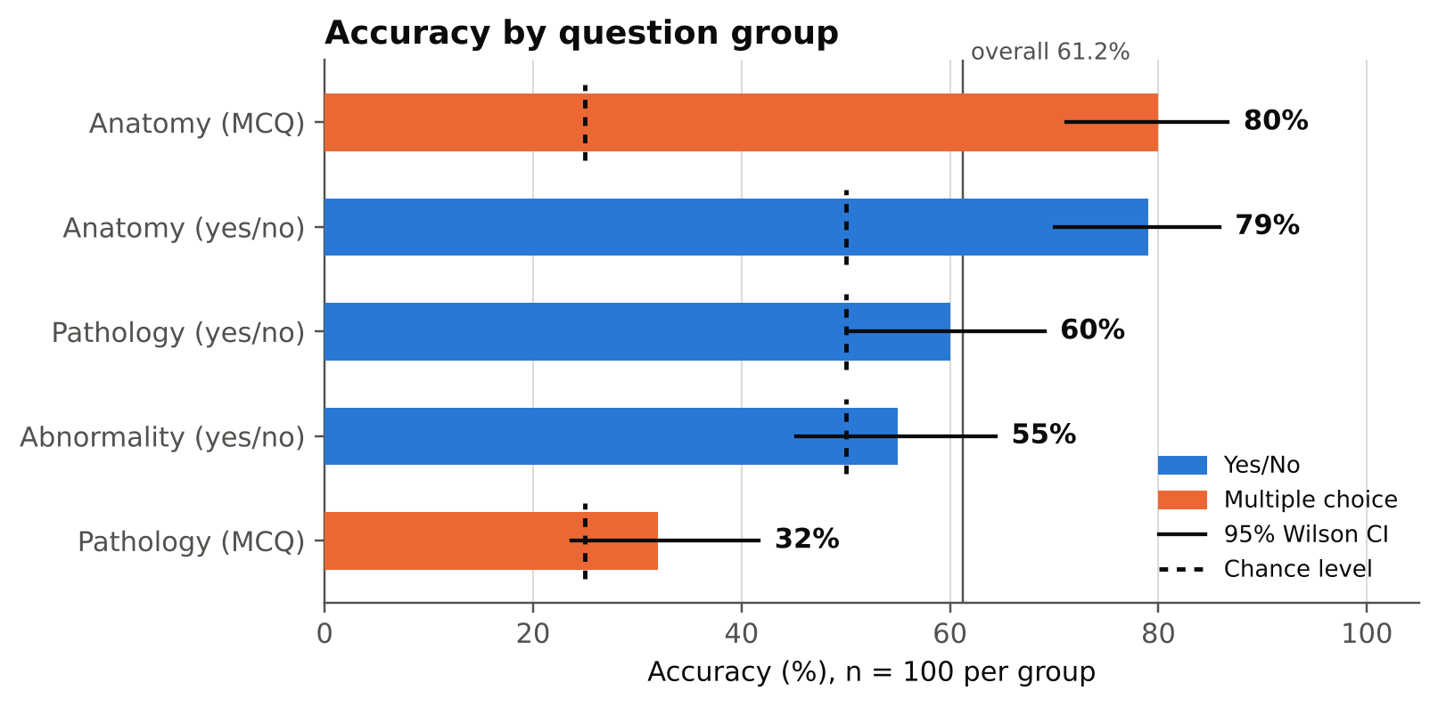
Figure 1. Accuracy by question group with 95% Wilson intervals. Dashed marks show chance level for each group.

3. Yes/No analysis
MedGemma’s yes/no answers lean toward “no” on the two pathology-related groups, the opposite of Gemma 3 4B-it (Figures 2–3, Table 4a).
- Abnormality: “yes” for 39 of 100 questions (exact binomial test against 50%: p = 0.035). It recognises 66% of normal scans (33/50) but only 44% of abnormal scans (22/50). Accuracy of 55% is not above chance.
- Pathology: “yes” for 32 of 100 questions. Recall of “yes” is 42%, of “no” 78%; errors are 29 misses against 11 false alarms.
- Anatomy: a slight lean toward “yes” (55%). Errors: 8 missed structures and 13 structures reported that are not in the scan (knee 4, abdomen 3, hip 3, lung 2, shoulder 1), the most false “yes” answers of the four models.
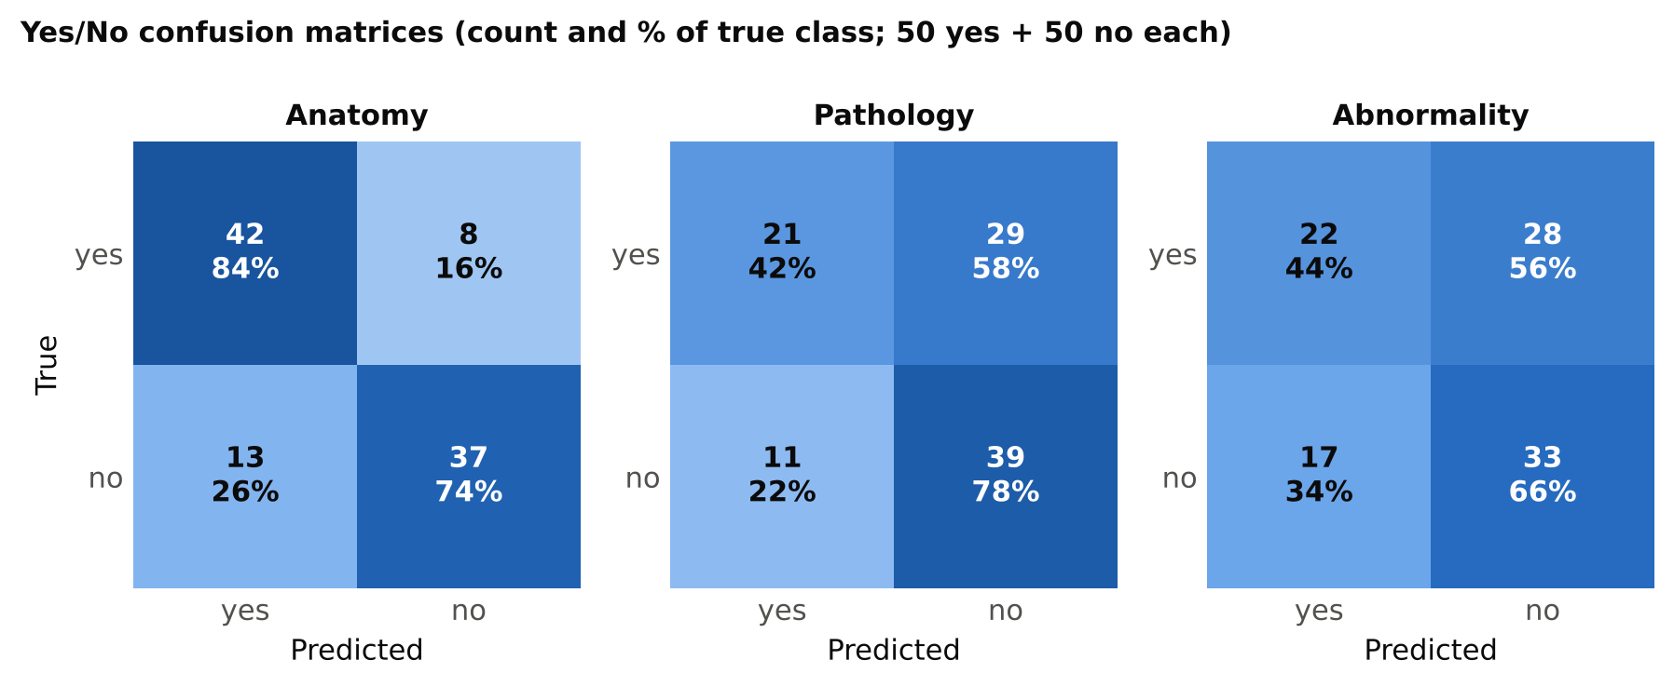
Figure 2. Yes/No confusion matrices. Each cell shows the count and the percentage of the true class.
Table 4a. Yes/No metrics (positive class = “yes”)
Group | Recall yes | Recall no | Precision yes | F1 yes | Predicted yes | Accuracy
Anatomy | 84% | 74% | 76.4% | 0.80 | 55% | 79%
Pathology | 42% | 78% | 65.6% | 0.51 | 32% | 60%
Abnormality | 44% | 66% | 56.4% | 0.49 | 39% | 55%
All yes/no | 56.7% | 72.7% | 67.5% | 0.62 | 42.0% | 64.7%
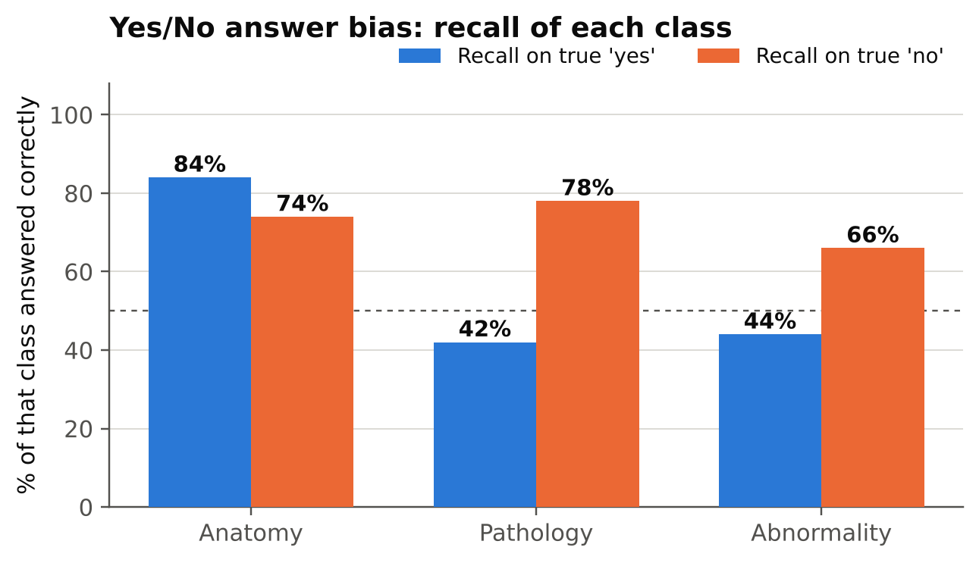
Figure 3. Recall of true “yes” and true “no” questions in each yes/no group. The dashed line marks 50%.
Effect of the sampling design. The full benchmark has more “yes” than “no” answers for abnormality (71.9% yes) and more “no” for pathology (64.1% no). Re-weighting the measured per-class recall to those natural shares gives the estimates in Table 4b. They are rough: each class rests on only 50 questions.
Table 4b. Estimated accuracy at the dataset’s natural yes/no mix
Group | Yes share (full set) | Accuracy on 50/50 sample | Estimated at natural mix | Always-majority baseline
Anatomy | 50.0% | 79.0% | 79.0% | 50.0%
Pathology | 36.0% | 60.0% | 65.1% | 64.1% (always “no”)
Abnormality | 71.9% | 55.0% | 50.2% | 71.9% (always “yes”)
MedGemma’s lean toward “no” happens to suit the pathology mix, where it would roughly match always answering “no”. On the abnormality mix, which is mostly abnormal, the same lean would cost it: about 50%, some 22 points below always answering “yes”. These are estimates from re-weighting, not measured results; the natural shares come from the earlier audit of the full split (abnormality 719 yes / 281 no; pathology 719 yes / 1,281 no).

4. Multiple-choice analysis
Anatomy MCQ errors are concentrated on lung scans. Pathology MCQ shows the strongest letter bias of the four models: option B.
- Anatomy: letter recall is 83% (A), 91% (B), 82% (C) and 64% (D). 20 errors: lung 9, abdomen 4, hip 3, knee 3, brain 1. Six of the 22 true-D questions were answered B.
- Pathology: the model chose B 42 times against 22 correct Bs (exact binomial test against 25%: p < 0.001). Letter recall is 55% for B but only 20% for A, 20% for C and 36% for D. B was the answer for 9 of 25 true-A, 11 of 25 true-C and 10 of 28 true-D questions. Much of its 32% comes from the B questions.
Table 5. Option-letter statistics
Group | Letter | Correct answers (n) | Model answers (n) | Recall
Anatomy (MCQ) | A | 29 | 27 | 82.8%
 | B | 22 | 32 | 90.9%
 | C | 27 | 25 | 81.5%
 | D | 22 | 16 | 63.6%
Pathology (MCQ) | A | 25 | 19 | 20.0%
 | B | 22 | 42 | 54.5%
 | C | 25 | 16 | 20.0%
 | D | 28 | 23 | 35.7%
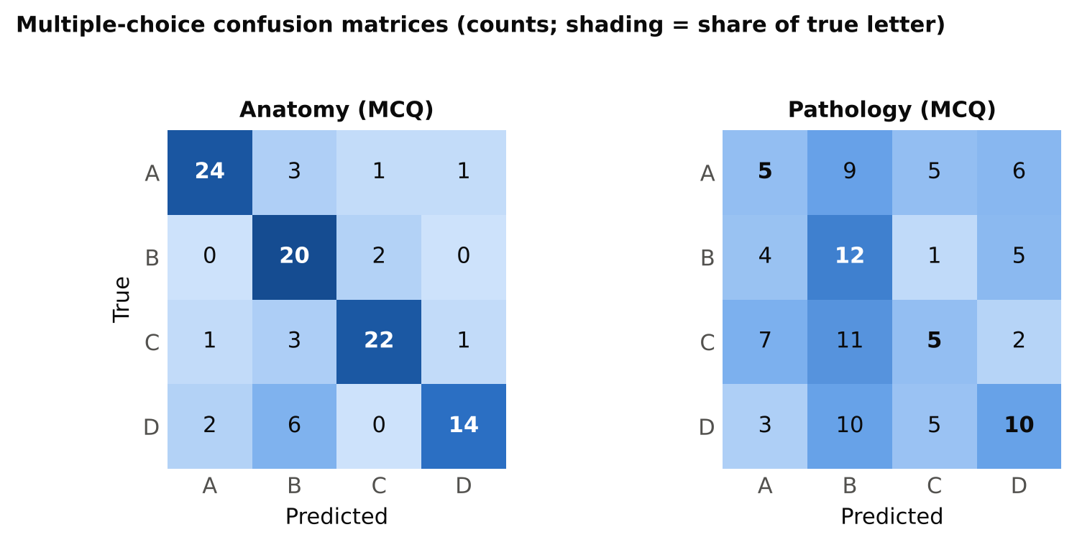
Figure 4. Multiple-choice confusion matrices (counts). In the pathology matrix, column B receives the most answers.
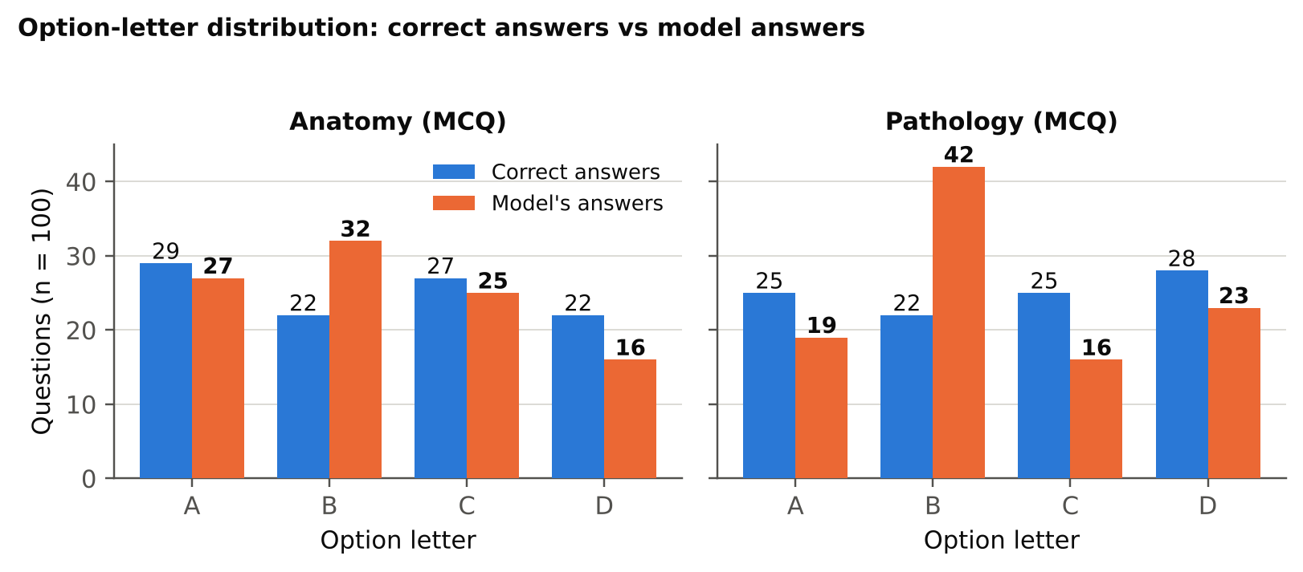
Figure 5. How often each letter is correct versus how often the model chooses it.

5. Anatomical regions
Accuracy varies by region, but most cells are small. Hip (14/38, 37%) is clearly weakest and knee (24/48, 50%) next; lung (70/116, 60%) and abdomen (107/163, 66%) are in between. Brain (25/31, 81%) is highest, on only 31 questions. Anatomy MCQ is again lower on lung (16/25) than on abdomen (30/34), and knee (6/9) and hip (5/8) are weak on both anatomy groups.
Abnormality by region follows the “no” lean. Ankle foot has 11 abnormal scans in the sample and the model finds 2 of them (18%); hip is 0 of 6. The model does better on regions where most scans in the sample are normal (abdomen 66%, lung 58%). Pathology MCQ is highest on lung (11/25) and brain (3/4) and 0/5 on spine; all these cells are small.
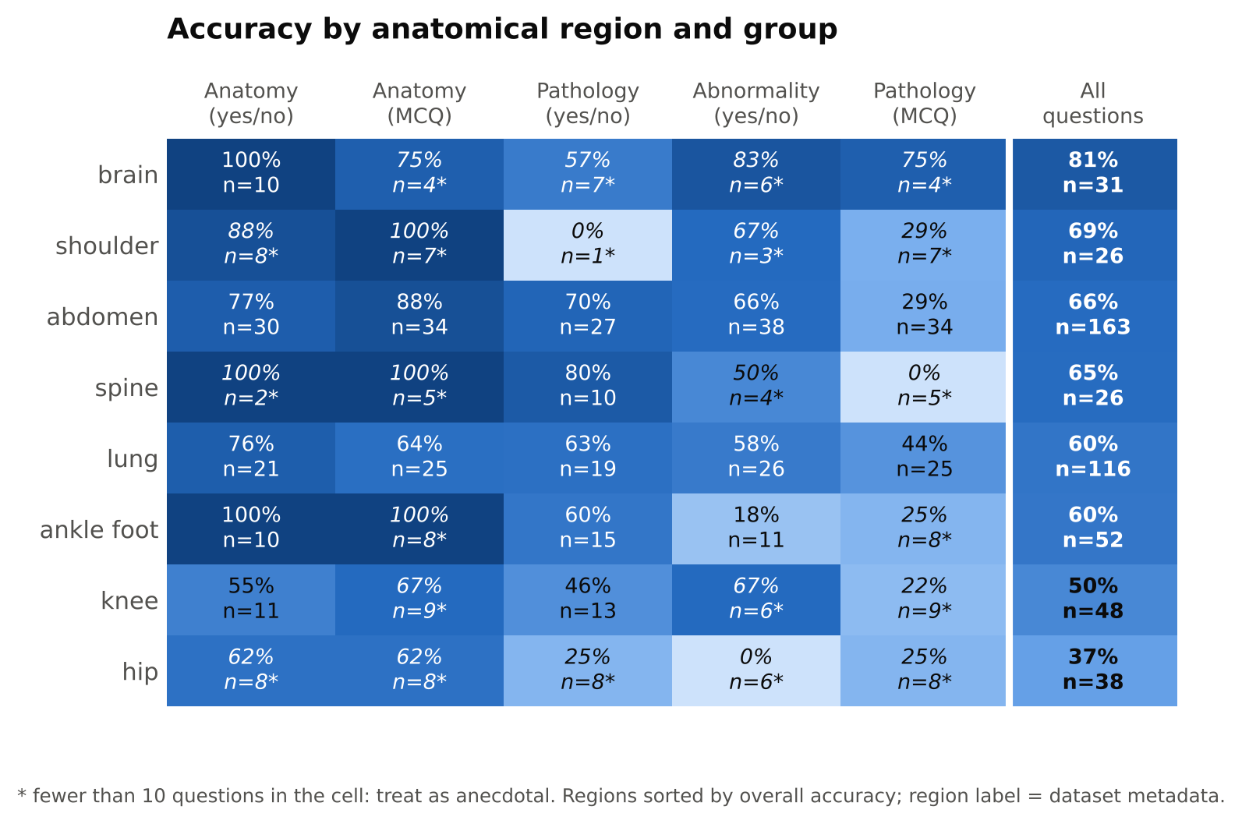
Figure 6. Accuracy by anatomical region (rows) and question group (columns). Starred cells have fewer than 10 questions.

6. Comparison with the other three models
All four models were run on the same 500 questions. Table 6 puts them side by side; Table 7 compares MedGemma with each of the others question by question.
Table 6. Accuracy of all four models (n = 100 per group)
Group | Qwen2-VL-2B | MedVLM-R1 | Gemma 3 4B | MedGemma 4B
Anatomy (yes/no) | 88 | 86 | 81 | 79
Anatomy (MCQ) | 87 | 88 | 84 | 80
Pathology (yes/no) | 57 | 57 | 61 | 60
Abnormality (yes/no) | 55 | 61 | 52 | 55
Pathology (MCQ) | 34 | 33 | 37 | 32
Overall (of 500) | 321 | 325 | 315 | 306
Share of “yes” answers: abnormality | 77% | 69% | 98% | 39%
Share of “yes” answers: pathology | 43% | 47% | 75% | 32%
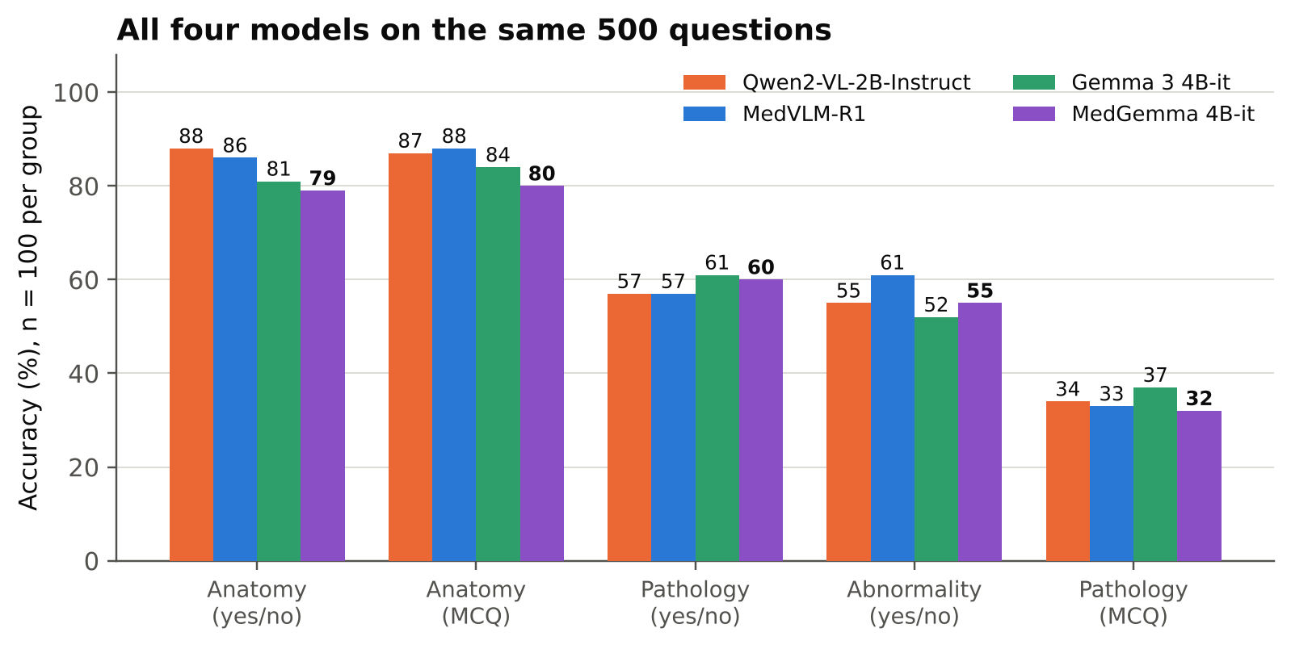
Figure 7. Accuracy of the four models on each group (same questions).
- No overall winner: the four totals range from 306 to 325 (19 questions). The largest paired gap, MedVLM-R1 over MedGemma (91 questions only MedVLM-R1, 72 only MedGemma), has McNemar p = 0.16.
- Medical tuning did not help here: MedVLM-R1 vs its Qwen base is +4 questions; MedGemma vs its Gemma 3 base is −9 questions (p = 0.56). Neither difference is significant.
- Where MedGemma trails: anatomy. Anatomy MCQ is 80 vs 87–88 for the Qwen-based models (p = 0.065 and 0.021, uncorrected) and anatomy yes/no is 79 vs 88 (p = 0.049 vs Qwen). With 15 comparisons in this table these are hints, not findings.
- Different answers: MedGemma gives the same answer as Qwen on 59% of questions, MedVLM-R1 on 60% and Gemma on 55%. On pathology MCQ the agreement is only 17–19%, no higher than the 25% two independently guessing models would show: on these questions the models are close to guessing, each with its own letter lean (MedGemma and Gemma toward B, Qwen and MedVLM-R1 toward C).
- Shared limits: 65 questions (13.0%) are wrong for all four models and 194 (38.8%) right for all four. A per-question oracle choosing the best of the four would score 87.0%.
Table 7. MedGemma versus each other model: questions only MedGemma gets right / only the other gets right (McNemar p)
Group | vs Qwen2-VL-2B | vs MedVLM-R1 | vs Gemma 3 4B
Anatomy (yes/no) | 4 / 13 (0.049) | 5 / 12 (0.14) | 6 / 8 (0.79)
Anatomy (MCQ) | 2 / 9 (0.065) | 1 / 9 (0.021) | 4 / 8 (0.39)
Pathology (yes/no) | 22 / 19 (0.76) | 22 / 19 (0.76) | 25 / 26 (1.00)
Abnormality (yes/no) | 24 / 24 (1.00) | 20 / 26 (0.46) | 31 / 28 (0.80)
Pathology (MCQ) | 24 / 26 (0.89) | 24 / 25 (1.00) | 23 / 28 (0.58)
Overall | 76 / 91 (0.28) | 72 / 91 (0.16) | 89 / 98 (0.56)
Same answer, overall | 59% | 60% | 55%
With 100 questions per group, only differences of roughly 15 points or more would be reliable.

7. Error analysis
- Abnormality: normal scans were answered correctly 33 of 50 times (abdomen 14/23, lung 13/19, brain 3/3, shoulder 2/2, spine 1/1, hip 0/2); abnormal scans only 22 of 50 (abdomen 11/15, knee 4/6, brain 2/3, lung 2/7, ankle foot 2/11, spine 1/3, hip 0/4, shoulder 0/1).
- Pathology negatives: among the 39 pathology_closed_neg questions (all true “no”) the model scored 74% (29 correct). Among the 61 pathology_closed_pos questions it scored 51% (31 correct): 21 of 50 true “yes” and 10 of 11 true “no”. The one error on the true-“no” questions was “osseous lesion” on a brain scan. With these sample sizes this is an observation, not a conclusion.
- Anatomy errors: 21 in total: 8 missed structures (abdomen 4, lung 3, knee 1) and 13 false “yes” answers (knee 4, abdomen 3, hip 3, lung 2, shoulder 1).
- Formatting: no unparsed outputs. Every raw output was exactly one token: “Yes”, “No”, or a letter.
Table 8. Examples of wrong answers
Group | Region | Question | True | Model
Anatomy yes/no | abdomen | Can you identify the abdomen in this image? | yes | no
Anatomy yes/no | hip | Is the spine present in this image? | no | yes
Abnormality | hip | Does this scan reveal any abnormalities? | yes | no
Abnormality | abdomen | Is there an abnormality present? | no | yes
Pathology yes/no | abdomen | Is the abdomen affected by bowel mass? | yes | no
Pathology yes/no | knee | Are there signs of fracture? | no | yes
Pathology MCQ | shoulder | What is the most likely pathology in this image? | C | B
Pathology MCQ | abdomen | Select the pathology that best describes this image: | C | B
The results file stores the question text but not the answer options, so the options behind a wrong MCQ letter cannot be read from it.

8. Limitations
- Sample size: 100 questions per group gives intervals of about ±9 points. Differences of a few points between groups or between models are not reliable, and most region-by-group cells have fewer than 30 questions.
- One run, one prompt: greedy decoding with a single fixed prompt shared by all four models. MedGemma’s lean toward “no” and toward B may depend on this prompt, and a medical model may respond better to its own recommended prompt format; this was not tested. Precision (bf16 here) was not varied.
- Sampling: yes/no groups are balanced by design. Natural-mix figures in Table 4b are estimates.
- Region labels: regions come from the dataset’s location field; they are not verified against the images.
- Possible overlap: the dataset is derived from RadImageNet; overlap with the models’ training data is unknown.
- Not a clinical evaluation: these results describe benchmark behaviour only.

9. Files and next steps
Files produced with this report: seven figures (PNG and PDF, figures/) and the tables as CSV files (tables/) matching Tables 3, 4a, 4b, 5, the paired comparisons in Table 7 and the region breakdown in Figure 6.
- Build one combined four-model comparison from the four result files, with balanced accuracy, recall of both classes and paired tests for every pair of models.
- Optionally test prompt sensitivity (for example a different wording, or a model-specific system prompt) on the two Gemma-based models, since both show a strong yes/no or letter bias.
- Add the answer options and the GPU used to the saved results for the next runs.

