MedVLM-R1 on RadImageNet-VQA
Zero-shot results on 500 closed-ended and multiple-choice questions
12 October 2026 · source files: vqa_results_medvlm_r1.csv, vqa_scores_medvlm_r1.csv

Summary
MedVLM-R1 answered 325 of 500 questions correctly (65.0%, 95% CI 60.7–69.1%). All 500 outputs were a single parseable answer. The pattern matches Qwen2-VL-2B-Instruct almost exactly: strong on anatomy, close to chance on pathology and abnormality questions.
- Anatomy: 88% on multiple-choice (chance 25%) and 86% on yes/no (chance 50%).
- Pathology: 33% on multiple-choice (chance 25%; interval 24.6–42.7% includes 25%) and 57% on yes/no (interval 47–66% includes 50%).
- Abnormality: 61% (interval 51–70%). The model answers “yes” to 69% of these questions: it finds 80% of abnormal scans but only 42% of normal ones.
- Pathology multiple-choice: the model picks option C for 35% of questions, although C is correct for 25%.
- Regions: weakest are hip (47%, n = 38) and lung (57%, n = 116); strongest are knee (75%, n = 48) and shoulder (73%, n = 26).
- Versus Qwen2-VL-2B-Instruct (same 500 questions): 325 vs 321 correct. The two models give the same answer on 93% of questions; the 4-question difference is not significant (McNemar p = 0.57).
Each yes/no group was sampled 50% yes and 50% no, so its accuracy equals balanced accuracy. It is not directly comparable to accuracy on the dataset’s natural yes/no mix (Table 4b).

1. Experimental setup
Table 1. Settings
Item | Setting
Model | JZPeterPan/MedVLM-R1, zero-shot (no further fine-tuning, no in-context examples). Loaded as a Qwen2-VL model; the processor comes from Qwen/Qwen2-VL-2B-Instruct and the config’s use_cache field was set to True (it was null).
Dataset | raidium/RadImageNet-VQA, benchmark/test split (9,000 questions on 1,000 CT/MRI images)
Questions used | Closed-ended (yes/no) and multiple-choice (4 options). Open-ended questions excluded.
Sample | 500 questions: 5 groups × 100, random seed 42; every yes/no group is 50 “yes” + 50 “no”. Identical to the sample used for Qwen2-VL-2B-Instruct.
Prompt | Fixed instruction asking for only the option letter, or only “Yes” / “No”; input is the image, the question and (for MCQ) the options
Decoding | Greedy (do_sample=False), at most 16 new tokens, batch size 1
Precision | bf16 weights, SDPA attention
Answer parsing | MCQ: first standalone letter A–D. Yes/No: first “yes” or “no” in the lowercased output. Text inside <answer>…</answer> is read first if present (it never occurred).
Scoring | Exact match with the reference answer. An unparsed answer would count as wrong (none occurred). 95% Wilson intervals; one-sided exact binomial test against chance.
Hardware | Not recorded in the output files

Table 2. Sample design (100 questions per group)
Group | Format | Example question | Class split | Chance
Anatomy yes/no | Yes/No | Is the knee visible in the image? | 50 / 50 | 50%
Abnormality yes/no | Yes/No | Does the lung look abnormal? | 50 / 50 | 50%
Pathology yes/no | Yes/No | Is there evidence of renal lesion in this image? | 50 / 50 | 50%
Anatomy MCQ | 4 options | Select the correct anatomical region. | random letters | 25%
Pathology MCQ | 4 options | What is the most likely pathology in this image? | random letters | 25%

Prompts (the question and options are filled in per item):
MCQ: You are a medical assistant. Look at this image and answer the following multiple-choice question with ONLY the letter of the correct option (e.g. 'B'), nothing else. Question: … Options: A. … B. … C. … D. …
Yes/No: You are a medical assistant. Look at this image and answer the following question with ONLY the single word 'Yes' or 'No'. Question: …
Important: MedVLM-R1 is a model trained to reason before answering. Because the prompt asks for one word or letter and generation stops at 16 tokens, every output was a bare answer. These results therefore describe the model in direct-answer mode, not in its reasoning mode.

2. Results by question group
Anatomy questions are answered well; the three pathology-related groups are near chance. The two anatomy groups beat chance by 36–63 points with intervals far from chance. Abnormality (p = 0.018), pathology yes/no (p = 0.097) and pathology multiple-choice (p = 0.045) are one-sided, uncorrected; none of the three clears a Bonferroni threshold for five groups (0.01).
Table 3. Accuracy by group
Group | Correct / n | Accuracy | 95% CI | Chance | p vs chance
Anatomy (MCQ) | 88 / 100 | 88% | 80.2–93.0% | 25% | < 0.001
Anatomy (yes/no) | 86 / 100 | 86% | 77.9–91.5% | 50% | < 0.001
Abnormality (yes/no) | 61 / 100 | 61% | 51.2–70.0% | 50% | 0.018
Pathology (yes/no) | 57 / 100 | 57% | 47.2–66.3% | 50% | 0.097
Pathology (MCQ) | 33 / 100 | 33% | 24.6–42.7% | 25% | 0.045
Overall | 325 / 500 | 65.0% | 60.7–69.1% | – | –
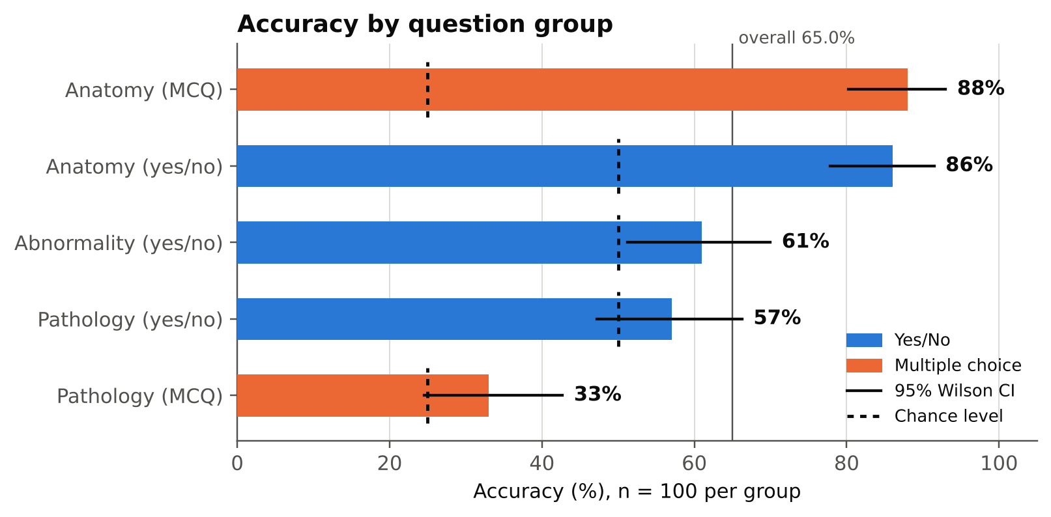
Figure 1. Accuracy by question group with 95% Wilson intervals. Dashed marks show chance level for each group.

3. Yes/No analysis
The yes/no errors are not symmetric: the model has a different answer bias in each group (Figures 2–3, Table 4a).
- Abnormality: the model answers “yes” for 69 of 100 questions (exact binomial test against 50%: p < 0.001). It recognises 80% of abnormal scans (40/50) but only 42% of normal scans (21/50). The 61% accuracy is a mix of these two very different rates.
- Anatomy: errors are mostly missed “yes” answers (11 of 14 errors). The model says “no” to a visible structure 22% of the time, but rarely says “yes” to an absent one (3 of 50).
- Pathology: errors are balanced (23 missed findings, 20 false alarms); recall of “yes” is 54% and of “no” 60%, close to a coin flip.
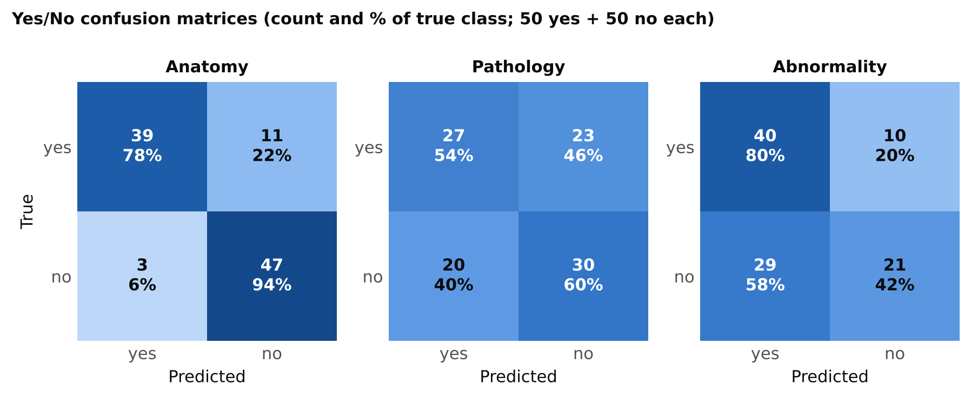
Figure 2. Yes/No confusion matrices. Each cell shows the count and the percentage of the true class.
Table 4a. Yes/No metrics (positive class = “yes”)
Group | Recall yes | Recall no | Precision yes | F1 yes | Predicted yes | Accuracy
Anatomy | 78% | 94% | 92.9% | 0.85 | 42% | 86%
Pathology | 54% | 60% | 57.4% | 0.56 | 47% | 57%
Abnormality | 80% | 42% | 58.0% | 0.67 | 69% | 61%
All yes/no | 70.7% | 65.3% | 67.1% | 0.69 | 52.7% | 68.0%
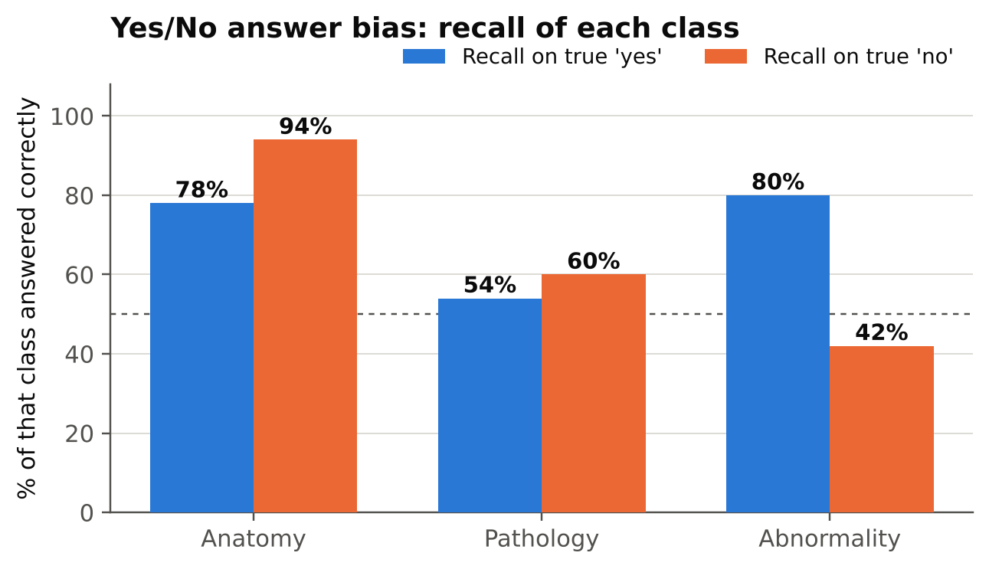
Figure 3. Recall of true “yes” and true “no” questions in each yes/no group. The dashed line marks 50%.
Effect of the sampling design. The full benchmark has more “yes” than “no” answers for abnormality (71.9% yes) and more “no” for pathology (64.1% no). Re-weighting the measured per-class recall to those natural shares gives the estimates in Table 4b. They are rough: each class rests on only 50 questions.
Table 4b. Estimated accuracy at the dataset’s natural yes/no mix
Group | Yes share (full set) | Accuracy on 50/50 sample | Estimated at natural mix | Always-majority baseline
Anatomy | 50.0% | 86.0% | 86.0% | 50.0%
Pathology | 36.0% | 57.0% | 57.8% | 64.1% (always “no”)
Abnormality | 71.9% | 61.0% | 69.3% | 71.9% (always “yes”)
On natural data the model would likely score below a constant-answer guess on the two pathology-related groups. This is an estimate from re-weighting, not a measured result; the natural shares come from the earlier audit of the full split (abnormality 719 yes / 281 no; pathology 719 yes / 1,281 no).

4. Multiple-choice analysis
Anatomy MCQ errors are scattered (12 errors; 7 on lung scans) with no strong favourite letter. Pathology MCQ shows a pull toward option C.
- Anatomy: letter recall is 97% (A), 86% (B), 93% (C) and 73% (D). The model’s answer counts closely follow the correct-answer counts.
- Pathology: the model chose C 35 times against 25 correct Cs (exact binomial test against 25%: p = 0.028, uncorrected). Only 5 of 22 true-B questions were answered correctly (23%); 8 of them went to C, as did 11 of the 28 true-D questions.
Table 5. Option-letter statistics
Group | Letter | Correct answers (n) | Model answers (n) | Recall
Anatomy (MCQ) | A | 29 | 30 | 96.6%
 | B | 22 | 22 | 86.4%
 | C | 27 | 29 | 92.6%
 | D | 22 | 19 | 72.7%
Pathology (MCQ) | A | 25 | 21 | 36.0%
 | B | 22 | 21 | 22.7%
 | C | 25 | 35 | 36.0%
 | D | 28 | 23 | 35.7%
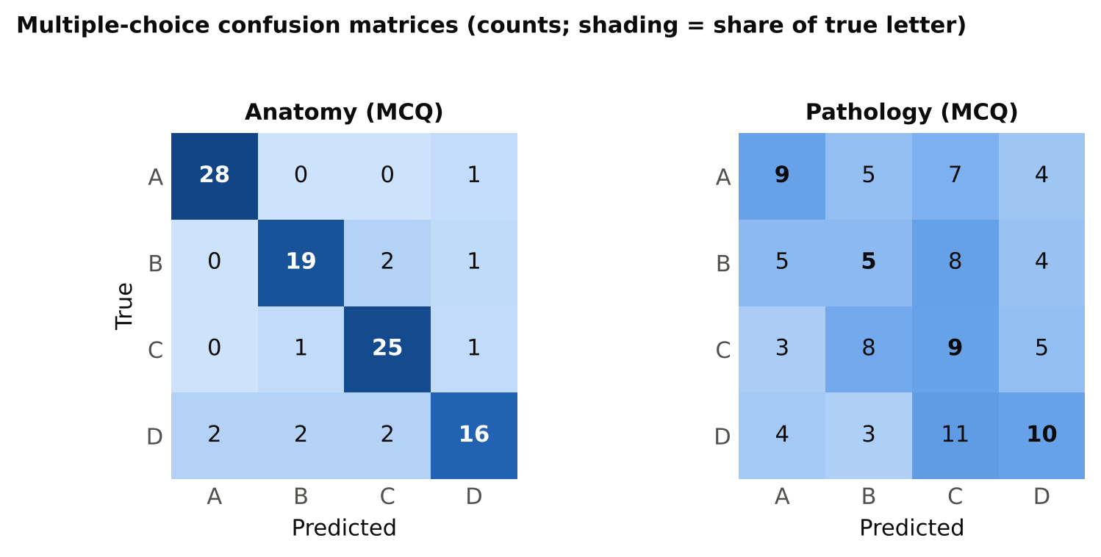
Figure 4. Multiple-choice confusion matrices (counts). The pathology matrix shows the shift toward column C.
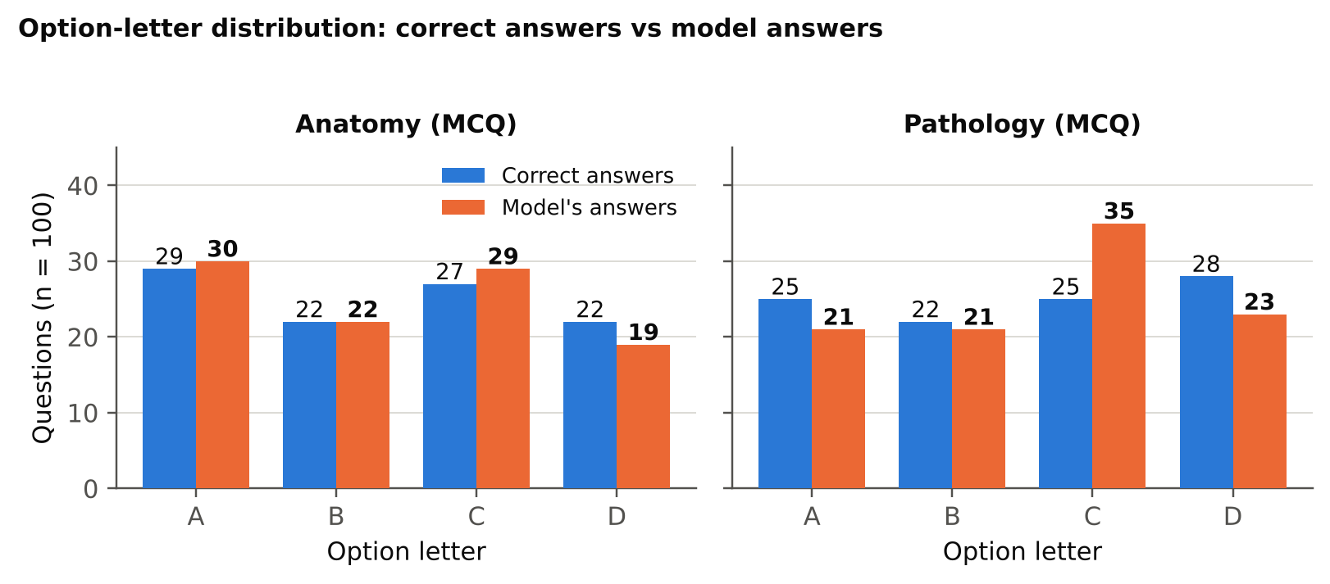
Figure 5. How often each letter is correct versus how often the model chooses it.

5. Anatomical regions
Accuracy varies by region, but most cells are small. Hip (18/38, 47%) and lung (66/116, 57%) are weakest. Abdomen, the largest region (163 questions), reaches 69%. The lung weakness appears even in anatomy questions (71% yes/no, 72% MCQ, against 93% and 94% for abdomen). Pathology MCQ is lowest on knee (1/9), hip (1/8), spine (1/5) and brain (1/4), but those cells are too small to rank regions reliably; the best region there is abdomen (15/34, 44%).
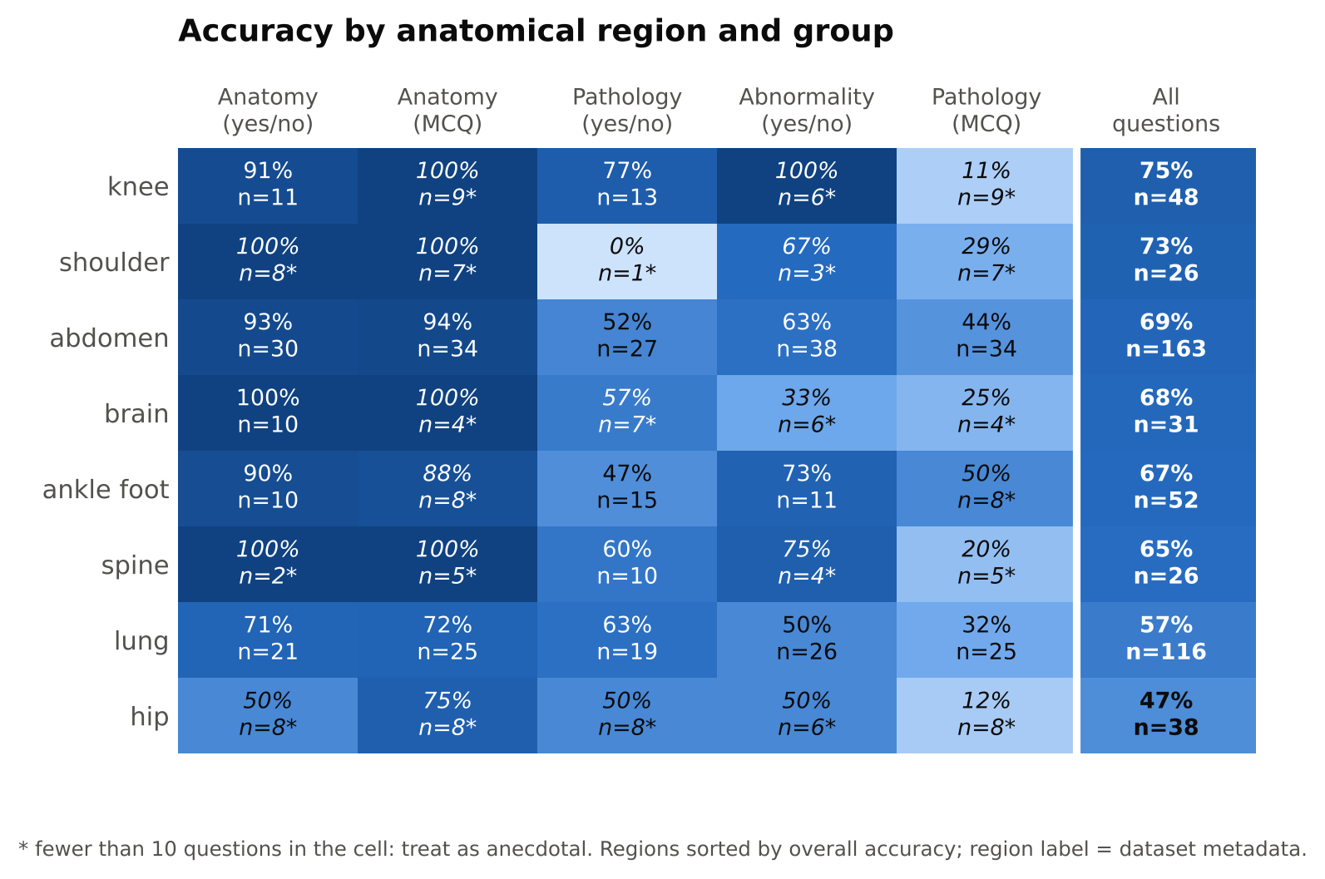
Figure 6. Accuracy by anatomical region (rows) and question group (columns). Starred cells have fewer than 10 questions.

6. Comparison with Qwen2-VL-2B-Instruct
Both models were run on the same 500 questions, so answers can be compared question by question. MedVLM-R1 is fine-tuned from the Qwen2-VL-2B family (as far as I know from its model card), and the results show how little that changed in this setting.
- Almost the same answers: the two models give an identical answer on 93% of questions (465 of 500).
- Net difference of 4 questions: 16 questions are right only for MedVLM-R1 and 12 only for Qwen (McNemar exact p = 0.57).
- Largest gap: abnormality, 61 vs 55 (9 questions only MedVLM-R1, 3 only Qwen; p = 0.15). MedVLM-R1 is less biased toward “yes” there (69% vs 77%) and recognises more normal scans (42% vs 28%), but its accuracy is still within the noise of the Qwen result.
- Everything else is a tie: anatomy 86/88 (yes/no) and 88/87 (MCQ), pathology 57/57 (yes/no) and 33/34 (MCQ).
- Shared weakness: 163 questions (32.6%) are wrong for both models; the best any per-question choice between the two could score is 67.4%.
Table 6. Paired comparison (same 500 questions)
Group | Qwen | MedVLM | Both right | Only MedVLM | Only Qwen | Both wrong | Same answer
Anatomy (yes/no) | 88 | 86 | 86 | 0 | 2 | 12 | 98%
Anatomy (MCQ) | 87 | 88 | 87 | 1 | 0 | 12 | 98%
Pathology (yes/no) | 57 | 57 | 53 | 4 | 4 | 39 | 92%
Abnormality (yes/no) | 55 | 61 | 52 | 9 | 3 | 36 | 88%
Pathology (MCQ) | 34 | 33 | 31 | 2 | 3 | 64 | 89%
Overall | 321 | 325 | 309 | 16 | 12 | 163 | 93%
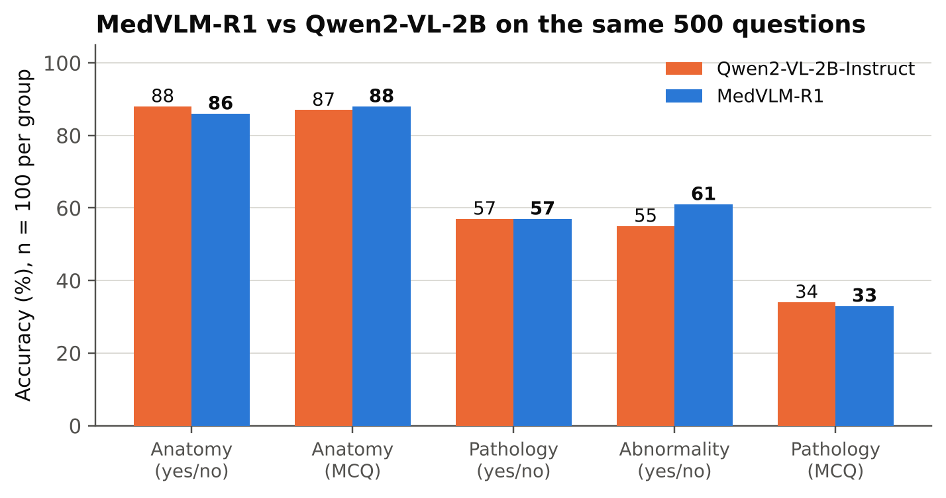
Figure 7. Accuracy of the two models on each group (same questions).
With 100 questions per group, none of the per-group differences is significant (McNemar p ≥ 0.15). For a four-model comparison it will be more informative to look at paired counts like these than at accuracy alone.

7. Error analysis
- Normal scans called abnormal: 29 of 50 normal scans were called abnormal. Correct “no” answers by region: abdomen 10/23, lung 8/19, brain 1/3, hip 1/2, shoulder 1/2, spine 0/1.
- Anatomy errors: 14 in total. 11 are missed “yes” answers: lung 5, abdomen 2, hip 2, knee 1, ankle foot 1. The 3 false “yes” answers are shoulder and spine on hip scans, and abdomen on a lung scan.
- Pathology negatives: 11 questions in the pathology_closed_pos question type have a true answer “no”. The model answered 8 correctly and said “yes” to three: renal lesion (abdomen scan), osseous lesion (brain scan) and cystic lesions (abdomen scan). With n = 11 this is an observation, not a conclusion.
- Formatting: no unparsed outputs. Every raw output was exactly one token: “Yes”, “No”, or a letter. There was no reasoning text and no <answer> tag.
Table 7. Examples of wrong answers
Group | Region | Question | True | Model
Anatomy yes/no | lung | Can you see the lung? | yes | no
Anatomy yes/no | hip | Is the shoulder present in this image? | no | yes
Abnormality | lung | Does the lung look abnormal? | no | yes
Abnormality | abdomen | Does the abdomen look abnormal? | no | yes
Abnormality | hip | Does this scan reveal any abnormalities? | yes | no
Pathology yes/no | abdomen | Does the patient have pancreatic lesion? | yes | no
Pathology yes/no | abdomen | Is there evidence of renal lesion in this image? | no | yes
Pathology MCQ | abdomen | What pathology is shown in this scan of abdomen | A | B
The results file stores the question text but not the answer options, so the options behind a wrong MCQ letter cannot be read from it.

8. Limitations
- Direct-answer mode only: MedVLM-R1 was designed to produce reasoning before its answer. This run forced a one-word answer, so it does not show what the model can do when it is allowed to reason.
- Sample size: 100 questions per group gives intervals of about ±9 points. Differences of a few points between groups or between models are not reliable, and most region-by-group cells have fewer than 30 questions.
- One run, one prompt: greedy decoding with a single fixed prompt. Sensitivity to prompt wording and to precision (bf16 here) was not tested.
- Sampling: yes/no groups are balanced by design. Natural-mix figures in Table 4b are estimates.
- Region labels: regions come from the dataset’s location field; they are not verified against the images.
- Possible overlap: the dataset is derived from RadImageNet; overlap with the model’s training data is unknown.
- Not a clinical evaluation: these results describe benchmark behaviour only.

9. Files and next steps
Files produced with this report: seven figures (PNG and PDF, figures/) and six tables (CSV, tables/) matching Tables 3, 4a, 4b, 5, 6 and the region breakdown in Figure 6.
- Run Gemma 3 4B-it and MedGemma 4B-it on the same 500 questions, then compare all four models with paired counts and a correction for the five groups.
- Optionally run MedVLM-R1 once with a prompt and token limit that let it reason (for example 512 new tokens, answer read from <answer>), as a separate condition.
- Add the answer options and the GPU used to the saved results for the next runs.

