Qwen2-VL-2B-Instruct on RadImageNet-VQA
Zero-shot results on 500 closed-ended and multiple-choice questions
12 October 2026 · source files: vqa_results_qwen2vl_2b.csv, vqa_scores_qwen2vl_2b.csv

Summary
Qwen2-VL-2B-Instruct answered 321 of 500 questions correctly (64.2%, 95% CI 59.9–68.3%). All 500 outputs were a single parseable answer. The model is strong on anatomy questions and close to chance on pathology and abnormality questions.
- Anatomy: 87% on multiple-choice (chance 25%) and 88% on yes/no (chance 50%).
- Pathology: 34% on multiple-choice (chance 25%) and 57% on yes/no. The yes/no interval (47–66%) includes 50%.
- Abnormality: 55% (interval 45–64%), no clear gain over chance. The model answers “yes” to 77% of these questions: it finds 82% of abnormal scans but only 28% of normal ones.
- Pathology multiple-choice: the model picks option C for 37% of questions, although C is correct for 25%.
- Regions: weakest are hip (47%, n = 38) and lung (53%, n = 116); strongest is brain (77%, n = 31).
Each yes/no group was sampled 50% yes and 50% no, so its accuracy equals balanced accuracy. It is not directly comparable to accuracy on the dataset’s natural yes/no mix (Table 4).

1. Experimental setup
Table 1. Settings
Item | Setting
Model | Qwen/Qwen2-VL-2B-Instruct, zero-shot (no fine-tuning, no in-context examples)
Dataset | raidium/RadImageNet-VQA, benchmark/test split (9,000 questions on 1,000 CT/MRI images)
Questions used | Closed-ended (yes/no) and multiple-choice (4 options). Open-ended questions excluded.
Sample | 500 questions: 5 groups × 100, random seed 42; every yes/no group is 50 “yes” + 50 “no”
Prompt | Fixed instruction asking for only the option letter, or only “Yes” / “No”; input is the image, the question and (for MCQ) the options
Decoding | Greedy (do_sample=False), at most 16 new tokens, batch size 1
Precision | bf16 weights, SDPA attention
Answer parsing | MCQ: first standalone letter A–D. Yes/No: first “yes” or “no” in the lowercased output. Text inside <answer>…</answer> is read first if present.
Scoring | Exact match with the reference answer. An unparsed answer would count as wrong (none occurred). 95% Wilson intervals; one-sided exact binomial test against chance.
Hardware | Not recorded in the output files

Table 2. Sample design (100 questions per group)
Group | Format | Example question | Class split | Chance
Anatomy yes/no | Yes/No | Is the knee visible in the image? | 50 / 50 | 50%
Abnormality yes/no | Yes/No | Does the lung look abnormal? | 50 / 50 | 50%
Pathology yes/no | Yes/No | Are there signs of fracture? | 50 / 50 | 50%
Anatomy MCQ | 4 options | Select the correct anatomical region. | random letters | 25%
Pathology MCQ | 4 options | What is the most likely pathology in this image? | random letters | 25%

Prompts (the question and options are filled in per item):
MCQ: You are a medical assistant. Look at this image and answer the following multiple-choice question with ONLY the letter of the correct option (e.g. 'B'), nothing else. Question: … Options: A. … B. … C. … D. …
Yes/No: You are a medical assistant. Look at this image and answer the following question with ONLY the single word 'Yes' or 'No'. Question: …

2. Results by question group
Anatomy questions are answered well; the three pathology-related groups are near chance. The two anatomy groups beat chance by 37–38 points, with intervals far from chance. Pathology multiple-choice is 9 points above chance (p = 0.028 one-sided, uncorrected; it would not survive a Bonferroni correction over the five groups, threshold 0.01).
Table 3. Accuracy by group
Group | Correct / n | Accuracy | 95% CI | Chance | p vs chance
Anatomy (yes/no) | 88 / 100 | 88% | 80.2–93.0% | 50% | < 0.001
Anatomy (MCQ) | 87 / 100 | 87% | 79.0–92.2% | 25% | < 0.001
Pathology (yes/no) | 57 / 100 | 57% | 47.2–66.3% | 50% | 0.097
Abnormality (yes/no) | 55 / 100 | 55% | 45.2–64.4% | 50% | 0.184
Pathology (MCQ) | 34 / 100 | 34% | 25.5–43.7% | 25% | 0.028
Overall | 321 / 500 | 64.2% | 59.9–68.3% | – | –
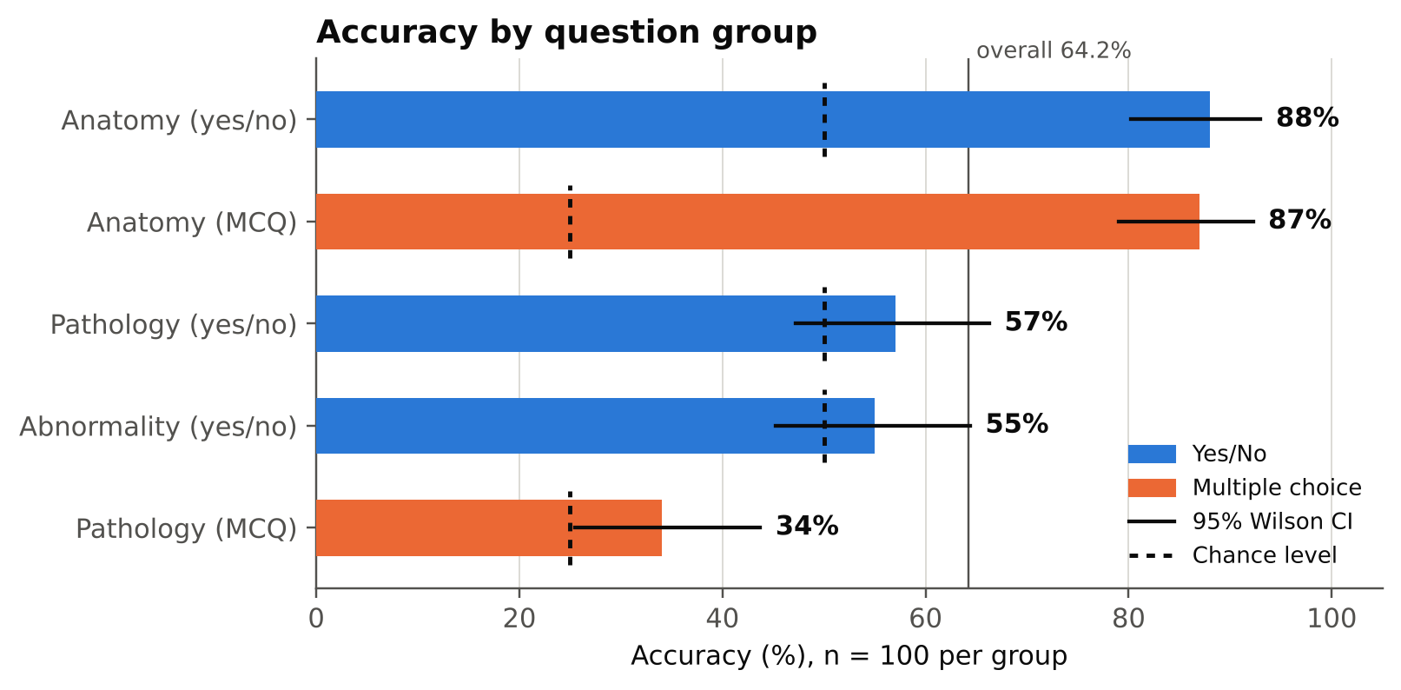
Figure 1. Accuracy by question group with 95% Wilson intervals. Dashed marks show chance level for each group.

3. Yes/No analysis
The yes/no errors are not symmetric: the model has a different answer bias in each group (Figures 2–3, Table 4).
- Abnormality: the model answers “yes” for 77 of 100 questions (exact binomial test against 50%: p < 0.001). It recognises 82% of abnormal scans (41/50) but only 28% of normal scans (14/50). Its accuracy of 55% is entirely this bias.
- Anatomy: errors are mostly missed “yes” answers (10 of 12 errors). The model says “no” to a visible structure about 20% of the time, but almost never says “yes” to an absent one (2 of 50).
- Pathology: errors are balanced (25 missed findings, 18 false alarms); recall of “yes” is 50%, i.e. no better than a coin flip.
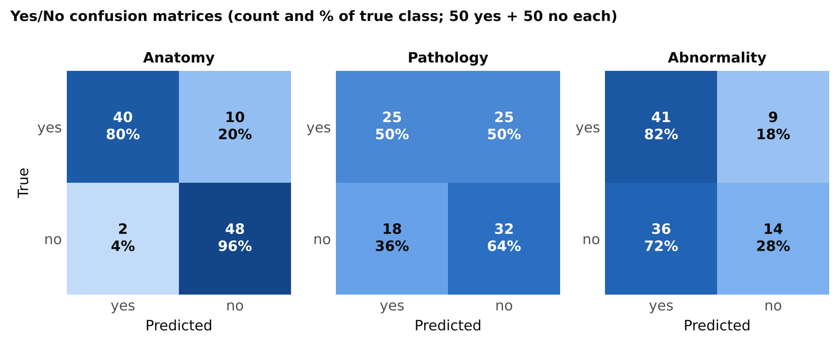
Figure 2. Yes/No confusion matrices. Each cell shows the count and the percentage of the true class.
Table 4a. Yes/No metrics (positive class = “yes”)
Group | Recall yes | Recall no | Precision yes | F1 yes | Predicted yes | Accuracy
Anatomy | 80% | 96% | 95.2% | 0.87 | 42% | 88%
Pathology | 50% | 64% | 58.1% | 0.54 | 43% | 57%
Abnormality | 82% | 28% | 53.2% | 0.65 | 77% | 55%
All yes/no | 70.7% | 62.7% | 65.4% | 0.68 | 54% | 66.7%
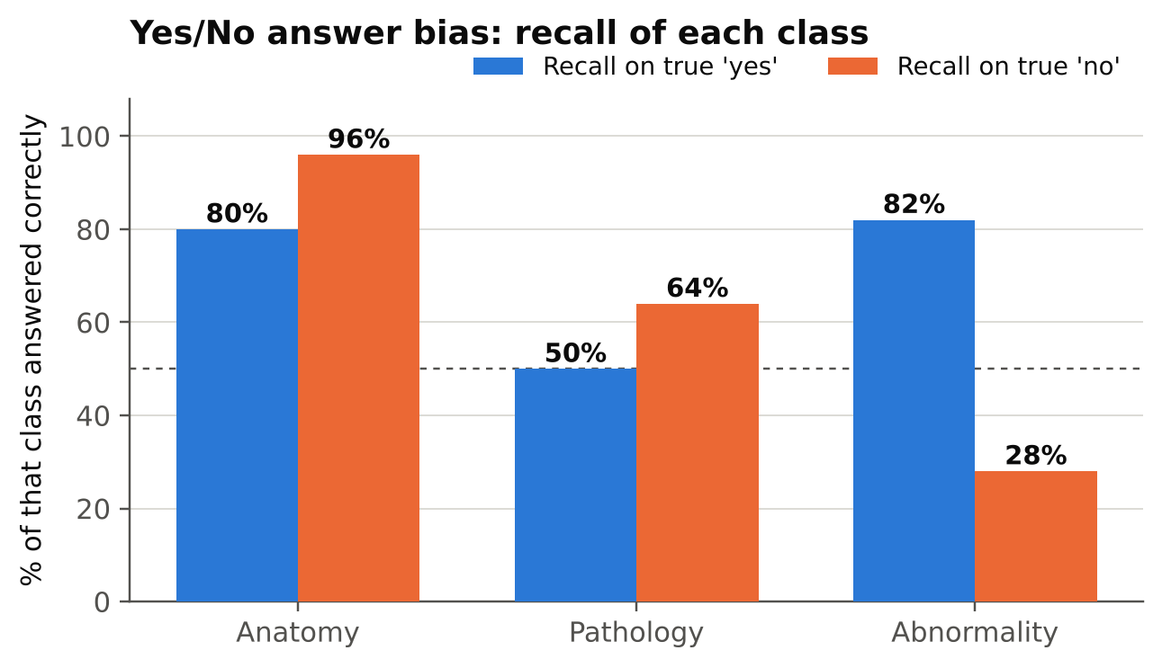
Figure 3. Recall of true “yes” and true “no” questions in each yes/no group. The dashed line marks 50%.
Effect of the sampling design. The full benchmark has more “yes” than “no” answers for abnormality (71.9% yes) and more “no” for pathology (64.1% no). Re-weighting the measured per-class recall to those natural shares gives the estimates in Table 4b. They are rough: each class rests on only 50 questions.
Table 4b. Estimated accuracy at the dataset’s natural yes/no mix
Group | Yes share (full set) | Accuracy on 50/50 sample | Estimated at natural mix | Always-majority baseline
Anatomy | 50.0% | 88.0% | 88.0% | 50.0%
Pathology | 36.0% | 57.0% | 59.0% | 64.1% (always “no”)
Abnormality | 71.9% | 55.0% | 66.8% | 71.9% (always “yes”)
On natural data the model would likely score below a constant-answer guess on the two pathology-related groups. This is an estimate from re-weighting, not a measured result; the natural shares come from the earlier audit of the full split (abnormality 719 yes / 281 no; pathology 719 yes / 1,281 no).

4. Multiple-choice analysis
Anatomy MCQ errors are scattered (13 errors; 7 on lung scans) with no strong favourite letter. Pathology MCQ shows a clear pull toward option C.
- Anatomy: letter recall is 93% (A), 86% (B), 93% (C) and 73% (D). The model’s answer counts closely follow the correct-answer counts.
- Pathology: the model chose C 37 times against 25 correct Cs (exact binomial test against 25%: p = 0.008). Only 5 of 22 true-B questions were answered correctly (23%); 10 of them went to C, as did 11 of the 28 true-D questions.
Table 5. Option-letter statistics
Group | Letter | Correct answers (n) | Model answers (n) | Recall
Anatomy (MCQ) | A | 29 | 30 | 93.1%
 | B | 22 | 22 | 86.4%
 | C | 27 | 28 | 92.6%
 | D | 22 | 20 | 72.7%
Pathology (MCQ) | A | 25 | 20 | 36.0%
 | B | 22 | 22 | 22.7%
 | C | 25 | 37 | 36.0%
 | D | 28 | 21 | 39.3%
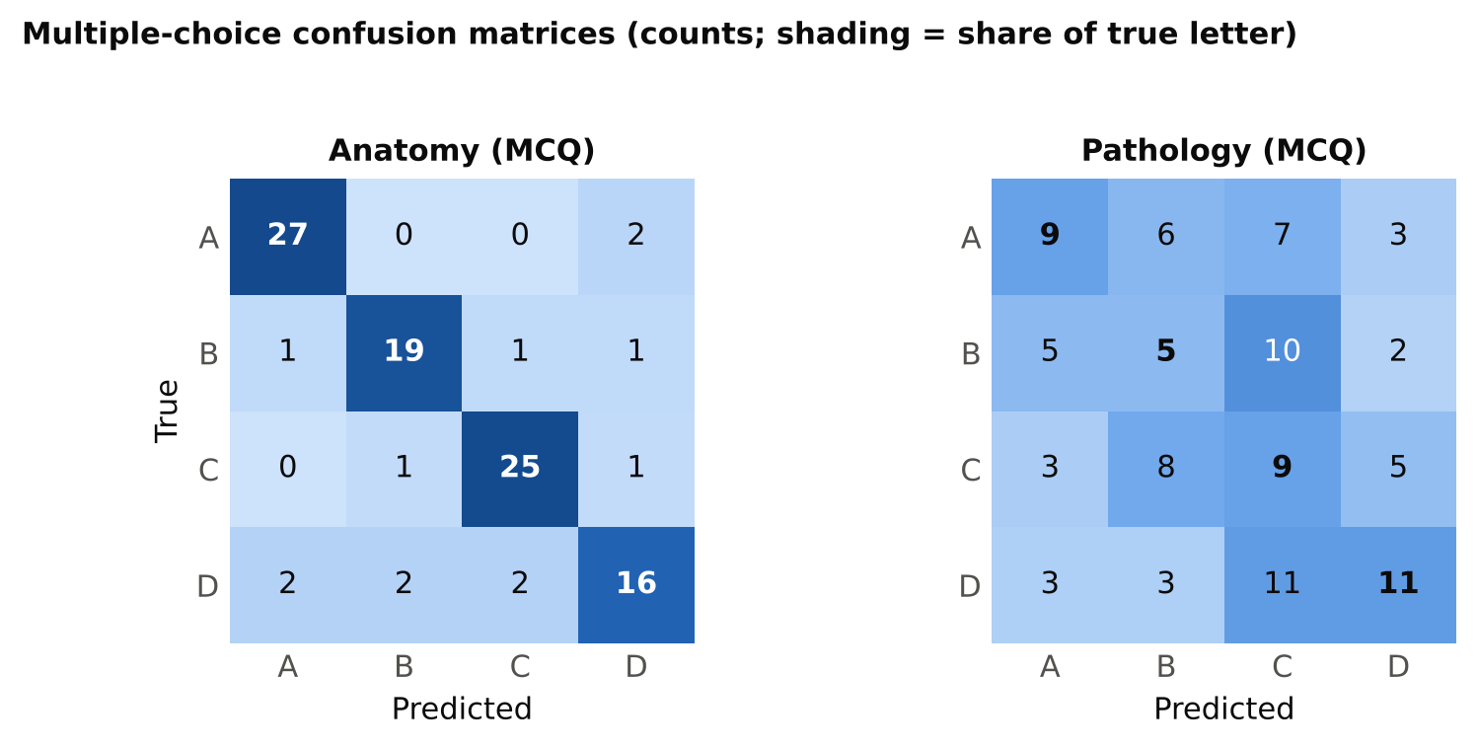
Figure 4. Multiple-choice confusion matrices (counts). The pathology matrix shows the shift toward column C.
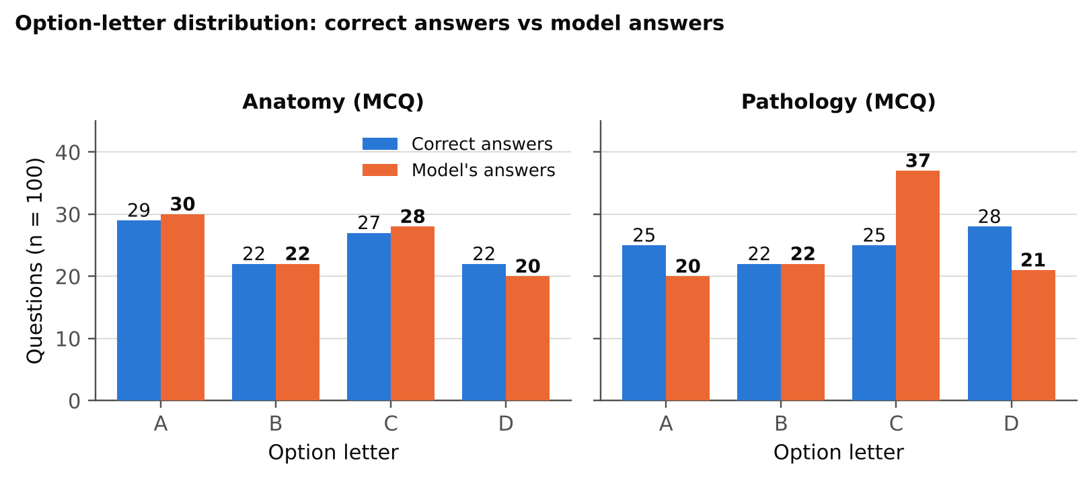
Figure 5. How often each letter is correct versus how often the model chooses it.

5. Anatomical regions
Accuracy varies by region, but most cells are small. Lung (62/116 correct, 53%) and hip (18/38, 47%) are weakest. Abdomen, the largest region (163 questions), reaches 69%. The lung weakness appears even in anatomy questions (71% yes/no, 72% MCQ, against 93% and 94% for abdomen). Pathology MCQ is lowest on hip (0/8), knee (1/9), spine (1/5) and brain (1/4), but those cells are too small to rank regions reliably.
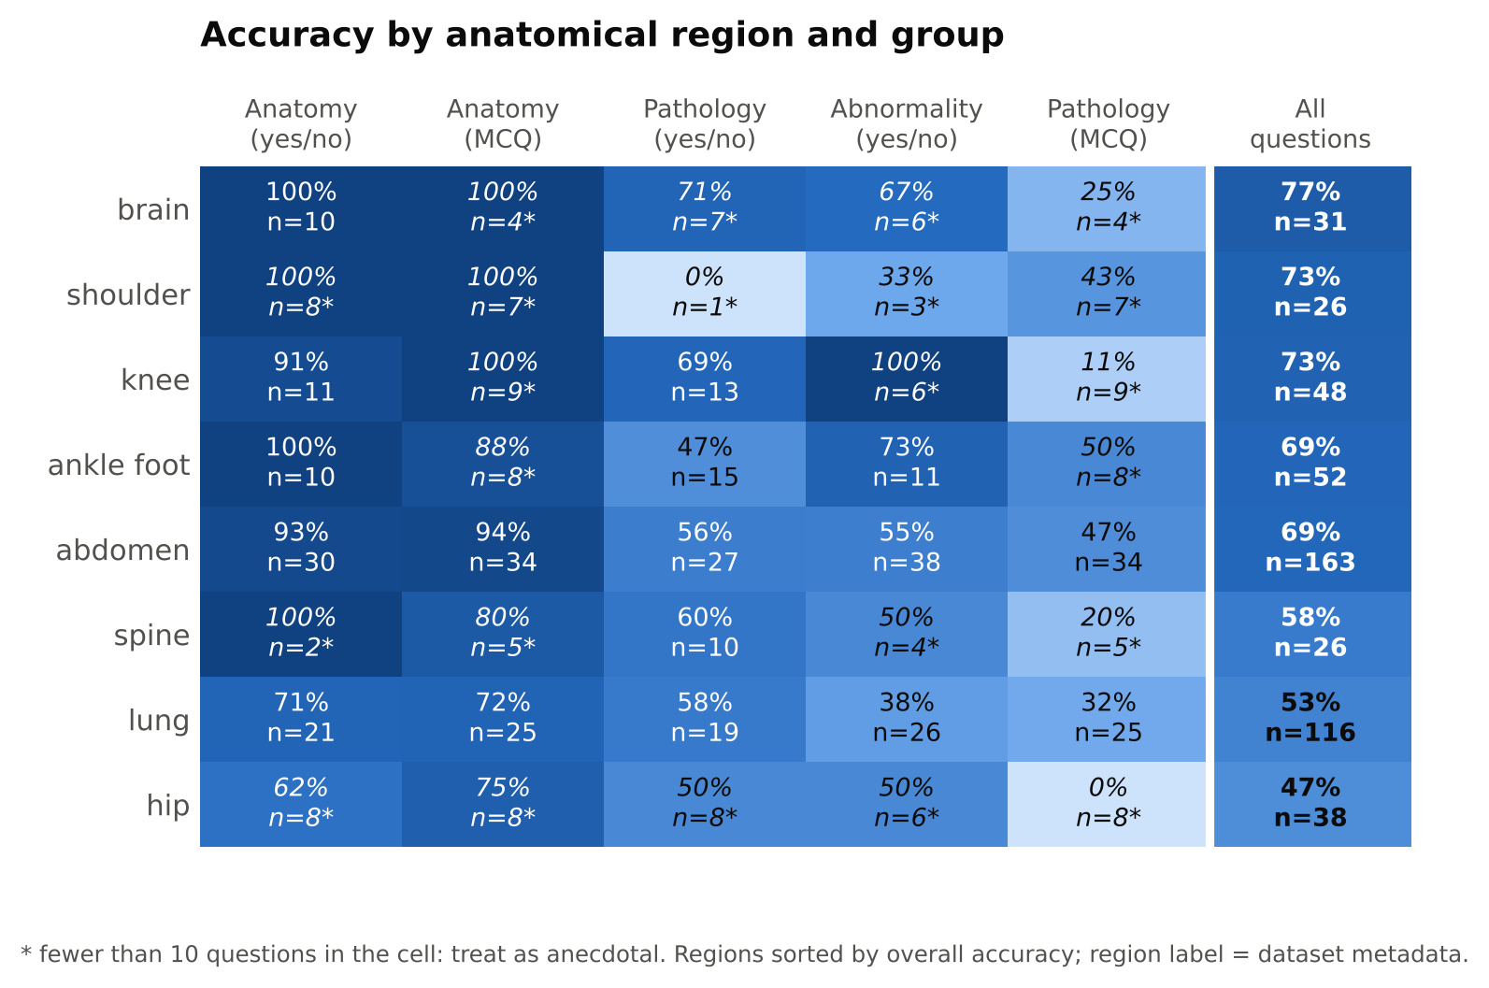
Figure 6. Accuracy by anatomical region (rows) and question group (columns). Starred cells have fewer than 10 questions.

6. Error analysis
- Normal scans called abnormal: 36 of 50 normal scans were called abnormal. Correct “no” answers by region: abdomen 7/23, lung 5/19, brain 1/3, hip 1/2, shoulder 0/2, spine 0/1.
- Anatomy misses: all 10 missed “yes” answers in the anatomy yes/no group are structures the model says it cannot see: lung 5, abdomen 2, hip 2, knee 1.
- Pathology negatives: 11 questions have a true answer “no” under the pathology_closed_pos question type. By my reading of the question text, 7 of them ask about findings from another body region (for example biceps pathology on an abdominal scan, or liver disease on a lung scan) and the model answered all 7 correctly. Of the 4 same-region findings it got 2 right and said “yes” to renal and cystic lesions on abdominal scans. With n = 11 this is an observation, not a conclusion.
- Formatting: no unparsed outputs. Every raw output was exactly one token: “Yes”, “No”, or a letter.
Table 6. Examples of wrong answers
Group | Region | Question | True | Model
Anatomy yes/no | lung | Can you see the lung? | yes | no
Abnormality | lung | Does the lung look abnormal? | no | yes
Abnormality | abdomen | Does the abdomen look abnormal? | no | yes
Abnormality | hip | Does this scan reveal any abnormalities? | yes | no
Pathology yes/no | abdomen | Are there signs of urolithiasis? | yes | no
Pathology yes/no | abdomen | Does the patient have pancreatic lesion? | yes | no
Pathology yes/no | lung | Is there evidence of interstitial lung disease in this image? | no | yes
Pathology MCQ | hip | What pathology is shown in this scan of hip | A | C
The results file stores the question text but not the answer options, so the options behind a wrong MCQ letter cannot be read from it.

7. Limitations
- Sample size: 100 questions per group gives intervals of about ±9 points. Differences of a few points between groups are not reliable, and most region-by-group cells have fewer than 30 questions.
- One run, one prompt: greedy decoding with a single fixed prompt. Sensitivity to prompt wording and to precision (bf16 here) was not tested.
- Sampling: yes/no groups are balanced by design. Natural-mix figures in Table 4b are estimates.
- Region labels: regions come from the dataset’s location field; they are not verified against the images.
- Possible overlap: the dataset is derived from RadImageNet; overlap with the model’s pre-training data is unknown.
- Not a clinical evaluation: these results describe benchmark behaviour only.

