RadImageNet-VQA: blank-image control across four models
Real image versus blank white image, same 500 questions per model
13 November 2026 – built from the blank-control and real-image results CSVs of each model
Summary
Replacing every scan with a blank white image lowers accuracy for all four models. The size of the drop shows how much of each group’s real-image score depends on the image; what remains above chance comes from the question wording, the options, or a fixed answer habit.
Gemma 3 4B-it: 315/500 (6300.0%) with real images, 194/500 (3880.0%) blank (-24.2 points); McNemar exact p = < 0.001; same answer on 25% of questions.
MedGemma 4B-it: 306/500 (6120.0%) with real images, 192/500 (3840.0%) blank (-22.8 points); McNemar exact p = < 0.001; same answer on 44% of questions.
MedVLM-R1: 325/500 (6500.0%) with real images, 219/500 (4380.0%) blank (-21.2 points); McNemar exact p = < 0.001; same answer on 34% of questions.
Qwen2-VL-2B-Instruct: 321/500 (6420.0%) with real images, 208/500 (4160.0%) blank (-22.6 points); McNemar exact p = < 0.001; same answer on 33% of questions.
1. Accuracy by group
Table 1. Real-image / blank-image correct answers out of 100 (chance in the last column)
Group | Gemma | MedGemma | MedVLM-R1 | Qwen2-VL-2B | Chance
Anatomy (yes/no) | 81 / 52 | 79 / 51 | 86 / 57 | 88 / 55 | 50
Anatomy (MCQ) | 84 / 11 | 80 / 15 | 88 / 36 | 87 / 28 | 25
Pathology (yes/no) | 61 / 53 | 60 / 51 | 57 / 51 | 57 / 51 | 50
Abnormality (yes/no) | 52 / 54 | 55 / 50 | 61 / 50 | 55 / 50 | 50
Pathology (MCQ) | 37 / 24 | 32 / 25 | 33 / 25 | 34 / 24 | 25
Overall (of 500) | 315 / 194 | 306 / 192 | 325 / 219 | 321 / 208 | –

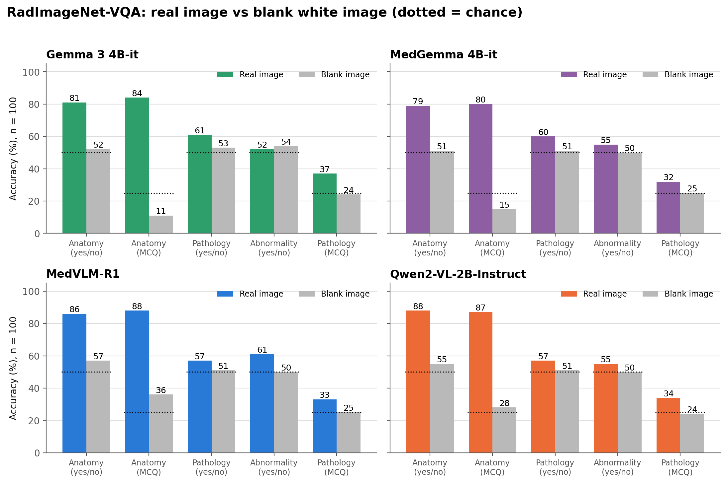
Figure 1. Real-image versus blank-image accuracy for each model and group. Dotted marks show chance level.
2. Yes/No answer habits on the blank image
Table 2. Number of “yes” answers out of 100 (real image / blank image)
Group | Gemma | MedGemma | MedVLM-R1 | Qwen2-VL-2B
Anatomy | 49 / 76 | 55 / 41 | 42 / 31 | 42 / 29
Pathology | 75 / 9 | 32 / 1 | 47 / 7 | 43 / 7
Abnormality | 98 / 4 | 39 / 0 | 69 / 0 | 77 / 0

A model that answers the same way whatever the question scores exactly 50% on a balanced yes/no group. Blank-image yes/no scores close to 50% show the model gets no usable signal from the blank image; the real-image gap above that is the image-dependent part of the score.
3. Notes
Per-model reports (figures 1–8 and Tables 1–7) are in each model’s blank-control results folder, with every file name ending in _blank. The earlier blank-image attempt in BLANK_IMAGE_discarded was not used.

