Gemma 3 4B-it on BUS-BRA
Zero-shot benign vs malignant classification of breast ultrasound images (400 images)
12 October 2026 · source files: classification_results_gemma3_4b.csv, classification_scores_gemma3_4b.csv · run notebook: BUS_BRA_Final_Gemma_MedGemma.ipynb (bus-bra-final-v2-compact)

Summary
Gemma 3 4B-it classified 201 of 400 images correctly (50.25%, 95% CI 45.4–55.1%), which is chance on this balanced sample (one-sided exact binomial p = 0.48). The reason: the model answered “malignant” for 391 of 400 images (97.75%), the mirror image of the Qwen-family models, which answered “benign” for everything.
- Sensitivity (malignant found): 196 of 200 (98.0%, CI 95.0–99.2%). Almost every cancer was flagged.
- Specificity (benign found): 5 of 200 (2.5%, CI 1.1–5.7%). Almost every benign lesion was also called malignant.
- No evidence of image use: the 9 “benign” answers are 5 truly benign and 4 truly malignant images (Fisher exact p = 1.0 against the other 391 answers). The Matthews correlation coefficient is 0.017, essentially zero.
- Not a parsing artefact: all 400 raw outputs are the single word “malignant” (391) or “benign” (9) followed by Gemma’s end-of-turn marker; no row is unparsed.
- By image-ID suffix (-l, -r, -s): accuracy is 48%, 54% and 48%, and the share of “malignant” answers is 98%, 97% and 99%. The differences are within chance variation.
The high sensitivity is not detection ability: calling nearly everything malignant finds the cancers and fails every benign case. In practice the output would flag almost every patient. This describes the model, prompt and setting, not the dataset. Against the Qwen models, Gemma agrees on only 9 of 400 images (Section 4).

1. Experimental setup
Table 1. Settings (from the run notebook)
Item | Setting
Model | google/gemma-3-4b-it, revision 093f9f38…, zero-shot (no fine-tuning, no in-context examples). Loaded with Gemma3ForConditionalGeneration.
Dataset | BUS-BRA, breast ultrasound images with benign / malignant labels (1,875 images in the metadata file)
Sample | 400 frozen images: 200 benign + 200 malignant, one image per source Case (400 distinct Cases). Selection used seed 42; the 20 pilot Cases and 13 previously flagged Cases are excluded. Patient identity is not independently verified. The sample is protected by a SHA-256 manifest check.
Image IDs | bus_XXXX-l, -r or -s (166, 151 and 83 images)
Task | Single-label classification: benign or malignant
Input | Only the original image and the fixed prompt; no labels or metadata reach the model
Prompt | “You are a medical assistant. Examine this breast ultrasound image. Classify the lesion as exactly ONE of the following: - benign: non-cancerous lesion - malignant: cancerous lesion. Respond with ONLY the label: benign or malignant.”
Decoding | Greedy (do_sample=False, one beam), at most 32 new tokens, batch size 1, explicit generation settings checked at load time
Precision / hardware | bf16 weights, SDPA attention, device_map="auto", no CPU or disk offloading. Run on Kaggle T4 x2, where bf16 is emulated (not native). The exact GPU used is not stored in the output files.
Answer parsing | Strict: the answer text (with the final end-of-turn token removed) must be exactly benign or malignant (optionally after Final answer:, inside <answer>…</answer>, or after one <think>…</think> block). Anything else is unparsed and counts as wrong. A guard also marks a result unparsed if the model produced invalid scores (NaN or infinity).
Scoring | Exact match with the reference label. 95% Wilson intervals; one-sided exact binomial test against 50%.

Checks: the 400 image IDs in the results file are identical, and in the same order, to the frozen ID list in the notebook and to those in the Qwen and MedVLM-R1 results files; the question column equals the notebook prompt; the scores file reports lesion_classification with 201 correct out of 400 (0.5025), matching the per-row results. The notebook as supplied has no saved cell outputs, so no execution log (token counts, stop reasons, GPU) was available. Minor: in the notebook’s save_results, the results file is written as _results_{tag}.csv, while the download cell lists classification_results_{tag}.csv; the file supplied has the latter name, so it was renamed or the notebook was edited. The raw output keeps Gemma’s <end_of_turn> marker, which is expected and is removed before parsing.

2. Results
Table 2. Summary metrics (positive class = malignant)
Metric | Value | Note
Accuracy | 50.25% (201 / 400) | 95% CI 45.4–55.1%
p-value vs 50% chance (one-sided) | 0.48 | not above chance
Sensitivity (recall of malignant) | 98.0% (196 / 200) | 95% CI 95.0–99.2%
Specificity (recall of benign) | 2.5% (5 / 200) | 95% CI 1.1–5.7%
Balanced accuracy | 50.25% | equals accuracy: balanced sample
Precision of “malignant” | 50.1% (196 / 391) | equals the share of malignant in the sample
F1 for malignant | 0.66 | high only because recall is high
Matthews correlation coefficient | 0.017 | no association with the labels
Share of answers that are “malignant” | 97.75% (391 / 400) | vs 50% true
Unparsed answers | 0
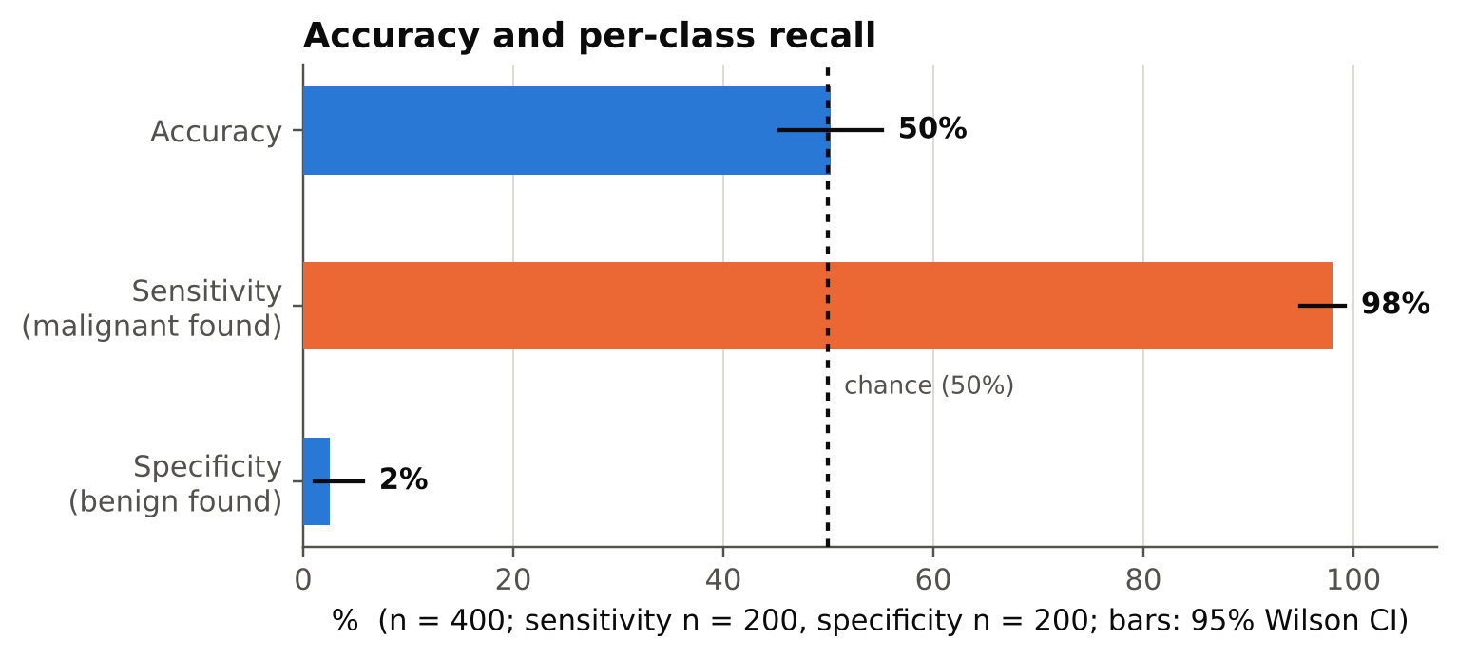
Figure 1. Accuracy and per-class recall with 95% Wilson intervals. The dashed line is chance.
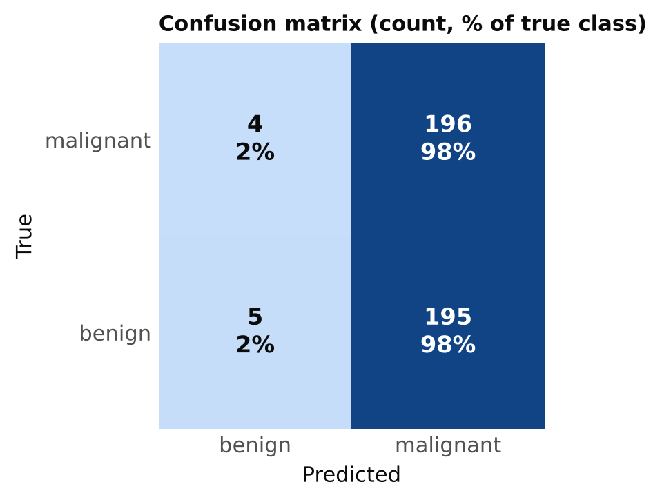
Figure 2. Confusion matrix. Each cell shows the count and the percentage of the true class.
Table 3. Confusion matrix
 | Predicted benign | Predicted malignant
True malignant (n = 200) | 4 | 196
True benign (n = 200) | 5 | 195
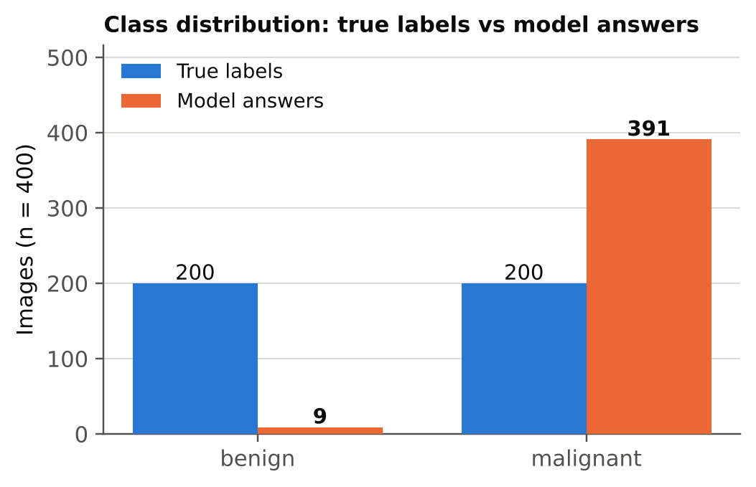
Figure 3. True labels versus model answers: the model chose “malignant” for almost every image.

3. By image-ID suffix
The only metadata in the results file is the image ID. IDs end in -l, -r or -s; I have not interpreted these suffixes (the file does not say what they mean). Because the model nearly always says “malignant”, accuracy in each suffix is close to the share of malignant images in it.
Table 4. Results by ID suffix
Suffix | n | Malignant / benign | Accuracy | 95% CI | Sensitivity | Specificity
-l | 166 | 79 / 87 | 48.2% | 40.7–55.7% | 98.7% | 2.3%
-r | 151 | 80 / 71 | 53.6% | 45.7–61.4% | 97.5% | 4.2%
-s | 83 | 41 / 42 | 48.2% | 37.8–58.8% | 97.6% | 0.0%
The share of “malignant” answers is 98.2% (-l), 96.7% (-r) and 98.8% (-s). The confidence intervals overlap and all contain 50%, so no suffix differs from chance.
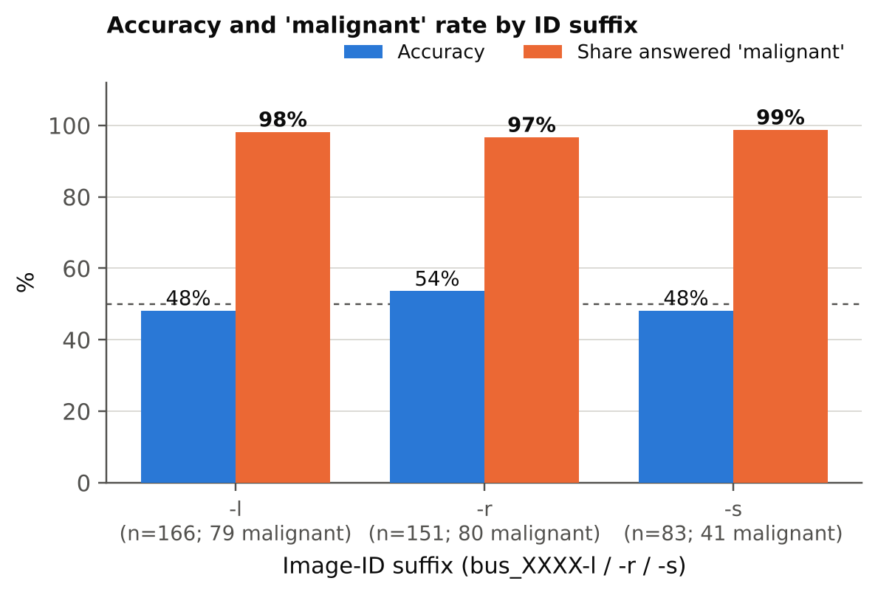
Figure 4. Accuracy and share of “malignant” answers by ID suffix.

4. Comparison with Qwen2-VL-2B-Instruct and MedVLM-R1
Qwen2-VL-2B-Instruct and MedVLM-R1 gave the same answer, “benign”, on all 400 images. Gemma 3 4B-it gives the opposite constant answer. All three were run on the same 400 images with the same prompt, parser and settings.
Table 5. Gemma 3 4B-it versus the Qwen-family models (identical for both)
 | Gemma 3 4B-it | Qwen2-VL / MedVLM-R1
Accuracy | 50.25% (201 / 400) | 50.0% (200 / 400)
Answered “malignant” | 391 / 400 | 0 / 400
Sensitivity | 98.0% | 0.0%
Specificity | 2.5% | 100%
MCC | 0.017 | 0.000
Identical answers to Gemma | — | 9 / 400 (2.25%)

- Paired accuracy: both right on 5 images, only Gemma right on 196, only the Qwen model right on 195, both wrong on 4. McNemar exact p = 1.0, so the one-image accuracy difference is meaningless. The two strategies are near-complements, so each is right on a different half of the sample.
- Same underlying failure, opposite direction: three models, one fixed answer each, with the image not changing it. Gemma’s 9 “benign” answers are not better than its other answers.
- Why “malignant”: not determinable from these files. It could be the prompt wording, the model’s training, or a safety lean toward the serious label. A swapped-order prompt and per-image scores (Section 6) would help to tell these apart.

5. Interpretation and caveats
- What the result says: with this prompt and setting, Gemma has a fixed answer (“malignant”) and does not use the image to decide. Nothing in these files shows whether it can see the lesions.
- What it does not say: whether the model would separate the classes if asked differently. A near-constant answer can come from a strong prior, the prompt wording or weak image influence. Accuracy alone cannot tell these apart.
- Natural class mix: the sample is balanced on purpose. In the full dataset benign images are more common than malignant ones, so this always-malignant behaviour would score below 50% there, the reverse of the Qwen models. Specificity matters as much as sensitivity here.
- Sample size: with 200 images per class, even modest discrimination would show up as a difference between the two groups of answers. The nine “benign” answers are too few to say anything about them.
- Not a clinical evaluation: these results describe benchmark behaviour only.

6. Next steps
- Run the same analysis for MedGemma 4B-it on the same 400 images, then compare all four models with sensitivity, specificity, MCC and paired tests (McNemar).
- Pipeline sanity check: run the same prompt on a few blank (black) images, for all models. An unchanged answer would mean the output does not depend on the image.
- Save a score for each image (for example the log-probability of “benign” versus “malignant”). The notebook stores only decoded text, so AUC cannot be computed. For Gemma this matters: a strong “malignant” lean could hide a real ranking of lesions.
- Optionally test one prompt variant (label order swapped) to see whether the fixed answer depends on the wording.
- Keep the executed notebook and logs with the results; this copy has no outputs. Fix the _results_{tag}.csv filename in save_results so the download cell finds its file.

