MedGemma 4B-it on BUS-BRA
Zero-shot benign vs malignant classification of breast ultrasound images (400 images)
12 October 2026 · source files: classification_results_medgemma_4b.csv, classification_scores_medgemma_4b.csv · run notebook: BUS_BRA_Final_Gemma_MedGemma.ipynb (bus-bra-final-v2-compact)

Summary
MedGemma 4B-it classified 230 of 400 images correctly (57.5%, 95% CI 52.6–62.3%). This is the only one of the four models that is above chance on BUS-BRA, and the only one whose answers are clearly informative (one-sided exact binomial p = 0.0016, below the Bonferroni threshold of 0.0125 for four models). The effect is modest: it leans “benign” (266 of 400 answers) and misses most cancers.
- Sensitivity (malignant found): 82 of 200 (41.0%, CI 34.4–47.9%). 118 of 200 cancers were called benign.
- Specificity (benign found): 148 of 200 (74.0%, CI 67.5–79.6%).
- Answers are informative but weakly: of 134 “malignant” answers 82 were right (precision 61.2%, CI 52.7–69.0%); of 266 “benign” answers 148 were right (55.6%, CI 49.6–61.5%). Odds ratio 1.98, Fisher exact p = 0.002. MCC 0.159, balanced accuracy 57.5%.
- Not a parsing artefact: every raw output is the single word “benign” (266) or “malignant” (134) followed by Gemma’s end-of-turn marker; no row is unparsed.
- By image-ID suffix (-l, -r, -s): accuracy 58%, 54% and 63%, not significantly different (chi-square p = 0.39). The share of “malignant” answers does differ: 45%, 28% and 22% (p = 0.0003).
- Versus the other models: Qwen2-VL-2B and MedVLM-R1 answered “benign” for everything (50.0%); Gemma 3 4B-it answered “malignant” for 97.75% (50.25%). MedGemma is ahead of both, but the paired difference to Gemma 3 is not significant (McNemar p = 0.08).
Net: a small, real signal that is far from clinical usefulness (about 59% of cancers are missed at this operating point). It describes this model, prompt and setting only.

1. Experimental setup
Table 1. Settings (from the run notebook)
Item | Setting
Model | google/medgemma-4b-it, revision 290cda5e…, zero-shot (no further fine-tuning, no in-context examples). Loaded with Gemma3ForConditionalGeneration.
Dataset | BUS-BRA, breast ultrasound images with benign / malignant labels (1,875 images in the metadata file)
Sample | 400 frozen images: 200 benign + 200 malignant, one image per source Case (400 distinct Cases). Selection used seed 42; the 20 pilot Cases and 13 previously flagged Cases are excluded. Patient identity is not independently verified. The sample is protected by a SHA-256 manifest check.
Image IDs | bus_XXXX-l, -r or -s (166, 151 and 83 images)
Task | Single-label classification: benign or malignant
Input | Only the original image and the fixed prompt; no labels or metadata reach the model
Prompt | “You are a medical assistant. Examine this breast ultrasound image. Classify the lesion as exactly ONE of the following: - benign: non-cancerous lesion - malignant: cancerous lesion. Respond with ONLY the label: benign or malignant.”
Decoding | Greedy (do_sample=False, one beam), at most 32 new tokens, batch size 1, explicit generation settings checked at load time
Precision / hardware | bf16 weights, SDPA attention, device_map="auto", no CPU or disk offloading. Run on Kaggle T4 x2, where bf16 is emulated (not native). The exact GPU used is not stored in the output files.
Answer parsing | Strict: the answer text (with the final end-of-turn token removed) must be exactly benign or malignant (optionally after Final answer:, inside <answer>…</answer>, or after one <think>…</think> block). Anything else is unparsed and counts as wrong. A guard also marks a result unparsed if the model produced invalid scores (NaN or infinity).
Scoring | Exact match with the reference label. 95% Wilson intervals; one-sided exact binomial test against 50%.

Checks: the 400 image IDs in the results file are identical, and in the same order, to the frozen ID list in the notebook and to those in the other three models’ results files; the question column equals the notebook prompt; the scores file reports lesion_classification with 230 correct out of 400 (0.575), matching the per-row results. The notebook as supplied has no saved cell outputs, so no execution log (token counts, stop reasons, GPU) was available. Minor: in the notebook’s save_results, the results file is written as _results_{tag}.csv, while the download cell lists classification_results_{tag}.csv; the file supplied has the latter name, so it was renamed or the notebook was edited. The raw output keeps Gemma’s <end_of_turn> marker (preceded by a newline), which is removed before parsing.

2. Results
Table 2. Summary metrics (positive class = malignant)
Metric | Value | Note
Accuracy | 57.5% (230 / 400) | 95% CI 52.6–62.3%
p-value vs 50% chance (one-sided) | 0.0016 | two-sided 0.0031
Sensitivity (recall of malignant) | 41.0% (82 / 200) | 95% CI 34.4–47.9%
Specificity (recall of benign) | 74.0% (148 / 200) | 95% CI 67.5–79.6%
Balanced accuracy | 57.5% | equals accuracy: balanced sample
Precision of “malignant” | 61.2% (82 / 134) | 95% CI 52.7–69.0%
Negative predictive value | 55.6% (148 / 266) | 95% CI 49.6–61.5%
F1 for malignant | 0.49
Matthews correlation coefficient | 0.159 | weak association with the labels
Share of answers that are “malignant” | 33.5% (134 / 400) | vs 50% true
Unparsed answers | 0
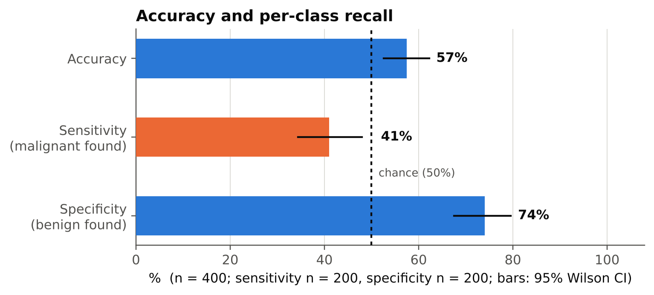
Figure 1. Accuracy and per-class recall with 95% Wilson intervals. The dashed line is chance.
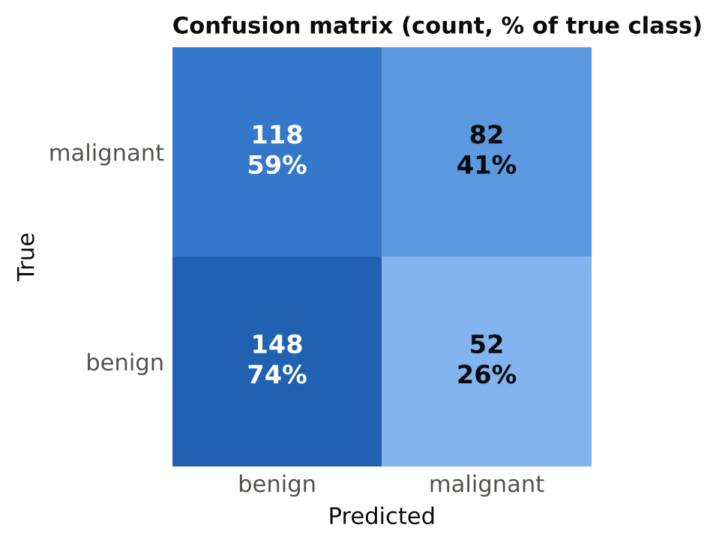
Figure 2. Confusion matrix. Each cell shows the count and the percentage of the true class.
Table 3. Confusion matrix
 | Predicted benign | Predicted malignant
True malignant (n = 200) | 118 | 82
True benign (n = 200) | 148 | 52
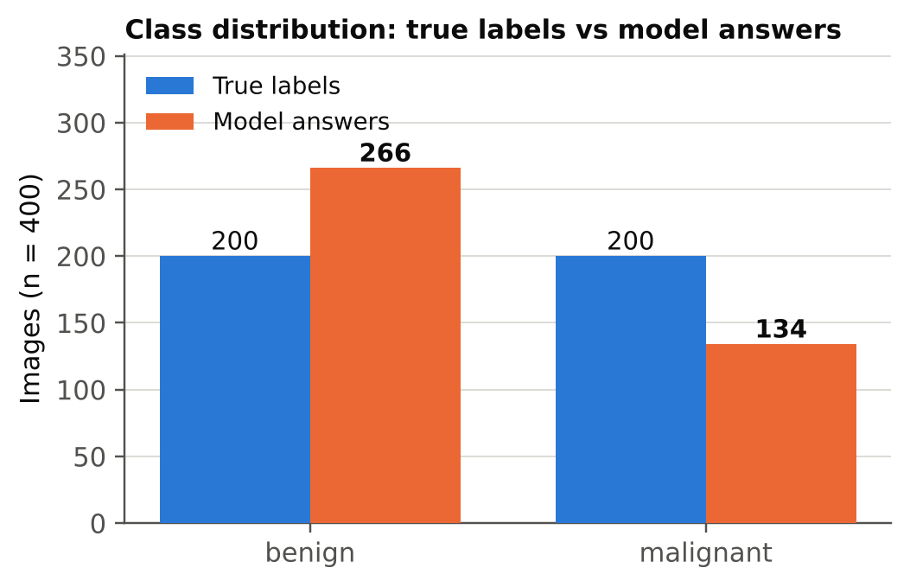
Figure 3. True labels versus model answers: the model chose “benign” more often than the 50% it should.

3. By image-ID suffix
The only metadata in the results file is the image ID. IDs end in -l, -r or -s; I have not interpreted these suffixes (the file does not say what they mean).
Table 4. Results by ID suffix
Suffix | n | Malignant / benign | Accuracy | 95% CI | Sens. | Spec. | Said malig.
-l | 166 | 79 / 87 | 58.4% | 50.8–65.7% | 53.2% | 63.2% | 44.6%
-r | 151 | 80 / 71 | 53.6% | 45.7–61.4% | 32.5% | 77.5% | 27.8%
-s | 83 | 41 / 42 | 62.7% | 51.9–72.3% | 34.1% | 90.5% | 21.7%
Accuracy does not differ detectably between suffixes (chi-square p = 0.39; the -r interval contains 50%). The share of “malignant” answers does (74, 42 and 18 answers; chi-square p = 0.0003), and the operating point moves with it: sensitivity is higher and specificity lower in -l than in -r and -s. The files do not say why; the suffix may correspond to a different image type, which I cannot confirm.
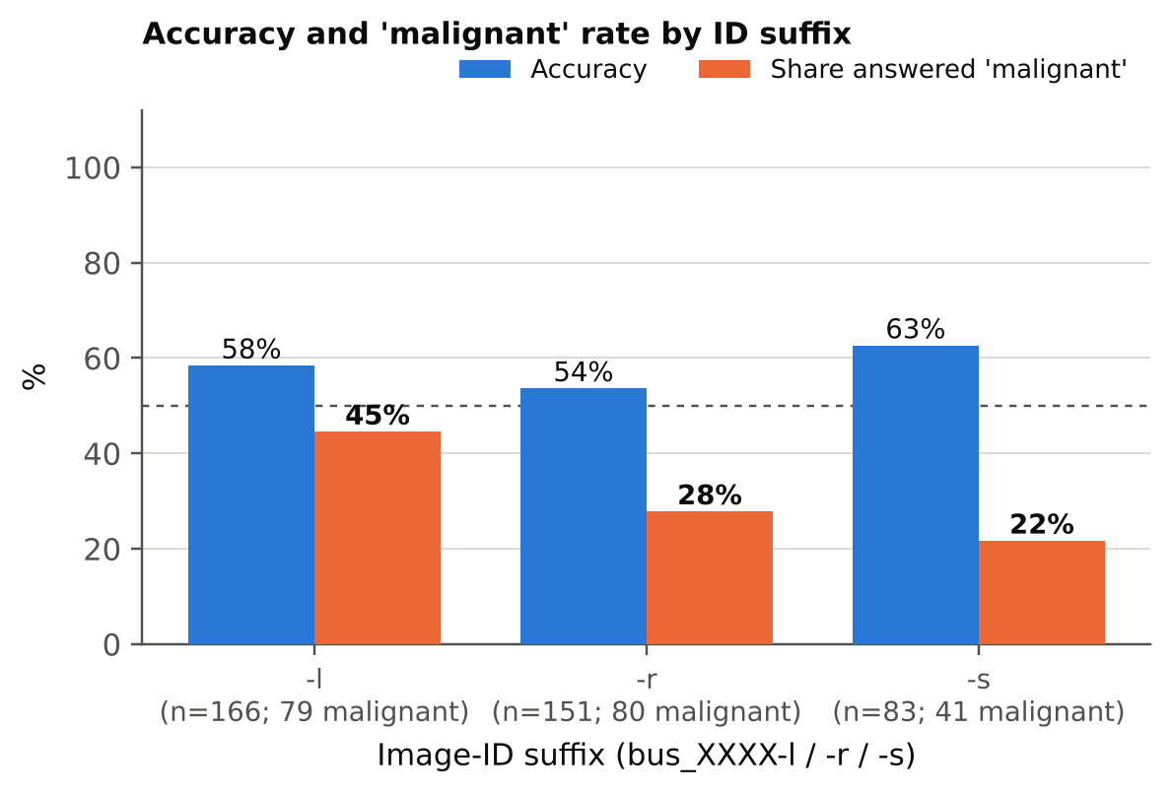
Figure 4. Accuracy and share of “malignant” answers by ID suffix.

4. Comparison with the other three models
Table 5. BUS-BRA results for all four models (same 400 images, prompt, parser and settings)
 | Qwen2-VL-2B | MedVLM-R1 | Gemma 3 4B | MedGemma 4B
Accuracy | 50.0% | 50.0% | 50.25% | 57.5%
p vs 50% (one-sided) | 0.52 | 0.52 | 0.48 | 0.0016
Sensitivity | 0.0% | 0.0% | 98.0% | 41.0%
Specificity | 100% | 100% | 2.5% | 74.0%
MCC | 0.000 | 0.000 | 0.017 | 0.159
Answered “malignant” | 0 / 400 | 0 / 400 | 391 / 400 | 134 / 400

Table 6. MedGemma versus each model (paired, same images)
 | Both right | MedGemma only | Other only | Neither | McNemar p
vs Gemma 3 4B-it | 86 | 144 | 115 | 55 | 0.082
vs Qwen2-VL / MedVLM-R1 | 148 | 82 | 52 | 118 | 0.012
- Agreement: MedGemma gives the same answer as Gemma 3 on 141 of 400 images (35%), and the same as the Qwen models on 266 of 400 (66.5%), which are exactly its “benign” answers.
- Against Gemma 3: same base architecture, but the difference (230 vs 201 correct) is not significant in a paired test (p = 0.082), and Gemma 3’s accuracy is itself chance level. Medical fine-tuning is therefore consistent with a gain here, but this sample does not establish it.
- Against the Qwen models: the McNemar p of 0.012 is unadjusted and, because those models are constant, it adds little beyond MedGemma’s own test against chance (p = 0.0016).
- Multiple comparisons: MedGemma’s result against chance remains significant after a Bonferroni correction for four models (threshold 0.0125). It is one run with one prompt, so it does not measure variation across prompts or samples.

5. Interpretation and caveats
- What the result says: MedGemma’s answers carry some information about the label (precision 61%, odds ratio about 2), so it is not purely prior-driven. The signal is weak.
- Operating point: it leans benign, so 59% of cancers are missed. For a screening-type use this is the costly error. Whether another threshold would help cannot be tested because only decoded text was saved.
- Natural class mix: the sample is balanced on purpose. In the full dataset benign images are more common than malignant ones, so a benign-leaning model would look better on accuracy there; a comparison with an always-benign baseline would then be needed before drawing conclusions. Sensitivity and specificity are the numbers to carry across.
- Does it use the image? Varying answers and above-chance accuracy suggest yes, but the files do not rule out other cues. The suffix effect on the “malignant” rate shows that something in the input changes the answer; a blank-image control would show how much the answer depends on the lesion itself.
- Unknowns: whether BUS-BRA or similar data was part of MedGemma’s training cannot be determined from these files.
- Not a clinical evaluation: these results describe benchmark behaviour only.

6. Next steps
- Compare all four models on both datasets in one report (BUS-BRA and RadImageNet-VQA), if wanted.
- Pipeline sanity check: run the same prompt on a few blank (black) images for all four models. MedGemma’s answers on blank images give a baseline for how much of its signal comes from the lesion.
- Save a score for each image (for example the log-probability of “benign” versus “malignant”). With it, AUC and the sensitivity at a chosen specificity can be computed, which matters most for MedGemma and Gemma 3, whose fixed leanings hide any ranking.
- Test one prompt variant (label order swapped) to see how much of MedGemma’s benign lean depends on wording.
- Keep the executed notebook and logs with the results; this copy has no outputs. Fix the _results_{tag}.csv filename in save_results so the download cell finds its file.

