Zero-shot Bangla Medical VQA
Gemma 3 4B-it on BanglaMedVQA
500 questions (5 categories × 2 sources × 50) · open-ended · paper's zero-shot prompt · LAVE judge: GPT-4.1-mini

1. Summary
Exact-match accuracy is 2.4% (12 of 500). LAVE is 24.1% (95% CI 20.9–27.3), BERTScore F1 69.0. ChestX-ray8 23.7% vs MedICaT 24.5% LAVE; the intervals overlap, so there is no clear source difference.
Modality (ChestX-ray8 64.4%, MedICaT 57.0%) and Organ (ChestX-ray8 47.8%, MedICaT 46.4%) are the categories with real signal (LAVE). The other 3 categories score between 0.0% and 9.6%.

2. Setup
Item | Value
Model | google/gemma-3-4b-it, bf16, greedy decoding, 96 new tokens max
Data | BanglaMedVQA, Bangla columns only (question_bn, answer_bn). Train splits of ChestX-ray8 and MedICaT
Sample | 50 questions per category per source = 500. Seed 42, one image per question, abnormality balanced 25 Yes / 25 No per source. Same 500 for every model
Prompt | Paper's English zero-shot system prompt (one word or short phrase, no punctuation); Bangla question as the user turn; no options, no few-shot
Metrics | Accuracy (exact match after minimal cleaning), BERTScore F1 (mBERT, layer 9, no rescaling), LAVE (GPT-4.1-mini, paper's simplified judge prompt, one pair per call, temperature 0). Normalized accuracy is our supplementary metric
Confidence intervals | Accuracy: Wilson 95%. LAVE: percentile bootstrap, 5,000 resamples

3. Results

3.1 Headline numbers
Source | n | Accuracy % (CI) | Norm. acc. % | BERTScore | LAVE % (CI) | English-only % | Empty %
ChestX-ray8 | 250 | 0.0 (0.0–1.5) | 2.8 | 67.8 | 23.7 (19.2–28.4) | 88.4 | 2.4
MedICaT | 250 | 4.8 (2.8–8.2) | 6.8 | 70.2 | 24.5 (20.0–29.3) | 84.8 | 2.0
All 500 | 500 | 2.4 (1.4–4.1) | 4.8 | 69.0 | 24.1 (20.9–27.3) | 86.6 | 2.2
Avg. of sources | 500 | 2.4 | 4.8 | 69.0 | 24.1
Table 1. Paper-style headline table. 'Avg. of sources' is the paper's Overall (Avg.): the mean of the two source scores.
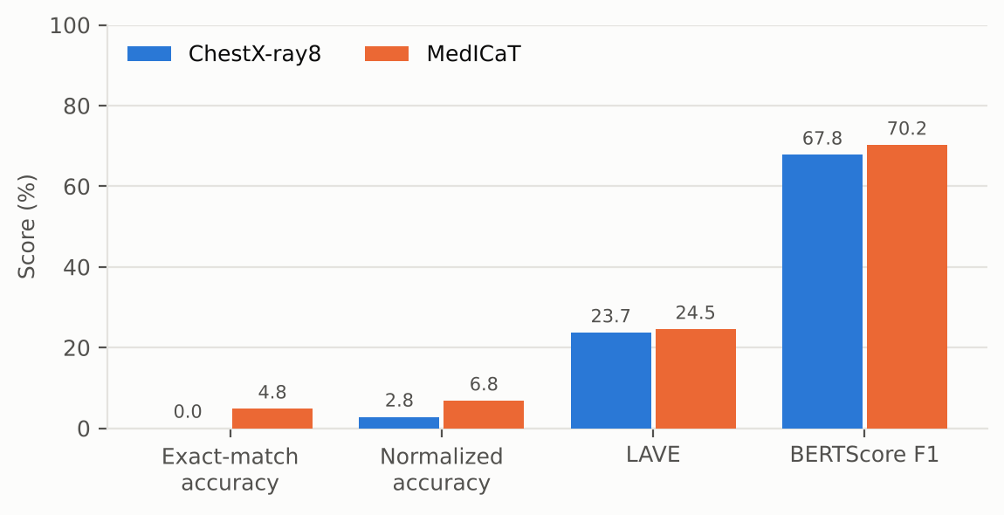
Figure 1. The four metrics on one scale. Exact match is only 2.4% because answers are rarely in correct Bangla; BERTScore is high for wrong answers too (Section 6).

3.2 Per category
Source | Category | Acc. % | Norm. acc. % | BERTScore | LAVE % (CI) | English-only % | >6 words %
ChestX-ray8 | Abnormality | 0 | 14 | 63.4 | 0.0 (0–0) | 92 | 0
ChestX-ray8 | Condition | 0 | 0 | 60.4 | 3.6 (1–7) | 98 | 0
ChestX-ray8 | Modality | 0 | 0 | 74.6 | 64.4 (53–75) | 100 | 0
ChestX-ray8 | Organ | 0 | 0 | 74.4 | 47.8 (37–59) | 68 | 0
ChestX-ray8 | Position | 0 | 0 | 66.0 | 2.6 (0–5) | 84 | 0
MedICaT | Abnormality | 0 | 10 | 64.0 | 0.0 (0–0) | 90 | 0
MedICaT | Condition | 0 | 0 | 66.2 | 9.6 (3–17) | 100 | 0
MedICaT | Modality | 0 | 0 | 70.7 | 57.0 (49–66) | 98 | 0
MedICaT | Organ | 24 | 24 | 82.2 | 46.4 (33–59) | 42 | 0
MedICaT | Position | 0 | 0 | 67.9 | 9.6 (3–18) | 94 | 0
Table 2. Per-category results (n = 50 each). Acc. is exact match. Shaded cells are the categories with real signal. A LAVE interval of 0–0 means every one of the 50 answers scored 0.
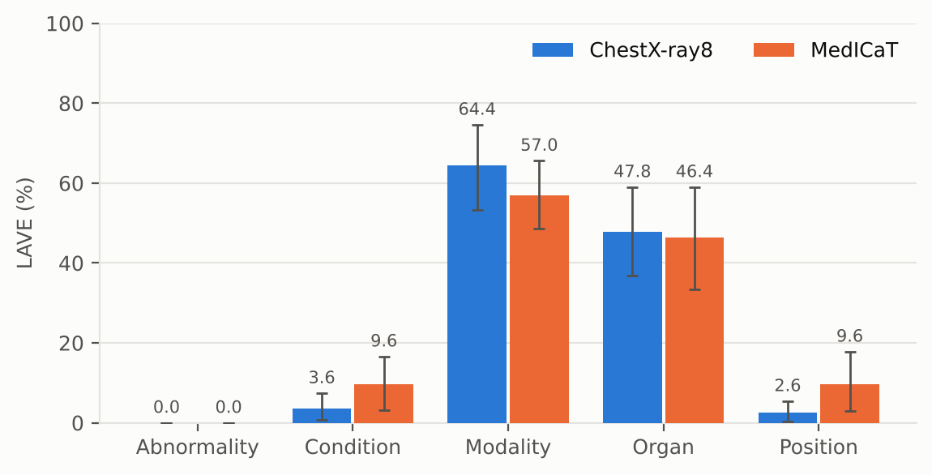
Figure 2. LAVE by category and source with 95% bootstrap intervals. Modality and Organ are clearly above the rest.

4. What the model actually outputs
It answers in English. 86.6% of answers contain only Latin text. The 67 answers that contain Bangla score a mean LAVE of 32.8% (higher than English-only answers: when it does answer in Bangla it is more often right); English-only answers score 22.7% (n = 433). Exact matches: all 12 come from MedICaT organ (12); the most frequent matching answer is "মস্তিষ্ক" (12).
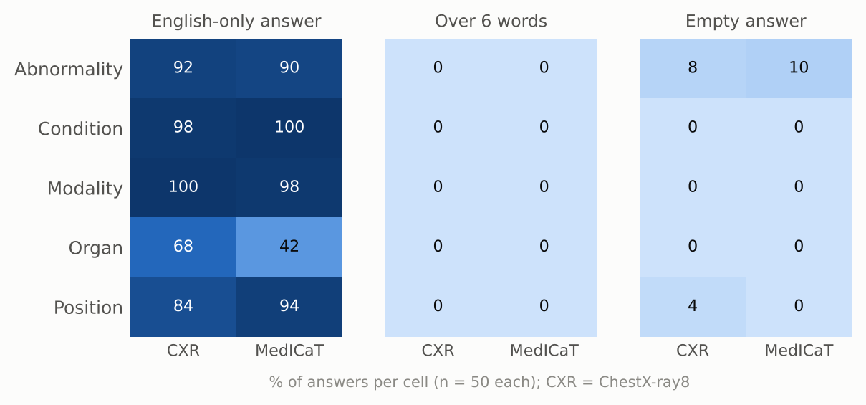
Figure 3. Output-format failures per cell. No answer exceeds 6 words. Empty answers: ChestX-ray8 abnormality, ChestX-ray8 position, MedICaT abnormality.
It repeats a few stock answers. On ChestX-ray8 condition, 50% of answers are "pneumothorax". 72% of modality answers are "x-ray" (correct for most of these questions, but it shows how little image-specific variation there is). The top ChestX-ray8 organ answer (56%) is "chest".
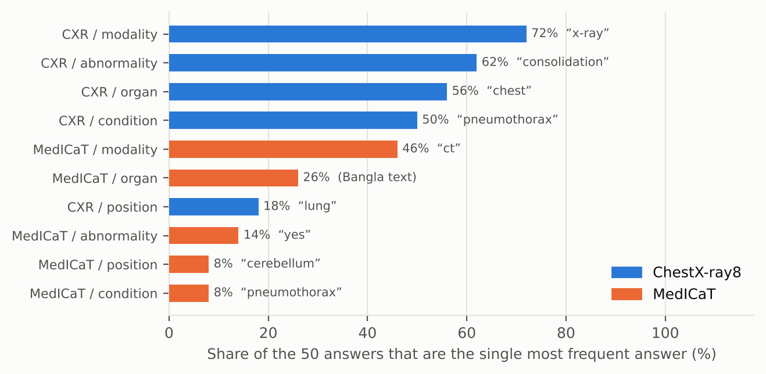
Figure 4. Share of the 50 answers in each cell taken by the single most frequent answer.

5. Abnormality (Yes/No)
The 100 abnormality questions are balanced (50 Yes, 50 No), so a constant answer scores 50%. We classified each model answer by rule: "no", "no abnormality", "there is no abnormality" count as No; anything without a clear Yes/No is Other.
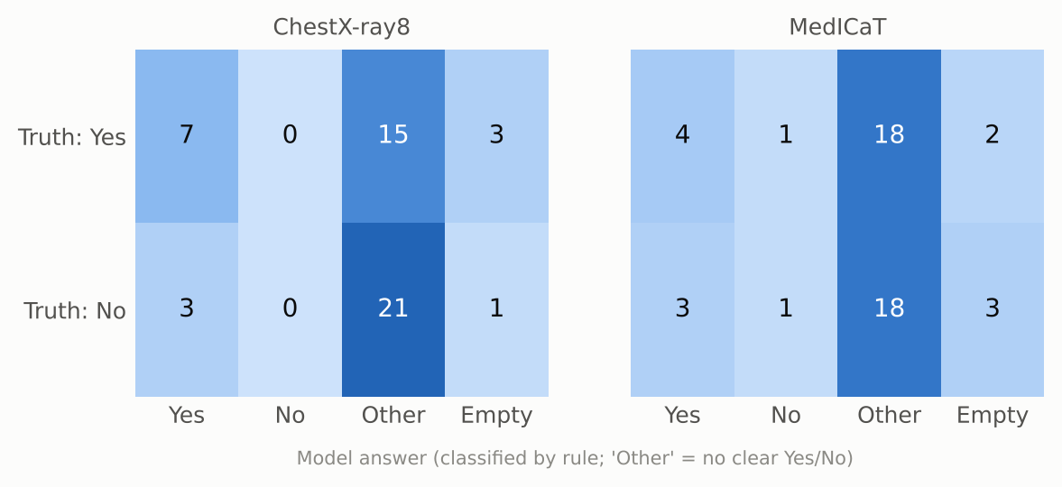
Figure 5. Abnormality: reference label (rows) against the model's answer (columns). Rule-based classification of the model answer.
- Answer breakdown (of 100): Yes 17, No 2, other 72, empty 9. The most common "other" answers are "Consolidation" (33), "Lesion" (4), "Pneumothorax" (3).
- Of its 19 clear Yes/No answers, 12 match the reference (63%); chance on this balanced set is 50%.
- On ChestX-ray8, the 25 Yes questions got: Yes 7, No 0, other 15, empty 3. The 25 No questions got: Yes 3, No 0, other 21, empty 1.

6. How far to trust the scores

6.1 BERTScore only partly separates right from wrong
Mean BERTScore F1 is 66.0 for answers the judge scored 0, 70.8 for 0 < LAVE ≤ 0.5, and 76.5 for LAVE > 0.5. Non-empty answers range from 53.8 to 100.0, and the rank correlation with LAVE is 0.43. Without baseline rescaling (as run here) multilingual BERT gives most Bangla text pairs a high similarity, so BERTScore is a moderate, at best, signal here.

6.2 LAVE is bimodal and noisy on cross-language pairs
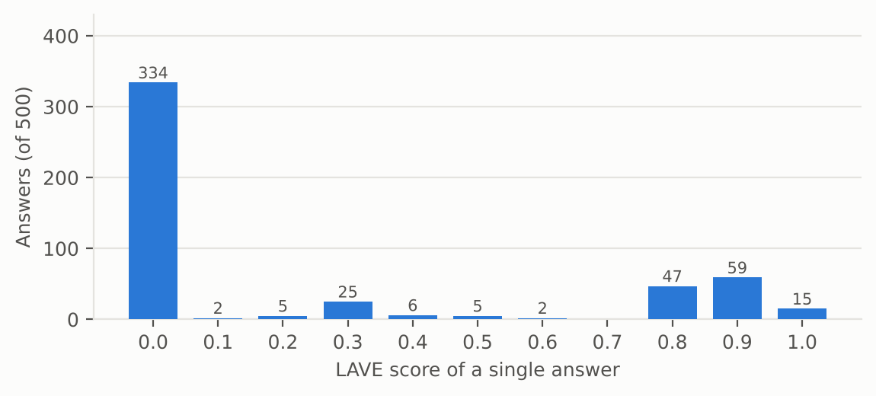
Figure 6. Distribution of single-answer LAVE scores. 334 of 500 answers (67%) get exactly 0; 121 get 0.8 or more.
Because the judge sees only the reference and the prediction, an English answer to a Bangla reference is sometimes accepted and sometimes not. Two audits that do not use the judge:
- Modality. A rule-based match of the imaging modality (X-ray, CT, MRI in English or Bangla) finds the right modality in 98 of 100 answers (100% ChestX-ray8, 96% MedICaT). Mean LAVE on those same 100 answers is only 61%. "CT" answers, all correct, average 33% against 87% for "X-ray".
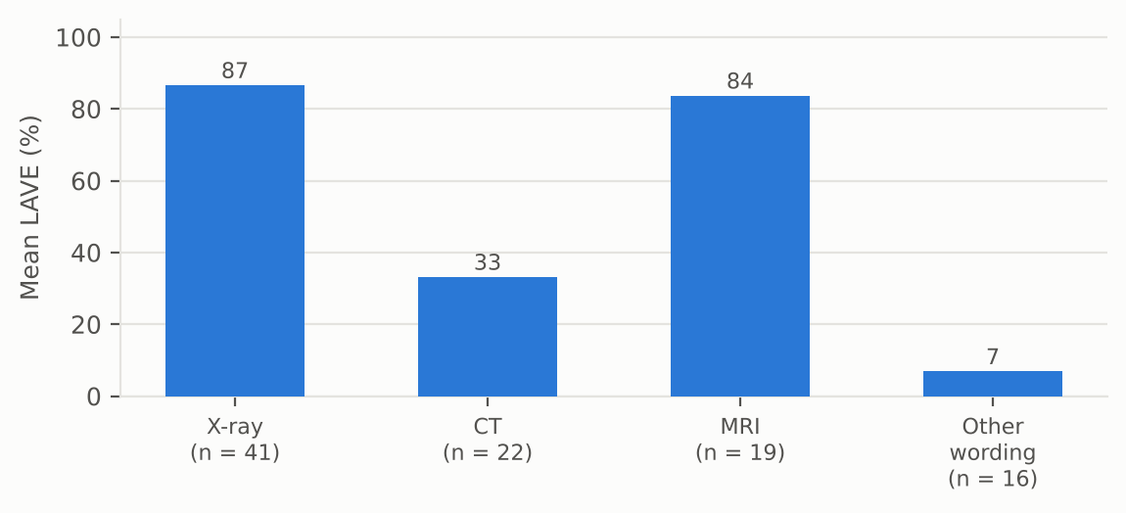
Figure 7. Mean LAVE for answers whose modality is correct by rule-based matching. Same meaning, very different scores.
- Yes/No. 12 abnormality answers are a correct Yes or No (Yes where the reference is Yes, No where it is No). The judge gives credit to 0 of them. Identical meaning, different string, different score:
Reference | Model answer | n | Mean LAVE
হ্যাঁ | Yes | 11 | 0.00
না | No | 1 | 0.00
Table 3. LAVE for correct Yes/No answers, by exact answer string.
Reading. For this model the paper's LAVE protocol is a noisy lower bound: it under-credits correct English answers. Exact match gives no credit for the same reason. Use LAVE as the main metric, but read its category pattern together with the audits above.

7. Example answers
Cell | Question | Reference | Model answer | LAVE
ChestX-ray8 / abnormality | ছবিতে কোনও অস্বাভাবিকতা সনাক্ত হয়েছে কি? | না | Consolidation | 0.0
ChestX-ray8 / condition | এখানে কোন নির্দিষ্ট অবস্থা চিহ্নিত করা হয়েছে? | প্রলায়, এম্ফিসেমা, এবং মাঝ বাম দিকে নিউমোথোরেক্স | Bronchogram | 0.0
ChestX-ray8 / modality | এই ইমেজিং পদ্ধতিটি কী ধরণের? | এক্স-রে | X-ray | 0.9
ChestX-ray8 / organ | এই ছবিতে প্রাথমিকভাবে কোন অঙ্গতন্ত্র চিত্রিত হয়েছে? | বুক | ফুসফুস | 0.0
ChestX-ray8 / position | চিহ্নিত কোনও অবস্থার অ্যানাটোমিক্যাল অবস্থানগুলি কী কী? | কোন অবস্থা চিহ্নিত করা হয়নি। | Chest X-ray | 0.0
MedICaT / abnormality | ছবিতে কি কোনো অস্বাভাবিকতা আছে? | না | Liver | 0.0
MedICaT / condition | ছবিতে কী কী অবস্থা দেখা যাচ্ছে? | প্লুরাল-ভিত্তিক ঘনত্ব | Pneumothorax | 0.0
MedICaT / modality | এই ছবিতে কোন ইমেজিং মোডালিটি ব্যবহার করা হয়েছে? | এমআরআই | MRI | 0.0
MedICaT / organ | এই ছবিতে কোন অঙ্গ দেখানো হয়েছে? | বুক | Lung | 0.0
MedICaT / position | সাবঅ্যারাকনয়েড হেমোরেজ (SAH) এর অবস্থান কোথায়? | ইন্ট্রাক্রানিয়াল | Subarachnoid hemorrhage | 0.0
Table 4. One random example per cell (seed 7).

8. What we take from this
- Gemma 3 4B is weak zero-shot on Bangla medical VQA: exact match 12/500, LAVE 24.1%, BERTScore 69.0.
- Modality and Organ are the categories with signal (LAVE 61% and 47% on average). Rule-based matching finds the right modality in 98 of 100 answers, but modality is nearly a base-rate task (X-ray is 56% of the references in this sample).
- The model mostly does not answer in Bangla (87% English-only). Answers that contain Bangla score LAVE 32.8% against 22.7% for English-only answers.
- Abnormality: a clear Yes/No on only 19 of 100 questions (Yes 17, No 2); 12 of those are right. Its most common other answer is "Consolidation" (33), a finding rather than a Yes/No.
- It leans on stock answers ("pneumothorax" for 50% of ChestX-ray8 conditions).
- The paper's LAVE gives inconsistent credit to English answers for Bangla references (credit for 0 of 12 correct Yes/No answers), and BERTScore (no rescaling) only partly discriminates. Read LAVE as a lower bound.

Caveats
- Sample is from the train splits, not the paper's test split. n = 50 per cell, so category-level intervals are wide (Table 2).
- References are LLM-generated from metadata (paper: 97% acceptance on an expert-checked subset). Some references are generic, for example "no specific condition identified".
- LAVE uses the paper's simplified prompt (reference and prediction only, no question). The Yes/No classification and modality matching in Sections 5 and 6 are our own rule-based audits, not paper metrics.
- One greedy run per question; no variance across seeds or prompts.

