Zero-shot Bangla Medical VQA
MedVLM-R1 on BanglaMedVQA
500 questions (5 categories × 2 sources × 50) · open-ended · paper's zero-shot prompt · LAVE judge: GPT-4.1-mini

1. Summary
Exact-match accuracy is 0.0% (0 of 500). LAVE is 16.0% (95% CI 13.4–18.7), BERTScore F1 68.4. ChestX-ray8 16.9% vs MedICaT 15.1% LAVE; the intervals overlap, so there is no clear source difference.
Modality (ChestX-ray8 58.6%, MedICaT 54.4%) is the only category with real signal (LAVE). The other 4 categories score between 0.0% and 12.8%.

2. Setup
Item | Value
Model | JZPeterPan/MedVLM-R1 (Qwen2-VL-2B with reinforcement-learning fine-tuning on medical VQA), bf16, greedy decoding, 256 new tokens max
Data | BanglaMedVQA, Bangla columns only (question_bn, answer_bn). Train splits of ChestX-ray8 and MedICaT
Sample | 50 questions per category per source = 500. Seed 42, one image per question, abnormality balanced 25 Yes / 25 No per source. Same 500 for every model
Prompt | Paper's English zero-shot system prompt (one word or short phrase, no punctuation); Bangla question as the user turn; no options, no few-shot
Metrics | Accuracy (exact match after minimal cleaning), BERTScore F1 (mBERT, layer 9, no rescaling), LAVE (GPT-4.1-mini, paper's simplified judge prompt, one pair per call, temperature 0). Normalized accuracy is our supplementary metric
Confidence intervals | Accuracy: Wilson 95%. LAVE: percentile bootstrap, 5,000 resamples

3. Results

3.1 Headline numbers
Source | n | Accuracy % (CI) | Norm. acc. % | BERTScore | LAVE % (CI) | English-only % | Empty %
ChestX-ray8 | 250 | 0.0 (0.0–1.5) | 5.2 | 70.2 | 16.9 (13.2–20.9) | 85.2 | 0.0
MedICaT | 250 | 0.0 (0.0–1.5) | 1.6 | 66.6 | 15.1 (11.7–18.6) | 92.0 | 1.2
All 500 | 500 | 0.0 (0.0–0.8) | 3.4 | 68.4 | 16.0 (13.4–18.7) | 88.6 | 0.6
Avg. of sources | 500 | 0.0 | 3.4 | 68.4 | 16.0
Table 1. Paper-style headline table. 'Avg. of sources' is the paper's Overall (Avg.): the mean of the two source scores.
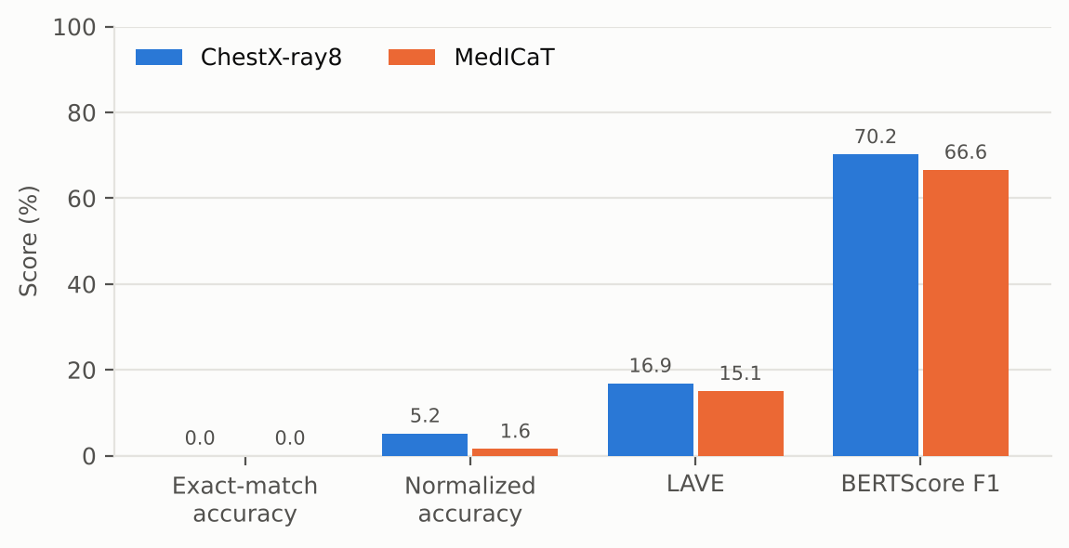
Figure 1. The four metrics on one scale. Exact match is 0 because answers are rarely in correct Bangla; BERTScore is high for wrong answers too (Section 6).

3.2 Per category
Source | Category | Acc. % | Norm. acc. % | BERTScore | LAVE % (CI) | English-only % | >6 words %
ChestX-ray8 | Abnormality | 0 | 26 | 71.2 | 12.8 (7–20) | 76 | 0
ChestX-ray8 | Condition | 0 | 0 | 63.3 | 3.8 (1–8) | 100 | 2
ChestX-ray8 | Modality | 0 | 0 | 73.7 | 58.6 (48–69) | 100 | 0
ChestX-ray8 | Organ | 0 | 0 | 73.9 | 5.2 (2–10) | 62 | 6
ChestX-ray8 | Position | 0 | 0 | 69.1 | 4.0 (1–8) | 88 | 0
MedICaT | Abnormality | 0 | 8 | 63.8 | 0.0 (0–0) | 94 | 12
MedICaT | Condition | 0 | 0 | 65.1 | 12.2 (6–20) | 92 | 34
MedICaT | Modality | 0 | 0 | 69.5 | 54.4 (45–64) | 100 | 0
MedICaT | Organ | 0 | 0 | 69.4 | 5.4 (2–9) | 76 | 10
MedICaT | Position | 0 | 0 | 65.3 | 3.4 (1–6) | 98 | 14
Table 2. Per-category results (n = 50 each). Acc. is exact match. Shaded cells are the categories with real signal. A LAVE interval of 0–0 means every one of the 50 answers scored 0.
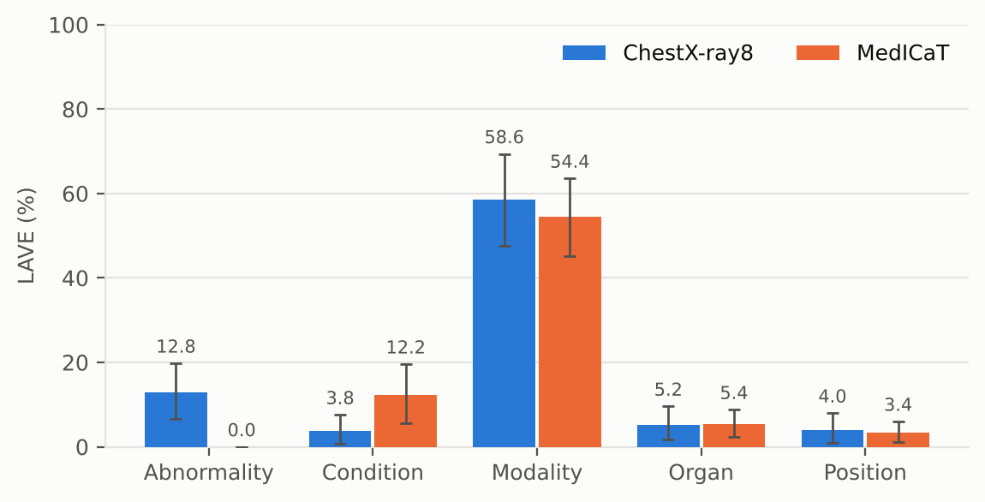
Figure 2. LAVE by category and source with 95% bootstrap intervals. Modality is clearly above the rest.

4. What the model actually outputs
It answers in English. 88.6% of answers contain only Latin text. The 57 answers that contain Bangla score a mean LAVE of 1.2% (mostly garbled Bangla); English-only answers score 17.9% (n = 443).
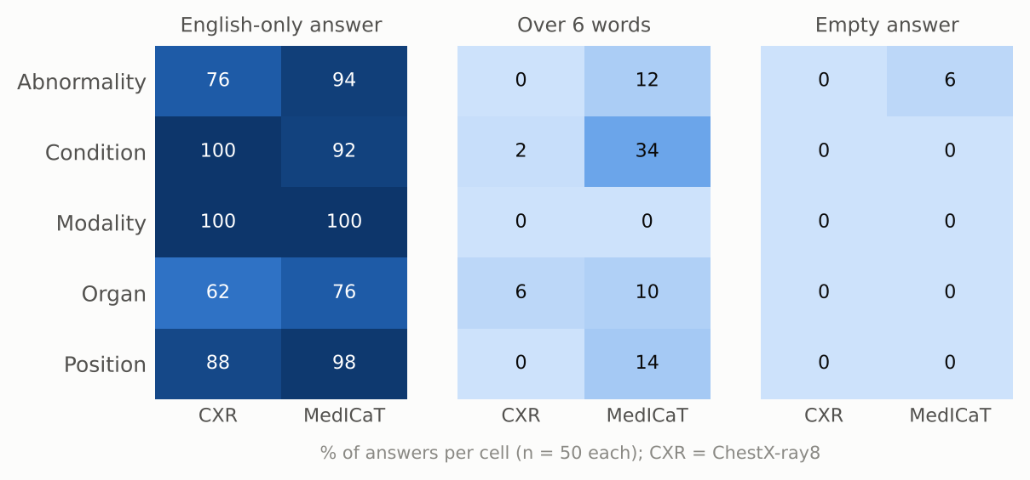
Figure 3. Output-format failures per cell. Answers over 6 words are concentrated in MedICaT (caption-like sentences). Empty answers: MedICaT abnormality.
It collapses onto one answer. On ChestX-ray8 condition, 74% of answers are "pneumonia". 64% of modality answers are "x-ray" (correct for most of these questions, but it shows how little image-specific variation there is). The top ChestX-ray8 organ answer (18%) is a Bangla word meaning "line", not an organ.
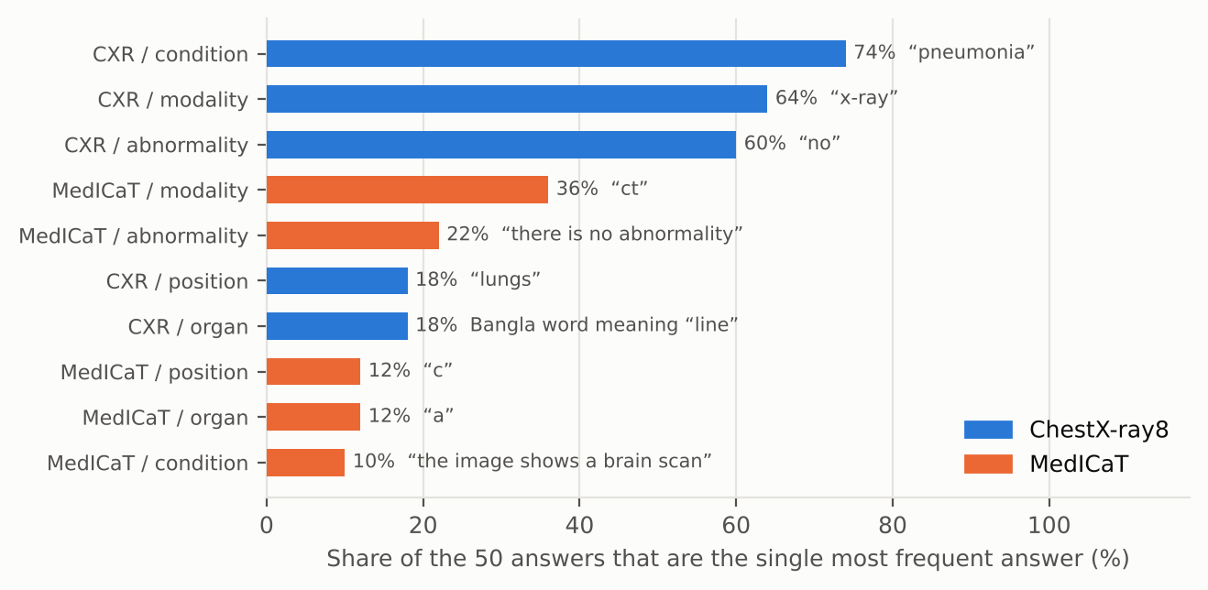
Figure 4. Share of the 50 answers in each cell taken by the single most frequent answer.
It treats MedICaT questions as multiple choice. 24 MedICaT answers are a bare option letter ("A", "C") or start with one ("A) MRI"): 7 in organ, 10 in position, 2 in abnormality, 3 in condition, 2 in modality. No options were shown, so most of these carry no answer content. ChestX-ray8 has none.
No reasoning text. 0 of 500 raw outputs contain a <think> tag and 0 contain an <answer> tag; the longest output is 224 characters. Under the paper's prompt this reasoning-tuned model answered directly, so its extra token budget was never used.
Repetition loops. 1 answer is a degenerate loop (the same word repeated until the token limit).

5. Abnormality (Yes/No)
The 100 abnormality questions are balanced (50 Yes, 50 No), so a constant answer scores 50%. We classified each model answer by rule: "no", "no abnormality", "there is no abnormality" count as No; anything without a clear Yes/No is Other.
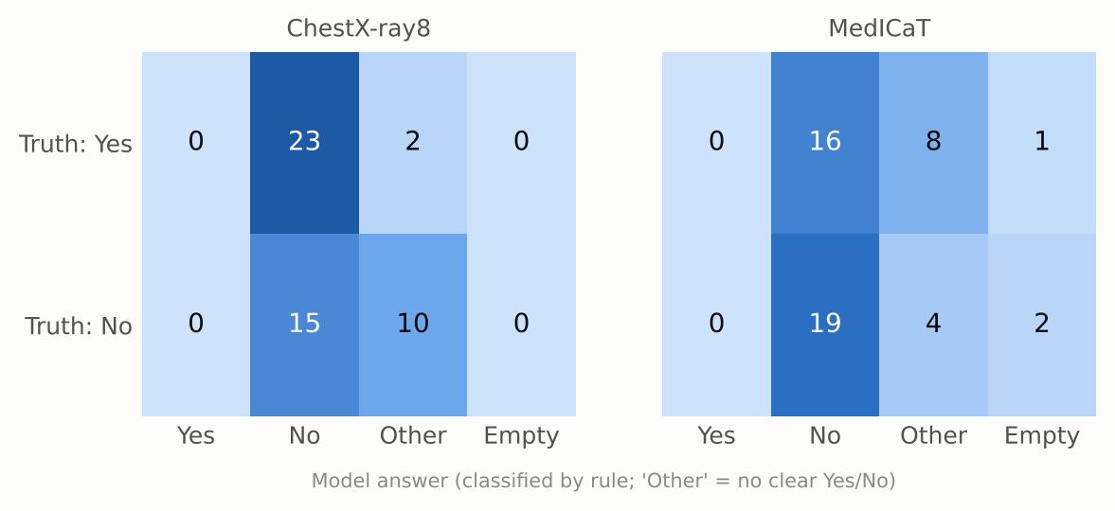
Figure 5. Abnormality: reference label (rows) against the model's answer (columns). Rule-based classification of the model answer.
- Answer breakdown (of 100): Yes 0, No 73, other 24, empty 3. The model never says Yes. The most common "other" answers are "প্রাকৃতিক অস্বাভাবিকতা" (9), "প্রাকৃতিক বিকাশ" (1), "প্রাকৃতিক স্থানীয় অস্বাভাবিকতা" (1).
- Of its 73 clear Yes/No answers, 34 match the reference (47%); chance on this balanced set is 50%. It does not discriminate normal from abnormal images.
- On ChestX-ray8, the 25 Yes questions got: Yes 0, No 23, other 2, empty 0. The 25 No questions got: Yes 0, No 15, other 10, empty 0.

6. How far to trust the scores

6.1 BERTScore barely separates right from wrong
Mean BERTScore F1 is 67.3 for answers the judge scored 0, 70.1 for 0 < LAVE ≤ 0.5, and 72.5 for LAVE > 0.5. Non-empty answers range from 53.6 to 82.9, and the rank correlation with LAVE is 0.31. Without baseline rescaling (as run here) multilingual BERT gives most Bangla text pairs a high similarity, so BERTScore is a weak signal here.

6.2 LAVE is bimodal and noisy on cross-language pairs
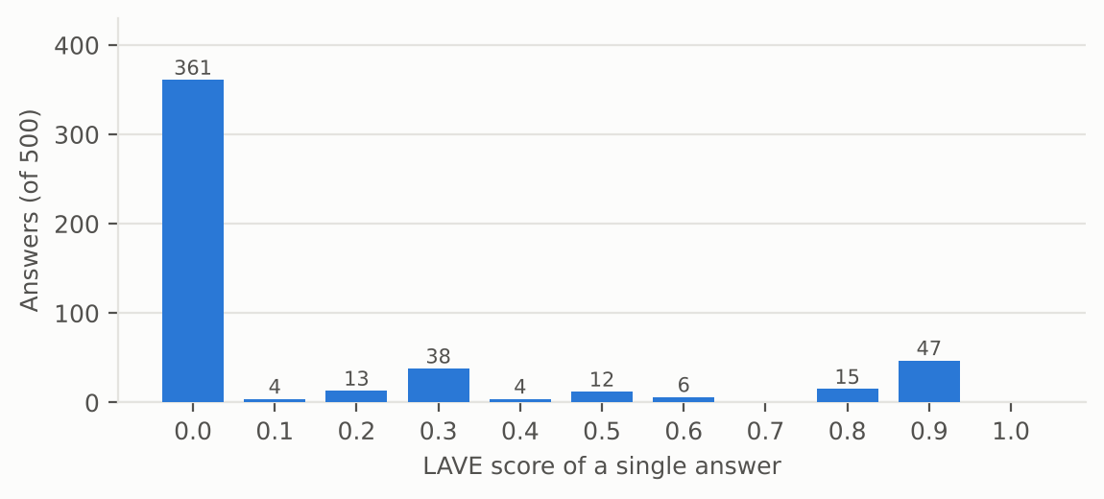
Figure 6. Distribution of single-answer LAVE scores. 361 of 500 answers (72%) get exactly 0; 62 get 0.8 or more.
Because the judge sees only the reference and the prediction, an English answer to a Bangla reference is sometimes accepted and sometimes not. Two audits that do not use the judge:
- Modality. A rule-based match of the imaging modality (X-ray, CT, MRI in English or Bangla) finds the right modality in 84 of 100 answers (72% ChestX-ray8, 96% MedICaT). Mean LAVE on those same 100 answers is only 56%. "CT" answers, all correct, average 32% against 87% for "X-ray".
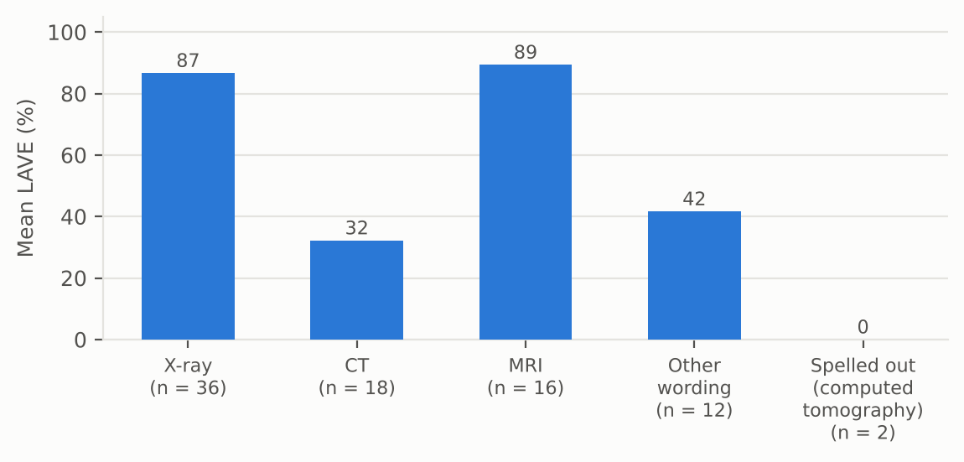
Figure 7. Mean LAVE for answers whose modality is correct by rule-based matching. Same meaning, very different scores.
- Yes/No. 34 abnormality answers are a correct Yes or No (Yes where the reference is Yes, No where it is No). The judge gives credit to 11 of them. Identical meaning, different string, different score:
Reference | Model answer | n | Mean LAVE
না | no | 14 | 0.46
না | There is no abnormality | 9 | 0.00
না | No abnormality | 5 | 0.00
না | No | 3 | 0.00
না | No abnormalities | 2 | 0.00
না | no significant brain parenchymal abnormality | 1 | 0.00
Table 3. LAVE for correct Yes/No answers, by exact answer string.
Reading. For this model the paper's LAVE protocol is a noisy lower bound: it under-credits correct English answers. Exact match gives no credit for the same reason. Use LAVE as the main metric, but read its category pattern together with the audits above.

7. Comparison with Qwen2-VL-2B
MedVLM-R1 is built on Qwen2-VL-2B (reinforcement-learning fine-tuning on medical VQA), so Qwen2-VL-2B is the natural baseline. Both models answered the same 500 questions with the same prompt, so the comparison is paired: for each question we take the LAVE difference and bootstrap the mean (5,000 resamples).
Source | Category | LAVE % Qwen2-VL-2B | LAVE % MedVLM-R1 | Difference, pts (95% CI) | Same answer %
ChestX-ray8 | Abnormality | 10.6 | 12.8 | +2.2 (-2.6 to 7.6) | 72
ChestX-ray8 | Condition | 4.4 | 3.8 | -0.6 (-2.6 to 0.8) | 96
ChestX-ray8 | Modality | 61.2 | 58.6 | -2.6 (-7.8 to 1.4) | 84
ChestX-ray8 | Organ | 2.2 | 5.2 | +3.0 (0.6 to 6.6) | 58
ChestX-ray8 | Position | 1.8 | 4.0 | +2.2 (0.0 to 6.0) | 68
MedICaT | Abnormality | 1.6 | 0.0 | -1.6 (-4.8 to 0.0) | 70
MedICaT | Condition | 12.2 | 12.2 | 0.0 (-1.6 to 1.6) | 68
MedICaT | Modality | 50.4 | 54.4 | +4.0 (-0.4 to 9.4) | 88
MedICaT | Organ | 4.4 | 5.4 | +1.0 (-2.4 to 4.2) | 64
MedICaT | Position | 2.6 | 3.4 | +0.8 (-1.0 to 2.6) | 56
Table 4. Per-cell LAVE, paired difference (MedVLM-R1 minus Qwen2-VL-2B) and share of word-for-word identical answers.
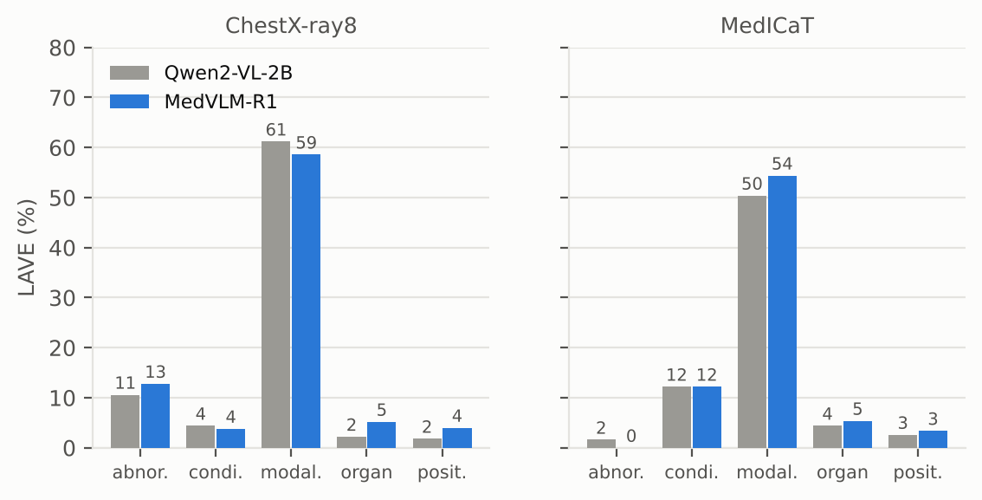
Figure 8. LAVE per category, Qwen2-VL-2B (grey) against MedVLM-R1 (blue).
- Overall LAVE 16.0% against 15.1%: a difference of +0.8 points (95% CI -0.2 to 2.0). The interval includes zero, so the two models are not distinguishable.
- 362 of 500 answers (72%) are word-for-word identical, and 439 questions get the same LAVE. MedVLM-R1 scores higher on 38 questions and lower on 23.
- Only one cell has a paired interval that excludes zero (ChestX-ray8 organ, +3.0 points). With 10 cells, one such result is within what chance alone produces.
- Normalized accuracy 3.4% against 2.4%, BERTScore 68.4 against 68.6, English-only answers 88.6% against 81.4%.

8. Example answers
Cell | Question | Reference | Model answer | LAVE
ChestX-ray8 / abnormality | ছবিতে কোনও অস্বাভাবিকতা সনাক্ত হয়েছে কি? | না | no | 0.5
ChestX-ray8 / condition | এখানে কোন নির্দিষ্ট অবস্থা চিহ্নিত করা হয়েছে? | প্রলায়, এম্ফিসেমা, এবং মাঝ বাম দিকে নিউমোথোরেক্স | pneumonia | 0.2
ChestX-ray8 / modality | এই ইমেজিং পদ্ধতিটি কী ধরণের? | এক্স-রে | lung | 0.0
ChestX-ray8 / organ | এই ছবিতে প্রাথমিকভাবে কোন অঙ্গতন্ত্র চিত্রিত হয়েছে? | বুক | লাইন | 0.0
ChestX-ray8 / position | চিহ্নিত কোনও অবস্থার অ্যানাটোমিক্যাল অবস্থানগুলি কী কী? | কোন অবস্থা চিহ্নিত করা হয়নি। | The image shows the lungs | 0.0
MedICaT / abnormality | ছবিতে কি কোনো অস্বাভাবিকতা আছে? | না | There is no abnormality | 0.0
MedICaT / condition | ছবিতে কী কী অবস্থা দেখা যাচ্ছে? | প্লুরাল-ভিত্তিক ঘনত্ব | The image shows a chest radiograph | 0.0
MedICaT / modality | এই ছবিতে কোন ইমেজিং মোডালিটি ব্যবহার করা হয়েছে? | এমআরআই | T2 | 0.0
MedICaT / organ | এই ছবিতে কোন অঙ্গ দেখানো হয়েছে? | বুক | Aorta | 0.0
MedICaT / position | সাবঅ্যারাকনয়েড হেমোরেজ (SAH) এর অবস্থান কোথায়? | ইন্ট্রাক্রানিয়াল | C | 0.0
Table 5. One random example per cell (seed 7).

9. What we take from this
- MedVLM-R1 is close to unusable zero-shot on Bangla medical VQA: exact match 0/500, LAVE 16.0%, BERTScore 68.4.
- Modality is the only category with signal (LAVE 56% on average). Rule-based matching finds the right modality in 84 of 100 answers, but modality is nearly a base-rate task (X-ray is 56% of the references in this sample).
- The model mostly does not answer in Bangla (89% English-only). Answers that contain Bangla score LAVE 1.2% (mostly garbled) against 17.9% for English-only answers.
- Abnormality: a clear Yes/No on only 73 of 100 questions (Yes 0, No 73); 34 of those are right. It never says Yes.
- It leans on stock answers ("pneumonia" for 74% of ChestX-ray8 conditions) and answers 24 MedICaT questions with option letters.
- The paper's LAVE gives inconsistent credit to English answers for Bangla references (credit for 11 of 34 correct Yes/No answers), and BERTScore (no rescaling) barely discriminates. Read LAVE as a lower bound.
- It never produced reasoning text (0 <think> tags in 500 outputs), so the reasoning mode this model was trained for is not triggered by the paper's short-answer prompt.
- Against Qwen2-VL-2B: LAVE 16.0% vs 15.1% (paired difference +0.8 points, 95% CI -0.2 to 2.0), with 72% of answers identical. Medical fine-tuning made no measurable difference to zero-shot Bangla answers.

Caveats
- Sample is from the train splits, not the paper's test split. n = 50 per cell, so category-level intervals are wide (Table 2).
- References are LLM-generated from metadata (paper: 97% acceptance on an expert-checked subset). Some references are generic, for example "no specific condition identified".
- LAVE uses the paper's simplified prompt (reference and prediction only, no question). The Yes/No classification and modality matching in Sections 5 and 6 are our own rule-based audits, not paper metrics.
- One greedy run per question; no variance across seeds or prompts.

