Zero-shot Bangla Medical VQA
MedGemma 4B-it on BanglaMedVQA
500 questions (5 categories × 2 sources × 50) · open-ended · paper's zero-shot prompt · LAVE judge: GPT-4.1-mini

1. Summary
Exact-match accuracy is 1.6% (8 of 500). LAVE is 31.5% (95% CI 28.1–34.9), BERTScore F1 71.4. ChestX-ray8 36.4% vs MedICaT 26.5% LAVE; the intervals do not overlap.
Modality (ChestX-ray8 84.8%, MedICaT 61.8%) and Organ (ChestX-ray8 78.4%, MedICaT 47.8%) are the categories with real signal (LAVE). The other 3 categories score between 3.2% and 12.4%.

2. Setup
Item | Value
Model | google/medgemma-4b-it (Gemma 3 4B with medical image and text pre-training), bf16, greedy decoding, 96 new tokens max
Data | BanglaMedVQA, Bangla columns only (question_bn, answer_bn). Train splits of ChestX-ray8 and MedICaT
Sample | 50 questions per category per source = 500. Seed 42, one image per question, abnormality balanced 25 Yes / 25 No per source. Same 500 for every model
Prompt | Paper's English zero-shot system prompt (one word or short phrase, no punctuation); Bangla question as the user turn; no options, no few-shot
Metrics | Accuracy (exact match after minimal cleaning), BERTScore F1 (mBERT, layer 9, no rescaling), LAVE (GPT-4.1-mini, paper's simplified judge prompt, one pair per call, temperature 0). Normalized accuracy is our supplementary metric
Confidence intervals | Accuracy: Wilson 95%. LAVE: percentile bootstrap, 5,000 resamples

3. Results

3.1 Headline numbers
Source | n | Accuracy % (CI) | Norm. acc. % | BERTScore | LAVE % (CI) | English-only % | Empty %
ChestX-ray8 | 250 | 1.2 (0.4–3.5) | 12.0 | 71.5 | 36.4 (31.4–41.6) | 98.8 | 0.0
MedICaT | 250 | 2.0 (0.9–4.6) | 12.4 | 71.3 | 26.5 (21.9–31.3) | 97.6 | 0.0
All 500 | 500 | 1.6 (0.8–3.1) | 12.2 | 71.4 | 31.5 (28.1–34.9) | 98.2 | 0.0
Avg. of sources | 500 | 1.6 | 12.2 | 71.4 | 31.5
Table 1. Paper-style headline table. 'Avg. of sources' is the paper's Overall (Avg.): the mean of the two source scores.
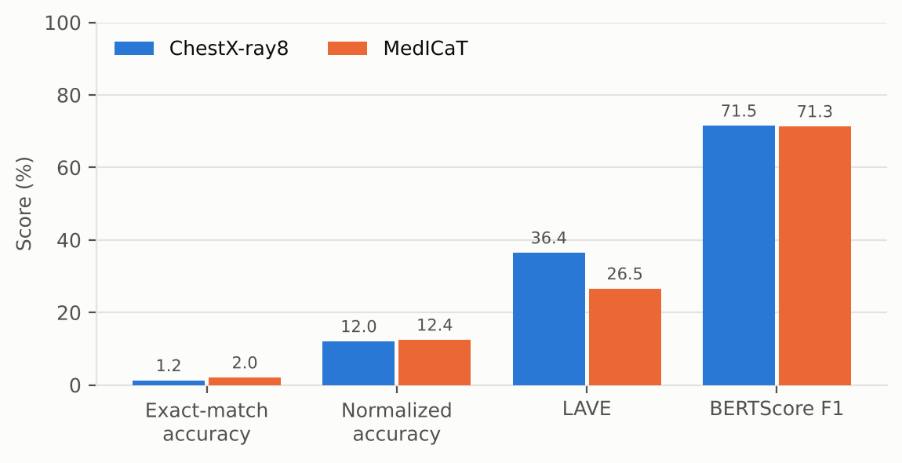
Figure 1. The four metrics on one scale. Exact match is only 1.6% because answers are rarely in correct Bangla; BERTScore is high for wrong answers too (Section 6).

3.2 Per category
Source | Category | Acc. % | Norm. acc. % | BERTScore | LAVE % (CI) | English-only % | >6 words %
ChestX-ray8 | Abnormality | 6 | 60 | 77.1 | 6.0 (0–14) | 94 | 0
ChestX-ray8 | Condition | 0 | 0 | 62.2 | 9.8 (4–16) | 100 | 0
ChestX-ray8 | Modality | 0 | 0 | 75.6 | 84.8 (80–88) | 100 | 0
ChestX-ray8 | Organ | 0 | 0 | 73.9 | 78.4 (73–82) | 100 | 0
ChestX-ray8 | Position | 0 | 0 | 68.5 | 3.2 (0–7) | 100 | 0
MedICaT | Abnormality | 4 | 56 | 75.8 | 4.0 (0–10) | 96 | 0
MedICaT | Condition | 0 | 0 | 67.0 | 12.4 (6–20) | 100 | 0
MedICaT | Modality | 0 | 0 | 70.1 | 61.8 (53–70) | 100 | 0
MedICaT | Organ | 6 | 6 | 75.0 | 47.8 (35–59) | 94 | 0
MedICaT | Position | 0 | 0 | 68.6 | 6.6 (2–12) | 98 | 0
Table 2. Per-category results (n = 50 each). Acc. is exact match. Shaded cells are the categories with real signal.
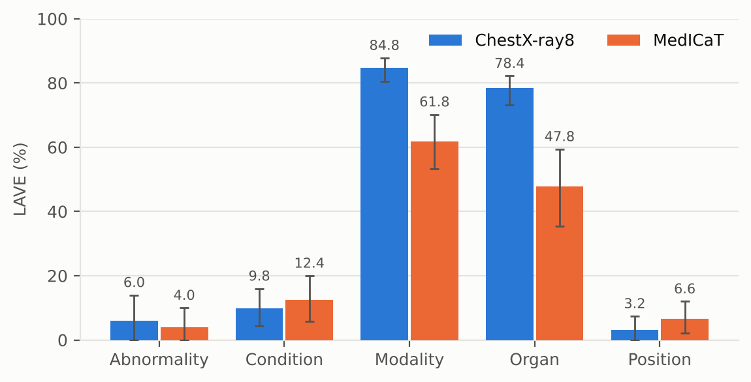
Figure 2. LAVE by category and source with 95% bootstrap intervals. Modality and Organ are clearly above the rest.

4. What the model actually outputs
It answers in English. 98.2% of answers contain only Latin text. The 9 answers that contain Bangla score a mean LAVE of 91.1% (higher than English-only answers: when it does answer in Bangla it is more often right); English-only answers score 30.4% (n = 491). Exact matches: all 8 come from ChestX-ray8 abnormality (3), MedICaT abnormality (2) and MedICaT organ (3); the most frequent matching answer is "হ্যাঁ" (3).
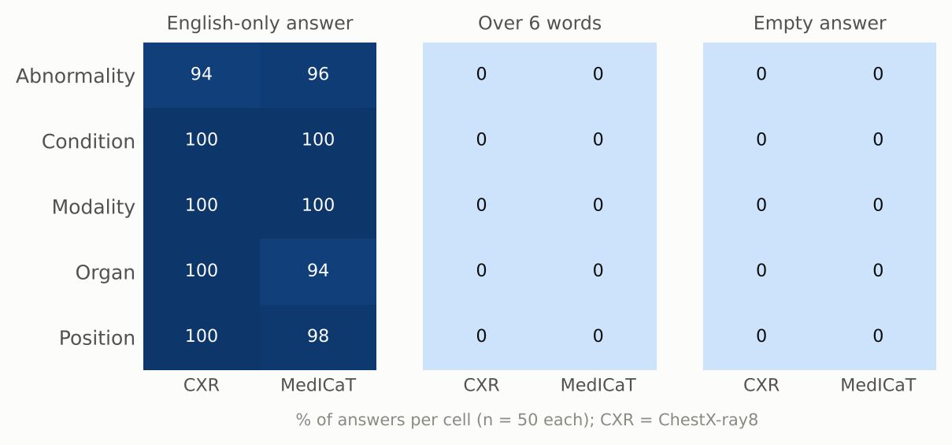
Figure 3. Output-format failures per cell. No answer exceeds 6 words. No empty answers.
It repeats a few stock answers. On ChestX-ray8 condition, 32% of answers are "pneumonia". 98% of modality answers are "x-ray" (correct for most of these questions, but it shows how little image-specific variation there is). The top ChestX-ray8 organ answer (96%) is "chest".
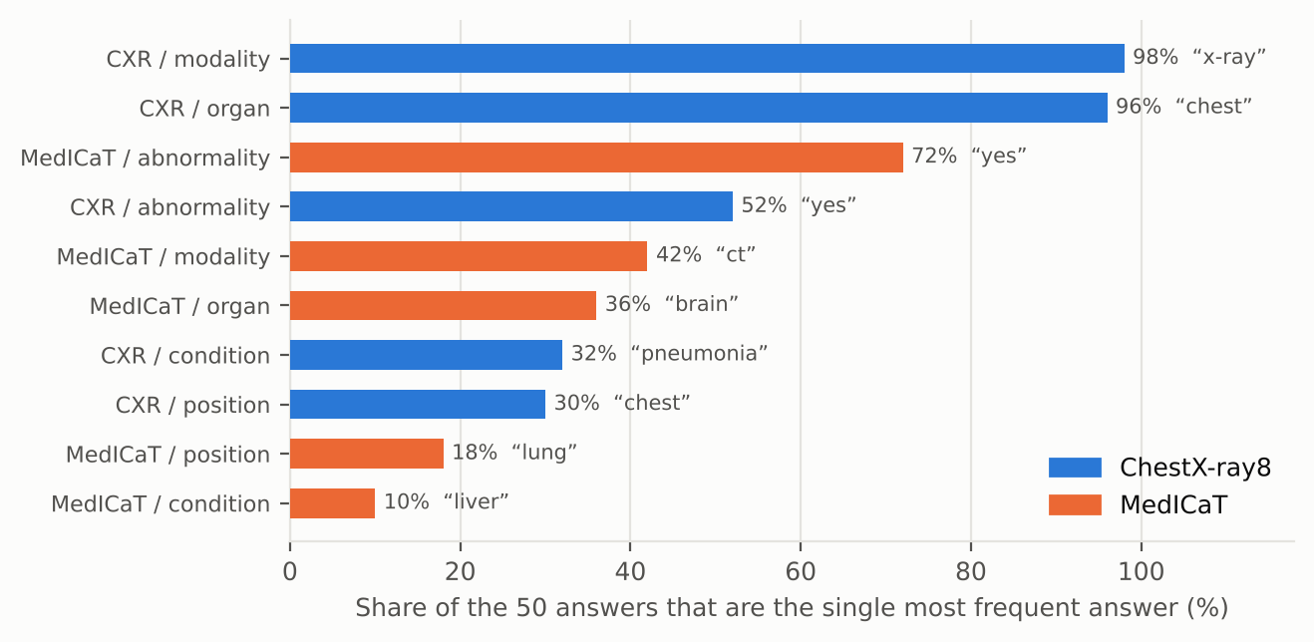
Figure 4. Share of the 50 answers in each cell taken by the single most frequent answer.

5. Abnormality (Yes/No)
The 100 abnormality questions are balanced (50 Yes, 50 No), so a constant answer scores 50%. We classified each model answer by rule: "no", "no abnormality", "there is no abnormality" count as No; anything without a clear Yes/No is Other.
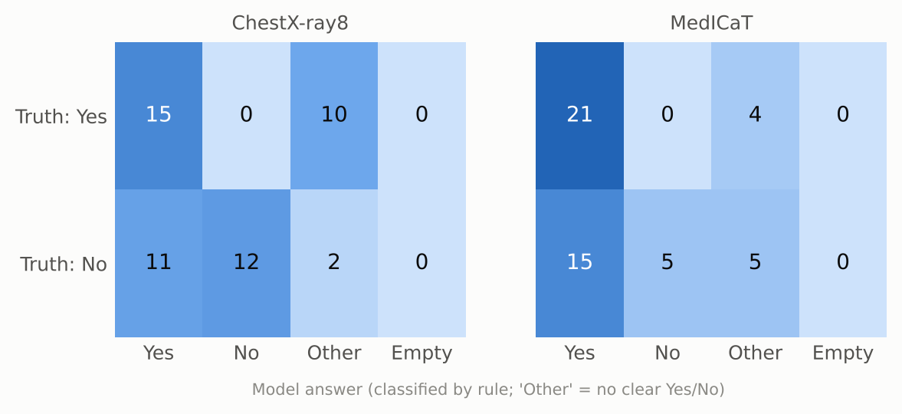
Figure 5. Abnormality: reference label (rows) against the model's answer (columns). Rule-based classification of the model answer.
- Answer breakdown (of 100): Yes 62, No 17, other 21, empty 0. The most common "other" answers are "হ্যাঁ" (3), "Right lung" (3), "Pneumonia" (2).
- Of its 79 clear Yes/No answers, 53 match the reference (67%); chance on this balanced set is 50%.
- On ChestX-ray8, the 25 Yes questions got: Yes 15, No 0, other 10, empty 0. The 25 No questions got: Yes 11, No 12, other 2, empty 0.

6. How far to trust the scores

6.1 BERTScore barely separates right from wrong
Mean BERTScore F1 is 70.0 for answers the judge scored 0, 69.5 for 0 < LAVE ≤ 0.5, and 74.2 for LAVE > 0.5. Non-empty answers range from 57.8 to 100.0, and the rank correlation with LAVE is 0.29. Without baseline rescaling (as run here) multilingual BERT gives most Bangla text pairs a high similarity, so BERTScore is a weak signal here.

6.2 LAVE is bimodal and noisy on cross-language pairs
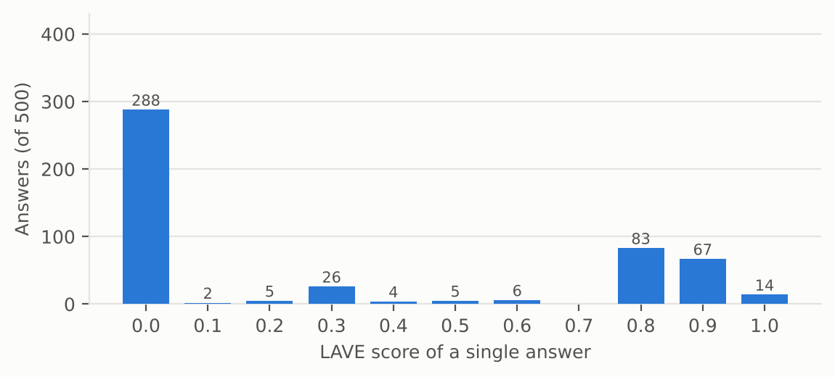
Figure 6. Distribution of single-answer LAVE scores. 288 of 500 answers (58%) get exactly 0; 164 get 0.8 or more.
Because the judge sees only the reference and the prediction, an English answer to a Bangla reference is sometimes accepted and sometimes not. Two audits that do not use the judge:
- Modality. A rule-based match of the imaging modality (X-ray, CT, MRI in English or Bangla) finds the right modality in 99 of 100 answers (98% ChestX-ray8, 100% MedICaT). Mean LAVE on those same 100 answers is only 73%. "CT" answers, all correct, average 32% against 87% for "X-ray".
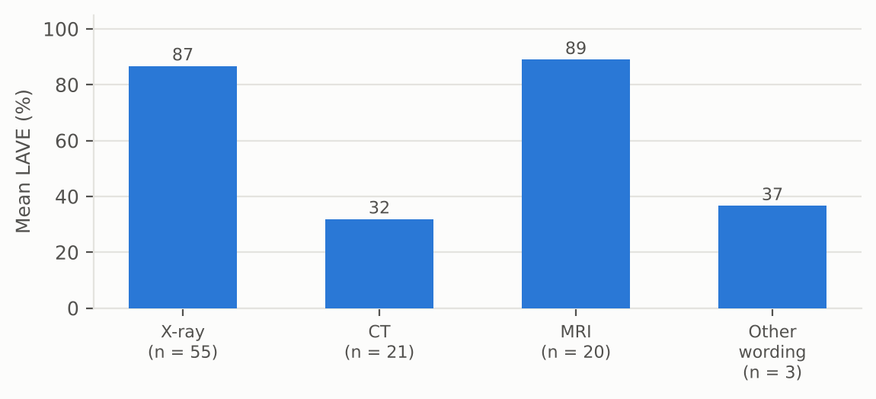
Figure 7. Mean LAVE for answers whose modality is correct by rule-based matching. Same meaning, very different scores.
- Yes/No. 53 abnormality answers are a correct Yes or No (Yes where the reference is Yes, No where it is No). The judge gives credit to 0 of them. Identical meaning, different string, different score:
Reference | Model answer | n | Mean LAVE
হ্যাঁ | Yes | 36 | 0.00
না | No | 17 | 0.00
Table 3. LAVE for correct Yes/No answers, by exact answer string.
Reading. For this model the paper's LAVE protocol is a noisy lower bound: it under-credits correct English answers. Exact match gives no credit for the same reason. Use LAVE as the main metric, but read its category pattern together with the audits above.

7. Comparison with Gemma 3 4B
MedGemma 4B is built on Gemma 3 4B (further medical pre-training), so Gemma 3 4B is the natural baseline. Both models answered the same 500 questions with the same prompt, so the comparison is paired: for each question we take the LAVE difference and bootstrap the mean (5,000 resamples).
Source | Category | LAVE % Gemma 3 4B | LAVE % MedGemma 4B | Difference, pts (95% CI) | Same answer %
ChestX-ray8 | Abnormality | 0.0 | 6.0 | +6.0 (0.0 to 14.0) | 20
ChestX-ray8 | Condition | 3.6 | 9.8 | +6.2 (-0.2 to 12.8) | 10
ChestX-ray8 | Modality | 64.4 | 84.8 | +20.4 (10.8 to 31.0) | 72
ChestX-ray8 | Organ | 47.8 | 78.4 | +30.6 (19.0 to 42.2) | 54
ChestX-ray8 | Position | 2.6 | 3.2 | +0.6 (-2.4 to 4.2) | 24
MedICaT | Abnormality | 0.0 | 4.0 | +4.0 (0.0 to 10.0) | 18
MedICaT | Condition | 9.6 | 12.4 | +2.8 (-4.0 to 9.6) | 22
MedICaT | Modality | 57.0 | 61.8 | +4.8 (-0.8 to 11.6) | 92
MedICaT | Organ | 46.4 | 47.8 | +1.4 (-8.8 to 12.0) | 26
MedICaT | Position | 9.6 | 6.6 | -3.0 (-10.4 to 3.4) | 22
Table 4. Per-cell LAVE, paired difference (MedGemma 4B minus Gemma 3 4B) and share of word-for-word identical answers.
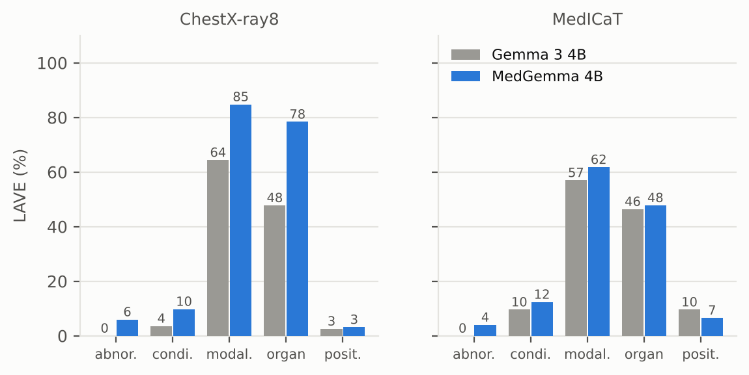
Figure 8. LAVE per category, Gemma 3 4B (grey) against MedGemma 4B (blue).
- Overall LAVE 31.5% against 24.1%: a difference of +7.4 points (95% CI 4.8 to 10.0). The interval excludes zero.
- 180 of 500 answers (36%) are word-for-word identical, and 370 questions get the same LAVE. MedGemma 4B scores higher on 85 questions and lower on 45.
- 2 cells have a paired interval that excludes zero (ChestX-ray8 modality, +20.4 points; ChestX-ray8 organ, +30.6 points). With 10 cells and 95% intervals, chance alone would flag about half a cell on average.
- Normalized accuracy 12.2% against 4.8%, BERTScore 71.4 against 69.0, English-only answers 98.2% against 86.6%.

8. Comparison with the paper
The paper reports Med-Gemma 4B in the Bangla zero-shot setting (its Tables 2 and 4). Our run is not the paper's experiment: it uses a 500-question sample from the train splits (paper: 400 test questions) and its own set of judge calls. Treat the gaps below as indicative only.
 | Acc paper | Acc ours | BERT paper | BERT ours | LAVE paper | LAVE ours
ChestX-ray8 | 4.0 | 1.2 | 68.9 | 71.5 | 11.9 | 36.4
MedICaT | 18.5 | 2.0 | 76.0 | 71.3 | 27.8 | 26.5
Overall (avg.) | 11.3 | 1.6 | 72.5 | 71.4 | 19.9 | 31.5
Table 5. Headline metrics, paper against this run (%).
Source | Category | LAVE % paper | LAVE % ours | Ours minus paper
ChestX-ray8 | Abnormality | 0.0 | 6.0 | +6.0
ChestX-ray8 | Condition | 0.5 | 9.8 | +9.3
ChestX-ray8 | Modality | 6.0 | 84.8 | +78.8
ChestX-ray8 | Organ | 50.0 | 78.4 | +28.4
ChestX-ray8 | Position | 3.0 | 3.2 | +0.2
MedICaT | Abnormality | 67.1 | 4.0 | -63.1
MedICaT | Condition | 0.0 | 12.4 | +12.4
MedICaT | Modality | 36.1 | 61.8 | +25.7
MedICaT | Organ | 16.3 | 47.8 | +31.5
MedICaT | Position | 19.5 | 6.6 | -12.9
Table 6. Per-category LAVE, paper (Table 4, base prompt on Bangla QA pairs) against this run (%).
- Overall LAVE is higher here (31.5% against 19.85%), mainly because ChestX-ray8 Modality and Organ score far higher in our run (84.8% and 78.4% against 6.0% and 50.0%). The paper does not say why its Modality score is so low; we have not checked whether the answer language or format differed.
- MedICaT Abnormality goes the other way (paper 67.1%, ours 4.0%). In our run every English "Yes"/"No" answer is scored 0 by the judge (Section 6), whereas a 67% score in the paper means Yes/No answers were credited there. So the zero-credit effect seen here cannot simply be assumed to explain the paper's 0.00 on ChestX-ray8 Abnormality; the two runs behave differently and we do not know why.
- Exact accuracy is lower here (paper 11.25%, ours 1.6%; the gap is largest on MedICaT, 18.5% against 2.0%), and BERTScore is close (72.47 against 71.4).
- Our MedICaT Abnormality sample is balanced 25 Yes / 25 No by design. The paper's test split is likely Yes-heavy (other models score around 90% there), which changes what a constant answer earns.

9. Example answers
Cell | Question | Reference | Model answer | LAVE
ChestX-ray8 / abnormality | ছবিতে কোনও অস্বাভাবিকতা সনাক্ত হয়েছে কি? | না | No | 0.0
ChestX-ray8 / condition | এখানে কোন নির্দিষ্ট অবস্থা চিহ্নিত করা হয়েছে? | প্রলায়, এম্ফিসেমা, এবং মাঝ বাম দিকে নিউমোথোরেক্স | Chest | 0.0
ChestX-ray8 / modality | এই ইমেজিং পদ্ধতিটি কী ধরণের? | এক্স-রে | X-ray | 0.8
ChestX-ray8 / organ | এই ছবিতে প্রাথমিকভাবে কোন অঙ্গতন্ত্র চিত্রিত হয়েছে? | বুক | Chest | 0.8
ChestX-ray8 / position | চিহ্নিত কোনও অবস্থার অ্যানাটোমিক্যাল অবস্থানগুলি কী কী? | কোন অবস্থা চিহ্নিত করা হয়নি। | Chest | 0.0
MedICaT / abnormality | ছবিতে কি কোনো অস্বাভাবিকতা আছে? | না | Yes | 0.0
MedICaT / condition | ছবিতে কী কী অবস্থা দেখা যাচ্ছে? | প্লুরাল-ভিত্তিক ঘনত্ব | Pneumothorax | 0.0
MedICaT / modality | এই ছবিতে কোন ইমেজিং মোডালিটি ব্যবহার করা হয়েছে? | এমআরআই | MRI | 0.9
MedICaT / organ | এই ছবিতে কোন অঙ্গ দেখানো হয়েছে? | বুক | Lung | 0.0
MedICaT / position | সাবঅ্যারাকনয়েড হেমোরেজ (SAH) এর অবস্থান কোথায়? | ইন্ট্রাক্রানিয়াল | Subarachnoid space | 0.0
Table 7. One random example per cell (seed 7).

10. What we take from this
- MedGemma 4B is weak zero-shot on Bangla medical VQA: exact match 8/500, LAVE 31.5%, BERTScore 71.4.
- Modality and Organ are the categories with signal (LAVE 73% and 63% on average). Rule-based matching finds the right modality in 99 of 100 answers, but modality is nearly a base-rate task (X-ray is 56% of the references in this sample).
- The model mostly does not answer in Bangla (98% English-only). Answers that contain Bangla score LAVE 91.1% against 30.4% for English-only answers.
- Abnormality: a clear Yes/No on 79 of 100 questions (Yes 62, No 17); 53 of those are right.
- It leans on stock answers ("pneumonia" for 32% of ChestX-ray8 conditions).
- The paper's LAVE gives inconsistent credit to English answers for Bangla references (credit for 0 of 53 correct Yes/No answers), and BERTScore (no rescaling) barely discriminates. Read LAVE as a lower bound.
- Against Gemma 3 4B: LAVE 31.5% vs 24.1% (paired difference +7.4 points, 95% CI 4.8 to 10.0), with 36% of answers identical. Medical pre-training made a measurable difference to zero-shot LAVE.

Caveats
- Sample is from the train splits, not the paper's test split. n = 50 per cell, so category-level intervals are wide (Table 2).
- References are LLM-generated from metadata (paper: 97% acceptance on an expert-checked subset). Some references are generic, for example "no specific condition identified".
- LAVE uses the paper's simplified prompt (reference and prediction only, no question). The Yes/No classification and modality matching in Sections 5 and 6 are our own rule-based audits, not paper metrics.
- One greedy run per question; no variance across seeds or prompts.

