MedVLM-R1 on BUS-BRA
Zero-shot benign vs malignant classification of breast ultrasound images (400 images)
12 October 2026 · source files: classification_results_medvlm_r1.csv, classification_scores_medvlm_r1.csv · run notebook: BUS_BRA_Final_Qwen_MedVLM.ipynb (bus-bra-final-v2-compact)

Summary
MedVLM-R1 classified 200 of 400 images correctly (50.0%, 95% CI 45.1–54.9%), which is exactly chance on this balanced sample. The reason is simple: the model answered “benign” for all 400 images.
- Sensitivity (malignant found): 0 of 200 (0%). Every malignant lesion was called benign.
- Specificity (benign found): 200 of 200 (100%). This is the only reason accuracy is not zero.
- No evidence of image use: a constant answer gives the same result on any image. Accuracy is not above chance (one-sided exact binomial p = 0.52), and the Matthews correlation coefficient is 0.
- Not a parsing artefact: the raw output for every row is the single word “benign” (6 characters) and no row is unparsed. The strict parser would have marked anything else as wrong, so the label comes from the model.
- By image-ID suffix (-l, -r, -s): accuracy is 52%, 47% and 51%, and the share of “malignant” answers is 0% in each. The differences only reflect the benign/malignant mix of each suffix.
This is a clinically unusable outcome (every cancer missed), but it is a statement about this model, prompt and setting, not about the dataset. The answers are identical to Qwen2-VL-2B-Instruct on all 400 images (Section 4).

1. Experimental setup
Table 1. Settings (from the run notebook)
Item | Setting
Model | JZPeterPan/MedVLM-R1, revision d256f2cf…, zero-shot (no further fine-tuning, no in-context examples). Loaded as a Qwen2-VL model, the same way as Qwen2-VL-2B-Instruct in this notebook.
Dataset | BUS-BRA, breast ultrasound images with benign / malignant labels (1,875 images in the metadata file)
Sample | 400 frozen images: 200 benign + 200 malignant, one image per source Case (400 distinct Cases). Selection used seed 42; the 20 pilot Cases and 13 previously flagged Cases are excluded. Patient identity is not independently verified. The sample is protected by a SHA-256 manifest check.
Image IDs | bus_XXXX-l, -r or -s (166, 151 and 83 images)
Task | Single-label classification: benign or malignant
Input | Only the original image and the fixed prompt; no labels or metadata reach the model
Prompt | “You are a medical assistant. Examine this breast ultrasound image. Classify the lesion as exactly ONE of the following: - benign: non-cancerous lesion - malignant: cancerous lesion. Respond with ONLY the label: benign or malignant.”
Decoding | Greedy (do_sample=False, one beam), at most 32 new tokens, batch size 1, explicit generation settings checked at load time
Precision / hardware | bf16 weights, SDPA attention, device_map="auto", no CPU or disk offloading. Run on Kaggle T4 x2, where bf16 is emulated (not native). The exact GPU used is not stored in the output files.
Answer parsing | Strict: the output must be exactly benign or malignant (optionally after Final answer:, inside <answer>…</answer>, or after one <think>…</think> block). Anything else is unparsed and counts as wrong. A guard also marks a result unparsed if the model produced invalid scores (NaN or infinity).
Scoring | Exact match with the reference label. 95% Wilson intervals; one-sided exact binomial test against 50%.

Checks: the 400 image IDs in the results file are identical, and in the same order, to the frozen ID list in the notebook; the question column equals the notebook prompt; the scores file reports lesion_classification with 200 correct out of 400 (0.5), matching the per-row results. The notebook as supplied has no saved cell outputs, so no execution log (token counts, stop reasons, GPU) was available to check.

2. Results
Table 2. Summary metrics (positive class = malignant)
Metric | Value | Note
Accuracy | 50.0% (200 / 400) | 95% CI 45.1–54.9%
p-value vs 50% chance (one-sided) | 0.52 | not above chance
Sensitivity (recall of malignant) | 0.0% (0 / 200) | 95% CI 0.0–1.9%
Specificity (recall of benign) | 100% (200 / 200) | 95% CI 98.1–100%
Balanced accuracy | 50.0% | equals accuracy: balanced sample
Precision of “malignant” | undefined | no image was called malignant
F1 for malignant | 0.00
Matthews correlation coefficient | 0.00 | no association with the labels
Share of answers that are “malignant” | 0.0% (0 / 400) | vs 50% true
Unparsed answers | 0
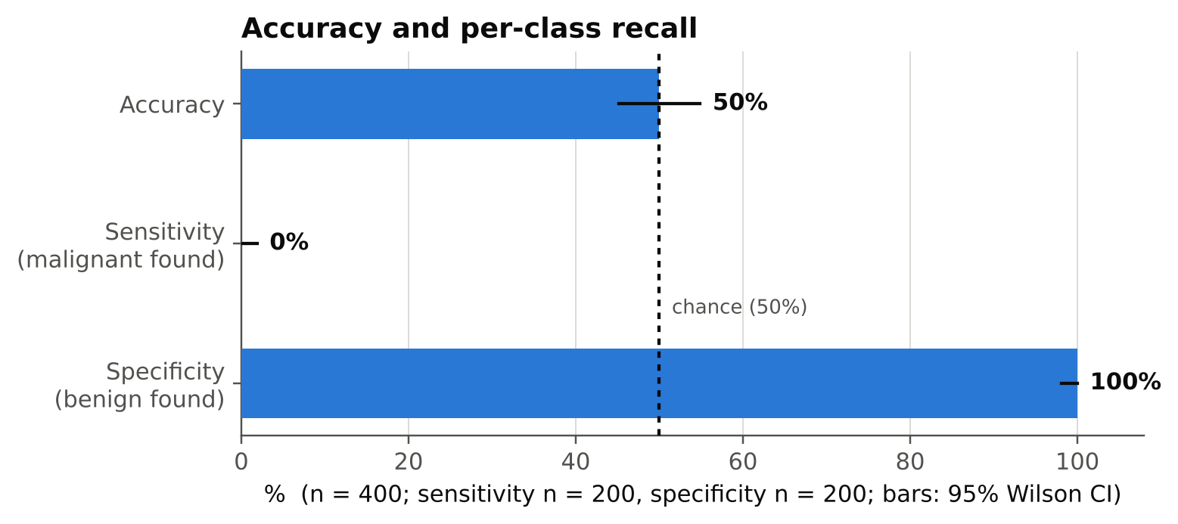
Figure 1. Accuracy and per-class recall with 95% Wilson intervals. The dashed line is chance.
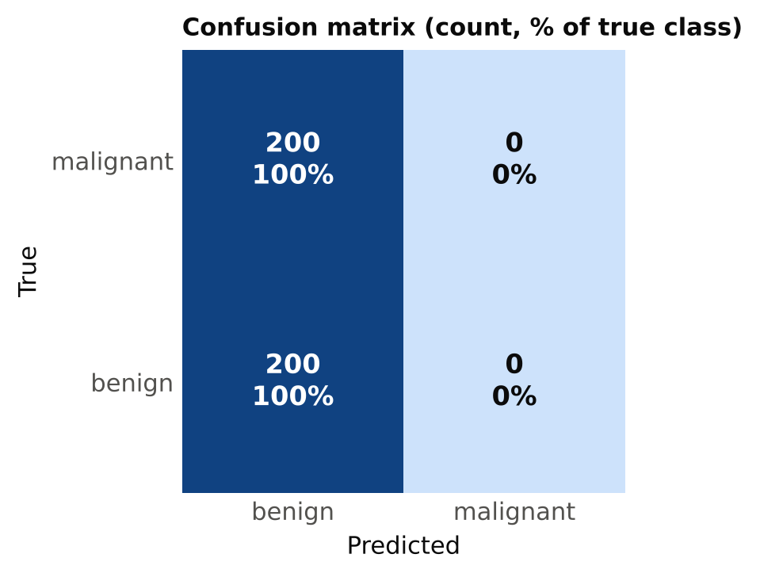
Figure 2. Confusion matrix. Each cell shows the count and the percentage of the true class.
Table 3. Confusion matrix
 | Predicted benign | Predicted malignant
True malignant (n = 200) | 200 | 0
True benign (n = 200) | 200 | 0
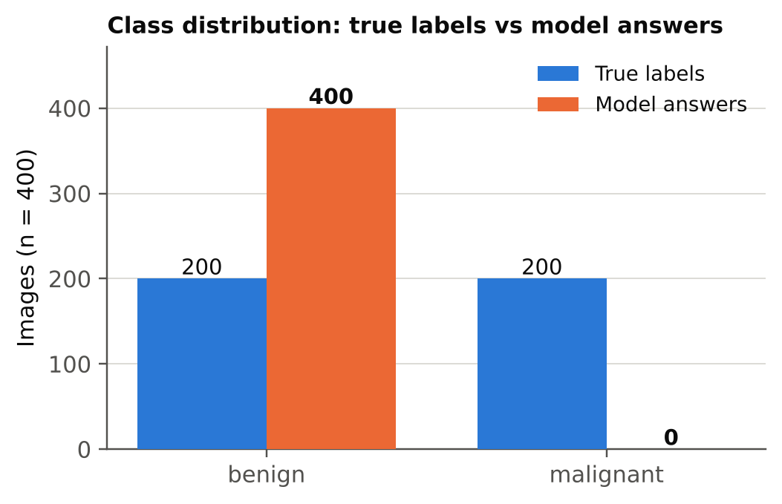
Figure 3. True labels versus model answers: the model never chose “malignant”.

3. By image-ID suffix
The only metadata in the results file is the image ID. IDs end in -l, -r or -s; I have not interpreted these suffixes (the file does not say what they mean). Accuracy by suffix simply equals the share of benign images in that suffix, because the model always says “benign”.
Table 4. Results by ID suffix
Suffix | n | Malignant / benign | Accuracy | 95% CI | Answered malignant
-l | 166 | 79 / 87 | 52.4% | 44.8–59.9% | 0%
-r | 151 | 80 / 71 | 47.0% | 39.2–55.0% | 0%
-s | 83 | 41 / 42 | 50.6% | 40.1–61.1% | 0%
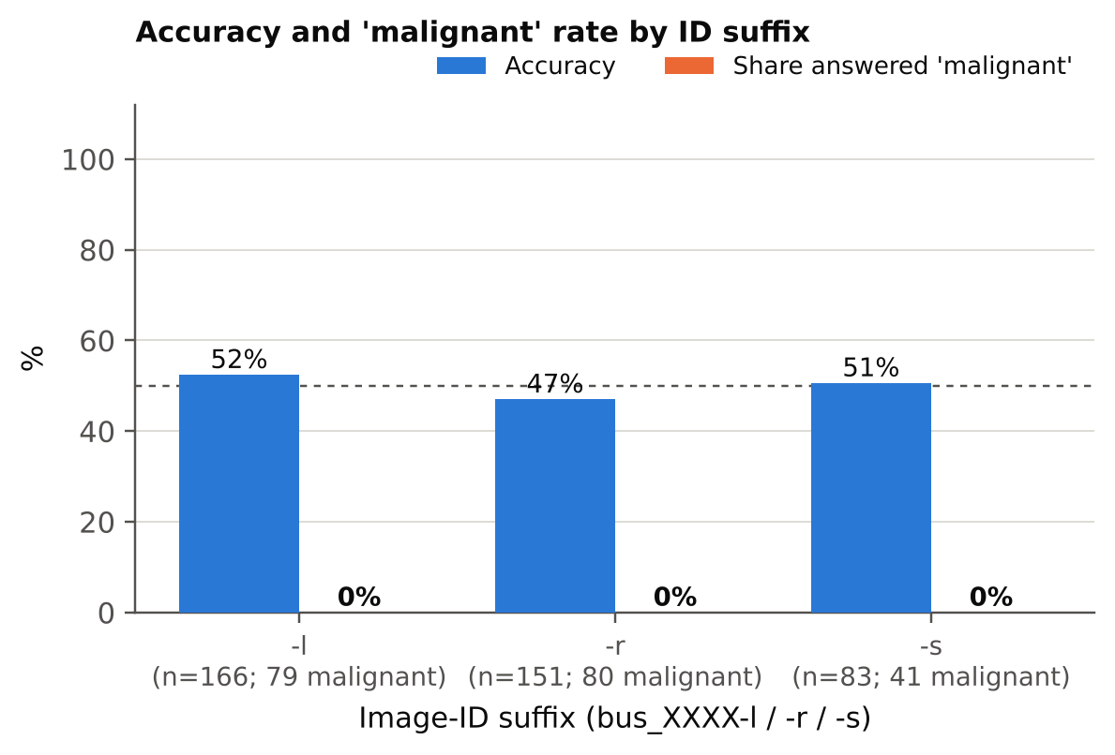
Figure 4. Accuracy and share of “malignant” answers by ID suffix.

4. Comparison with Qwen2-VL-2B-Instruct
Both models were run on the same 400 images with the same prompt, parser and settings. They gave the same answer, “benign”, for every image: 400 of 400 identical answers, 0 images where they differ. Their metrics are therefore identical (accuracy 50.0%, sensitivity 0%, specificity 100%), and a paired test (McNemar) has nothing to compare.
- The weights are not the same model: on RadImageNet-VQA the two models disagreed on 7% of questions (93% identical answers), so MedVLM-R1’s fine-tuning does change its outputs. On this task and prompt, both fall into the same fixed answer.
- What this suggests: a shared strong prior toward “benign” for this prompt in the Qwen2-VL family, with the image having little or no influence. It is also what a pipeline problem that hides the image would look like, so the blank-image check below is worth running before drawing conclusions about the models.
- Direct-answer mode: MedVLM-R1 is designed to reason before answering. The prompt asks for only the label and the cap is 32 tokens, so every output was the bare word “benign”; no <think> text appeared. The parser would accept one <think> block, but none occurred. These results describe direct-answer behaviour, not reasoning mode.

5. Interpretation and caveats
- What the result says: with this prompt and setting, the model has a fixed answer (“benign”) and does not use the image to decide. Nothing in these files shows whether it can see the lesions.
- What it does not say: whether the model would separate the classes if it were asked differently. A constant answer can come from a strong prior (the first-listed or more common label), from the prompt wording, or from the image not influencing the output. Accuracy alone cannot tell these apart.
- Natural class mix: the sample is balanced on purpose. In the full dataset benign images are more common than malignant ones, so a constant “benign” answer would score above 50% there while still finding no cancer. Sensitivity is the number to watch.
- Sample: with 200 images per class, even a modest detection ability would have shown up as sensitivity above 0. The interval for sensitivity is 0–1.9%.
- Not a clinical evaluation: these results describe benchmark behaviour only.

6. Next steps
- Run the same analysis for Gemma 3 4B-it and MedGemma 4B-it on the same 400 images, then compare all four models with sensitivity, specificity, MCC and paired tests (McNemar).
- Quick sanity check on the pipeline, for both models: run the same prompt on a few blank (black) images. If the answer is again “benign”, the output does not depend on the image content at all. Optionally also try a version that lets MedVLM-R1 reason (a longer token cap) as a separate condition.
- Save a score for each image (for example the log-probability of “benign” versus “malignant”). The notebook currently stores only the decoded text, so AUC cannot be computed. A score would show whether the model ranks malignant above benign even when its fixed answer hides it.
- Optionally test one variant of the prompt (label order swapped) to check whether the constant answer depends on the wording.
- Keep the executed notebook and logs with the results; this copy has no outputs.

