**Database Concepts Assignment Set 3**

***Instructions:***

1. Please type the answers below the questions directly. You may insert tables or figures. Scans of handwritten papers are not acceptable.
2. When it is done, rename the file to firstname-lastname.docx, export it into a PDF file, and submit it to Blackboard by the deadline.
3. Academic integrity is strictly reinforced. Detected plagiarized works will receive zero points and potentially a failure of the whole course.

*Problem description:*

James River Jewelry is a small jewelry shop. While James River Jewelry does sell typical jewelry purchased from jewelry vendors, including such items as rings, necklaces, earrings, and watches, it specializes in hard-to-find Asian jewelry. Although some Asian jewelry is manufactured jewelry purchased from vendors in the same manner as the standard jewelry is obtained, many of the Asian jewelry pieces are often unique single items purchased directly from the artisan who created the piece (the term “manufactured” would be an inappropriate description of these pieces). James River Jewelry has a small but loyal clientele, and it wants to further increase customer loyalty by creating a frequent buyer program. In this program, after every 10 purchases, a customer will receive a credit equal to 50 percent of the average of his or her 10 most recent purchases. This credit must be applied to the next (or 11th) purchase.

*Assume that James River designs a database with the following tables.*

**CUSTOMER (CustomerID, LastName, FirstName, Phone, EmailAddress)**

**PURCHASE (InvoiceNumber, InvoiceDate, PreTaxAmount, *CustomerID*)**

**PURCHASE_ITEM (*InvoiceNumber,* InvoiceLineNumber, *ItemNumber*, RetailPrice)**

**ITEM (ItemNumber, ItemDescription, Cost, ArtistLastName, ArtistFirstName)**

*The referential integrity constraints are:*

**CustomerID in PURCHASE must exist in CustomerID in CUSTOMER**

**InvoiceNumber in PURCHASE_ITEM must exist in InvoiceNumber in PURCHASE**

**ItemNumber in PURCHASE_ITEM must exist in ItemNumber in ITEM**

*Assume that CustomerID of CUSTOMER, ItemNumber of ITEM, and InvoiceNumber of PURCHASE*

*are all surrogate keys with values as follows:*

***CustomerID Start at 1 Increment by 1***

***InvoiceNumber Start at 1001 Increment by 1***

***ItemNumber Start at 1 Increment by 1***

*Write SQL statements and answer questions for this database as follows, based on the database you created in the last set of homework assignment.*

***C. Write SQL statements to list all columns for all tables (5 points).***

SELECT * FROM CUSTOMER;

SELECT * FROM ITEM;

SELECT * FROM PURCHASE_ITEM;

SELECT * FROM PURCHASE;

***D. Write an SQL statement to list ItemNumber and ItemDescription for all items that cost more than $100. (5 points)***

SELECT ItemNumber, ItemDescription FROM ITEM

WHERE Cost > 100.00;

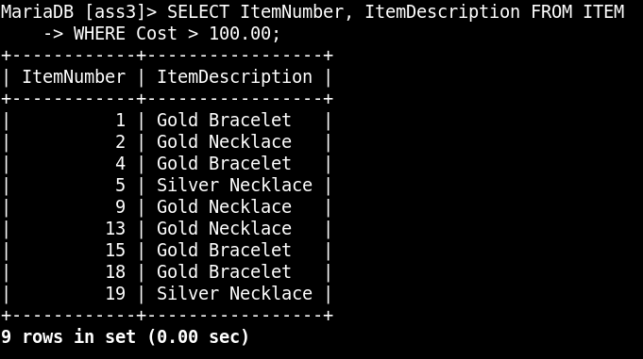

***E. Write an SQL statement to list LastName and FirstName of customers who have made at least one purchase with PreTaxAmount greater than $200. Use a subquery. (10 points)***

SELECT LastName, FirstName

FROM CUSTOMER

WHERE CustomerID IN (

SELECT CustomerID

FROM PURCHASE

WHERE PreTaxAmount > 200.00

);

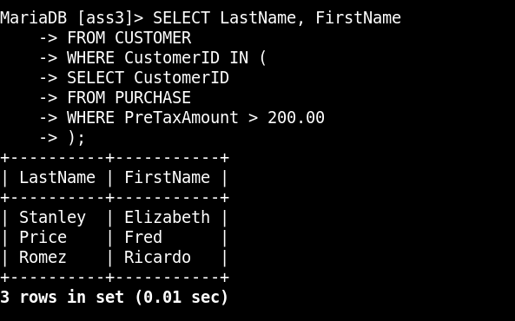

***F. Answer Question E but use a JOIN. What are the consequences of using (or not using) the DISTINCT keyword in this version of the query? (10 points)***

SELECT C.LastName, C.FirstName

FROM CUSTOMER as C, PURCHASE as P

WHERE C.CustomerID = P.CustomerID and PreTaxAmount > 200.00;

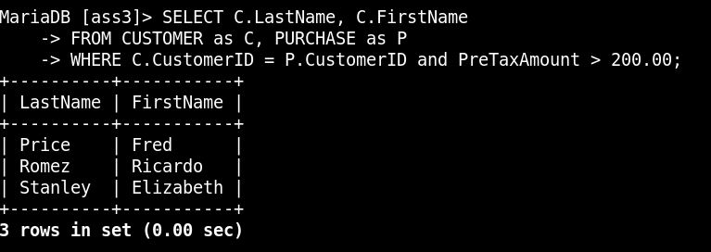

***G. Write an SQL statement to list LastName and FirstName of customers who have purchased an item that costs more than $50. Use a subquery. (10 points)***

SELECT LastName, FirstName

FROM CUSTOMER

WHERE CustomerID IN (

SELECT CustomerID

FROM PURCHASE

WHERE InvoiceNumber IN(

SELECT InvoiceNumber

FROM PURCHASE_ITEM

WHERE ItemNumber IN(

SELECT ItemNumber

FROM ITEM

WHERE Cost > 50

)

)

);

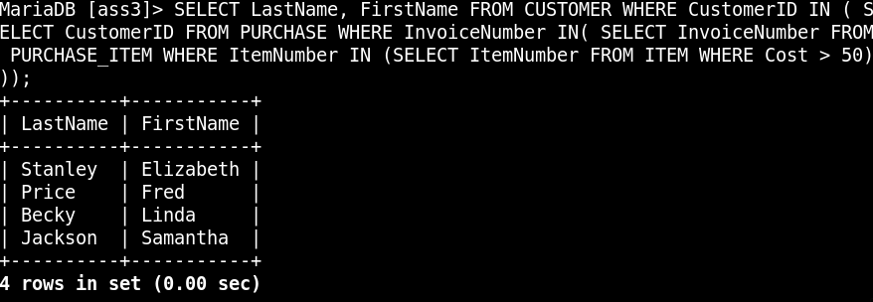

***H. Answer Question G but use a join using JOIN. What are the consequences of using (or not using) the DISTINCT keyword in this version of the query? (10 points)***

SELECT DISTINCT C.LastName, C.FirstName

FROM CUSTOMER AS C, PURCHASE AS P, PURCHASE_ITEM AS PI, ITEM AS I

WHERE C.CustomerID = P. CustomerID AND P. InvoiceNumber = PI.InvoiceNumber AND PI. ItemNumber = I.ItemNumber AND I.Cost>50;

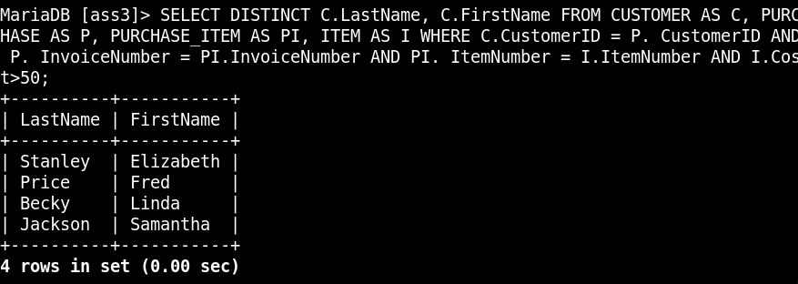

***I. Write an SQL statement to list LastName and FirstName of customers who have purchased an item that was created by an artist with a LastName that begins with the letter “J”. Use a subquery. (10 points)***

SELECT LastName, FirstName

FROM CUSTOMER

WHERE CustomerID IN (

SELECT CustomerID

FROM PURCHASE

WHERE InvoiceNumber IN(

SELECT InvoiceNumber

FROM PURCHASE_ITEM

WHERE ItemNumber IN(

SELECT ItemNumber

FROM ITEM

WHERE ArtistLastName LIKE ‘j%’

)

)

);

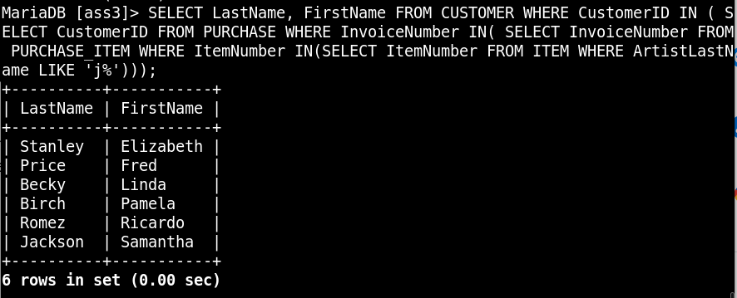

***J. Answer Question I but use a join using JOIN. What are the consequences of using (or not using) the DISTINCT keyword in this version of the query? (10 points)***

SELECT DISTINCT LastName, FirstName

FROM CUSTOMER AS C, PURCHASE AS P, PURCHASE_ITEM AS PI, ITEM AS I

WHERE C.CustomerID = P. CustomerID AND P. InvoiceNumber = PI.InvoiceNumber AND PI. ItemNumber = I.ItemNumber AND I.ArtistLastName LIKE ‘J%’;

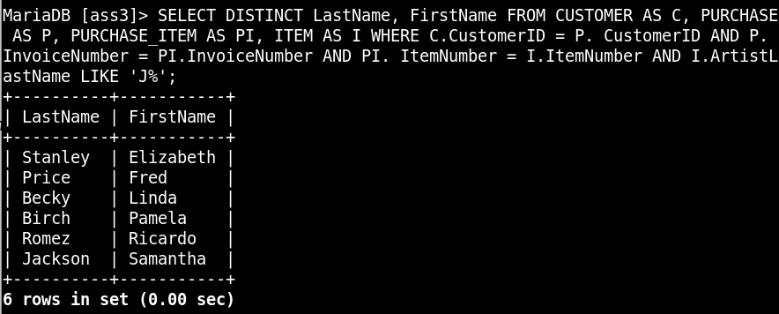

***K. Write an SQL statement to show the CustomerID, LastName, FirstName, and sum of PreTaxAmount for each customer. Use a join using JOIN. (10 points)***

SELECT C.CustomerID, C. LastName, C. FirstName, SUM(P.PreTaxAmount)

FROM CUSTOMER AS C, PURCHASE AS P

WHERE C.CustomerID = P.CustomerID

GROUP BY P.CustomerID;

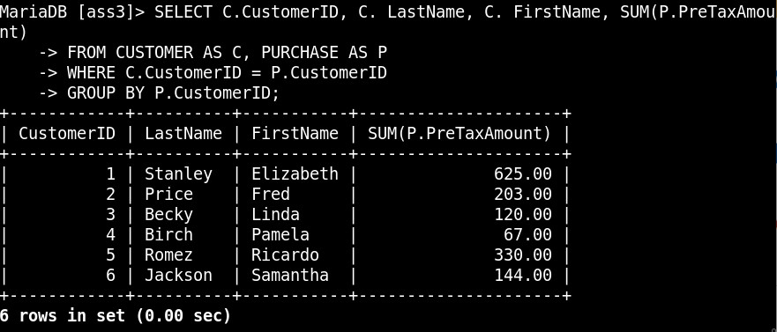

***L. Write an SQL statement to show the sum of PreTaxAmount for each artist (Hint: the result will have only one line per each artist). Use JOIN, and sort the results by ArtistLastName then ArtistFirstName in ascending order. Note this should include the full PreTaxAmount for any purchase in which the artist had an item, even if other items in the purchase were created by other artists. (10 points)***

SELECT I.ArtistLastName, I.ArtistFirstName, I.ItemDescription, SUM(P.PreTaxAmount)

FROM ITEM AS I, PURCHASE AS P, PURCHASE_ITEM AS PI

WHERE I.ItemNumber = PI.ItemNumber AND PI.InvoiceNumber = P.InvoiceNumber

GROUP BY I.ArtistLastName

ORDER BY I.ArtistLastName ASC, I.ArtistFirstName ASC;

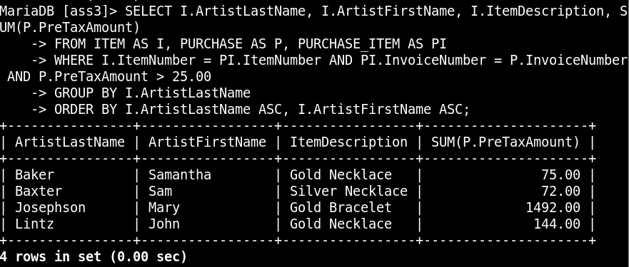

***M. Write an SQL statement to show the sum of PreTaxAmount for each artist, as in Question L, but exclude any purchases with PreTaxAmount over $25. Use JOIN, and sort the results by ArtistLastName and ArtistFirstName in descending order. (10 points)***

SELECT I.ArtistLastName, I.ArtistFirstName, I.ItemDescription, SUM(P.PreTaxAmount)

FROM ITEM AS I, PURCHASE AS P, PURCHASE_ITEM AS PI

WHERE I.ItemNumber = PI.ItemNumber AND PI.InvoiceNumber = P.InvoiceNumber AND P.PreTaxAmount

<= 25.00

GROUP BY I.ArtistLastName

ORDER BY I.ArtistLastName DESC, I.ArtistFirstName DESC;

