1. **Linear Search**

**#include<stdio.h>**

**int main() {**

**int A[10], i, n;**

**printf("Enter the number of elements: ");**

**scanf("%d", &n);**

**printf("Enter %d elements: ", n);**

**for(int i = 0; i < n; i++) {**

**scanf("%d", &A[i]);**

**}**

**printf("The elements are: ");**

**for(i = 0; i < n; i++) {**

**printf("%d ", A[i]);**

**}printf("\n");**

**int key;**

**printf("Enter the element you want to search: ");**

**scanf("%d", &key);**

**int flag = 0;**

**for(i = 0; i < n; i++ ) {**

**if (A[i] == key) flag = 1;**

**}**

**if(flag == 1) printf("Element found\n");**

**else printf("Element not found\n");**

**}**

**Output:**

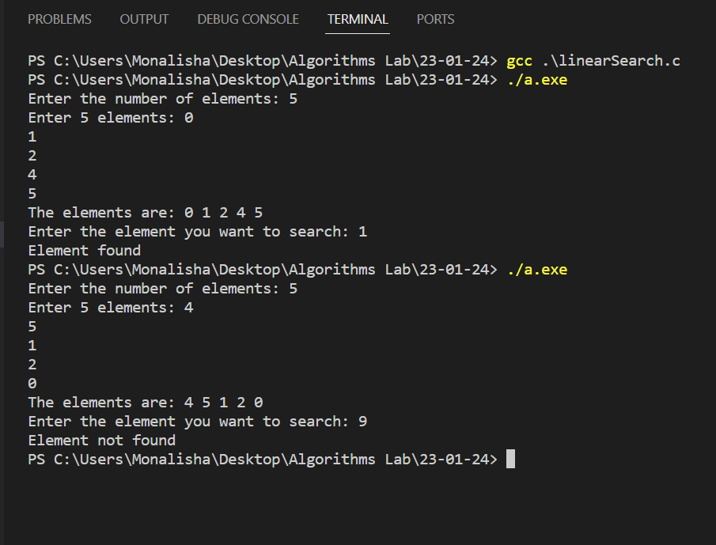

1. **Binary Search**

**#include<stdio.h>**

**void swap(int *a, int *b) {**

**int temp = *a;**

**\*a = *b;**

**\*b = temp;**

**}**

**void sort(int *arr, int n) {**

**int i, j;**

**for(i = 0; i < n; i++) {**

**for(int j = i + 1; j < n; j++) {**

**if (arr[i] > arr[j]) swap(&arr[i], &arr[j]);**

**}**

**}**

**}**

**int main() {**

**int A[10], i , n, mid, low, high;**

**printf("Enter the number of elements: ");**

**scanf("%d", &n);**

**printf("Enter %d values: ", n);**

**for(i = 0; i < n; i++) {**

**scanf("%d", &A[i]);**

**}**

**sort(A, n);**

**printf("The values are: ");**

**for(i = 0; i < n; i++) {**

**printf("%d ", A[i]);**

**}printf("\n");**

**printf("Enter the value you want to search for: ");**

**int key;**

**scanf("%d", &key);**

**int flag = 0;**

**low = 0;**

**high = n-1;**

**while(low<=high) {**

**mid = (low+high)/2;**

**if(A[mid] == key) {**

**flag = 1;**

**break;**

**}**

**else if(A[mid] < key) low = mid + 1;**

**else high = mid - 1;**

**}**

**if(flag == 1) printf("Element found\n");**

**else printf("Element not found\n");**

**}**

**Output:**

