SYSTEM INTEGRATION
DOCUMENTATION

Library Management System& Student Management System
API INTEGRATION

Submitted by:
Albuen, Monaliza F.

Submitted To:
Emannuel T. Saligue

Date:
May 14, 2026

- System Overview

This project is a school-based information system composed of two integrated platforms that share a centralized MySQL database through a Node.js REST API. The design follows a common database architecture, ensuring data consistency and seamless communication between both systems.

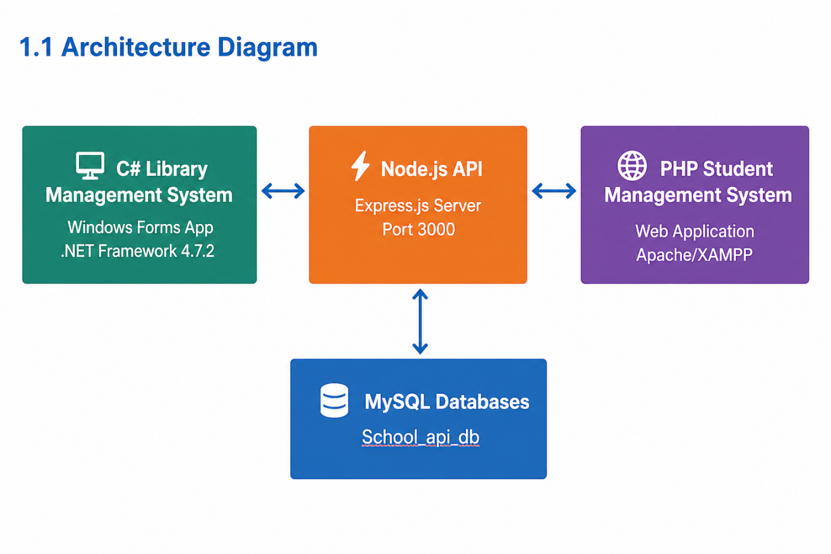

1.2 Technology Stack

Component | Technology
PHP System (Student Management System) | PHP 7+, HTML5, CSS3, JavaScript, cURL, Sessions
C# System (Library Management System) | .NET Framework 4.7.2, Windows Forms, Newtonsoft.Json, System.Net.Http
API Middleware | Node.js, Express.js, mysql2, cors, crypto
Database | MySQL (school_api_db)
API Protocol | HTTP REST — JSON request/response
API Base URL | http://localhost:3000

SYSTEM 1: Student Management System (PHP Web app)

2. Student Management System — PHP Web Application

The Student Management System is a browser-based academic system developed using PHP. It is primarily used by teachers to manage student records by adding and updating student information, assigning students to classrooms, and maintaining parent details. The system serves as the central source of student and parent data that are utilized by the Library Management System. All data is fetched and submitted through the Node.js API, ensuring centralized data management and seamless integration between the student and library systems.

2.1 System Purpose

• Allow administrators to add and update student information.
• Manage and maintain parent records associated with each student.
• Assign and organize students into specific classrooms.
• Provide accurate and centralized student data for use by the Library Management System.
• Ensure all student and parent data are processed through the Node.js API for seamless system integration.

2.2 File Structure

File | Purpose
index.php | Dashboard page displayed after login — retrieves system statistics through API
login.php | User login page — entry point of the system (authenticates via Node.js API)
student.php | Add, update, and retrieve student records through the Node.js API
parent.php | Add, update, and retrieve parent records through the Node.js API
database.php | API configuration and helper file for sending HTTP requests (no direct DB connection)
header.php | Contains header layout of the system
footer.php | Contains footer layout
navbar.php | Navigation menu for system pages
sidebar.php | Sidebar navigation panel

2.3 Pages and UI interface

2.3.1 Login (index.php)

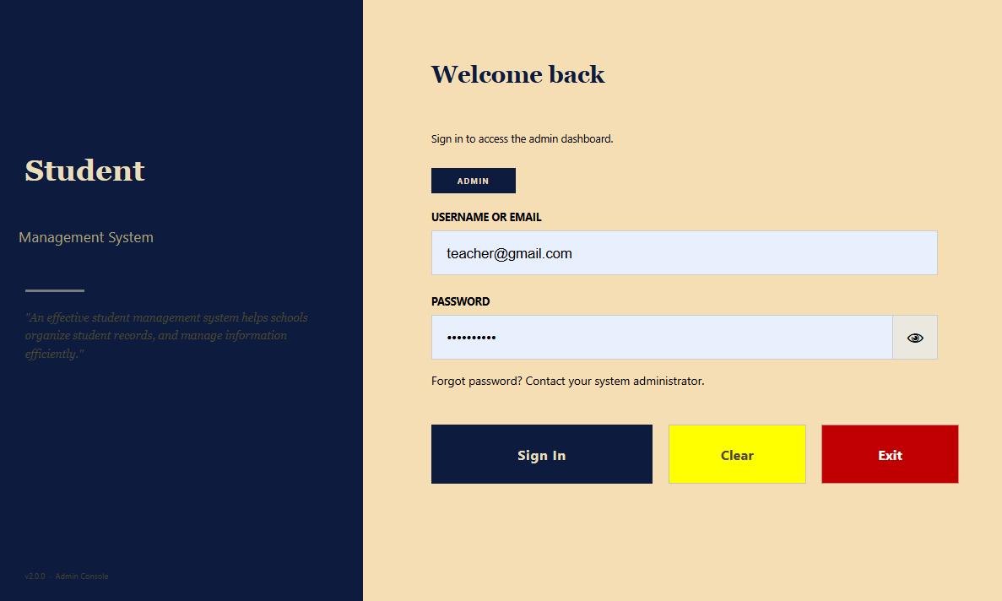

2.3.2 Admin Dashboard (index.php)

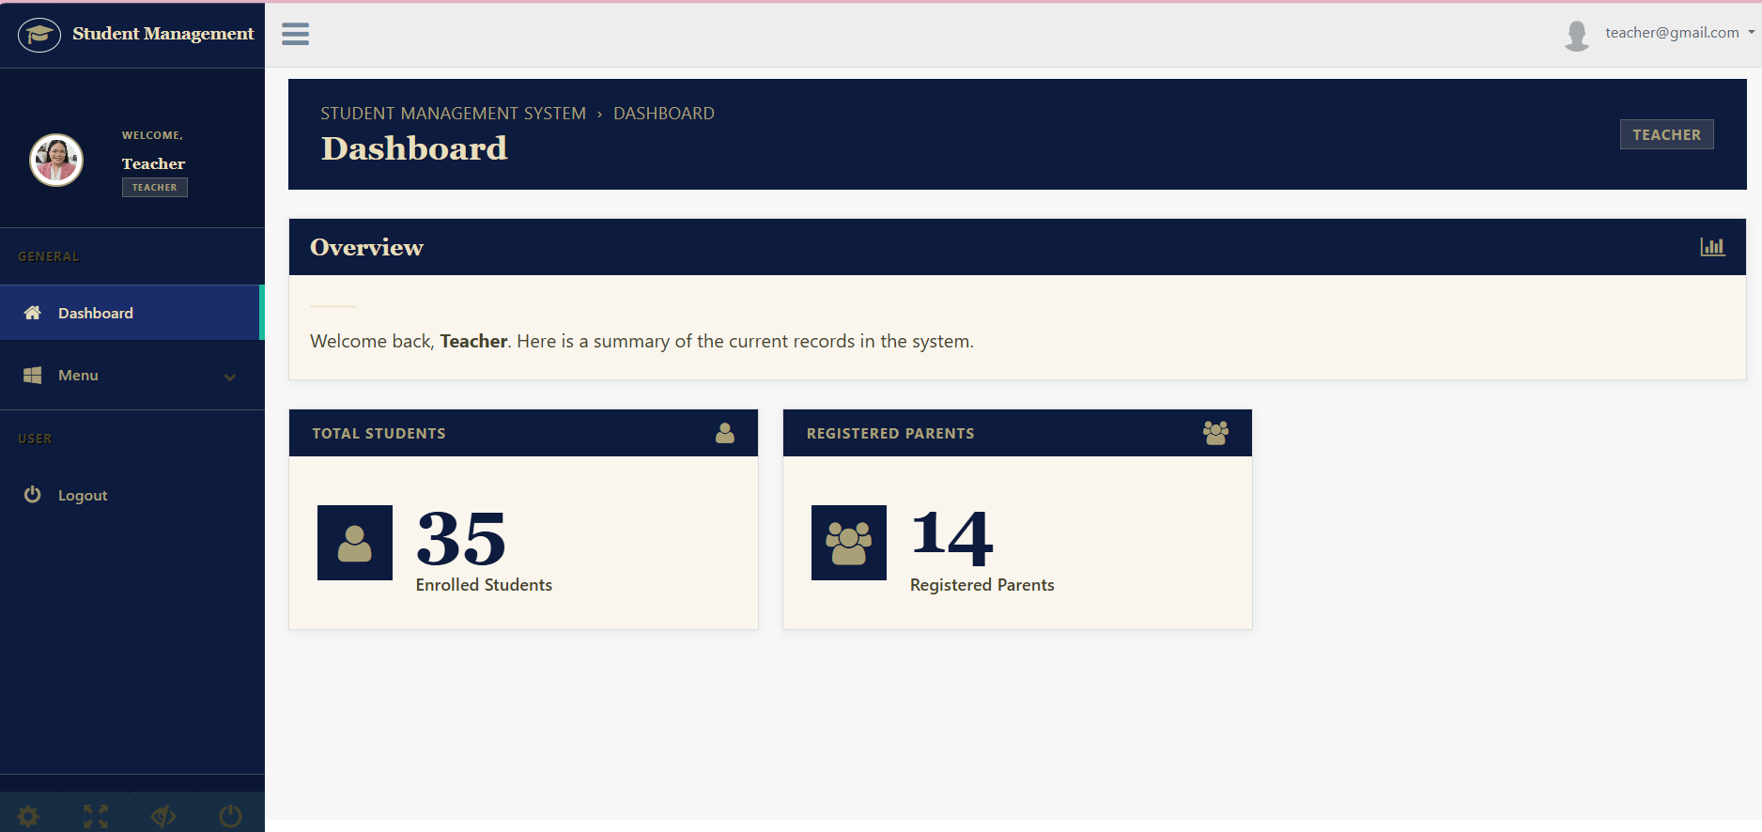

2.3.3 Add /Update student (student.php)

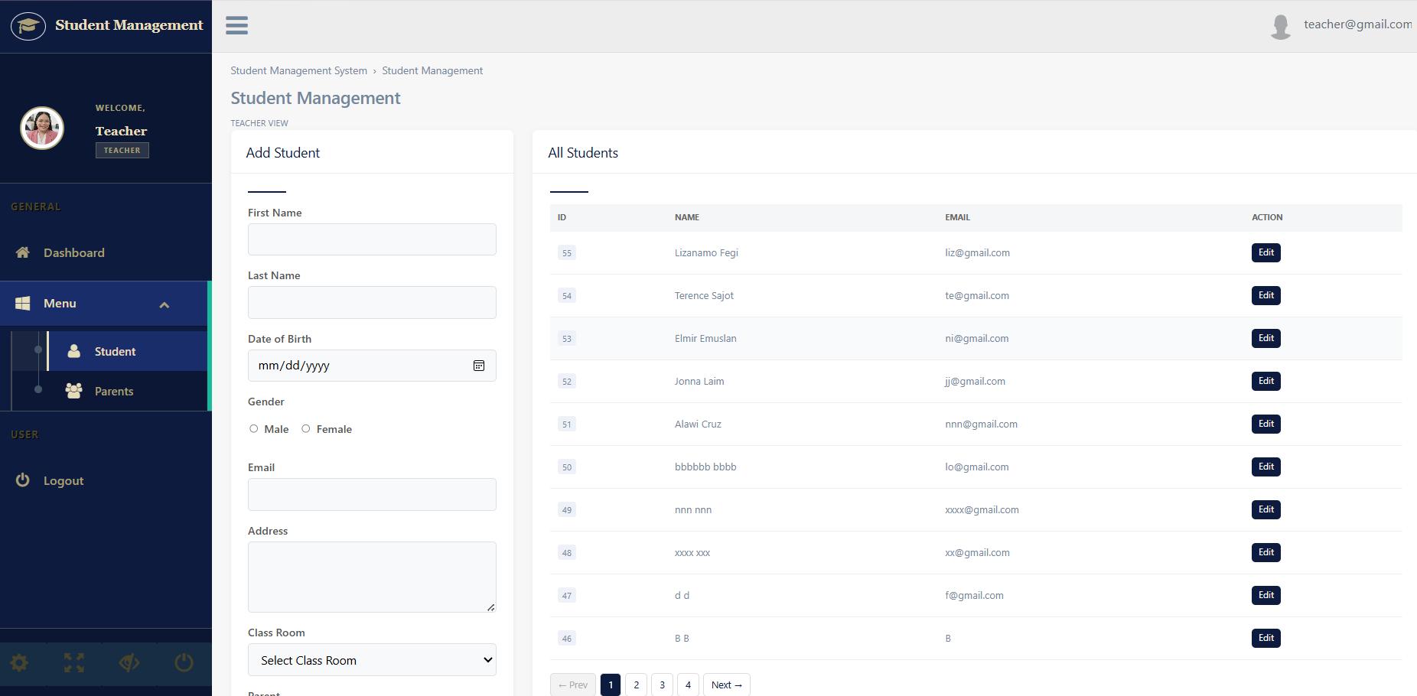

2.3.4 Add/Update parent (parent.php)

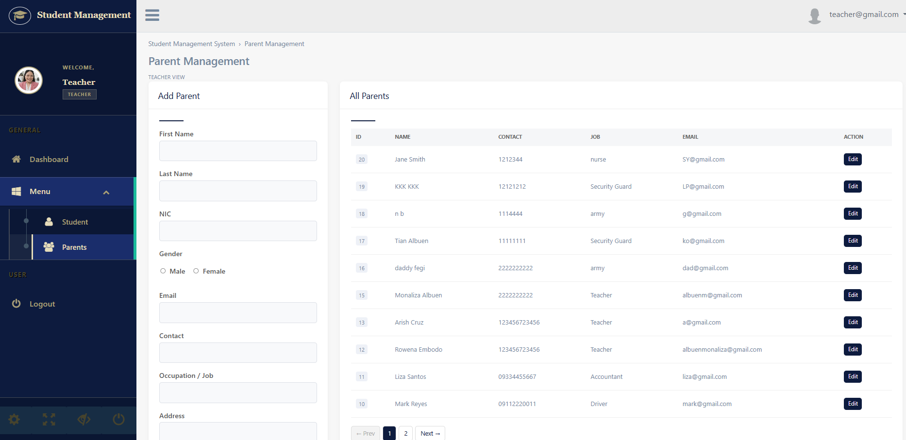

2.4 Database Tables Used (school_api_db)

Table Name | Description
books | Stores information about books such as title, author, genre, quantity, ISBN, and description
issuedbooks | Records book borrowing transactions including student, book, issue date, return date, and status.
parent | Stores parent details such as name, contact, occupation (job), address, and email.
reserved_books | Contains records of reserved books by students.
student | Stores student information including personal details, assigned classroom, and parent reference.
user | Stores system user credentials used for login authentication.

SYSTEM 2: Library Management System (C# Desktop App)

3. Library Management System — C# Desktop Application

The Library Management System is a Windows Forms desktop application developed in C# (.NET Framework 4.7.2). It provides a graphical interface for librarians to manage books, handle issuing and returning of materials, and monitor overall library operations. The system enables users to add, update, and track book records, as well as manage borrowing and reservation activities efficiently. All data operations are performed through a shared Node.js REST API, ensuring centralized data management and seamless integration with the Student Management System.

3.1 System Purpose

• Provide a desktop graphical interface for managing library operations.
• Allow librarians to add, update, and view book records.
• Enable issuing and returning of books to students.
• Manage book reservation activities.
• Display real-time data such as issued books and reservation records.
• Integrate with the Student Management System to retrieve student data through the API.

3.2 Project Structure

File/Form | Purpose
Program.cs | Application entry point — initializes and launches the main form
Form1.cs | Welcome/Startup form — serves as the main entry screen providing options for user login, API connection testing, and exiting the application
UserLogin.cs | User login form — authenticates via API (/login)
mainDashboard.cs | Main dashboard — navigation to all library functions
addBook.cs | Add book form — adds new books via API (/books)
AddStudent.cs | Add student form — adds student records and loads parent data via API (/students, /parents)
issueBook.cs | Issue book form — assigns books to students via API (/issue)
returnBooks.cs | Return book form — processes book returns via API (/return-book)
reserveBook.cs | Reservation form — manages book reservations via API (/reserve)
FormReports.cs | Reports form — displays issued and returned book records
Library Management System.csproj | .NET Framework 4.7.2 project file
packages.config | NuGet dependencies (e.g., Newtonsoft.Json)

3.3 Forms and UI Interface

3.3.1 Form1.cs

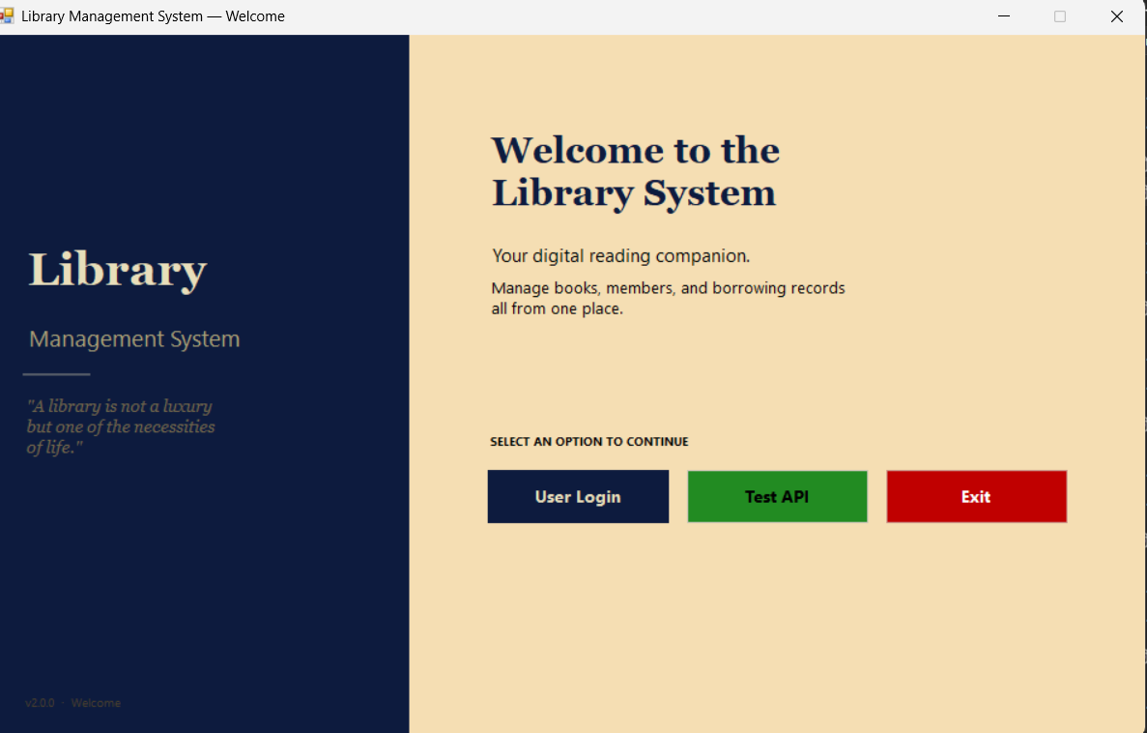

3.3.2 userLogin.cs

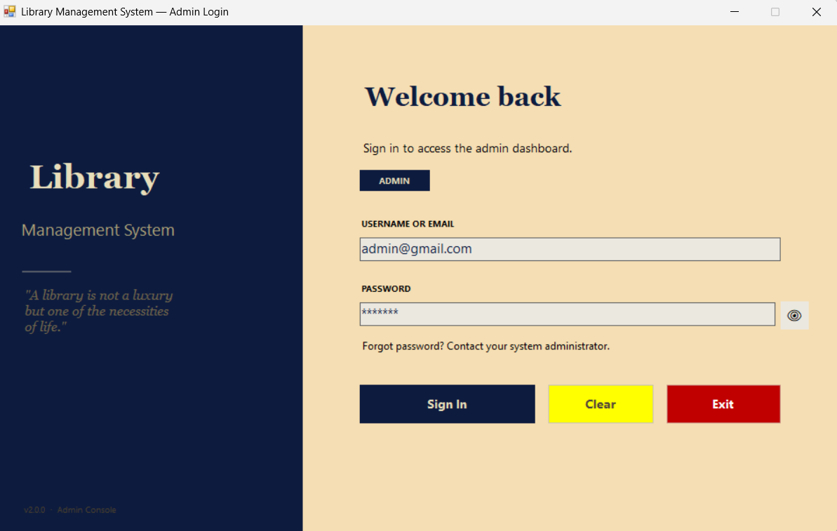

3.3.3 mainDashboard.cs

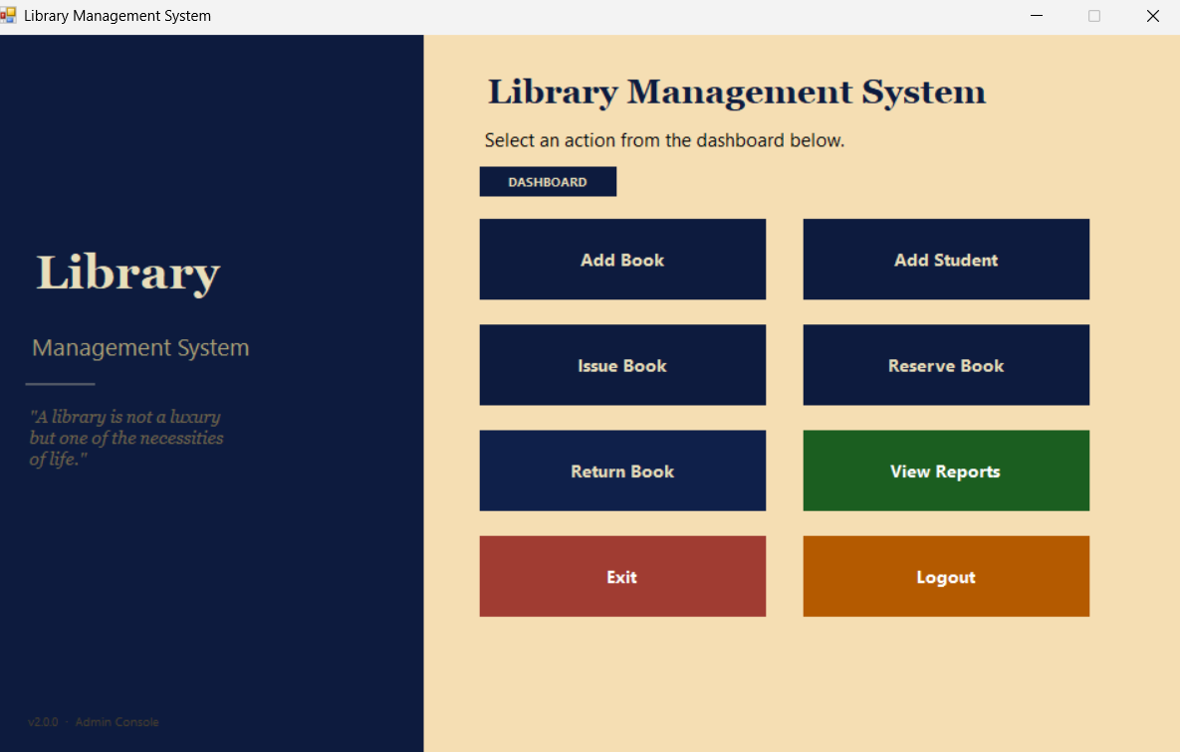

3.3.4 addBook.cs

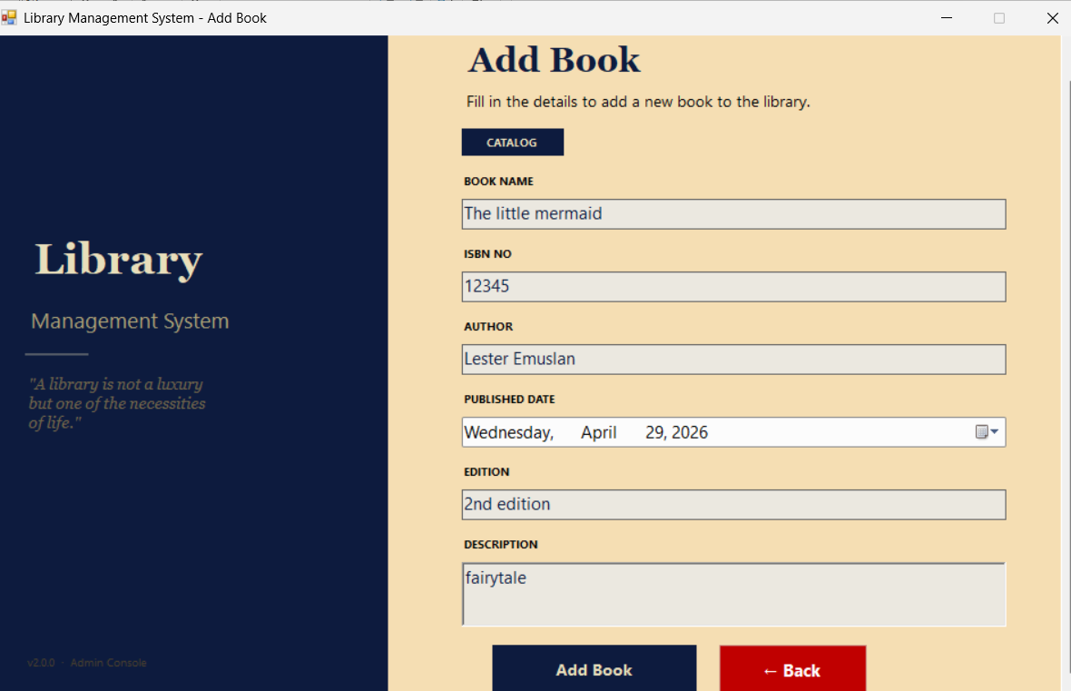

3.3.5 issueBook.cs

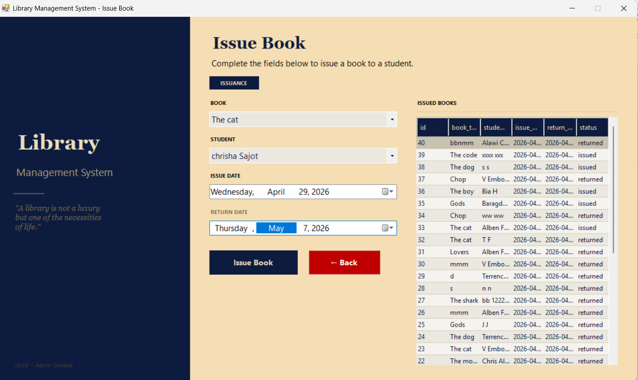

3.3.6 returnBook.cs

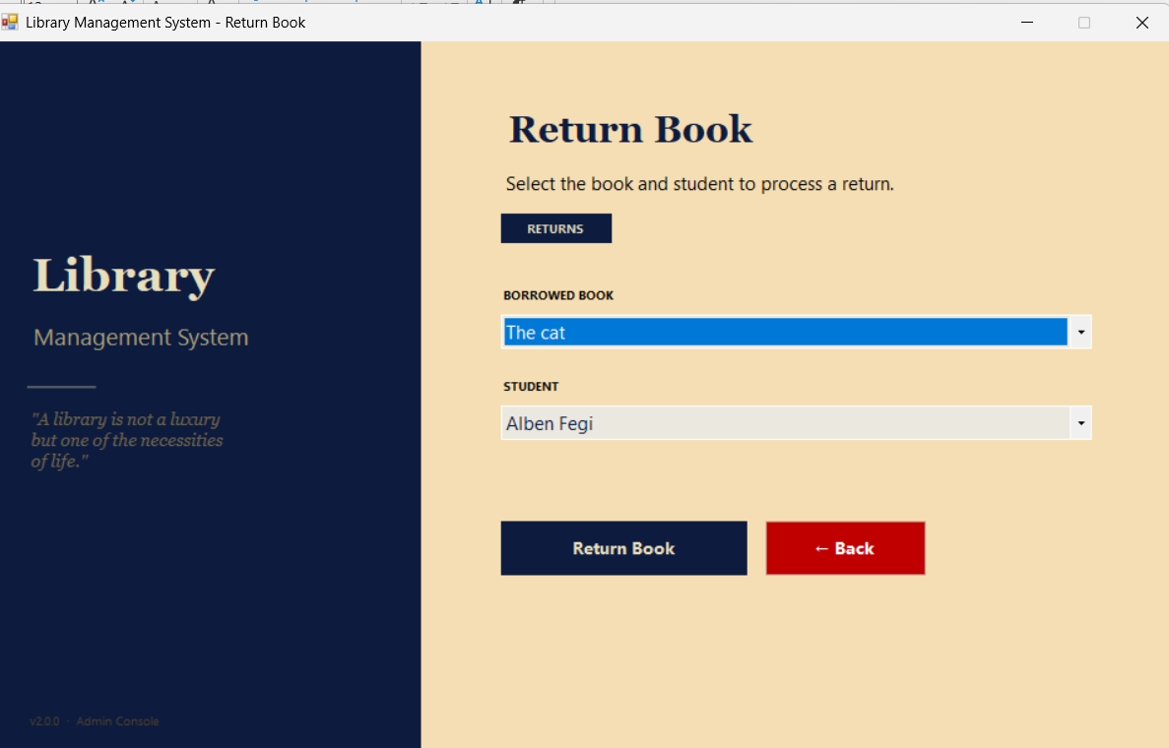

3.3.7 addStudent.cs

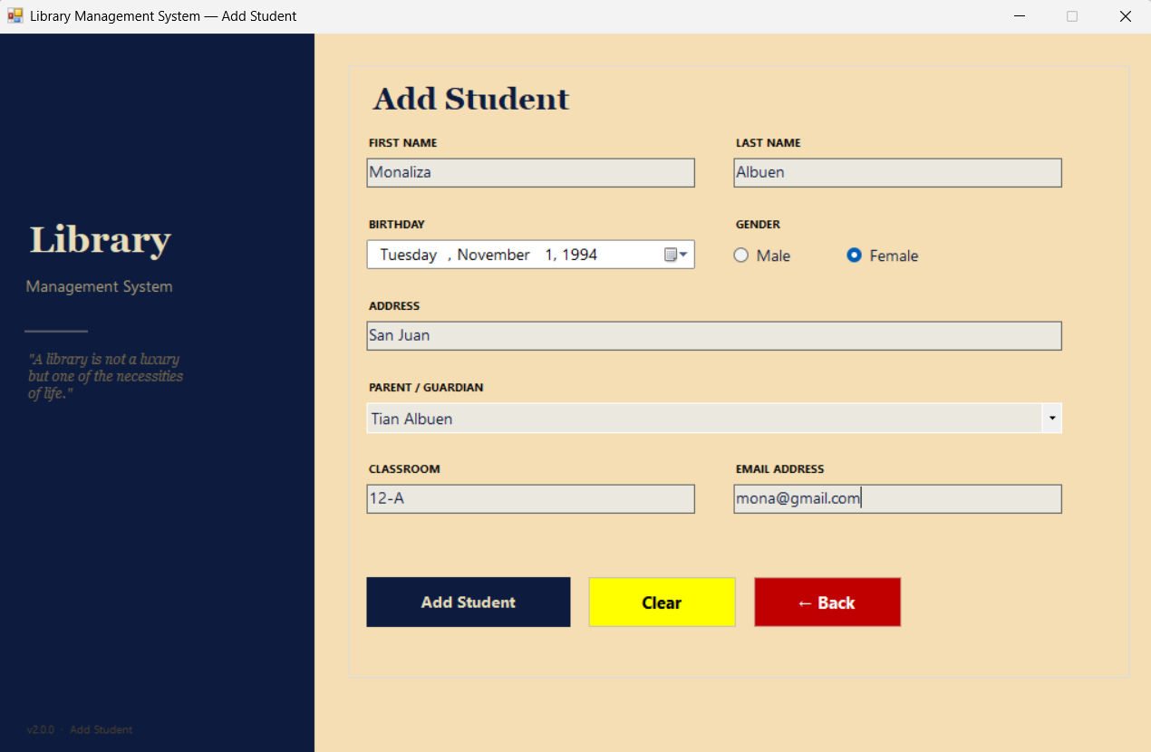

3.3.8 reserveBook.cs

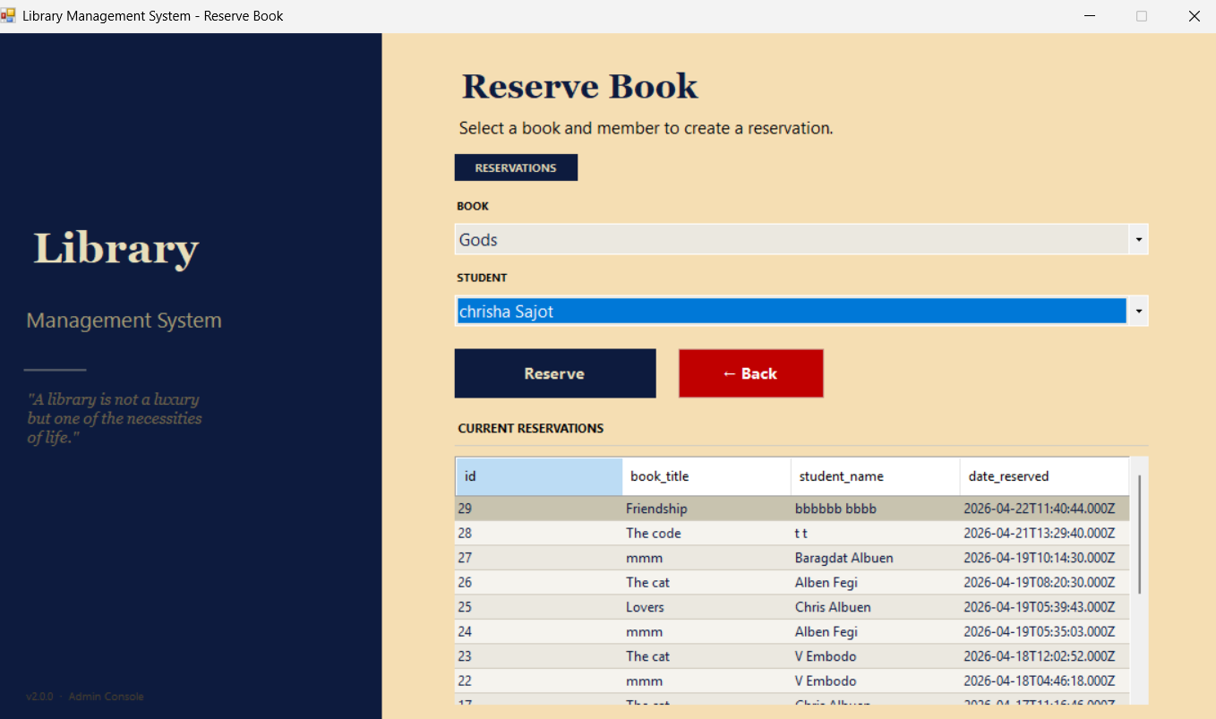

3.3.9 FormReports.cs

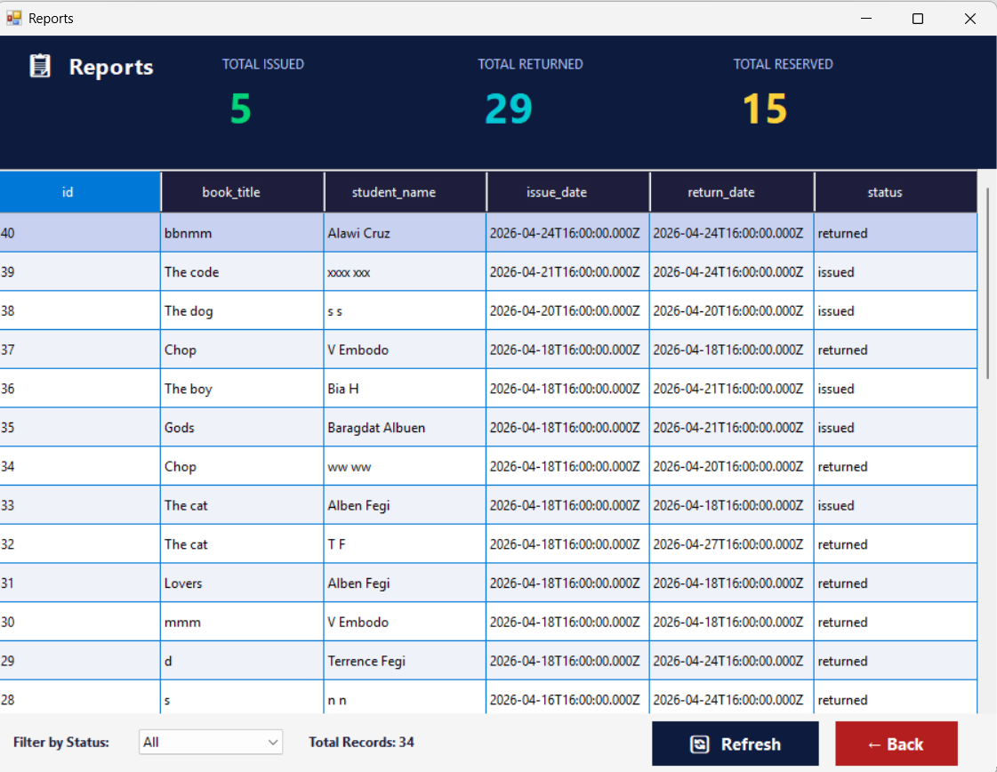

3.4 Database Table Used
The Library Management System uses a centralized and common MySQL database (school_api_db) that is shared with the Student Management System. This common database ensures that both systems access the same data source, promoting consistency, reducing redundancy, and enabling seamless integration through the Node.js API.

Table Name | Description
books | Stores book information such as title, author, genre, quantity, ISBN, and description.
issuedbooks | Records book borrowing transactions including student, book, issue date, return date, and status.
parent | Stores parent information linked to students.
reserved_books | Stores records of book reservations made by students.
student | Stores student details used during issuing and reservation processes.
user | Stores system user credentials for authentication.

3.5 Dependencies

Package | Version / Notes
Newtonsoft.Json | v13.0.4 — used for JSON serialization and deserialization for API communication
System.Net.Http | v4.3.4 — provides HttpClient for making REST API requests
Microsoft.CSharp | v4.7.0 — enables dynamic object support in C#
System.Runtime | v4.3.0 — provides core runtime functionality
.NET Framework | v4.7.2 — target framework of the application

THE BRIDGE: Node.js REST API (Shared Middleware)

4. Node.js REST API Documentation
The Node.js Express.js server acts as the central communication layer between the Student Management System (PHP web application) and the Library Management System (C# desktop application). It runs on port 3000 and connects to a centralized MySQL database (school_api_db). All data operations from both systems are handled through RESTful API endpoints, ensuring consistent data access, secure communication, and seamless integration between the two systems.

4.1 Server Configuration
Property | Value
Runtime | Node.js
Framework | Express.js
Port | 3000 (http://localhost:3000)
Body Parser | JSON (Content-Type: application/json)
Database | school_api_db (centralized database for Student and Library systems)
MySQL Host | localhost (root, no password — local development configuration)

4.2 Student Management System API Endpoints
The following endpoints serve the PHP Student Management System web application.
Method | Endpoint | Description | Auth
POST | /login | User login authentication | None
GET | /students | Retrieve all student records | Session (PHP)
GET | /students/:id | Retrieve a specific student by ID | Session (PHP)
POST | /students | Add a new student record | Session (PHP)
POST | /students/update | Update existing student information | Session (PHP)
GET | /students-page | Retrieve paginated student records | Session (PHP)
GET | /students-count | Get total number of students | Session (PHP)
GET | /parents | Retrieve all parent records (paginated) | Session (PHP)
GET | /parents/:id | Retrieve a specific parent by ID | Session (PHP)
POST | /parents | Add a new parent record | Session (PHP)
POST | /parents/update | Update existing parent information | Session (PHP)
GET | /parents-count | Get total number of parents | Session (PHP)
GET | /classrooms | Retrieve available classroom list | Session (PHP)

4.3 Library Management System API Endpoints
The following endpoints serve the C# Windows Forms Library Management System desktop application.

Method | Endpoint | Description | Auth
POST | /login | User login authentication | None
GET | /health | Test API connection | None
GET | /books | Retrieve all book records | App-level
GET | /books/:id | Retrieve a specific book by ID | App-level
POST | /books | Add a new book record | App-level
POST | /books/update | Update existing book information | App-level
DELETE | /books/:id | Delete a book record | App-level
GET | /books-count | Get total number of books | App-level
GET | /students | Retrieve student list for issuing/reserving books | App-level
POST | /students | Add student record from C# form | App-level
GET | /parents | Retrieve parent list for student form | App-level
POST | /issue | Issue a book to a student | App-level
GET | /issued | Retrieve all issued book records | App-level
GET | /borrowed-books | Retrieve currently borrowed books | App-level
GET | /students-by-book | Retrieve students who borrowed a selected book | App-level
GET | /issue-id | Retrieve issue record ID for return process | App-level
POST | /return-book | Process book return | App-level
POST | /reserve | Reserve a book for a student | App-level
GET | /reservations | Retrieve reservation records | App-level
GET | /reservations-count | Get total number of reservations | App-level
GET | /reports | Retrieve issued/returned book reports | App-level

4.4 Key API Endpoint Details
This section presents the API endpoints used by both the Student Management System and the Library Management System. These endpoints are responsible for handling core system operations such as user authentication, student and parent management, book management, data retrieval, and library transaction processing including book issuing, returning, and reservation functionalities.

4.4.1 API Base URL
The API Base URL serves as the main address used to access all endpoints of the Library Management System API. All API requests for authentication, student management, parent management, book management, issuing, returning, and reservation transactions are connected through this base URL.
http://localhost:3000
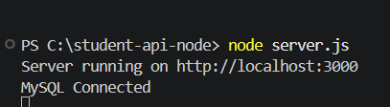

4.4.2 User Login
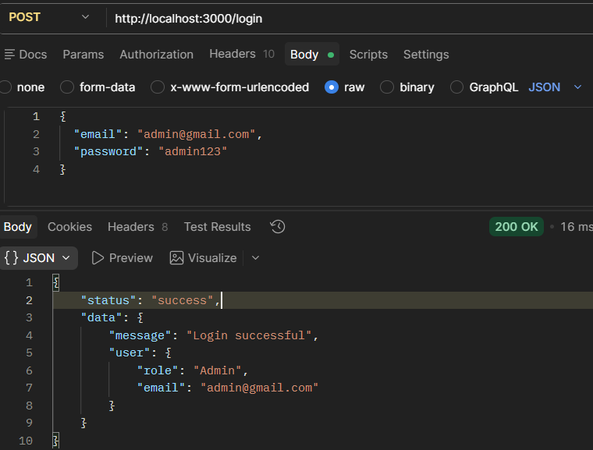
The /login endpoint is used to authenticate users of the system. It verifies the provided email and password and returns user information upon successful authentication.

4.4.3 Retrieve Student Records
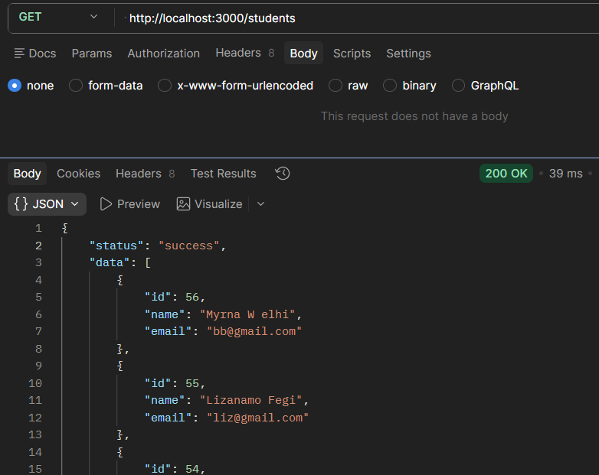
The /students endpoint retrieves a list of all student records stored in the database. This endpoint is used by both systems when displaying or selecting student data.

4.4.4 Retrieve Student Records with Pagination
The /students-page endpoint retrieves student records with pagination support. It allows the system to load student data page by page to improve performance when handling large datasets.
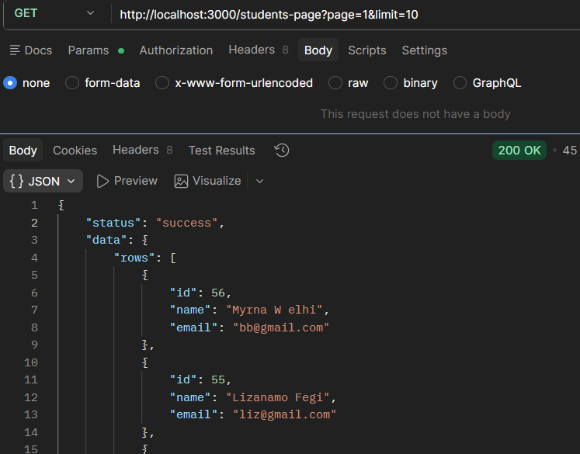
4.4.5 Retrieve Student Count
The /students-count endpoint retrieves the total number of student records stored in the database.
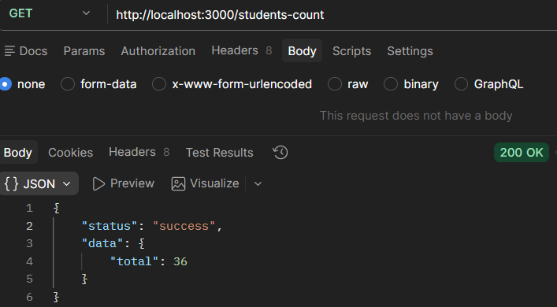

4.4.6 Retrieve Student by ID
The /students/:id endpoint retrieves the information of a specific student using the student ID.
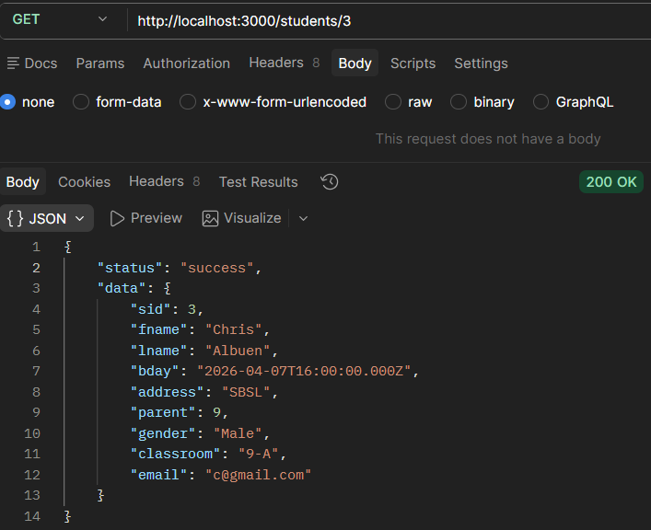

4.4.7 Add Student Record
The /students endpoint adds a new student record into the database. This endpoint is used when registering new students in the system.
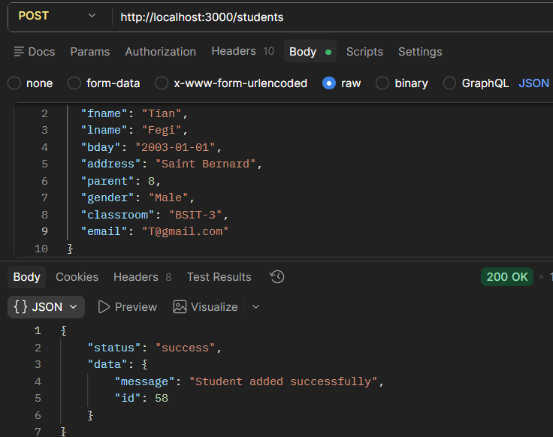

4.4.8 Update Student Record

The /students/update endpoint updates an existing student record in the database.

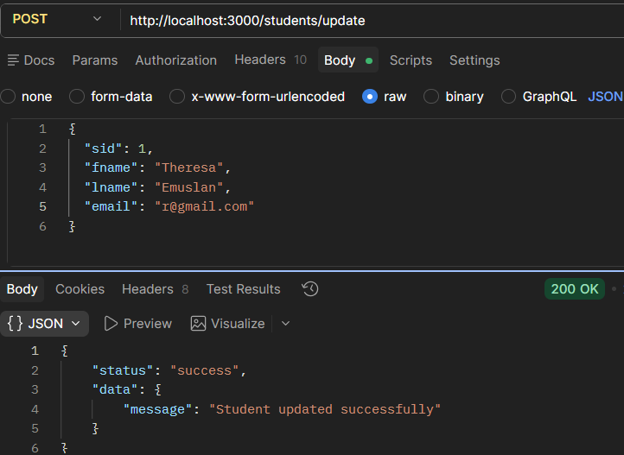

4.4.9 Retrieve Classrooms

The /classrooms endpoint retrieves all classroom records stored in the database.

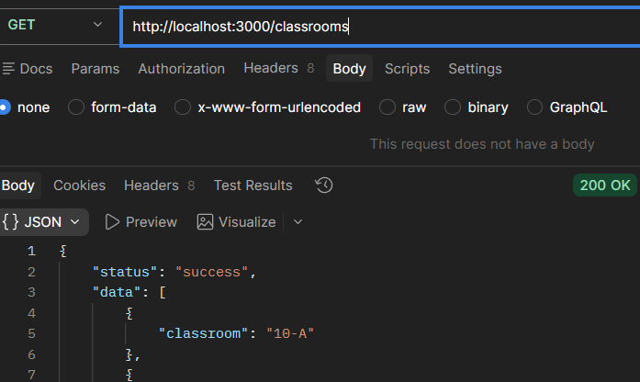

4.4.10 Retrieve Parent Records

The /parents endpoint retrieves all parent records stored in the database.

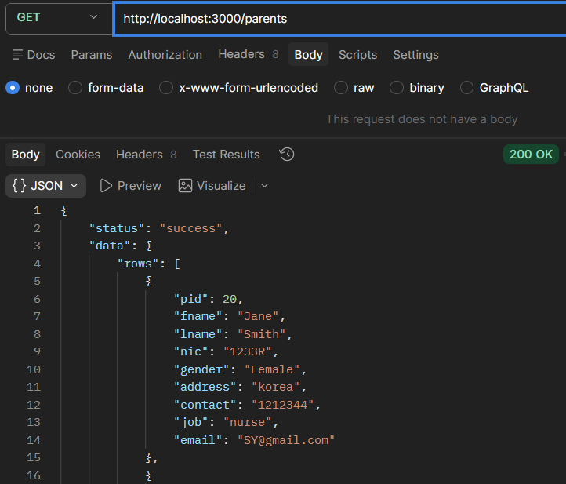

4.4.11 Retrieve Parent by ID

The /parents/:id endpoint retrieves a specific parent record using the parent ID.

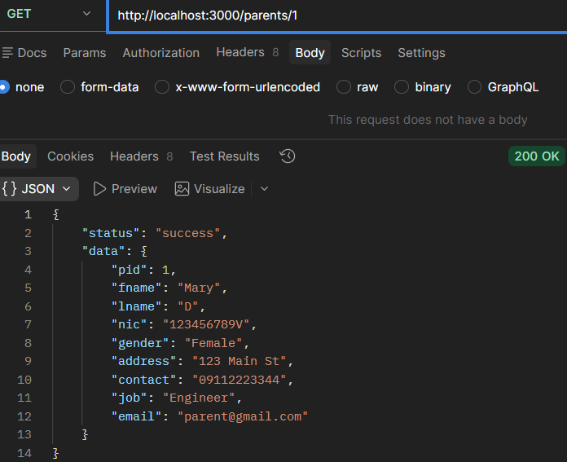

4.4.12 Add Parent Record

The /parents endpoint adds a new parent record into the database.

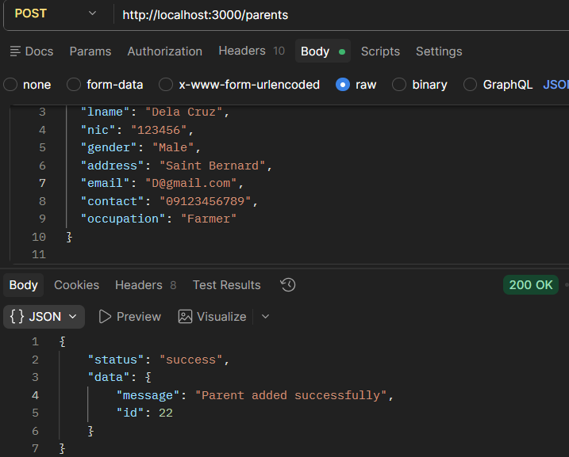

4.4.13 Update Parent Record

The /parents/update endpoint updates an existing parent record in the database.

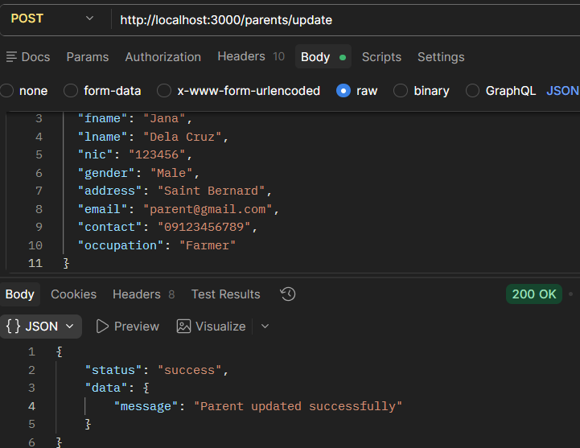

4.4.14 Get Parent Count

The /parents-count endpoint retrieves the total number of parent records stored in the database.

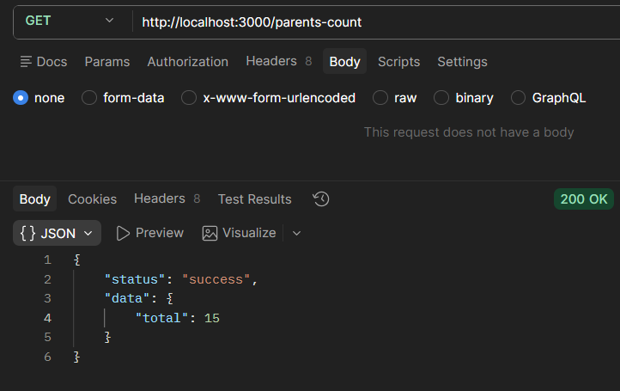

4.4.15 Retrieve Book Records

The /books endpoint retrieves all book records stored in the database.

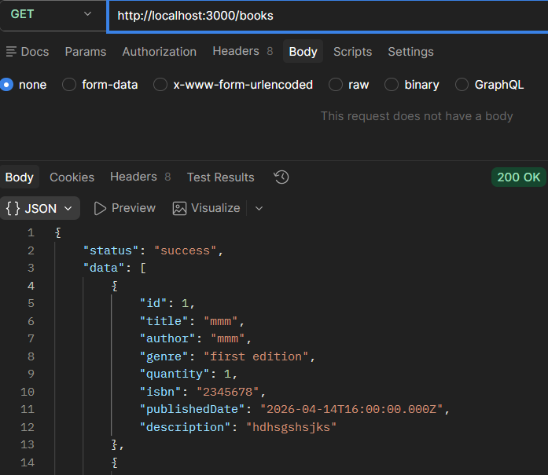

4.4.16 Retrieve Book by ID

The /books/:id endpoint retrieves a specific book record using the book ID.

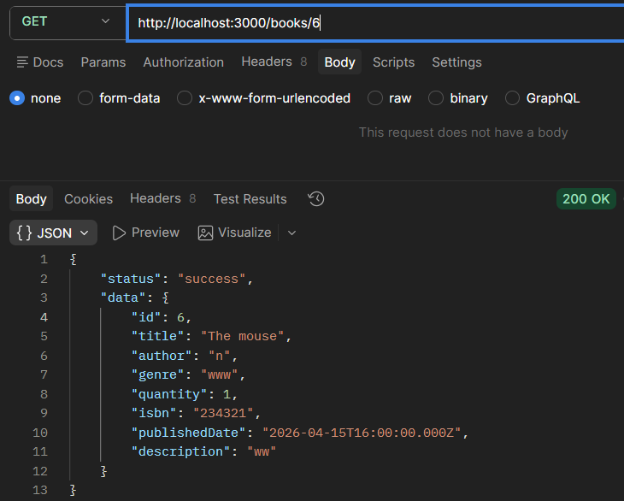

4.4.17 Add Book Record

The /books endpoint adds a new book record into the database.

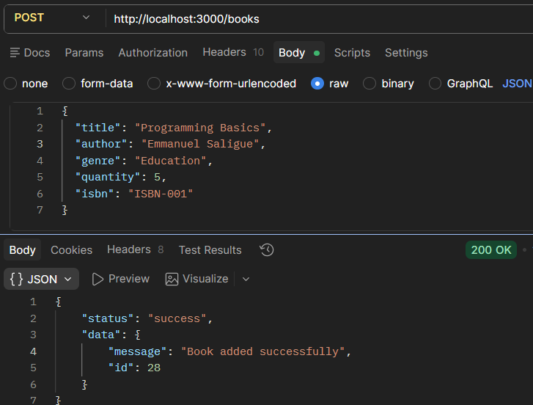

4.4.18 Update Book Record

The /books/update endpoint updates an existing book record in the database.

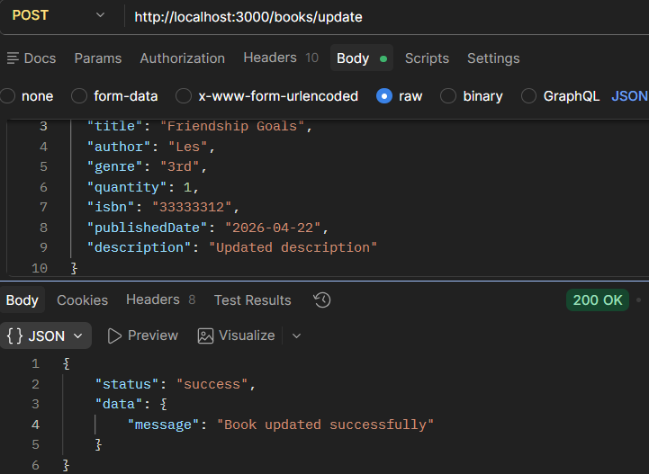

4.4.19 Delete Book Record

The /books/:id endpoint deletes a book record from the database using the book ID.

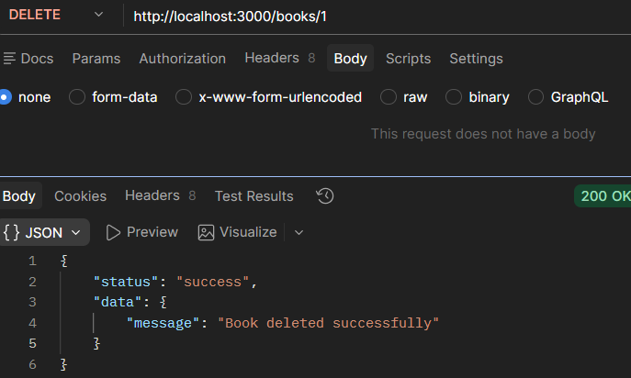

4.4.20 Retrieve Book Count

The /books-count endpoint retrieves the total number of books stored in the database.

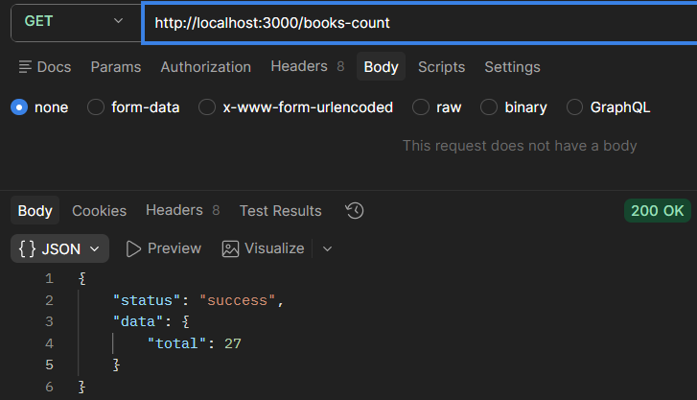

4.4.21 Issue Book

The /issue endpoint issues a selected book to a student and records the issue transaction in the database.

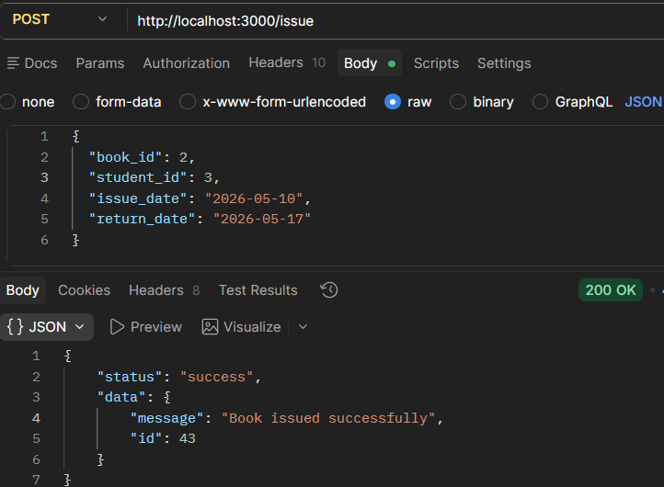

4.4.22 Return Book

The /return-book endpoint updates the status of an issued book to returned.

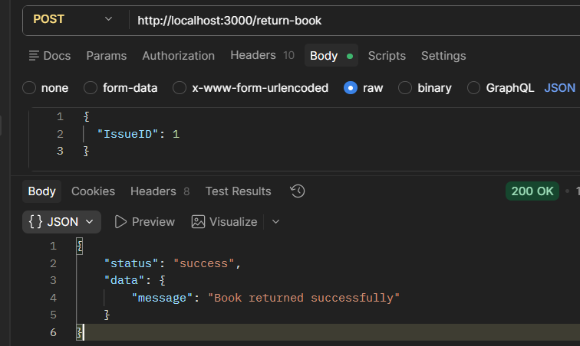

4.4.23 Reserve Book

The /reserve endpoint allows students to reserve available books in the library system.

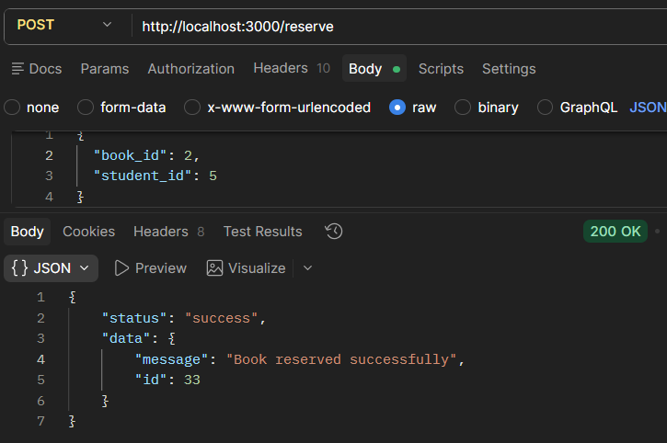

4.4.24 Retrieve Issued Books

The /issued endpoint retrieves all issued book transactions stored in the database.

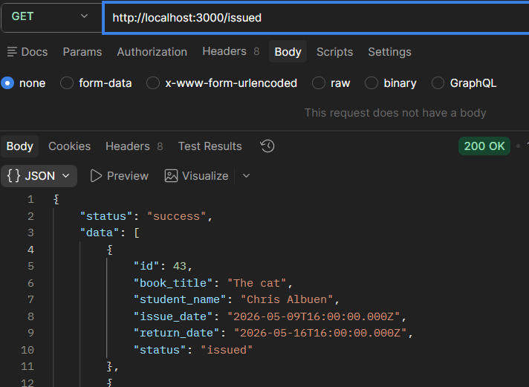

4.4.25 Retrieve Reservations

The /reservations endpoint retrieves all reserved book records stored in the database.

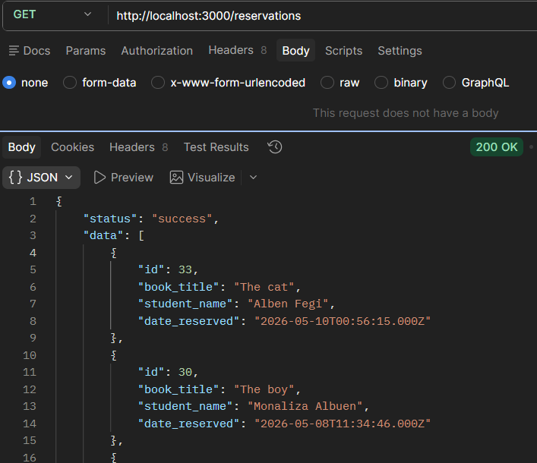

4.4.26 Retrieve Reports

The /reports endpoint retrieves borrowing and returning transaction reports from the database.

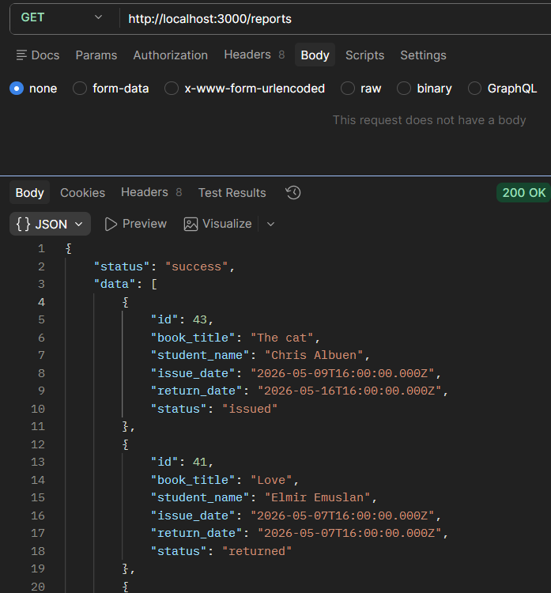

5.1 Prerequisites

Requirement | Details
XAMPP / WAMP | Apache + PHP 7+ + MySQL — for running the Student Management System (PHP) and the MySQL database
Node.js | v14 or later — for running the Node.js REST API server
npm packages | express, mysql2, cors — installed via npm install
Visual Studio | 2019 or later with .NET Framework 4.7.2 — for running the C# Library Management System
NuGet packages | Newtonsoft.Json 13.0.4 — used for JSON handling (auto-restored on build)
5.2 Step-by-Step Setup
Step 1: Set Up MySQL Database
• Start MySQL via XAMPP or your MySQL service.
• Create the database:
CREATE DATABASE school_api_db;
• Import or run the SQL file to create the required tables:
student, parent, books, issuedbooks, reserved_books, user
• Insert at least one user into the user table for login.

Step 2: Configure and Start the Node.js API
• Navigate to the API folder in the terminal.
• Run:
npm install
• Ensure database connection settings are correct:
host=localhost, user=root, password=''
• Start the server:
node server.js
• Confirm the server is running:
http://localhost:3000

Step 3: Set Up PHP Student Management System
• Copy the PHP files into your XAMPP htdocs folder
(e.g., htdocs/student-system/).
• Start Apache via XAMPP.
• Open a browser and navigate to:
http://localhost/student-system/index.php
• Log in using credentials from the user table.

Step 4: Run the C# Library Management System
• Open the project (.sln) in Visual Studio.
• Build the solution (NuGet packages will auto-restore).
• Run the application (F5 or Start).
• Log in using credentials from the user table.

5.3 Important Notes (Fixed Version)
⚠️ Important Operational Notes
• The Node.js API server must be running before using the PHP or C# systems, as both depend on it for all data operations.
• The system uses a centralized database (school_api_db), shared by both the Student Management System and the Library Management System.
• The API uses localhost URLs. If deployed on another machine, update all API URLs in both PHP and C# applications.
• Passwords are currently hashed using MD5 in the API. For production, stronger encryption (e.g., bcrypt) is recommended.
• Ensure all required tables exist before starting the API to avoid runtime errors.

6. Cross-System Data Flow

6.1 Student Data Management Flow (PHP → API → Database)

When an administrator manages student data in the Student Management System, the following process occurs:
Step | Action
1 | The administrator enters student information in the PHP form (e.g., name, classroom, parent).
2 | The PHP application sends an HTTP request (POST /students or /students/update) to the Node.js API via cURL.
3 | The API receives the request and validates the input data (e.g., required fields, duplicate email).
4 | If validation fails, the API returns an error response.
5. | If validation is successful, the API inserts or updates the student record in the student table.
6 | The API returns a success response to the PHP application.
7 | The PHP system displays a confirmation message and updates the student list.

7.2 Library Transaction Flow (C# ↔ API ↔ Database)

The C# Library Management System performs all operations through the Node.js API. It does not directly connect to the database.

🔹 Issue Book Flow
Step | Action
1 | Librarian selects a book and a student in the C# application
2 | C# sends POST /issue request to the API
3 | API inserts a new record into issuedbooks with status = 'issued.
4 | API returns success response
5 | C# displays confirmation message

🔹 Return Book Flow
Step | Action
1 | Librarian selects a borrowed book and student
2 | C# retrieves the IssueID via /issue-id
3 | C# sends POST /return-book request
4 | API updates issuedbooks (status = 'returned', ReturnDate = NOW())
5 | API returns success response
6 | C# updates the UI

🔹 Reserve Book Flow
Step | Action
1 | Librarian selects a book and student
2 | C# sends POST /reserve request
3 | API inserts a record into reserved_books
4 | API returns success response
5 | C# displays confirmation

7.3 Data Sharing Between Systems

Both systems share data through a centralized database accessed via the Node.js API.
Data Type | Source System | Used By
Student Data | PHP Student Management System | C# Library Management System
Parent Data | PHP Student Management System | C# Library Management System
Book Data | C# Library Management System | Both systems
Transactions (Issue/Return) | C# Library Management System | Reports

8. Error Handling

8.1 API Connectivity Errors
System | Error Type
PHP (cURL) | curl_exec() returns false
PHP (cURL) | HTTP status ≥ 500
PHP (cURL) | Timeout (e.g., 5 seconds)
C# (HttpClient) | HttpRequestException
C# (HttpClient) | TaskCanceledException
C# (HttpClient) | Timeout (e.g., 5 seconds)

8.2 Business Logic Errors
Scenario | Behavior
Missing required fields | API returns error message
Duplicate student email | API returns "Email already registered"
Invalid login credentials | API returns "Invalid credentials"
Book not found | API returns "Book not found"
No active issue found | API returns "No active issue found"
Missing IssueID on return | API returns "IssueID required"

9. Security Considerations

The current system is configured for local development. The following improvements are recommended for production:
Area | Current State
Password Storage | MD5 hashing (should be upgraded to bcrypt)
API Authentication | No tokens or API keys
Database Access | Root user, no password
CORS | Enabled for all origins
Input Validation | Basic validation only
HTTPS | Uses HTTP only
Session Handling | Standard PHP sessions
GITHUB REPOSITORY

Main Owner of the System:
SYSTEM | URL
Student Management System | https://github.com/sujanshresthanet/Student-Management-System.git
Library Management System | https://github.com/Dulyaaa/Library-Management-System.git

