CHURNGUARD AI
Customer Churn Prediction & Retention Intelligence System
PROJECT REPORT
Domain: Artificial Intelligence & Machine Learning
Primary Language: Python
Environment: Google Colab
Project Duration: 2 Days
Student Name: ____K Monasri__________________________
Participant ID: _____MT-SKT-1213_______________
End-to-end supervised machine-learning classification project

Project Overview
CHURNGUARD AI is an end-to-end machine-learning system designed to identify customers who are at risk of leaving a telecom service. The project follows the complete workflow from raw customer data to cleaning, exploratory analysis, preprocessing, model training, evaluation, risk prediction, and business interpretation. The system is built as a binary classification solution and produces both a churn prediction and a probability-based risk level that can support customer-retention decisions.
Core workflow
Raw Data -> Data Understanding -> Cleaning -> Exploratory Analysis -> Feature Preparation -> Model Training -> Evaluation -> Risk Prediction -> Business Insight

1. Project Title
CHURNGUARD AI - Customer Churn Prediction & Retention Intelligence System

2. Problem Statement
Businesses often identify customer churn only after a customer has already decided to leave. This delays retention action and can result in avoidable customer and revenue loss. The project addresses this problem by learning patterns from historical customer information and predicting whether a customer is likely to churn. The model is expected to distinguish high-risk customers from customers who are likely to stay, allowing the business to intervene earlier.

3. Objective
The main objective is to build a reliable and interpretable machine-learning classification workflow that predicts customer churn and converts the prediction into practical retention intelligence.
- Understand and clean a real customer-churn dataset.
- Explore patterns associated with churn using meaningful visualizations.
- Prepare numerical and categorical data for machine learning.
- Train and compare at least two classification models.
- Evaluate models using accuracy, precision, recall, F1-score, ROC-AUC, and a confusion matrix.
- Generate churn probabilities and LOW / MEDIUM / HIGH risk categories for new customers.
- Translate model output into business recommendations while clearly stating limitations.

4. Dataset Description
The project uses the IBM Telco Customer Churn dataset, a public sample dataset describing customers of a fictional telecommunications company. The target column, Churn, indicates whether a customer left within the last month. The original dataset contains 7,043 customer records and 21 columns including the customer identifier and the target variable.
Dataset Property | Description
Dataset | IBM Telco Customer Churn
Raw records | 7,043 customers
Raw columns | 21
Target | Churn (Yes / No)
Problem type | Binary classification
Main feature groups | Demographics, tenure, services, contract, billing, payment
Notable data issue | TotalCharges contains blank text values that must be converted/handled
Figure 1. Overall churn distribution in the standard IBM Telco sample
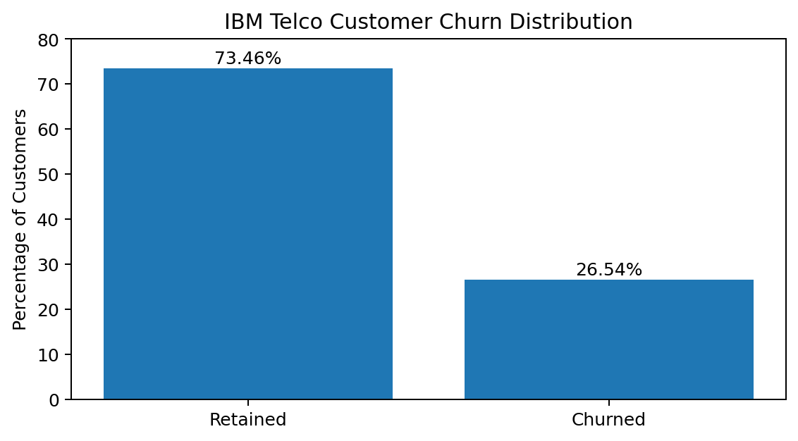
The standard IBM sample has an overall churn rate of approximately 26.5%, meaning the classes are not perfectly balanced. This is why evaluation should consider recall and F1-score in addition to accuracy.

5. Technologies Used
Technology | Purpose | Role in Project
Python | Programming language | Core implementation
Google Colab / Jupyter | Notebook environment | Run code and document analysis
Pandas | Data manipulation | Loading, inspection, cleaning
NumPy | Numerical operations | Supporting calculations
Matplotlib / Seaborn | Visualization | EDA charts
Scikit-learn | Machine learning | Splitting, preprocessing, training, evaluation
Joblib | Model persistence | Saving the trained pipeline
Streamlit (optional) | Web interface | Interactive risk predictor

6. Methodology
The project uses a structured supervised-learning methodology. Data is first inspected and cleaned, then exploratory analysis is performed to understand churn behavior. The target and predictors are separated, categorical variables are one-hot encoded, numerical variables are standardized, and the data is split into training and testing sets. Logistic Regression and Random Forest models are trained and compared. A tuned Random Forest is then evaluated as an improvement step. The final model is selected using balanced classification performance, with special attention to churn recall, F1-score, and false negatives.
1. Understand | 2. Prepare | 3. Train | 4. Evaluate | 5. Predict
Training and evaluation use an 80:20 stratified train-test split so the unseen test set preserves the churn proportion and gives a more realistic estimate of model behavior.

7. Data Preprocessing
- Convert TotalCharges from text to numeric using coercion for blank values.
- Remove duplicate rows if any are present.
- Remove customerID because it is an identifier and does not represent customer behavior.
- Handle the small number of missing TotalCharges records after conversion.
- Map the target Churn from Yes/No to 1/0.
- Detect numerical and categorical feature groups automatically.
- Standardize numerical features using StandardScaler.
- Convert categorical variables to machine-readable values using OneHotEncoder(handle_unknown="ignore").
- Perform a stratified 80:20 train-test split with random_state=42.
Data leakage prevention
Preprocessing is placed inside a scikit-learn Pipeline/ColumnTransformer so transformations are learned from the training data and then applied consistently to unseen test and new-customer data.

8. Exploratory Analysis
Exploratory data analysis is used to identify which customer characteristics are associated with higher or lower churn. The notebook examines churn distribution, contract type, tenure, monthly charges, internet service, and payment method. Each chart should be followed by a short interpretation rather than being included only for visual presentation.
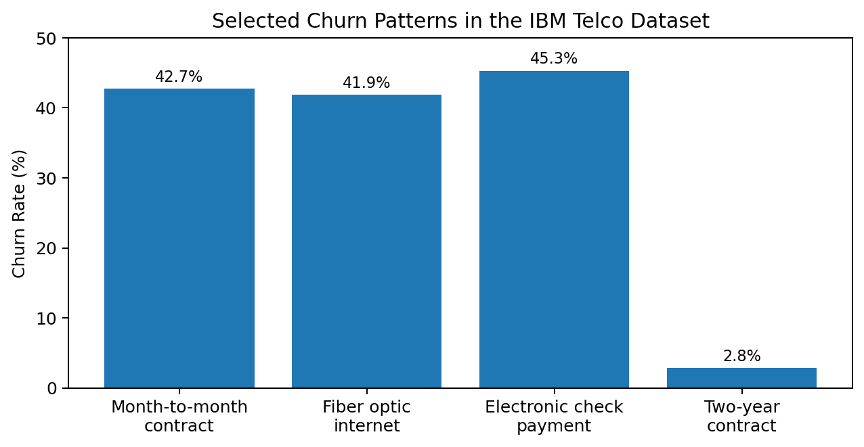
Figure 2. Selected churn patterns reported for the standard IBM Telco sample
- Month-to-month customers show substantially higher churn than customers on long-term contracts.
- Customers with fiber-optic internet show a comparatively high churn rate in the standard sample.
- Electronic-check users form one of the highest-risk payment groups.
- Customers early in their tenure are more likely to churn than long-tenure customers.
- Churned customers tend to have higher monthly charges on average than retained customers.
Validation note
The rates shown above are reference values for the standard IBM sample. The submitted notebook output should be treated as the final source for the exact values after your preprocessing steps.

9. Models Tested
Model | Purpose | Reason for Inclusion
Logistic Regression | Baseline linear classifier | Simple, efficient, and interpretable for binary classification.
Random Forest | Nonlinear ensemble classifier | Captures interactions and nonlinear patterns and provides feature importance.
Improved Random Forest | Tuned ensemble | Uses class balancing and GridSearchCV to test a meaningful improvement over the baseline.

10. Evaluation Results
The models are evaluated using multiple metrics because churn is an imbalanced business problem. Accuracy alone may hide missed churners. A false negative means the system predicts that a customer will stay when the customer actually churns; such errors are especially important because the business loses the opportunity to intervene.
Model | Accuracy | Precision | Recall | F1-score | ROC-AUC
Logistic Regression | Insert notebook output | Insert | Insert | Insert | Insert
Random Forest | Insert notebook output | Insert | Insert | Insert | Insert
Improved Random Forest | Insert notebook output | Insert | Insert | Insert | Insert
Important - final values needed
The supplied notebook has not been executed in this chat, so model scores are intentionally not fabricated. Run the notebook once and copy the printed model-comparison values into this table before final submission.

Model selection rule: choose the model with the strongest F1-score while also checking recall and the confusion matrix. If two models are close, prefer the model that reduces false negatives without creating an impractical number of false positives.

11. Final Model
The notebook automatically compares Logistic Regression, Random Forest, and the improved Random Forest, then selects the model with the highest F1-score as the final model. The selected pipeline contains both preprocessing and the classifier, so it can directly accept raw customer fields for prediction.
Selected Model | ____________________________
Final F1-score | ____________________________
Final Recall | ____________________________
The final system uses predict_proba() to obtain churn probability and maps the probability to a simple risk category: LOW for probability below 0.30, MEDIUM for probability from 0.30 to below 0.60, and HIGH for probability of 0.60 or above. These thresholds are project rules and can be changed later based on business cost and retention capacity.

12. Business Insights
- Prioritize month-to-month customers for retention campaigns because contract flexibility is strongly associated with churn.
- Focus onboarding and engagement on low-tenure customers, especially during the first year of the customer relationship.
- Review pricing, service quality, and support experience for fiber-optic customers because this segment shows elevated churn in the standard dataset.
- Investigate customers using electronic check and consider encouraging automatic payment methods if billing friction is contributing to churn.
- Use churn probability as a prioritization score rather than treating every prediction as certainty.
- For HIGH-risk customers, possible actions include proactive service review, retention offers, plan recommendations, and targeted customer outreach.

13. Limitations
- The IBM dataset is a public sample representing a fictional telecommunications company and may not reflect every real business environment.
- The data is cross-sectional rather than a sequence of monthly customer snapshots, so it does not model changing behavior over time.
- The dataset is moderately imbalanced, so accuracy may overstate performance if recall and F1-score are ignored.
- Predicted churn probability indicates statistical risk, not certainty that a specific customer will leave.
- Associations discovered by the model do not prove causation; for example, a feature may correlate with churn without directly causing it.
- Retention actions are not evaluated for causal effectiveness or financial return in the current version.

14. Future Improvements
- Tune classification thresholds using business costs so the model can prioritize recall when missing a churner is expensive.
- Evaluate additional algorithms such as Gradient Boosting, XGBoost, LightGBM, or CatBoost.
- Use cross-validation and broader hyperparameter optimization for more stable model selection.
- Add explainability techniques such as SHAP to show why individual customers receive high-risk scores.
- Engineer additional features such as service count, tenure bands, charges-to-tenure ratio, and bundled-support indicators.
- Build a Streamlit interface for real-time customer-risk prediction.
- Connect the model to CRM data and monitor model drift, fairness, and performance over time.
- Evaluate actual retention interventions with controlled experiments to measure whether predicted-risk actions reduce churn.

15. Conclusion
CHURNGUARD AI demonstrates a complete practical machine-learning workflow for customer churn prediction. The project moves beyond model training by combining data understanding, preprocessing, exploratory analysis, model comparison, probability-based risk scoring, and business interpretation. The most important professional lesson is that a churn prediction is a decision-support signal rather than a guarantee. A useful model must therefore be evaluated with business-relevant metrics and converted into clear, responsible retention actions.

Sources and References
1. Project brief: CHURNGUARD AI - Customer Churn Prediction & Retention Intelligence System (provided challenge document).
2. IBM Telco Customer Churn public sample dataset, IBM GitHub archive.
3. Scikit-learn documentation: train_test_split, ColumnTransformer, OneHotEncoder, LogisticRegression, RandomForestClassifier, classification metrics, GridSearchCV.
4. Public analyses of the standard IBM Telco sample were used only for the reference EDA rates shown in this report; exact submission values should come from the executed notebook.

