UNIVERSITY OF RWANDA
COLLEGE OF SCIENCE AND TECHNOLOGY SCHOOL OF ICT

COMPUTER AND SOFTWARE ENGINEERING DEPARTMENT NYARUGENGE CAMPUS
MODULE TITLE: SYSTEM ANALYSIS, DESIGN, AND DEVELOPMENT LAB
XYZ Management System, Case of Kaka, Sector, Rwanda

Names: ………….
Registration Numbers: …….
Year of study: …………….
Date: ………………….

Table of Contents
Chapter 1. Introduction 3
  - Historical background of the case study 3
  - Problem statement 4
  - Proposed Solution 5
  - Purpose 5
  - Objectives 5
Chapter 2. System analysis and Design 6
  - System analysis 6
    - Functional requirements 6
      - Login functionality 6
      - User Registration functionality 9
      - Logout functionality 10
      - View, Update Functionality 10
      - Delete Functionality 10
      - Check-in Functionality 10
      - Check-out Functionality 10
      - Check room availability Functionality 11
      - Booking Functionality 11
    - Users of the project 11
    - Partners 11
  - System design 11
    - UI design 11
2.2.2 Database design 12
Chapter 3. Implementation 13
3.1. Introduction 13
3.2 Tools and Technology 13
3.3. Screenshots 13
Chapter 4. Conclusion and Recommendation 36
  - State of implementation 36
  - Recommendations 36
Appendix 37

Table of figures

Figure 1: Login as admin 7
Figure 2: Login as executive 8
Figure 3: Login as client 9
Figure 4: UI module 12
Figure 5: Database ERD 12
Figure 6: Landing Page 14
Figure 7: User registration page 15
Figure 8: Login form validations 16
Figure 9: About content 16
Figure 10: Contact us page 17
Figure 11: Help center 17
Figure 12: Page footer 18
Figure 13: Booking homepage 18
Figure 14: Room availability 19
Figure 15: Room details 19
Figure 16: Booking form 20
Figure 17: User booking details 21
Figure 18: Login page 22
Figure 19: Admin dashboard 23
Figure 20: Booked rooms 23
Figure 21: User booking details by admin 24
Figure 22: Room categories 24
Figure 23: Add room category 25
Figure 24: Room category updates 25
Figure 25: Room category deletion 26
Figure 26: Rooms 27
Figure 27: Add rooms 27
Figure 28: View rooms 28
Figure 29: View rooms 29
Figure 30: Delete room 29
Figure 31: Users page 30
Figure 32: User account creation 30
Figure 33: User update 31
Figure 34: User deletion 31
Figure 35: System settings 32
Figure 36: Customers' messages 33
Figure 37: Staff dashboard 33
Figure 38: Booked rooms 34
Figure 39: Check-in page 34
Figure 40: Check in point 35
Figure 41: Check-out page 35

LIST OF ALL ABBREVIATIONS
- PHP: Hypertext Preprocessor
- HTML: Hypertext Markup Language CSS: Cascading Style Sheet
- SQL: Structured Query Language
- CBS: Computer booking system.

Chapter 1. Introduction

CREDO Hotel room reservation system is a system designed to manage booking information of CREDO Hotel, which provides the facilities for accommodation such as holiday apartments and other accommodations, for customers. This system will help them to manage the customers' bookings easily and to keep the customers' data safer. It will also help staff to keep track of their customers’ online booking requests as well as easily reply to the customers.

  - Historical background of the case study
The importance of computers and their applications has been recognized globally. The impact of computers on society has been felt in the hotel booking system.
The computer booking system (CBS) has brought a lot of changes, improvements, and efficiency in hotel operations.
There is a great need for an easy, quick, reliable, and information system to aid the traveler in planning their vacation. Shelter is one of their necessities in life. Individuals need a place to always stay, ranging from a businessman who travels from one place to another during their business to a student who goes to study away from their home. Different professionals travel out of their domain to achieve certain aims and objectives, such as tourism.
A hotel can simply be defined as a building or a place for guests to receive a room and stay for a short period, as well as a place of refreshment, entertainment, and protection for the visitors.

CREDO Hotel is one of the hotels in Rwanda that provides hotel-related services. This hotel faces different problems related to booking operations, as all operations are carried out manually, which is problematic.

  - Problem statement
The current manual reservation system uses paper and direct human interaction to book hotel rooms and manage reservations. This leads to delays in the exchange of information in the hotel.
Reservation is made via phone calls or by visit in person to the hotel reservation office. The guest’s details, such as name and duration of visit or stay, are entered during the booking made. Then the booking officer asks to prepare the room for the guest before his/ her check-in date.
The data and documents are transferred manually to the appropriate office for compilation of
the guest’s file. On the day of the check-in date, the file is transferred to the reception. On the day of checking in, the guest is given the key to their room, she/ he also asked if room service is needed.
The Front desk hands over the customer's file to the account department, where the guest pays for accommodation and another fee. The customer’s file is updated daily with his expenditure costs. The financial department generates the bills and delivers them to the customer in their rooms. The guest pays at the accounts department.
A day before their checkout day, their expenditures are generated. The guests receive their expenditure at the accounts office as they check out where they pay for the remaining balance, if any.

After analyzing various traditional hotel room booking systems, I noticed the following problems in their system.

- The manual system for storing records is not consistent, as some inaccuracy can creep in while writing records manually.
- Guests or visitors may have a hard time getting a place to stay in the area.
- It is difficult to store a record of the availability of rooms and the huge number of customers’ records.
- More manpower is required, and the current system consumes too much time to make a reservation and store data.
- Maintaining up-to-date availability of inventory is a bit difficult, thus, it is making it hard for executives to search for the records and the room.
- Payment processing and collection are difficult.
- Inaccurate of records or data.
- There is no centralized database that can be created as information is not in one place.
- More money and paper, and other resources are wasted to store the records of available rooms and customers.

  - Proposed Solution

The main aim of designing this project is to design a system that can manage and handle the activities that are involved in CREDO hotel reservations in an organized, cost-effective, and reliable way. It will help the administrative staff to do their work in a very simple manner without causing any trouble, and Visitors or customer to reserve their room according to their needs before they come to the hotel. Customers can use any electronic device, like a laptop, computer, smartphone, or tablet, to book and confirm their stay with the CREDO hotel. Based on the limitations and shortcomings identified in the existing Hotel Room reservation system, the solutions have been provided for better management of the organization and ease of access for the customer.
The proposed solution will have the ability to manage customers’ accounts, where they can save their preferences and personal information. The customer will have many options to compare rates and services based on their requirements. Efficient searching, sorting, and filtering are offered to the customer. Travelers or any other customer can book and secure their place to stay before or without visiting the hotel. Executives and business owners can easily manage the inventory and rates of their hotel rooms. The system will be 24*7 accessible.

  - Purpose
The purpose of this project is to create a functional web system for users to reserve hotel rooms across the world. Users of this website will be able to use an easy-to-use interface to search, sort, and reserve rooms and services across the world. Creating an account option will secure their data and allow easy access to various services and facilities. One of the main purposes of this project is to allow customers to have online booking of a room with a registered business partner. The basic requirements state that the users will be able to search for a room based on and able to make instant online payment. They will also be able to navigate through other available options by category, or by using a well-executed search function. The system will be maintained and managed by the administrator. They will have the authority to manage the Rooms and offers.

  - Objectives
The CREDO Hotel Room Reservation System is aimed at maintaining the day-to-day state of admission/vacation of residents. The following are specific objectives of the project:
- Access the current manual mechanisms they are using to record data.
- To analyze and design the proposed solution drawn from their challenges.
- To develop and test a working prototype.
The following features are the main outcomes of the project. It will support the CREDO officers and management activities, especially by:
- Keeping user satisfaction as top priority.
- Scheduling the allotment of users with room to make it convenient for the user.
- Keeping records of user registration details accurately arranged in order so that the treatment of Customers becomes quick and satisfactory.
- Keeping details about the users, their needs, and payment detail reports, etc.
- Keeping the best hotel facilities.
- Accurate and reliable reservations
- Keep the user connected to the hotel to receive the confirmation.

Chapter 2. System Analysis and Design
Users (Clients, employees, and Administrator) will need to log in to the system to begin using the other System Features. Personal identification is a high priority, as it satisfies safety requirements for the system. Login is done by entering registered account details (username, password).
2.1 System Requirements
2.1.1.1.1 Requirements for User login
REQ-1: User Interface elements are accessible at the home page, which allows the user to navigate to the login screen.
REQ-2: The login screen presents the user with prompts for username and password.
REQ-3: The system redirects the user to the homepage when login is done successfully.
REQ-4: Should the user attempt to enter a username or password that is not registered, the system presents the user with an error message describing the problem.
The following illustrations show what system users see after being logged in.
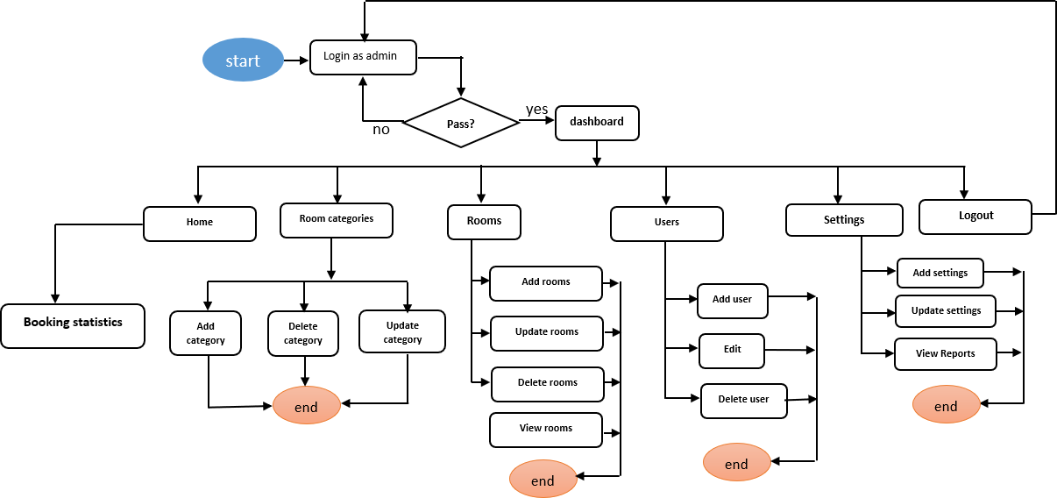
System Admin:

Figure 1 login as admin
When the admin is logged in, he/she can see and access different options. As illustrated above, when logged in as an admin is successful, the redirect is directly to the dashboard page where he/she can perform different operations until the end. Here, the admin can create rooms, offers, user accounts, and settings. Delete rights are also granted to the admin.
Hotel Executives

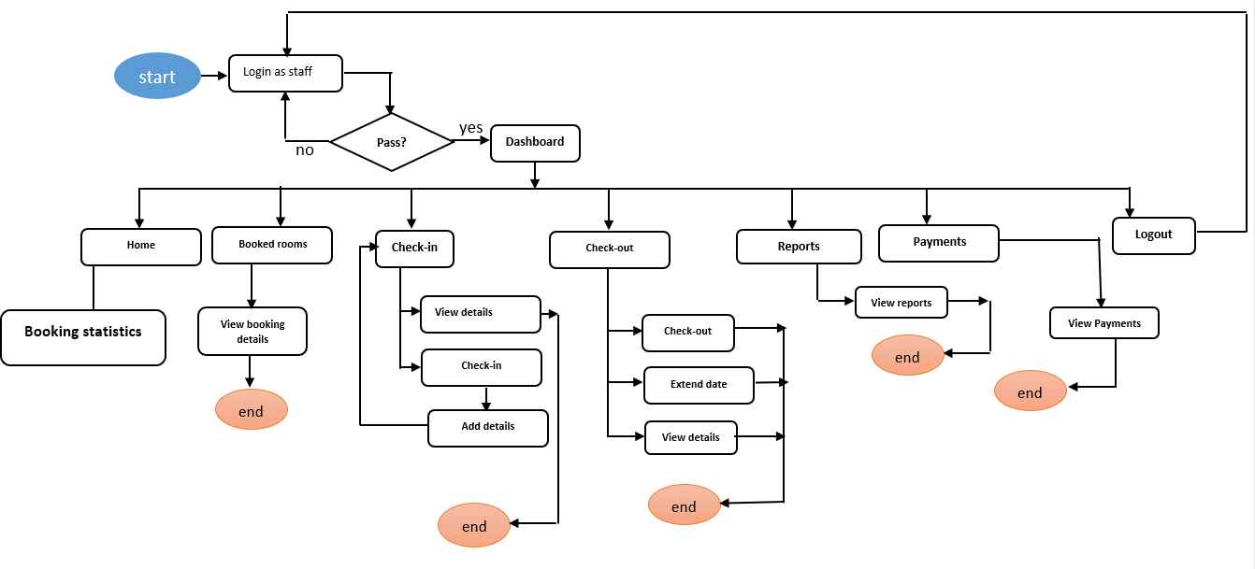
Figure 2: Log in as executive

When an executive is logged in, he/she can see and access different options. As illustrated above, when logged in as staff is successful, the redirect is directly to the dashboard page where he/she can perform different operations until the end. The main rights allowed are to view and update the records of customers.
Clients

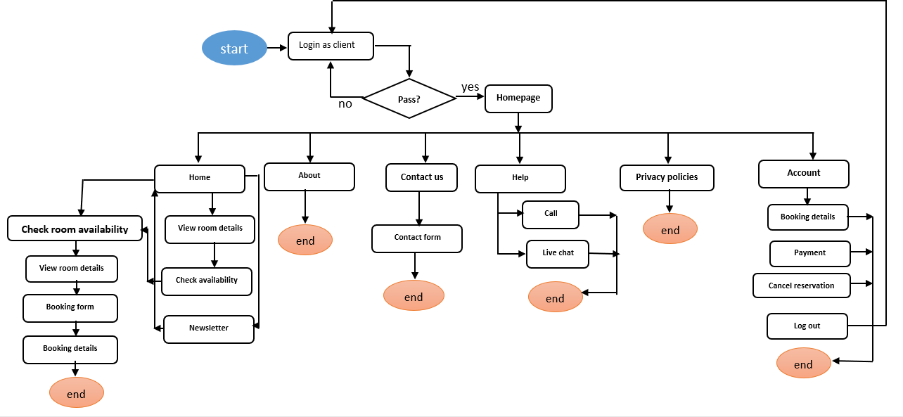

Figure 3: Login as client

When a client is logged in, he/she can see and access different options. As illustrated above, there are many functions he/she can navigate through in the booking process. He/she can also access his/her account and many more.
      - User Registration functionality
The first time a user accesses the system, she/he must create an account for personal identification with future use of the system. Initially, this account will include full names, email as username, and password, but may be expanded if additional information is required. Clients register themselves, but executive users are registered by the system administrator by creating accounts for them as well as setting their roles.
      - Requirements for User registration
REQ-1: User Interface elements are accessible at the home page, which allows the user to navigate to the account creation screen.
REQ-2: The account creation screen presents the user with prompts for name, email address, password, and user class (this is done for executive users by the admin and is set automatically for clients).
REQ-3: The system provides confirmation that the account creation process was done successfully and redirects the user to the login page.
REQ-4: Should the user attempt to create an account with a username that has already been registered, the system presents the user with an error message describing the problem.
      - Logout functionality
After creating an account, the user will be able to log in to the system using his/her username and password to protect his/her credentials and information he/she provided. The system provides a logout button that will remove all information used to log in.
      - View, Update Functionality
After creation of an account, clients, admin, and executive users will be able to view and update details associated with their account. The clients use this to view their booking details and make related updates.
      - Delete Functionality
Admin will be granted access to delete any of the created accounts by just clicking and confirming the deletion. He can also delete rooms and offers. The customers can also use this option to cancel their bookings.
      - Check-in Functionality
Hotel executives will be able to check in the room by entering the details of the customer on the date the customer is scheduled to check date.
      - Check-out Functionality
Hotel executives will be able to check out the room checked in before by simply clicking and confirming check-out.
      - Check room availability Functionality.
The booking process starts with checking available rooms by simply selecting the check-in date and check-out date, and this will show the available rooms within these dates.
      - Booking Functionality
Here, the user must fill out the booking form to provide all booking details needed and submit them to create a reservation with the hotel. It is the main function that the client can access in the system.

Users of the project
This system will have three main categories of users, which are:
- Platform administrator: Who will manage the daily running operations of the platform.
- Hotel executives (managers, accountants, customer care officers, …).
- Clients: who will use it to do all activities related to reservations with the CREDO Hotel.

Partners
This system will be implemented in collaboration with the following partners
- CREDO Hotel
- Financial institutions (Banks, ...)
- Internet service providers.

  - System Design

UI Data flow design
This illustration shows the data flow for a particular type of user. It shows what a user can do within the system.
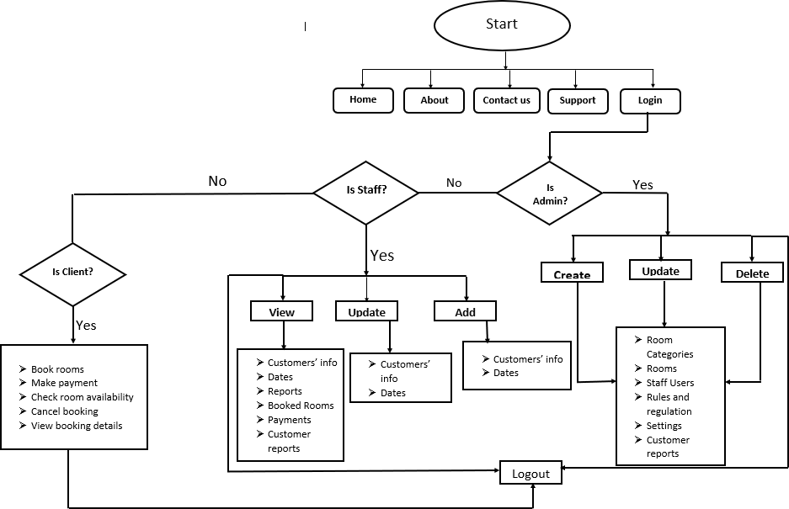

Figure 4: UI module

Database Design
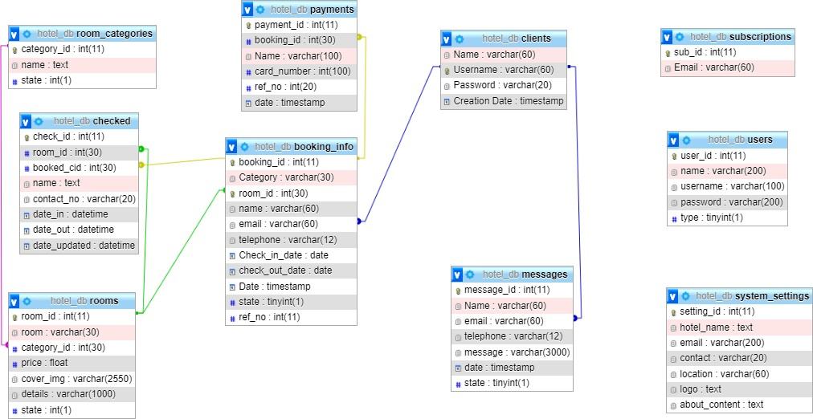
The database was designed using MYSQL with the help of XAMPP setup.

Figure 5: Database ERD

Chapter 3. Implementation

3.1. Introduction
This project was created to manage CREDO hotel reservations and can be used by clients to reserve their stays at the hotel.
3.2 Tools and Technology
The various tools used in developing this system are PHP (for creating code that links the web pages to the database), MYSQL (for creating the database), HTML, and CSS (for designing and styling the website). JavaScript for adding interactions to the user interface. These tools are used to develop an interactive system with users.
Visual Studio Code is used in this project as the main source code editor needed for developing this system. It supports several languages, which makes it suitable for this project.
3.3. Screenshots
During the use of this system, users will navigate through the following interfaces. Interfaces are in categories based on user type.
Clients
When a client comes first, he/she first land on the homepage where there are many links to navigate our system. There is also a display of all the rooms the hotel has inserted into the database.

Landing Page

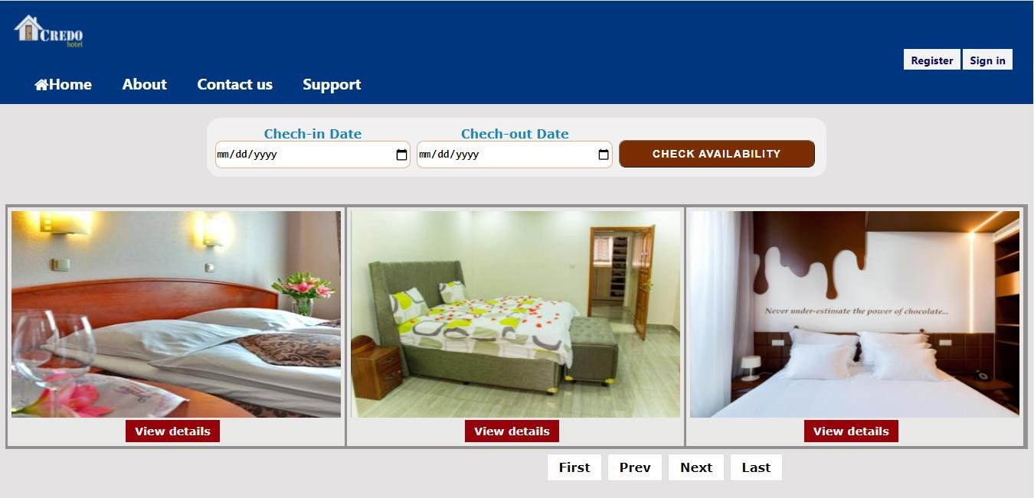

Figure 6: Homepage
All activities start at this homepage, where there is a display of rooms, and users can do different things such as registration or login, send messages via contact us, view the hotel's content, view room details, and view privacy policies. They can also subscribe to the hotel’s Newsletter. Let’s see in detail what users can do from this page.

Registration
Registration is required because it is required for the client to make a reservation, which will not be possible if not registered.

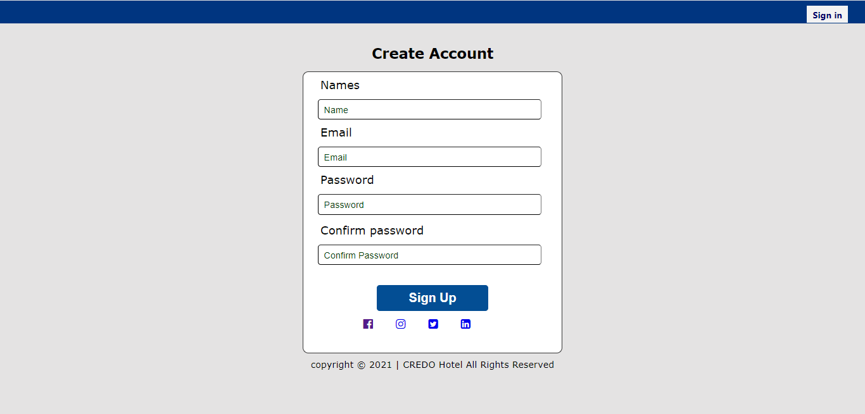

Figure 7: User registration page

Figure 2 shows the Sign-Up page for customers. From here, customers can register for the system by providing their necessary details (email, Name, password).
Here, the user fills in the registration form, and after he/she click sign up to register. The user is redirected to the login if the information provided is in the preferred format. If the user enters incorrect data, they will be asked to correct it by showing where there is an error.

Login
After being registered, for a client to make a reservation, a Login is required.
The way it is done is as follows: The client fills the required fields, and if he/she had registered, the redirect is done to the homepage. If not, the error will be displayed on the form.

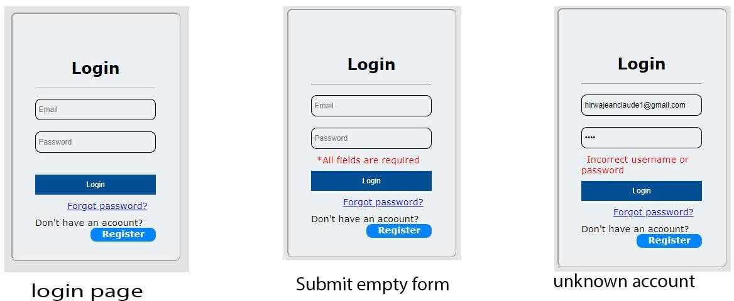

Figure 8: Login form validations

About content

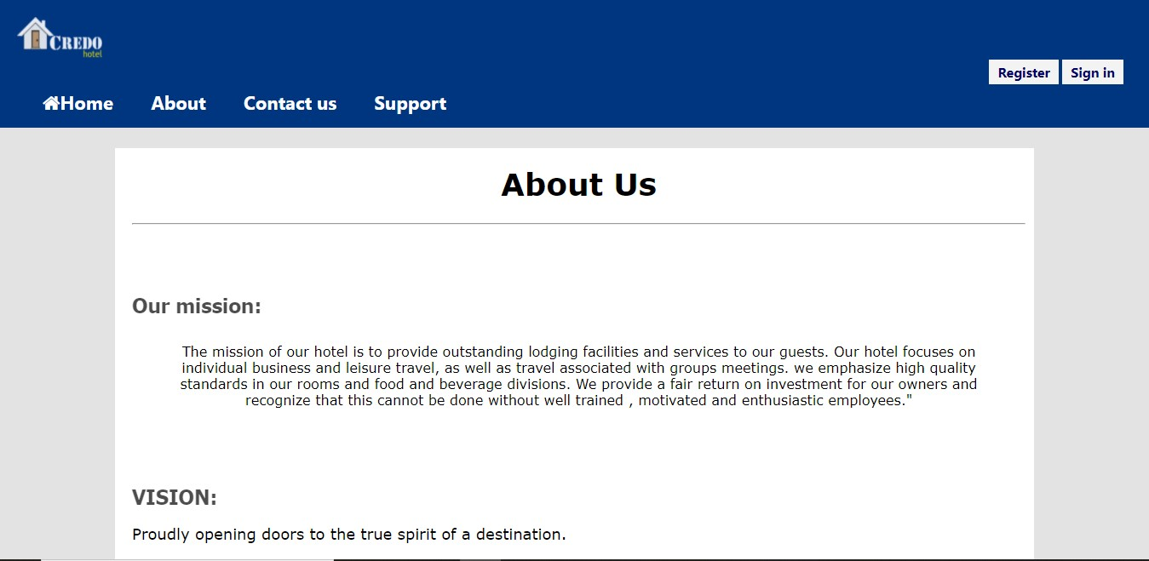
Figure 9: About content

On this page, the user can see the mission and the vision of the hotel. This information is created by the system administrator.

Contact us
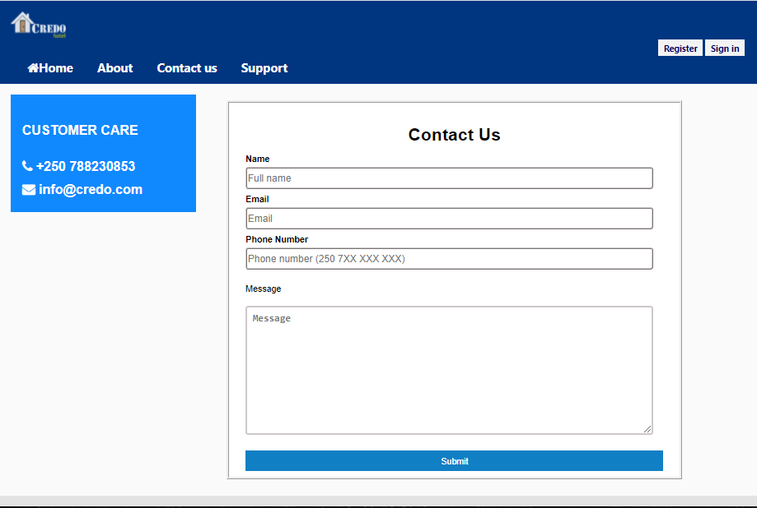

Figure 10: Contact us page.

On this page, the client can send a message or feedback to the hotel administration. This is done by filling out the form and then submitting it.

Support
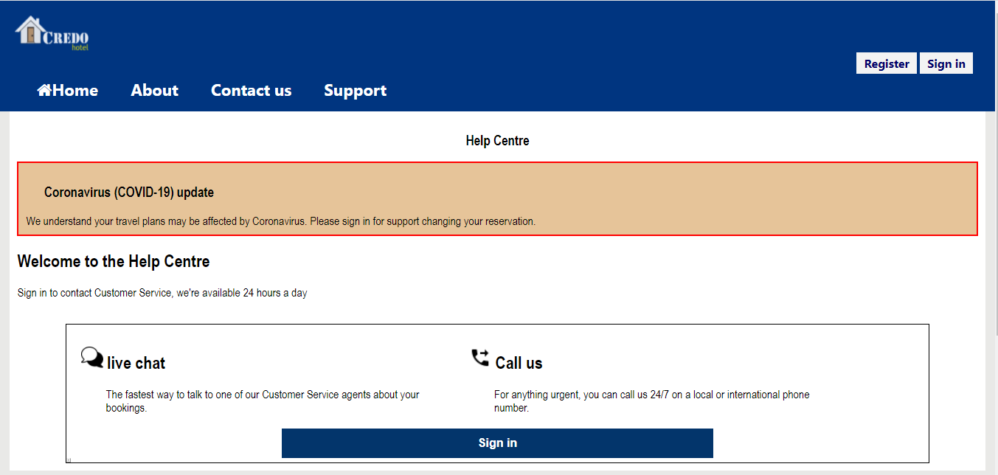
Figure 11: Help center

This is a support page where users can request help if they encounter difficulties.

Newsletter
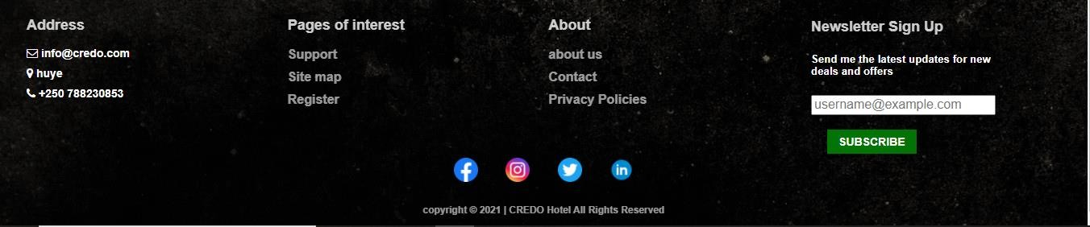
Figure 12: Page footer

By subscribing to the newsletter, the user confirms that he/she wants to receive updates about our services.

Booking process
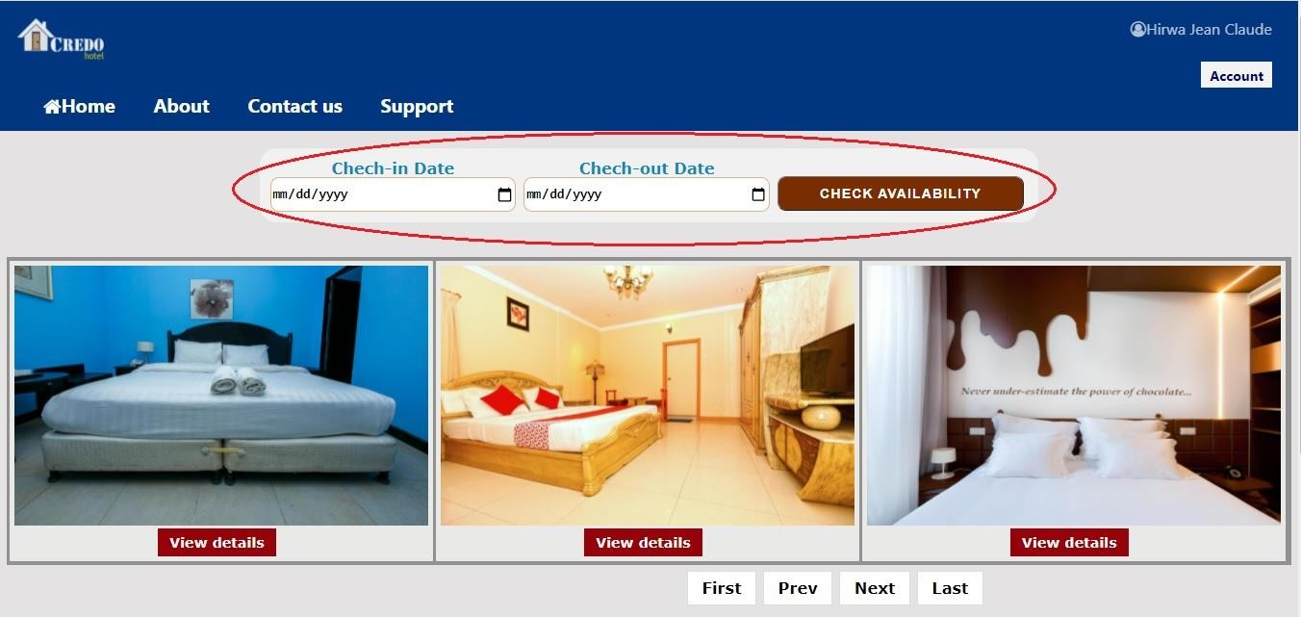
When the client wants to book a room, he must log in first. When logged in, he started by checking the availability of rooms.

Figure 13: Booking homepage.

Here, he/she selects the check-in date and check-out date and clicks on check availability. This operation will bring all rooms that are not booked on these dates.

Note: from the above figure, the red circle is for illustration only.

Check room availability results:
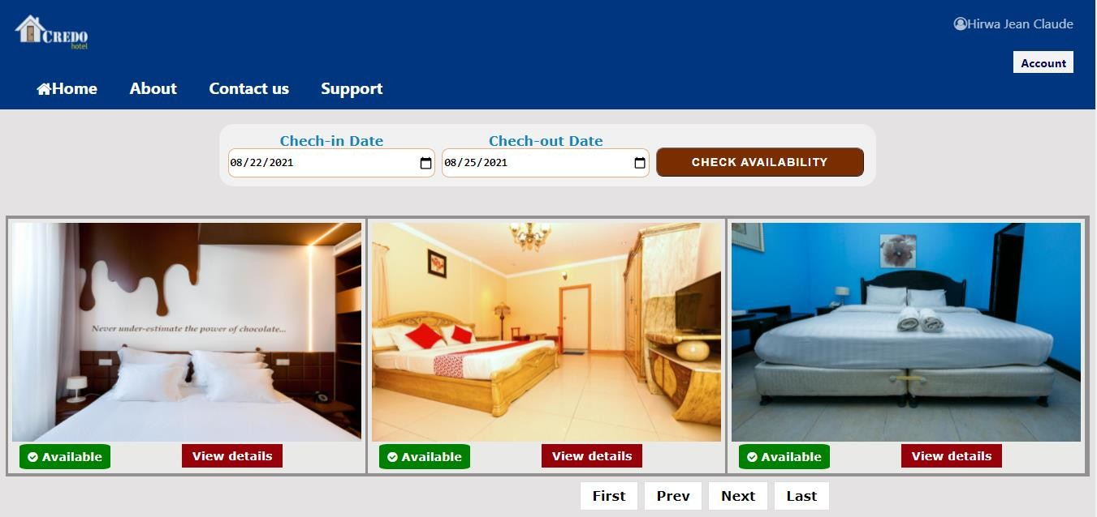
Figure 14: Room availability

Three rooms are displayed, and click next to view the other three.

View details
The customer views details of the selected room to see if it meets his/her requirements.
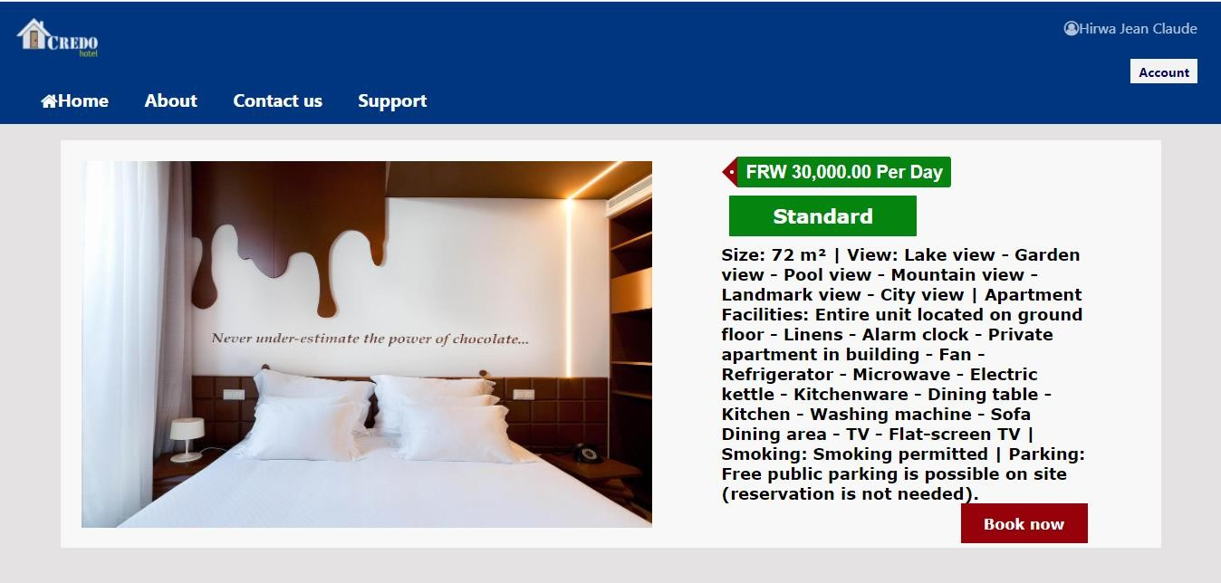
Figure 15: Room details

If he is satisfied with the details, he clicks the book now button and goes to the booking form where he/she provides all required booking details.
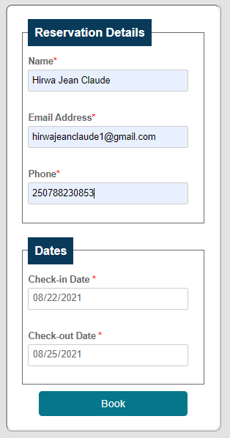
Figure 16: Booking form.

The form is filled and submitted by clicking the book button.
Check-in date and check-out date from check availability are printed on the form as read-only to disallow the client to change dates that will lead to booking errors.
Once the form is submitted. After the client receives information about his/her reservation.

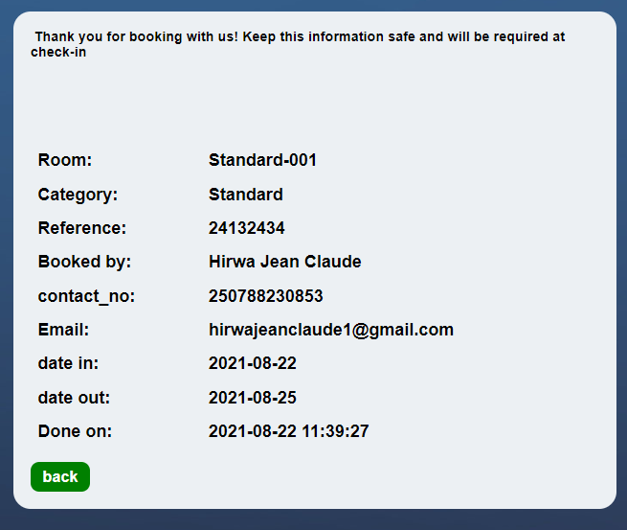

Figure 17: User booking details.

System admin
To access the admin panel, a login is required first. The figure below describes a login page.
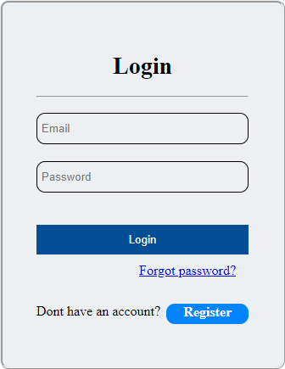

Figure 18: Login page

When the form is filled and the information matches these in the database, the redirect is done to the dashboard page.

Admin’s Dashboard
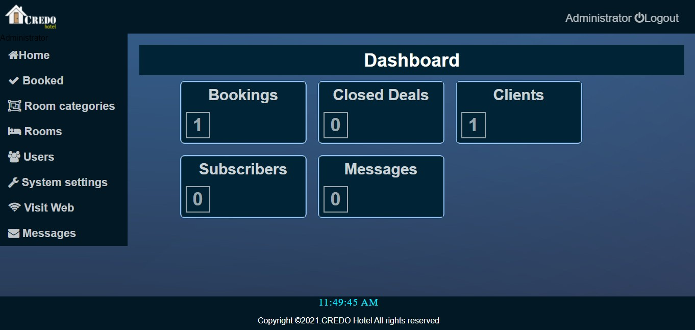
Figure 19: Admin dashboard

Here, the admin can do everything found in the system associated with his/ her role. He/she can create room categories, book rooms, view users, navigate system settings, and visit the web as a client. Admin is allowed to create, edit, and delete content associated with his/her role. All descriptions are done below.

Booked
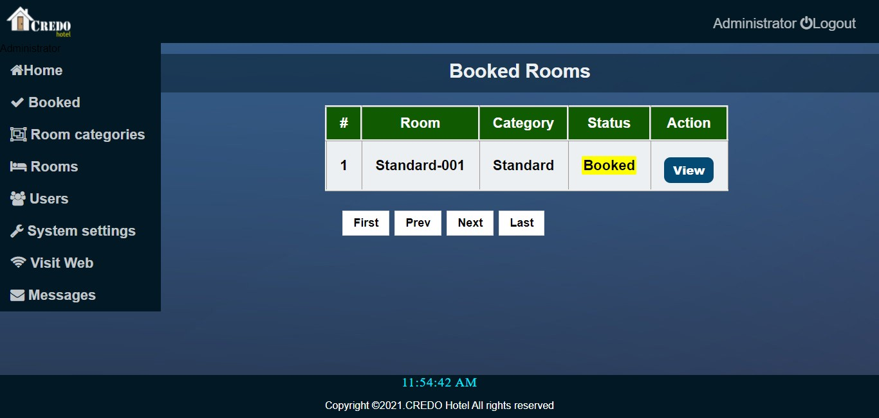
  - Booked Page

Figure 20: Booked rooms.

This figure illustrates the page where booked rooms will be displayed. Three records are selected, and you may use the page navigation options to view others (first, Prev, next, last).
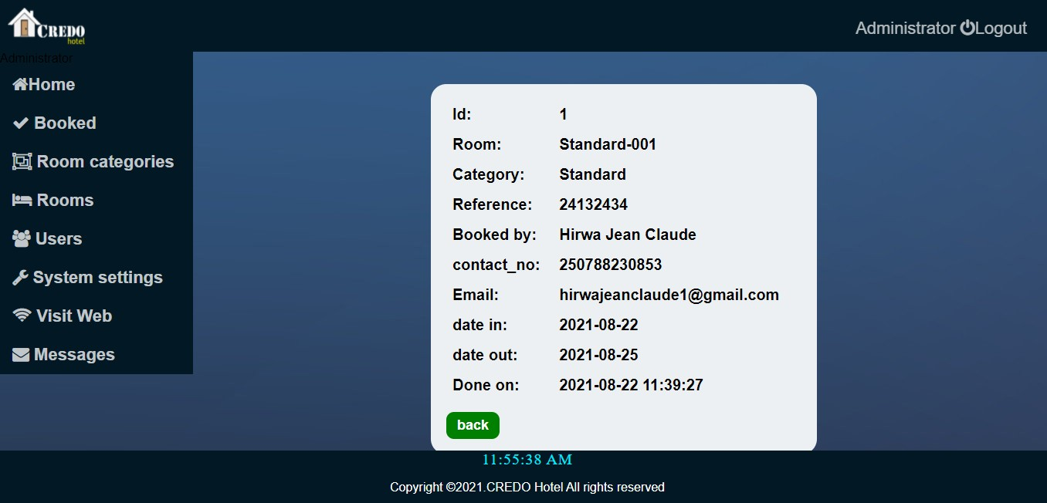
  - View the booking details page

Figure 21: User booking details by admin.

Room Categories
Every room in the hotel must be classified. Depending on the class of visitors, the hotel plans the room categories to ensure good service.
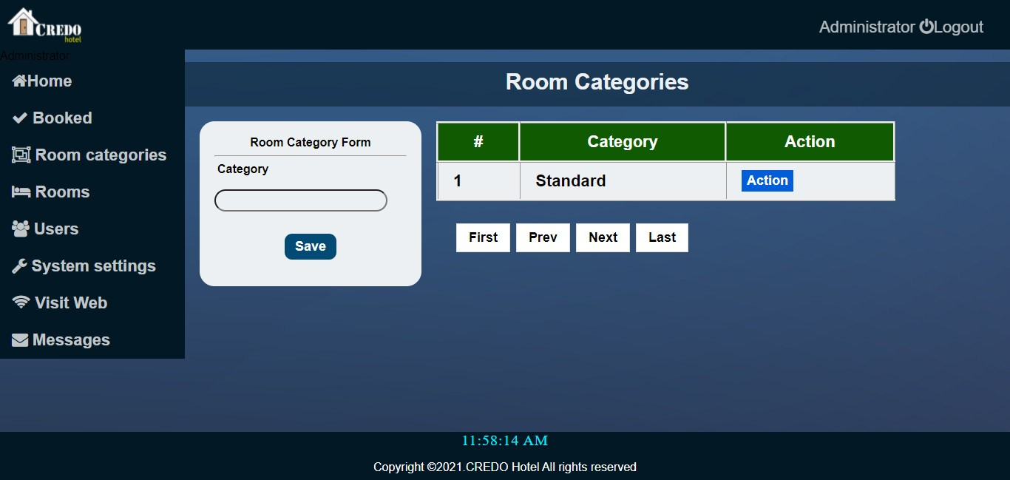
- Room categories Page

Figure 22: Room categories

Here admin can create room categories, update them as well, and delete them by using the action button.
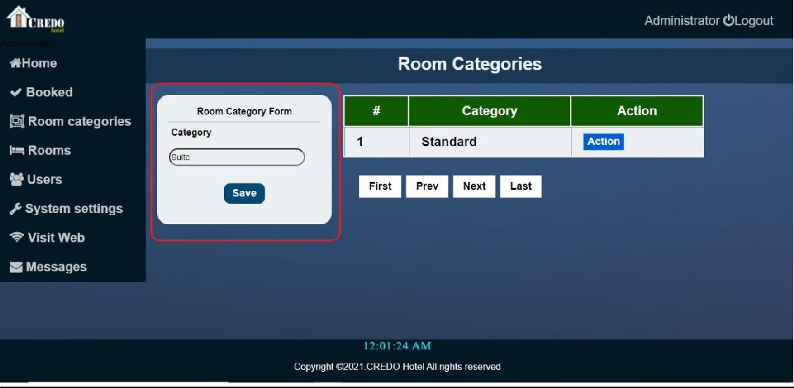
- Add room category.

Figure 23: Add room category.

This can be done without leaving the page. Admin fills the form and saves.

Edit the room category page.

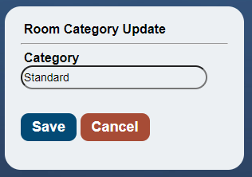

Figure 24: Room category updates

The selected category to update is “standard”. Here, the admin is required to change the name and click “save” to update. He can also decide not to update and click “cancel”.

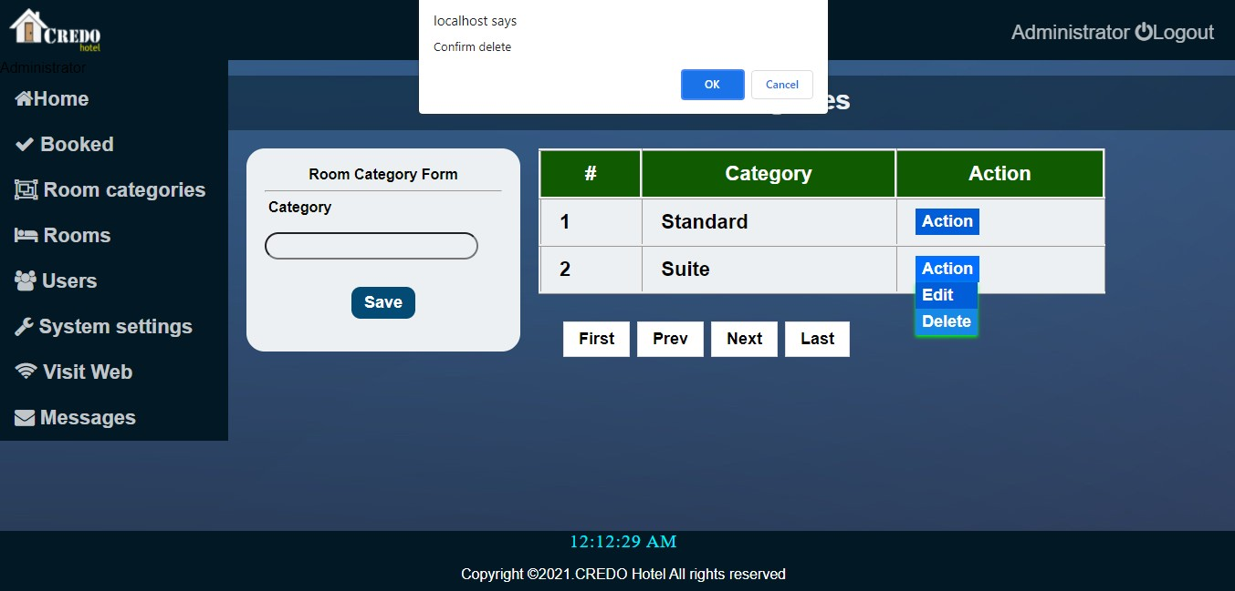
- Delete category.

Figure 25: Room category deletion

When the admin clicks on delete, they must confirm the deletion for the room to be deleted.

Rooms page

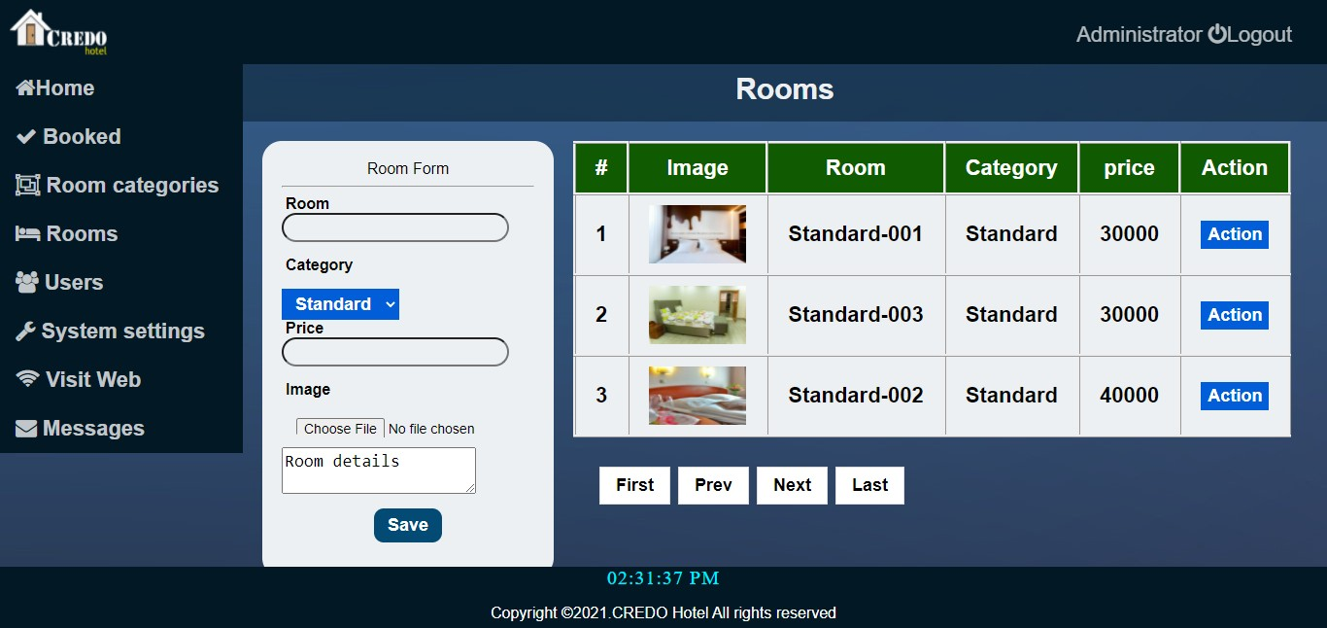

Figure 26: Rooms

Here admin can create rooms, update them as well, and delete them by using the action button.
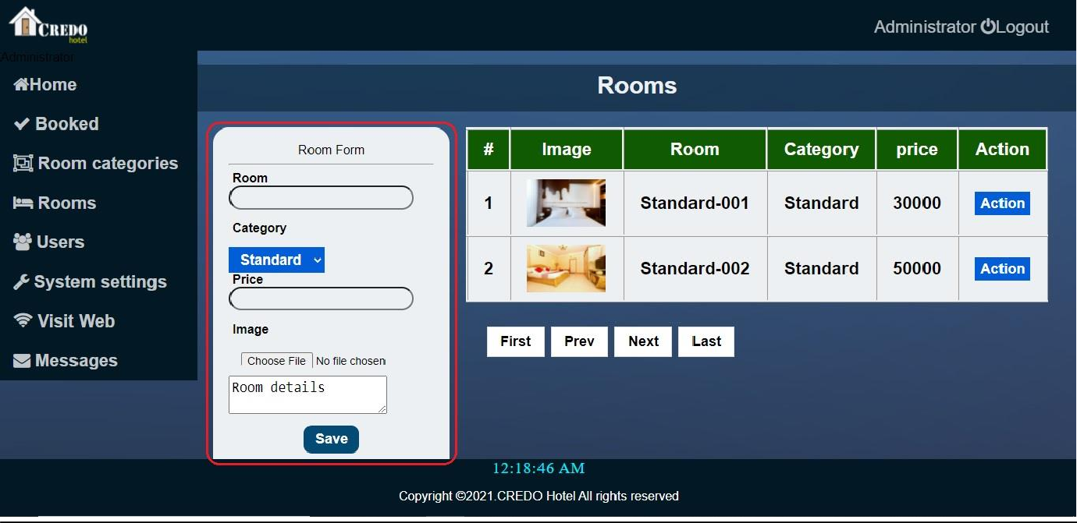
- Add a room.

Figure 27: Add rooms.

Admin must fill the form (the one bordered by a red rectangle (the color is for illustration only)) and click “save” to add the room. The room category is selected from the created categories.
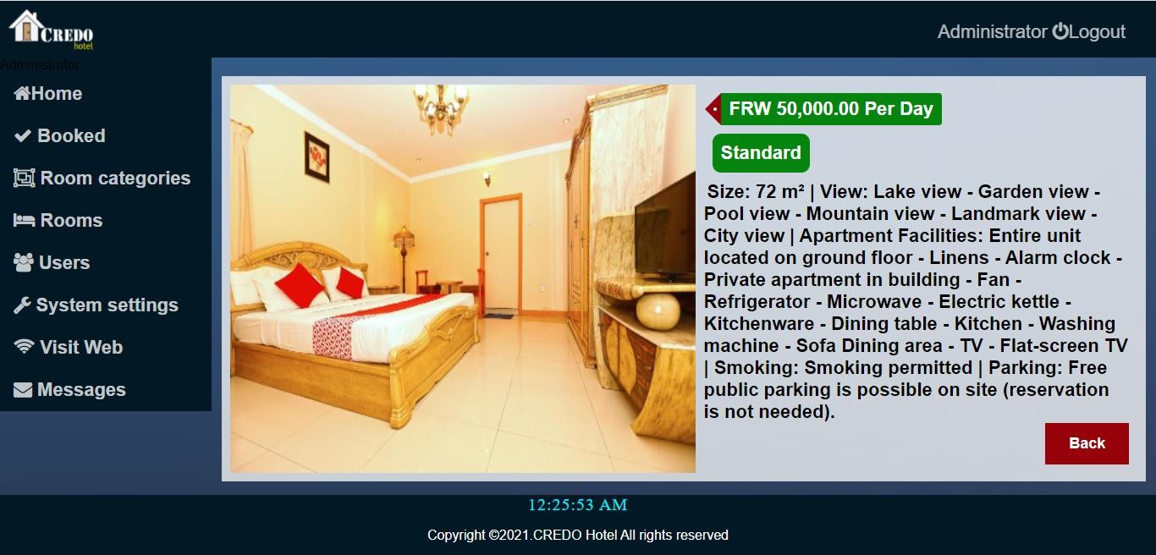
- View the room, Page.

Figure 28: View rooms

On this page, the admin can see the following: room image, category, and room details.
- Edit room.
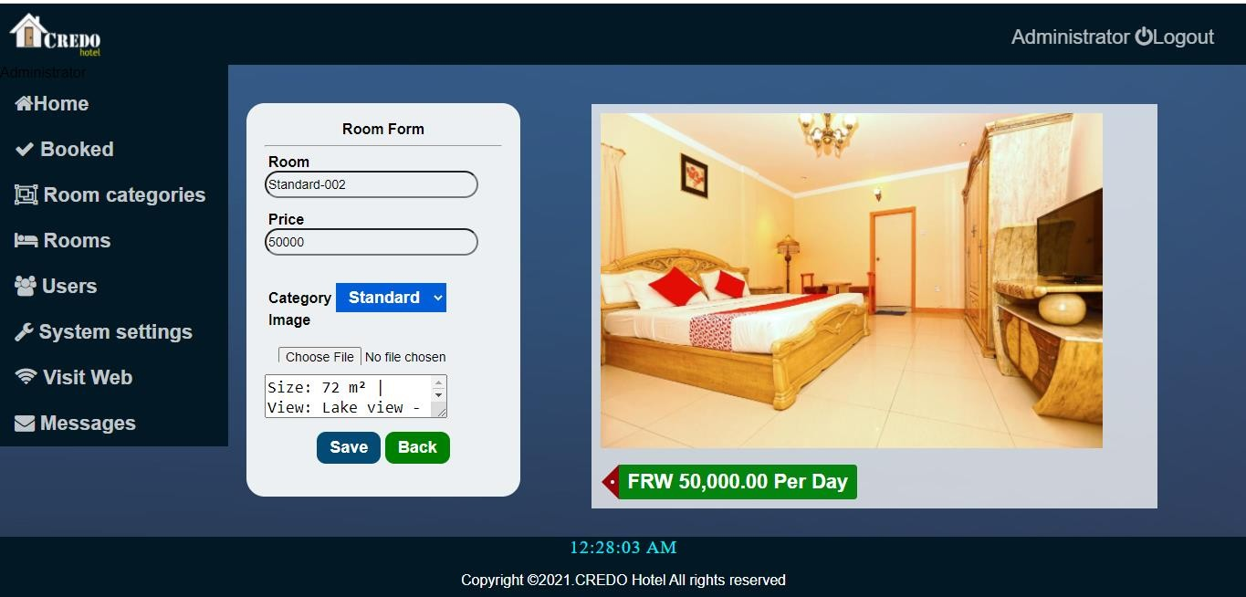

Figure 29: View rooms

Admin changes room information by filling in the form and saves it to update.

- Delete room.

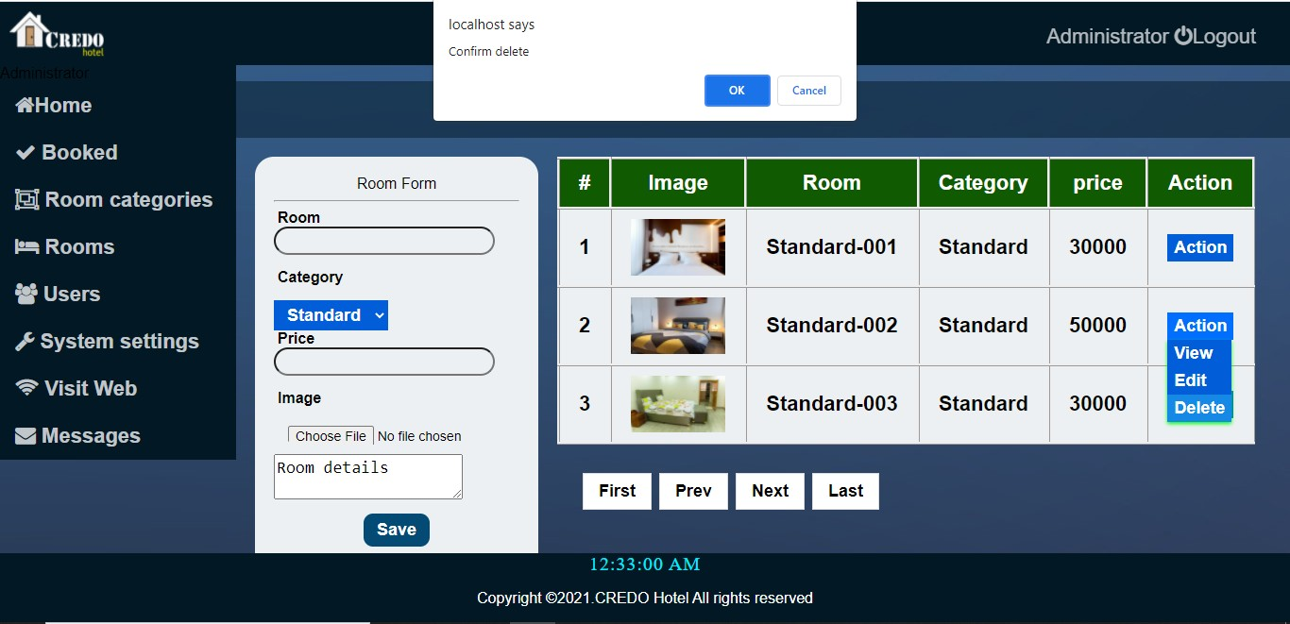

Figure 30: Delete room

When the admin clicks on delete, they must confirm the deletion for the room to be deleted.

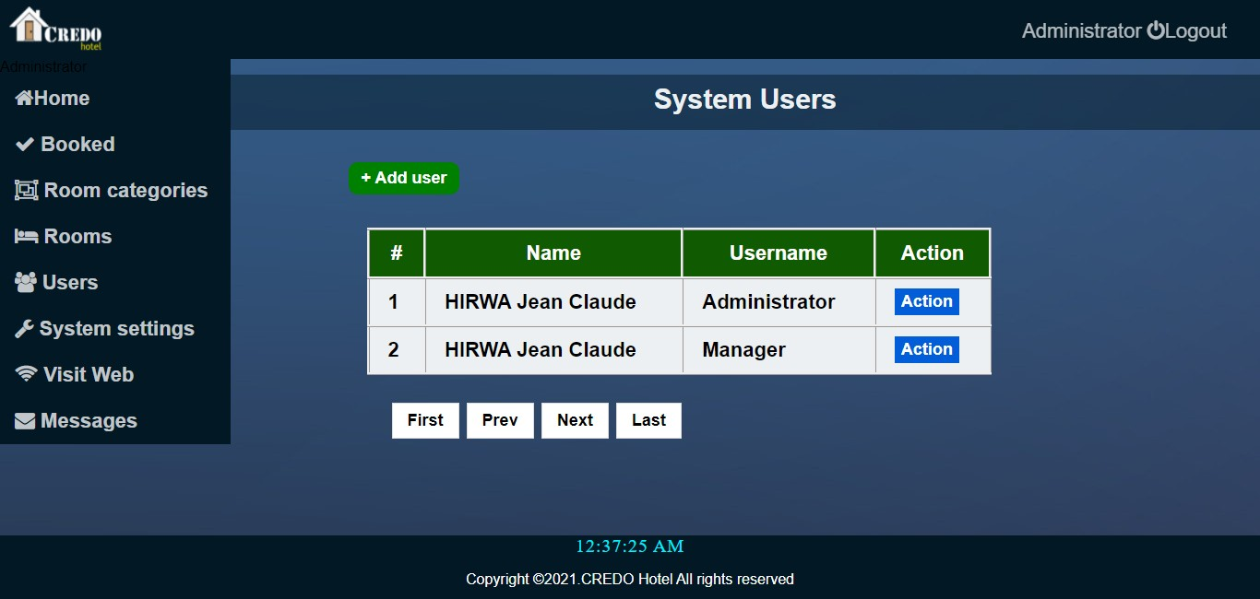
Users page

Figure 31: Users page

All system users except clients can be seen on this page. Admin can add users, edit user information, and delete users.
- Add user.
Admin can add new users by simply clicking on the “add user” button and filling the form, and then “save”.
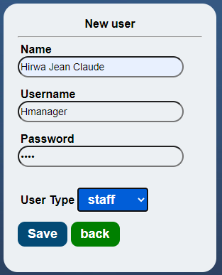
Figure 32: User account creation

The user type in the form specifies what the user can do in the system.

- Edit user.
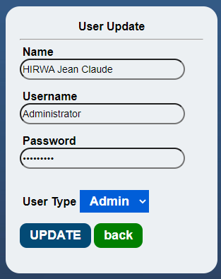
Admin fills the user update form and clicks update to change the data.

Figure 33: User update

- Delete user.
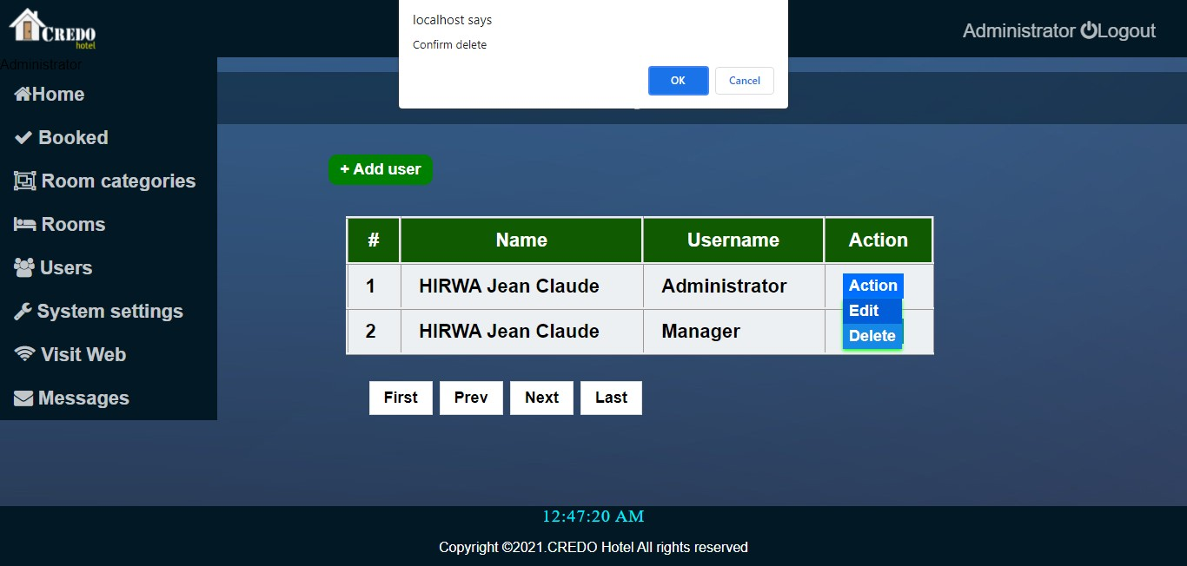
Figure 34: User deletion

Here admin can confirm to delete the selected user. If he clicks “ok,” the user will be deleted.

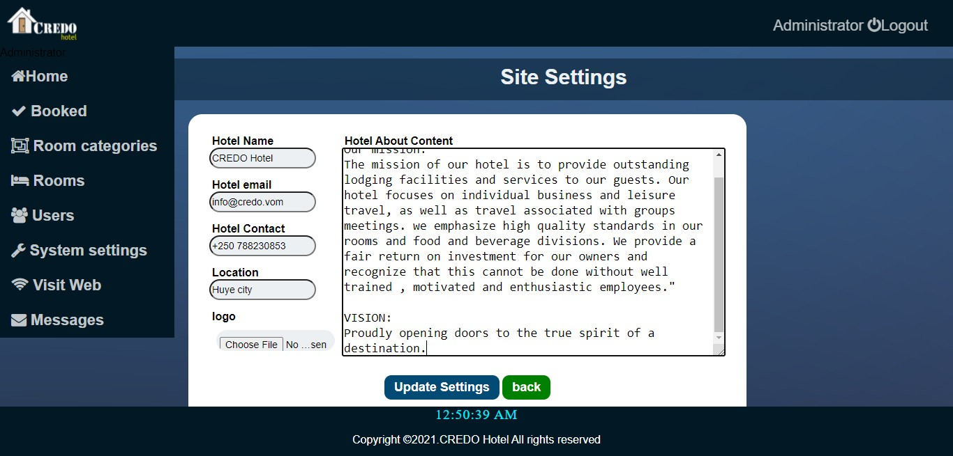
System settings

Figure 35: System settings

Here, all related information is added, and the user clicks update settings. What is updated here is the hotel name, email, contact, location, logo, and content. These settings are displayed on different pages based on their needs.
Messages:

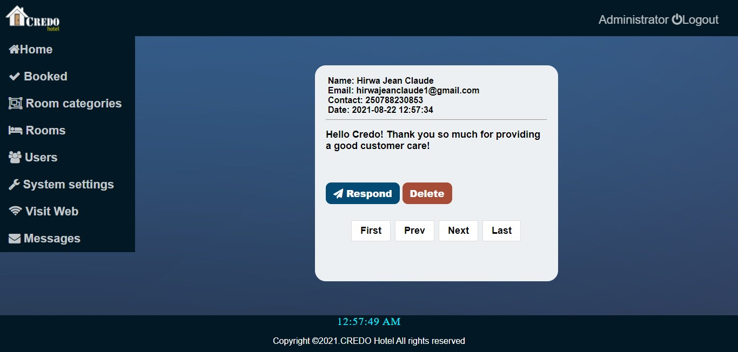

Figure 36: Customers' messages

These are messages sent by clients in contact with us. Admin can read, respond to them, and delete them.

3. Executive users

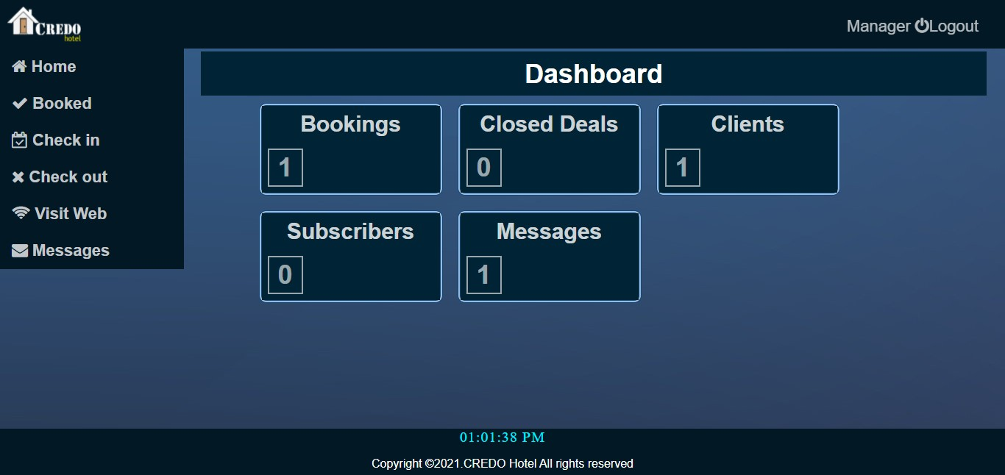
- Executive users’ dashboard

Figure 37: Staff dashboard

- Booked Room page.
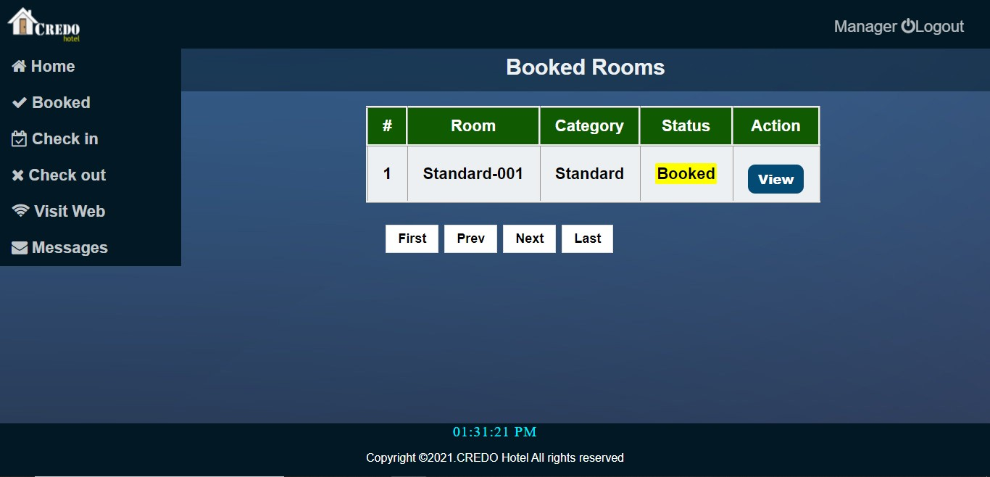
Figure 38: Booked rooms.

Here, the user can see booked rooms and view booking details.
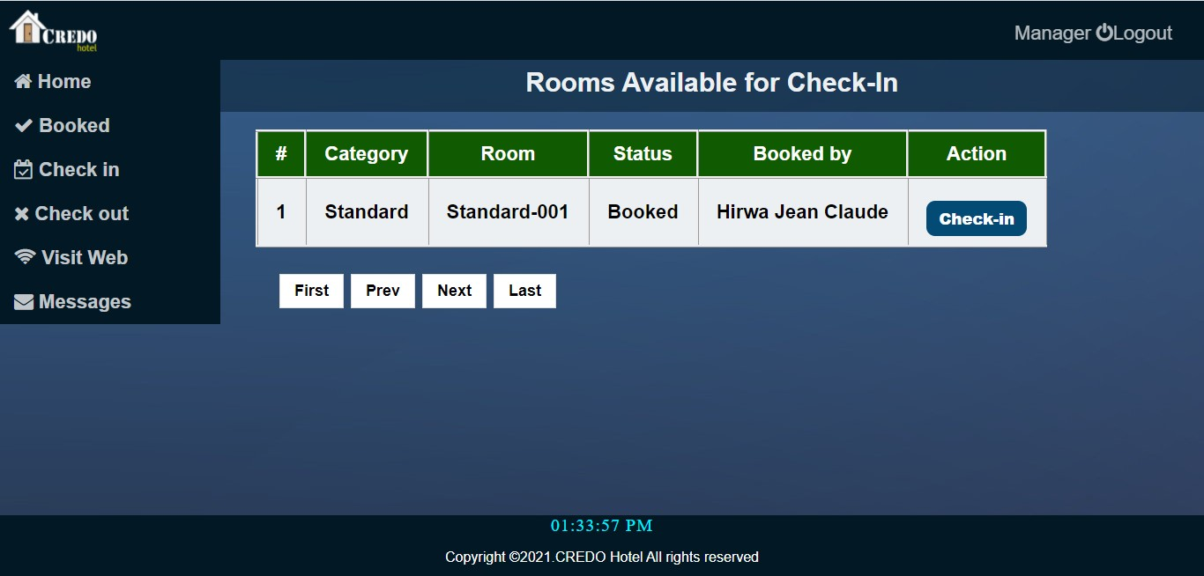
- Check-in page

Figure 39: Check-in page
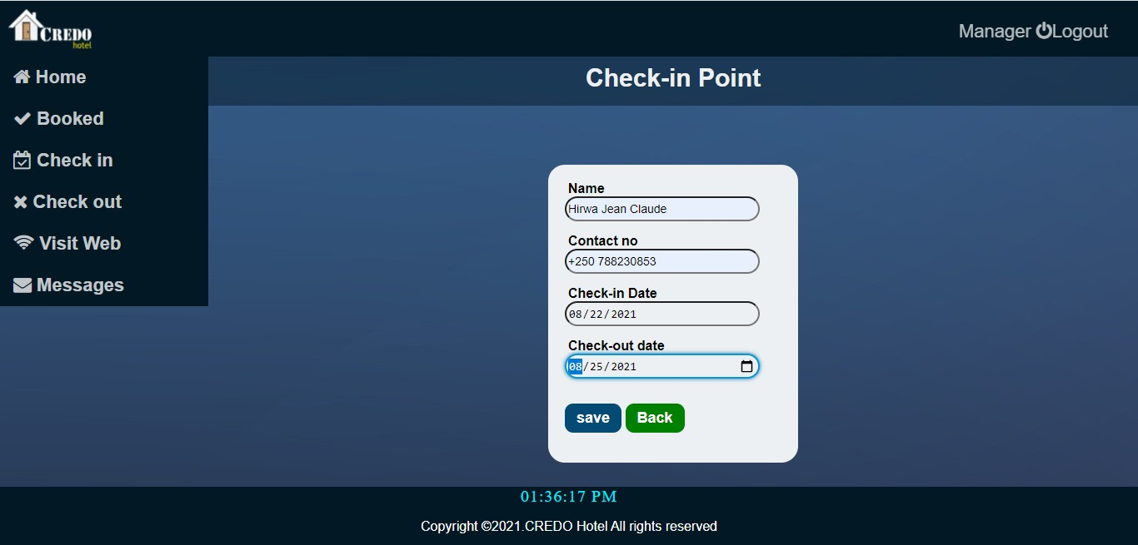
Here, the user can see the rooms available for check-in, and he/she can enter customer details to check in.

Figure 40: Check-in point

On this page, customer details are added to be assigned a room.

- Check out the page.
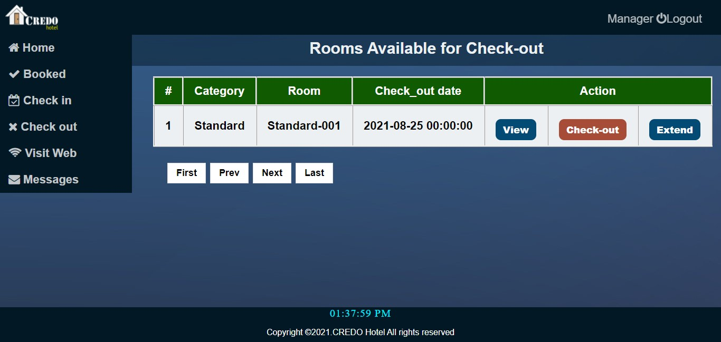
Figure 41: Check-out page
The user can view customers in the rooms and is allowed to check out the room or extend the booking duration when requested by the customer. Executive users can also view clients’ messages the same like an admin.

Chapter 4. Conclusion and Recommendation

  - State of implementation
Compared to what I have done here and what I was supposed to do, 85% was done, and that 15% is some challenges I have had in the design. The main challenge was a limited time of as this was combined with other courses. The missing features are payment activation, user account settings, and recovery. These will be added in the future for the project to be finalized.

  - Recommendations
  - Lecturer
Let me first appreciate the hard work of our lecturer for making me have the capacity to develop such a web-based system.
This is because he raised our confidence so that we did this. Even if we had limited time, we managed to learn new things on both System Analysis, Design, and Development, and now our level of understanding and analysis has been raised. I would like to recommend that our lecturer allow us to have a strong connection to him to continue raising our knowledge to the sky.

  - School
I also appreciate the University of Rwanda, especially the school of ICT support they provided us, such as access to the lab. What I recommend to them is about the time constraint. Through my work, I have met a challenge of limited time, as this was a combination of many modules to be completed within a short period. The project was designed within one month, which led to the submission of incomplete work. Also, there is a need well well-designed internet infrastructures, as I met with some challenges about internet access.

  - Students
I would like to thank my classmates for helping to understand the assignment-related questions more clearly. They did their best to design this project. What I recommend to them is that now they can start the exploitation of available opportunities to design a way to their future.
  - Business partners
I would like to thank CREDO Hotel for helping to obtain information about the current situation, to have an idea. What I recommend to them is that they can give time to the testing of this system so that it will be used in the future after completion.

  - Customers
I would like to ask customers for the time to understand the advantages of this system so that it will help them make their reservations very easily.

Appendix

  - Figma link
  - GitHub link: https://github.com/xyz/hotel_booking/tree/main/hotel_reservation
  - Administrator password: admin2020
  - Username: Administrator

