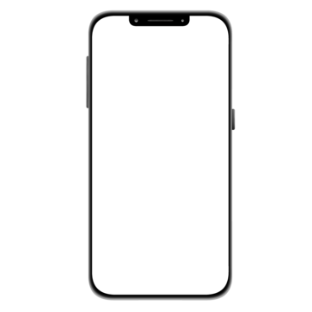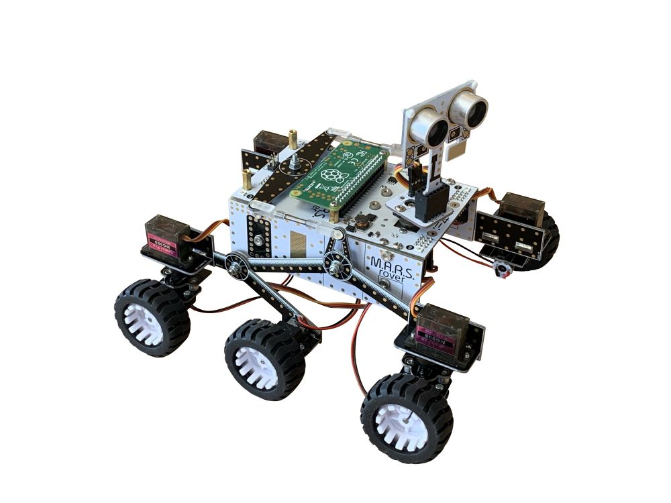

MQTT  
broker

/iotrover/move commands

Connection, sensor data and images

Web application container

Database container

Sensor data and images

Connection and /iotrover/move commands

Image  
gallery

Front-end updates

HTTP GET

Database interaction

Cloud environment