**Maltepe University**

**CEN 432 Introduction to Robotics**

**Project Report**

**Project Title:** Oil Trap

**Group Members:**

Merve Sandıkçı (Student ID: 210704905)

Emin Mert Demirci (Student ID: 180706023)

1. **Project Description:**

The aim of the project is to facilitate the easy restart of industrial spreading by first purifying household oils, isolating the water insulation, and protecting the water insulation. In this way, we aim to prevent environmental pollution. In our project, the Oil Trap works by taking advantage of the density difference between water and oil, keeping the water at the bottom and separating it from the oil. The separation process is achieved by keeping the water below, turning this into an advantage. The system accomplishes this permanently by three-stage filtering of water and oil in a container, ensuring the separation of water from oil. The system utilizes an Arduino set and a water pump to pump water, a filter to retain oil, and a servo motor to control the water inlet and outlet.

In our research for this project, we found that 1 liter of waste oil contaminates 1 million cubic meters of drinking water. Although widely used in the industrial sector, this system, which has not yet seen significant developments, is a priority for us to make available for household use. Our priority in this project designed to prevent increasing water pollution is to make this system usable in our homes. Another goal of ours is to raise awareness among people in this project that we designed to leave a cleaner environment for future generations.

1. **Materials Used:**

* Arduino Uno
* Servo motor
* Water Pump
* Filter
* Container

1. **Introduction:**

The "Oil Trap" project aims to efficiently separate oil from water through a multi-stage filtration process. By turning this density difference into an advantage, oil and water are separated from each other by keeping the water at the bottom. This separation process goes through three stages. The filtering process is repeated at each stage and the aim is to separate water from waste oil.

In the study published at Jun 30, 2021 Oil consumption while on average it is 15 kg year-1 per person in the world, it is 20 kg year-1 in our country. Approximately 1.5 million tons of vegetable oil is used annually in our country, and approximately 350 thousand tons of this is released as waste oil. Only 2% of waste vegetable oils are collected, and in recent years, with increased environmental awareness and licensed collectors, this rate can only be increased to 5%. Unfortunately, the remaining 95% is released to the environment uncontrolled. Our aim is to raise people's awareness and to prevent water pollution.

1. **Circuit Design:**

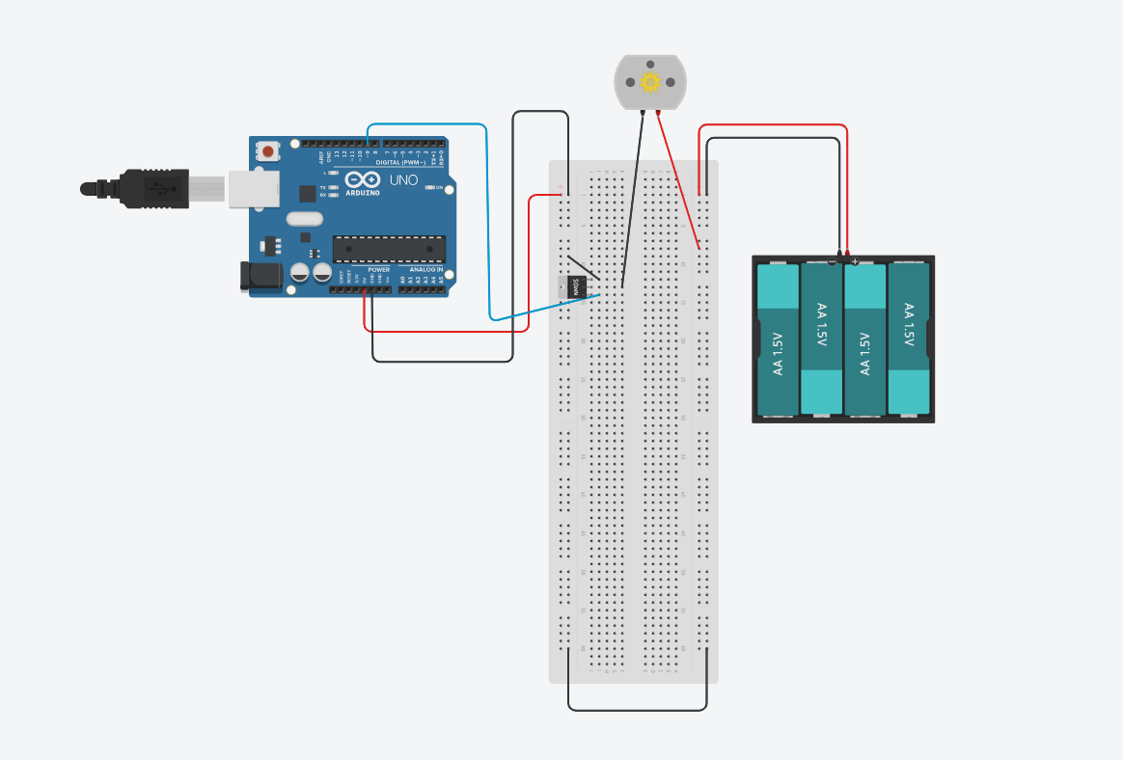

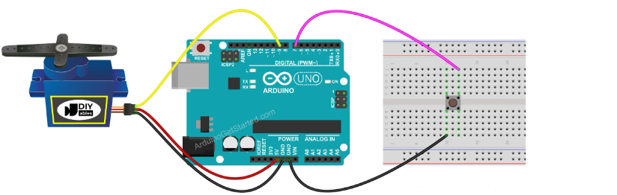

1. **Components Used:**

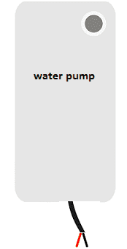

* Water Pump : The water pump is an electric device responsible for moving water. It can be submersible or non-submersible, depending on the application. Submersible pumps are designed to be placed underwater, while non-submersible pumps are used externally.

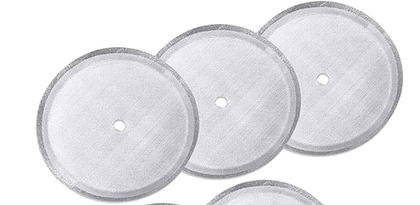

* Filter : Filters are devices that allow the separation or retention of unwanted particles or substances in a substance. They are generally used to remove solid particles, contaminants or other undesirable substances present in liquid or gas.

Liquid Filters; Sediment (Solid) Filters: Keeps large solid particles in the liquid.

Carbon Filters: Purifies water by absorbing chemicals.

Microbial Filters: Makes water sterile by retaining bacteria and germs.

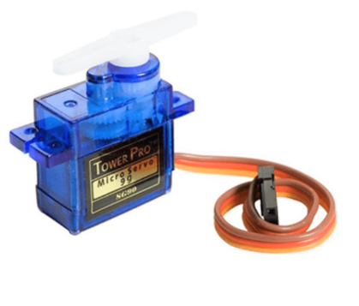

* Servo motor : A servo motor is a rotary actuator that allows for precise control of angular position. It consists of a small DC motor, a set of gears for precise movement, and a feedback control system that ensures the motor shaft reaches and maintains the desired position.

1. **Methodology:**

Following the water inlet, the initial filtration stage will focus on separating solid particles from the liquids. Subsequently, in the second filtration stage, the membrane filter will effectively separate the liquid and oil components. The density of the water will be assessed, and if the values deviate from the normal range, these processes will be reiterated using the water pump.

1. **Findings and Discussion:**

The system successfully separates water from waste oil and completes the filtering process.

We first thought of using load cells. We would find the density difference by calculating the masses. But then we removed the load cell from the system because we could filter it without the need for it.

1. **Lessons Learned:**

During the project, we learned about sensor interfacing, Arduino programming, and basic automationconcepts. This hands-on experience enhanced our understanding of practical applications of electronicsand programming in real-life scenarios. One of the most important things we learned throughout the project was how important soldering is. When working with sensitive devices, soldering was required to get the correct data.

1. **Conclusion:**

The oil trap was a successful project that could be applied to filter waste oils. Thanks to this project, waste oils unconsciously poured into the sink at home can be removed without any problems.

1. **Project Code:**

