Oil Trap

Merve Sandıkçı Emin Mert Demirci Computer / Software Engineering

Maltepe University İstanbul, Türkiye

[210704905@st.maltepe.edu.tr](mailto:210704905@st.maltepe.edu.tr) [180706023@st.maltepe.edu.tr](mailto:180706023@st.maltepe.edu.tr)

**Abstract - The project we developed to prevent environmental pollution caused by pouring cooking oils used in households directly into the sink without being separated, aims to purify water by separating water and waste oil with various filtering methods. For this purpose, it aims to prevent water pollution, which will be a significant problem in the future. By taking advantage of the density difference of water and oil, it is aimed to keep the cooking oil at a certain level and separate it from the water.** **Our priority is to make this system, which is not yet available in households although it is widely used in the industrial field, available in our homes as well.**

***Keywords— oil trap system, environmental pollution, Robotics.***

1. INTRODUCTION

The oil trap operating principle turns the density difference of water and oil into an advantage and separates oil and water from each other by keeping the water at the bottom. First, the filtering stage is started. The first filter is used to separate large particles in dirty water. In the second filtering, the waste oil is kept at the top and the water is passed through the bottom part, making the water cleaner. In the next step, the water is filtered by keeping the small amount of remaining oil at the top and is ready to be sent to the sewer.

In the research we conducted in this project, which we designed to prevent increasing water pollution, it is known that 1 liter of waste oil pollutes 1 million cubic meters of drinking water. We wanted to develop a low-cost but useful design to reduce this problem and leave a cleaner world to future generations.

1. RELATED WORKS

In the study [1] published at April 21, 2022 JOTCS (Journal Of The Turkish Chemical Society) is similar to our project. but has progressed in a different business line. They use membrane filtration separate to dirty oil from water like we did.

In the study [2] published at October 2022 Düzce University Science and Technology Journal Oil-grease separation was used as we did in our project as seen in this article. Separation; The collected wastewater is separated with water due to the density of oil and grease in it. Oil and grease rise to the surface of the water and are separated at this stage. Collection and Disposal; The oil and grease that rise to the surface are collected in a special unit or chamber. The oil and grease from this unit is then disposed of appropriately. In some cases, these oils can be recycled and contribute to energy production. This method was also used in our project.

The study [3] published at Mohr Separations Research, In this study, the decomposition method is used as a method that we use in our project. Coalescing plate module type oil-water separators are defined as a solution that separates oil from water using only the force of gravity. These module type separators are generally permanent and maintenance-free. Additionally, there is no need for consumables or absorbents such as filter cartridges.

1. OIL TRAP SYSTEM

Our project was specifically designed to reduce environmental pollution caused by improper disposal of cooking oils at home. Typically, these oils are poured into sinks, causing significant water pollution. The essence of our system is an innovative approach that takes advantage of the natural density difference between water and oil. By doing this, it efficiently separates waste cooking oil from water. This separation process is not only crucial to preventing oils from entering our waterways, but also plays an important role in reducing the load on wastewater treatment plants. In the first stage of filtration, our system aims to remove large particles from the water, making the subsequent stages more effective. Following this, a second, more refined filtering process takes place. Here, the waste oil is isolated at the top since its density is lighter, allowing the cleaner water at the bottom to pass through. This progressive filtration not only increases the purity of the water, but also facilitates the collection of waste oil, which can then be disposed of responsibly or repurposed.

The project consists of 2 parts. The parts are given below.

**Uno Arduino:** Water pumps are controlled using Uno Arduino. With the first water pump, water is sent into the oil trap. The second water pump ensures the flow of water in the oil trap.

XXX-X-XXXX-XXXX-X/XX/$XX.00 ©20XX IEEE

**Filtering System:** There are 3 filters in the oil trap: the head part, the middle part and the last part. The filter in the head separates the solid particles in the dirty water and allows the remaining dirty water to pass to the middle part. There is a filter in the middle part that will retain the oil at the upper level of the dirty water by using the density difference of oil and water. In the last part, the filtering method used in the beginning is used again and the dirty water is filtered one last time and transferred to the sewer.

1. SYSTEM ARCHITECTURE

In this section, information about the architecture of the system will be given. The usage scenario of the system is shown in the Sequence Diagram shown in Figure 1. This diagram shows the steps that wastewater goes through as it enters the system. The first step is to separate the particles from the wastewater.

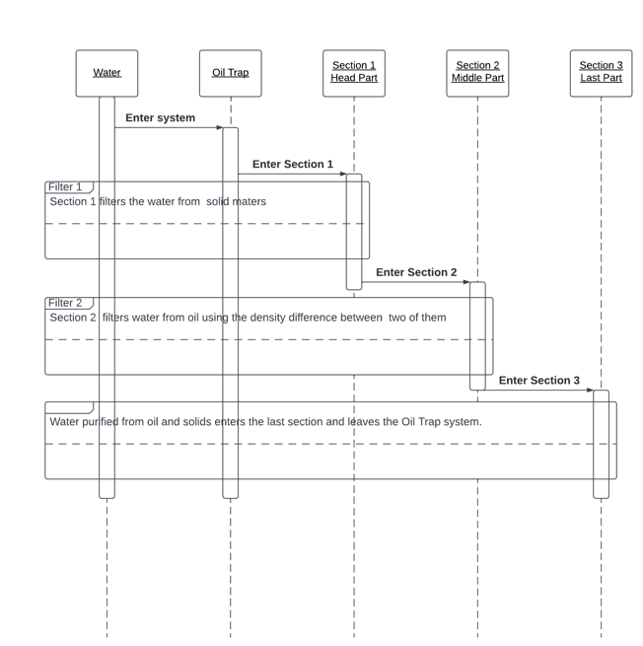Then, we proceed to the second filtering and separate the waste oil and water due to the density difference. In the last filtering stage, filtering is done based on the density difference, as in the second. Finally, the filtered water is released from the system.

Fig. 1. The Sequence Diagram of Project

Figure 2 represents the UML Activity Diagram. The working of this diagram system is in parts. This section shows 3 stages of filtering in the system encountered in system membership, member login, account control, office rental transactions and user authorization are given.

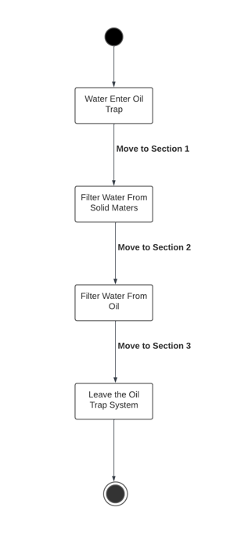

Fig. 2. The UML Activity of Project

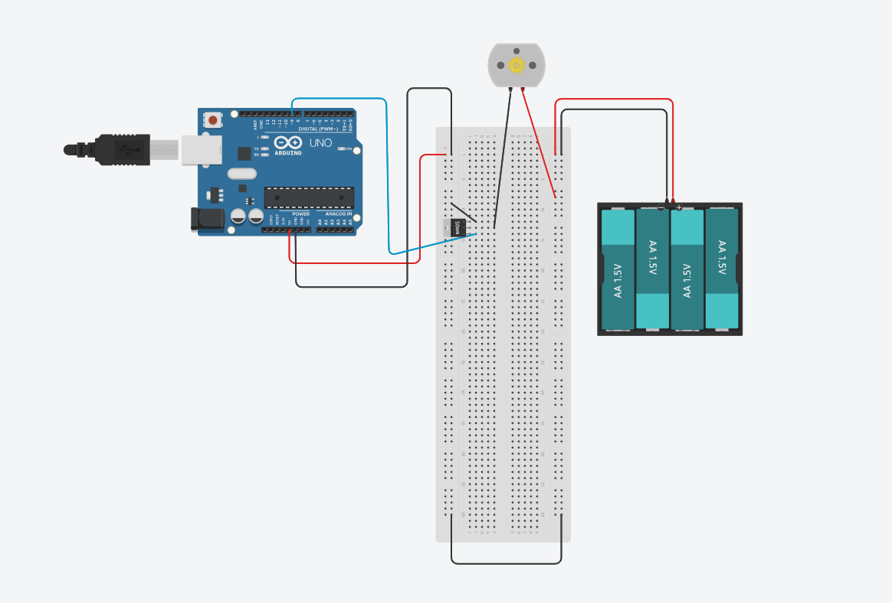

Fig. 3. Arduino water pump circuit

Thanks to the water pump, we ensure the flow of waste water in the system.

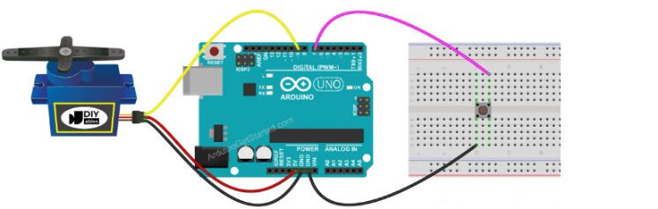

Fig. 4. Servo motor Arduino circuit

We use the servo motor to control the inlet and outlet of wastewater. Thanks to the button, we can control when water will be entered into the system.

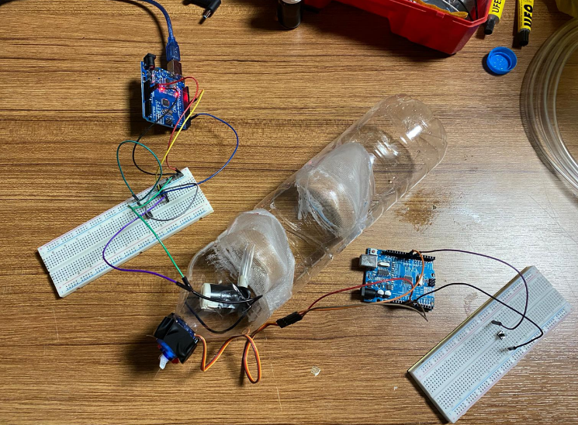

Fig 5. Final system

1. CONCLUSION

As a result of this study; It has been observed that the oil trap system operates smoothly. Filtering processes work smoothly thanks to the density difference. Although several different scenarios were considered, it was ultimately decided to use this system.

In the following versions of this study, we will focus on how it can be made more useful in all households. We aim for the filtering system to work more automatically.

REFERENCES

1. https://dergipark.org.tr/tr/download/article-file/2387928.
2. https://dergipark.org.tr/tr/download/article-file/1524868
3. https://www.oilandwaterseparator.com/wp-content/uploads/2014/09/How-Oil-Water-Separators-Work-and-How-to-Use-Them-Paper.p