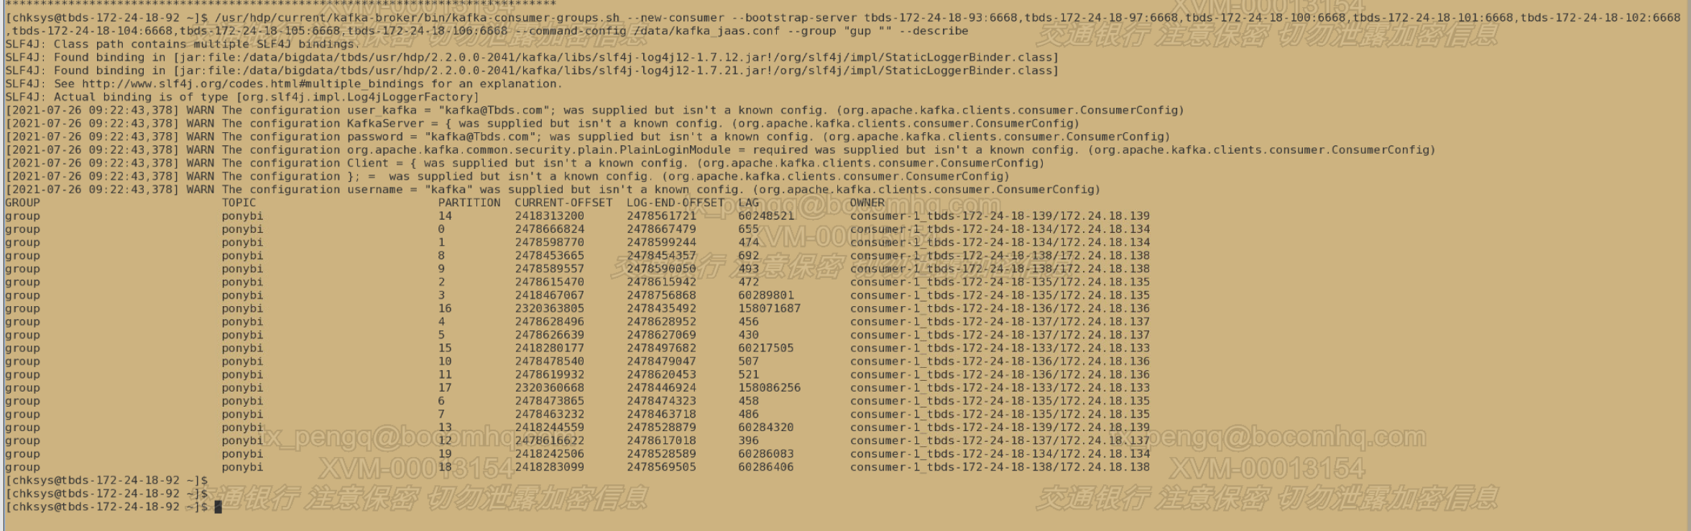

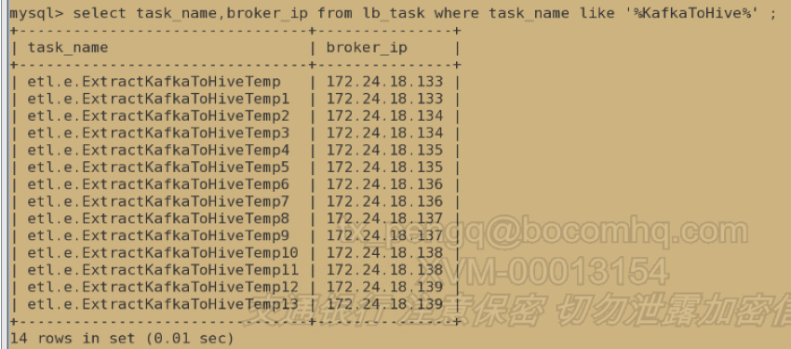

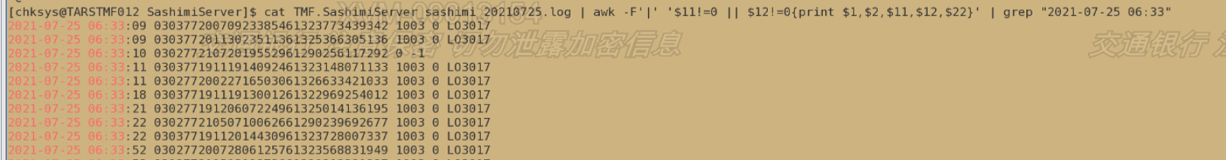

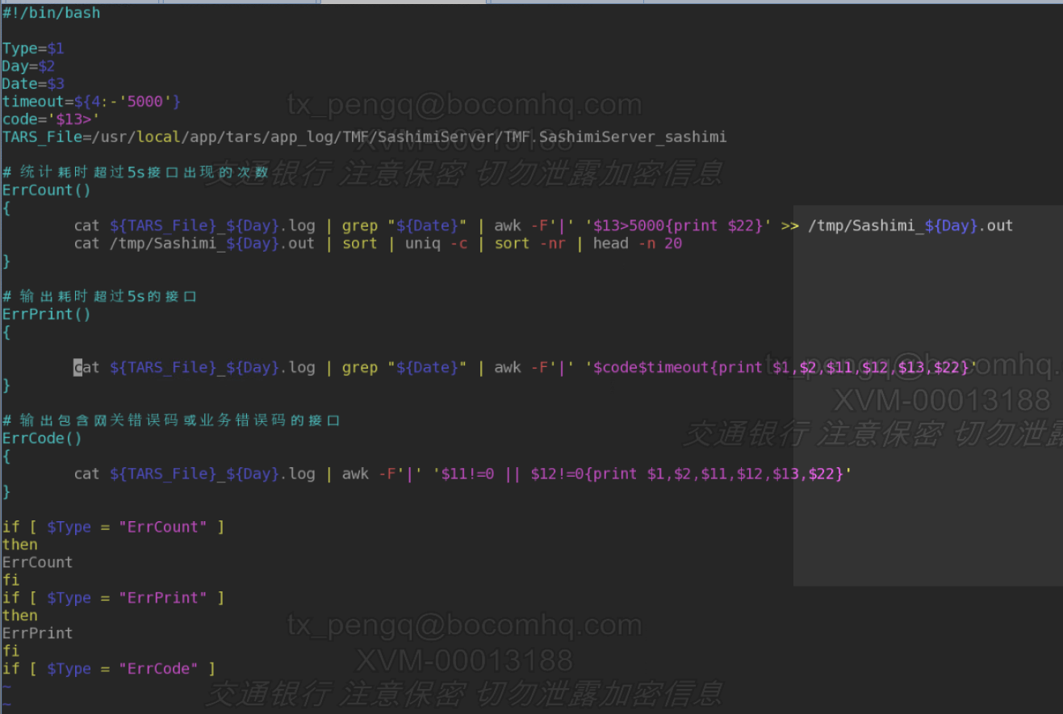

{"common":{"ar":"310000","ba":"Huawei","ch":"oppo","md":"Huawei P30","mid":"mid_36","os":"Android 10.0","uid":"155","vc":"v2.1.134"},"start":{"entry":"icon","loading_time":12946,"open_ad_id":11,"open_ad_ms":7649,"open_ad_skip_ms":3366},"ts":1627604275000}

{"common":{"ar":"110000","ba":"Xiaomi","ch":"xiaomi","md":"Xiaomi 10 Pro ","mid":"mid_1","os":"Android 11.0","uid":"205","vc":"v2.1.134"},"start":{"entry":"notice","loading_time":14566,"open_ad_id":20,"open_ad_ms":3317,"open_ad_skip_ms":0},"ts":1627604275000}

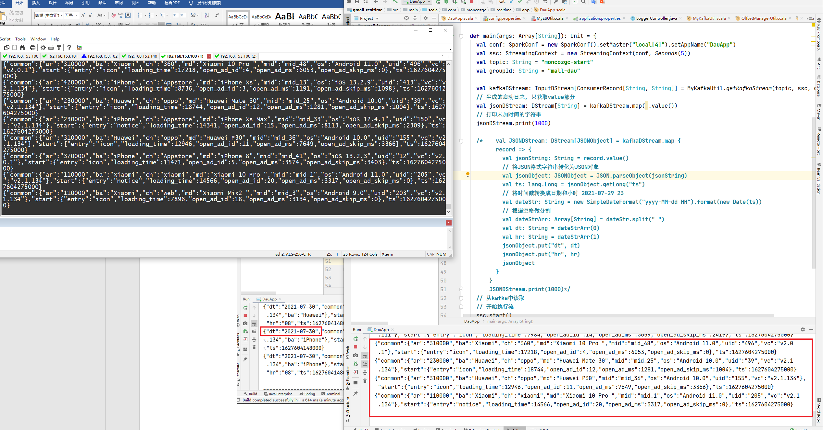

{"dt":"2021-07-30","common":{"ar":"310000","uid":"387","os":"iOS 13.3.1","ch":"Appstore","md":"iPhone X","mid":"mid_48","vc":"v2.1.134","ba":"iPhone"},"start":{"entry":"install","open_ad_skip_ms":0,"open_ad_ms":4183,"loading_time":4745,"open_ad_id":20},"hr":"08","ts":1627604148000}

